Task01:
Algorithm
Start from index i = 0 to n-2
Find the smallest element from i to n-1
Swap it with element at index i
Repeat until entire array is sorted

Task02:
Pseudo Code
for i = 0 to n - 2 do
minIndex = i
for j = i + 1 to n - 1 do
if A[j] < A[minIndex] then
minIndex = j
end for
if minIndex != i then
swap A[i] and A[minIndex]
end for

Task03:
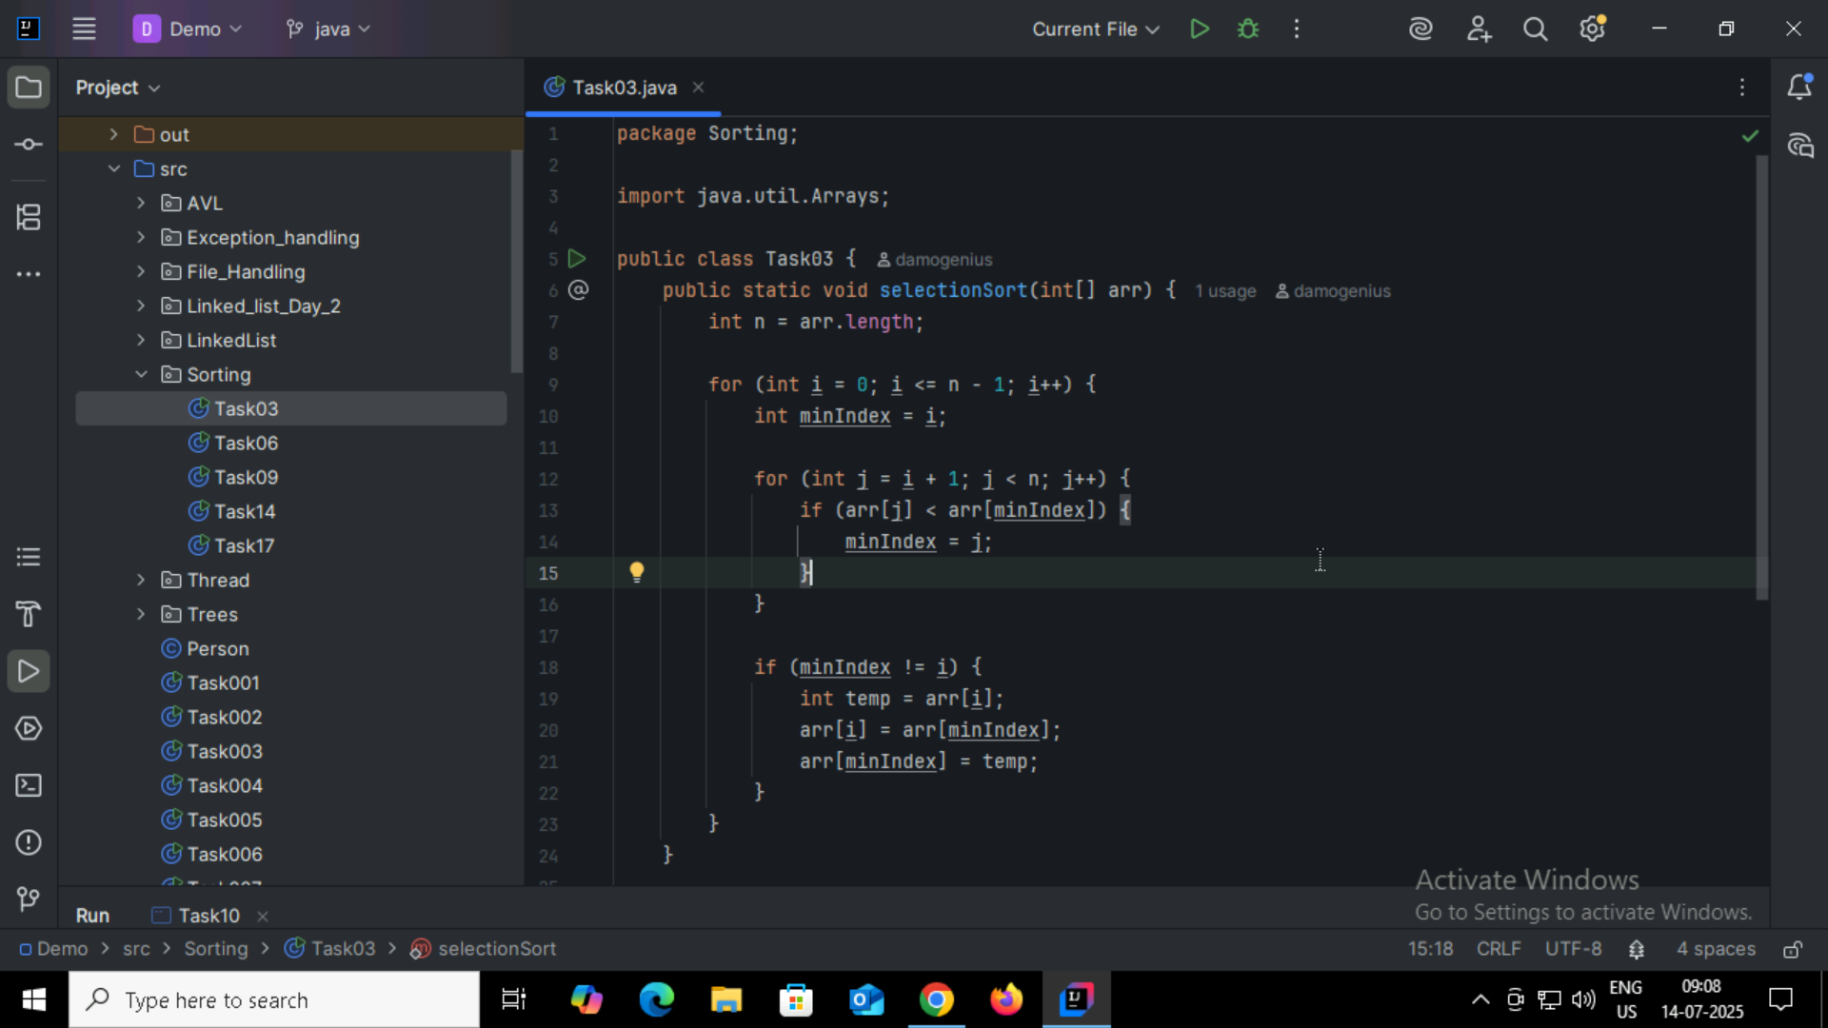
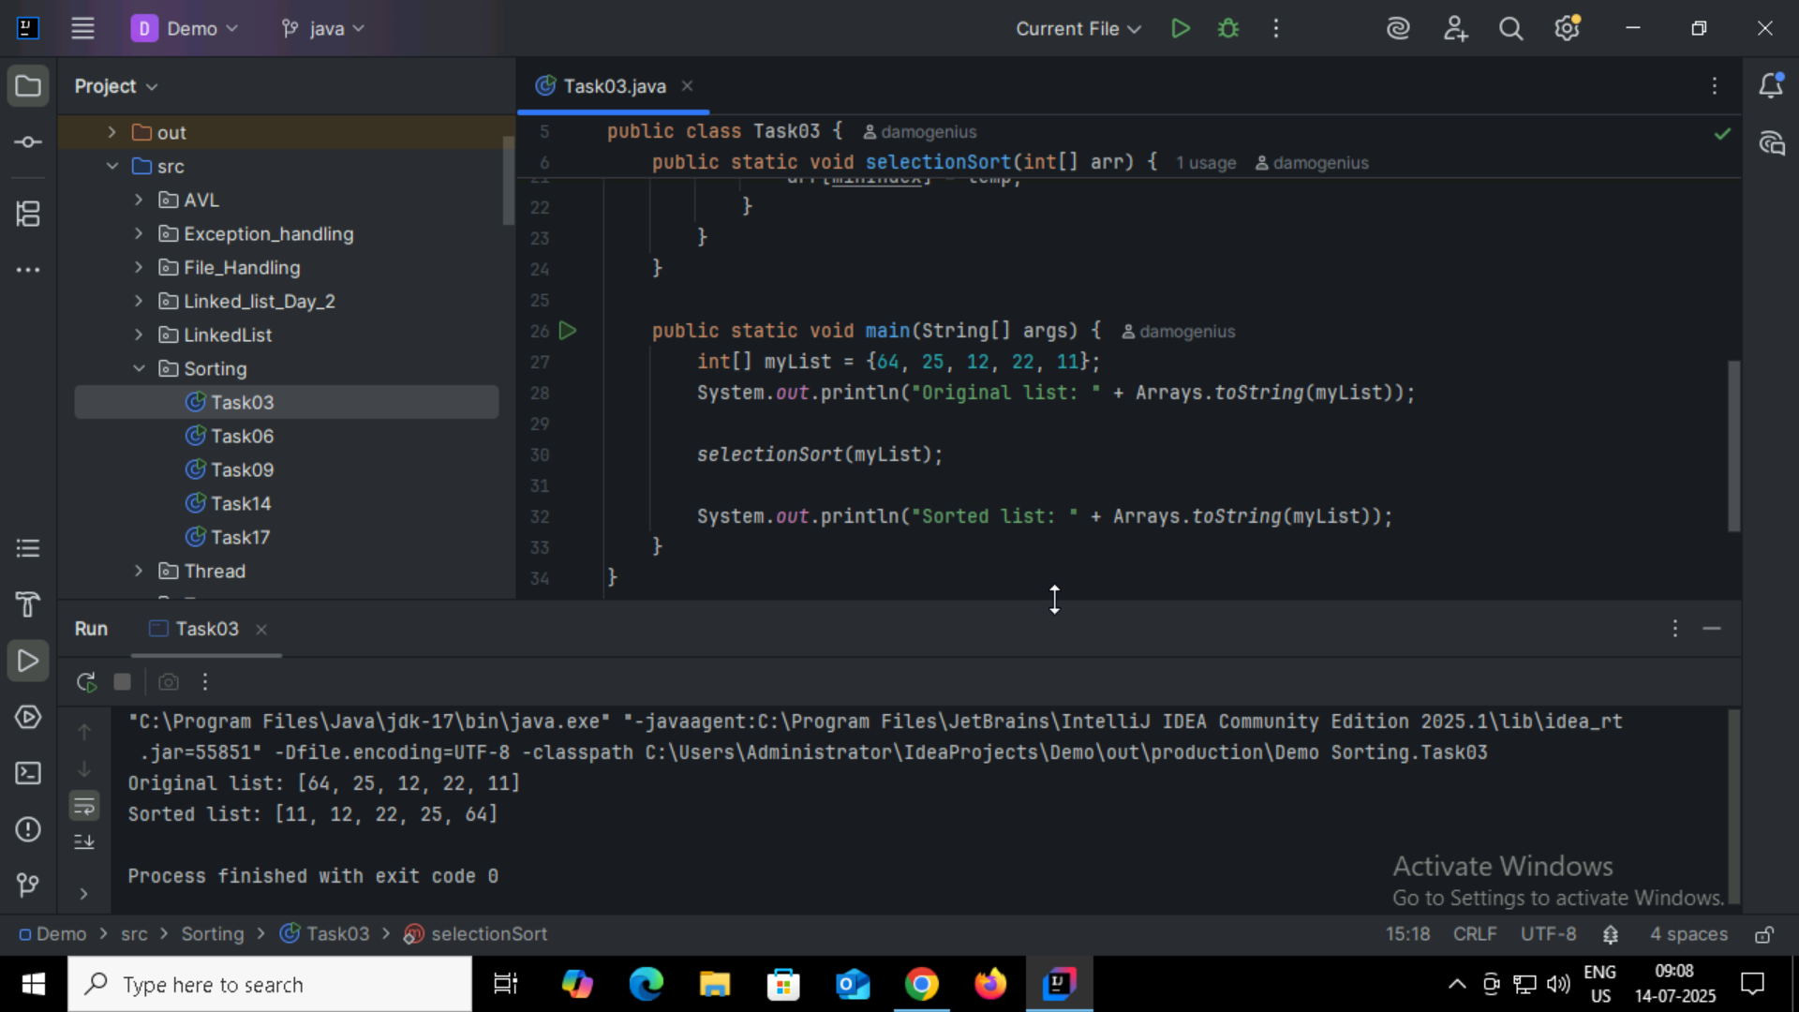

Task04:
Step 1: Start
Step 2: Repeat the following steps for all elements in the array, except the last one.
Step 3: For each pair of adjacent elements in the array:
a. Compare the current element with the next one.
b. If the current element is greater than the next one, swap them.
Step 4: Repeat the process for all remaining unsorted elements.
Step 5: Continue the process until the array is sorted (i.e., no swaps are needed in a full pass).
Step 6: Stop

Task05:
1. repeat
2. swapped = false
3. for i = 0 to n - 2 do
4. if A[i] > A[i + 1] then
5. swap A[i] and A[i + 1]
6. swapped = true
7. end for
8. until swapped = false

Task06:
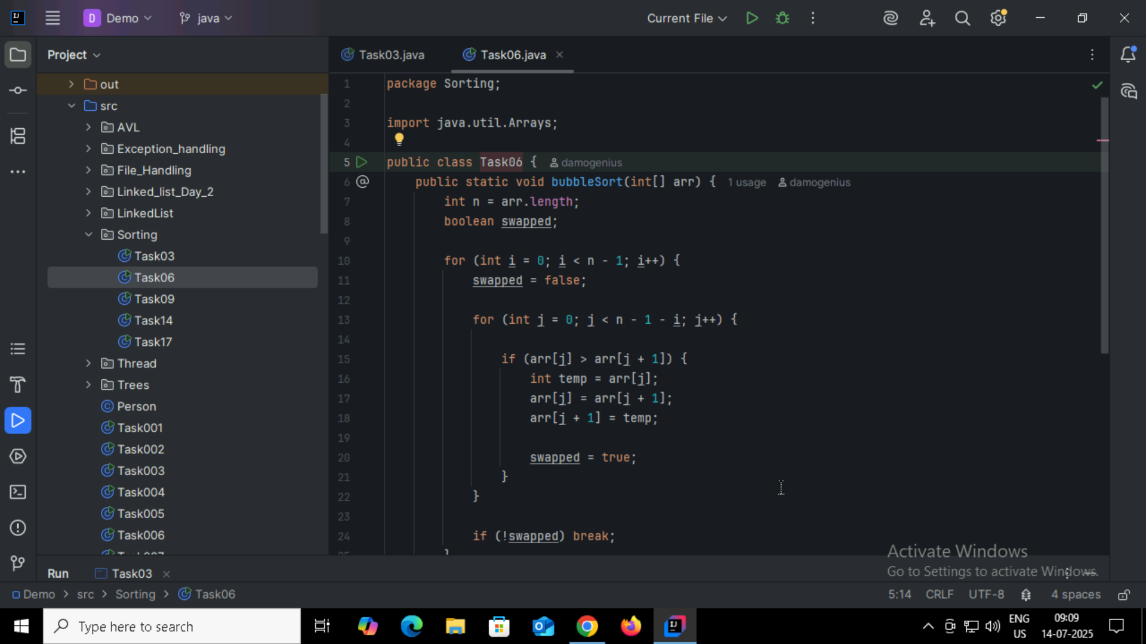
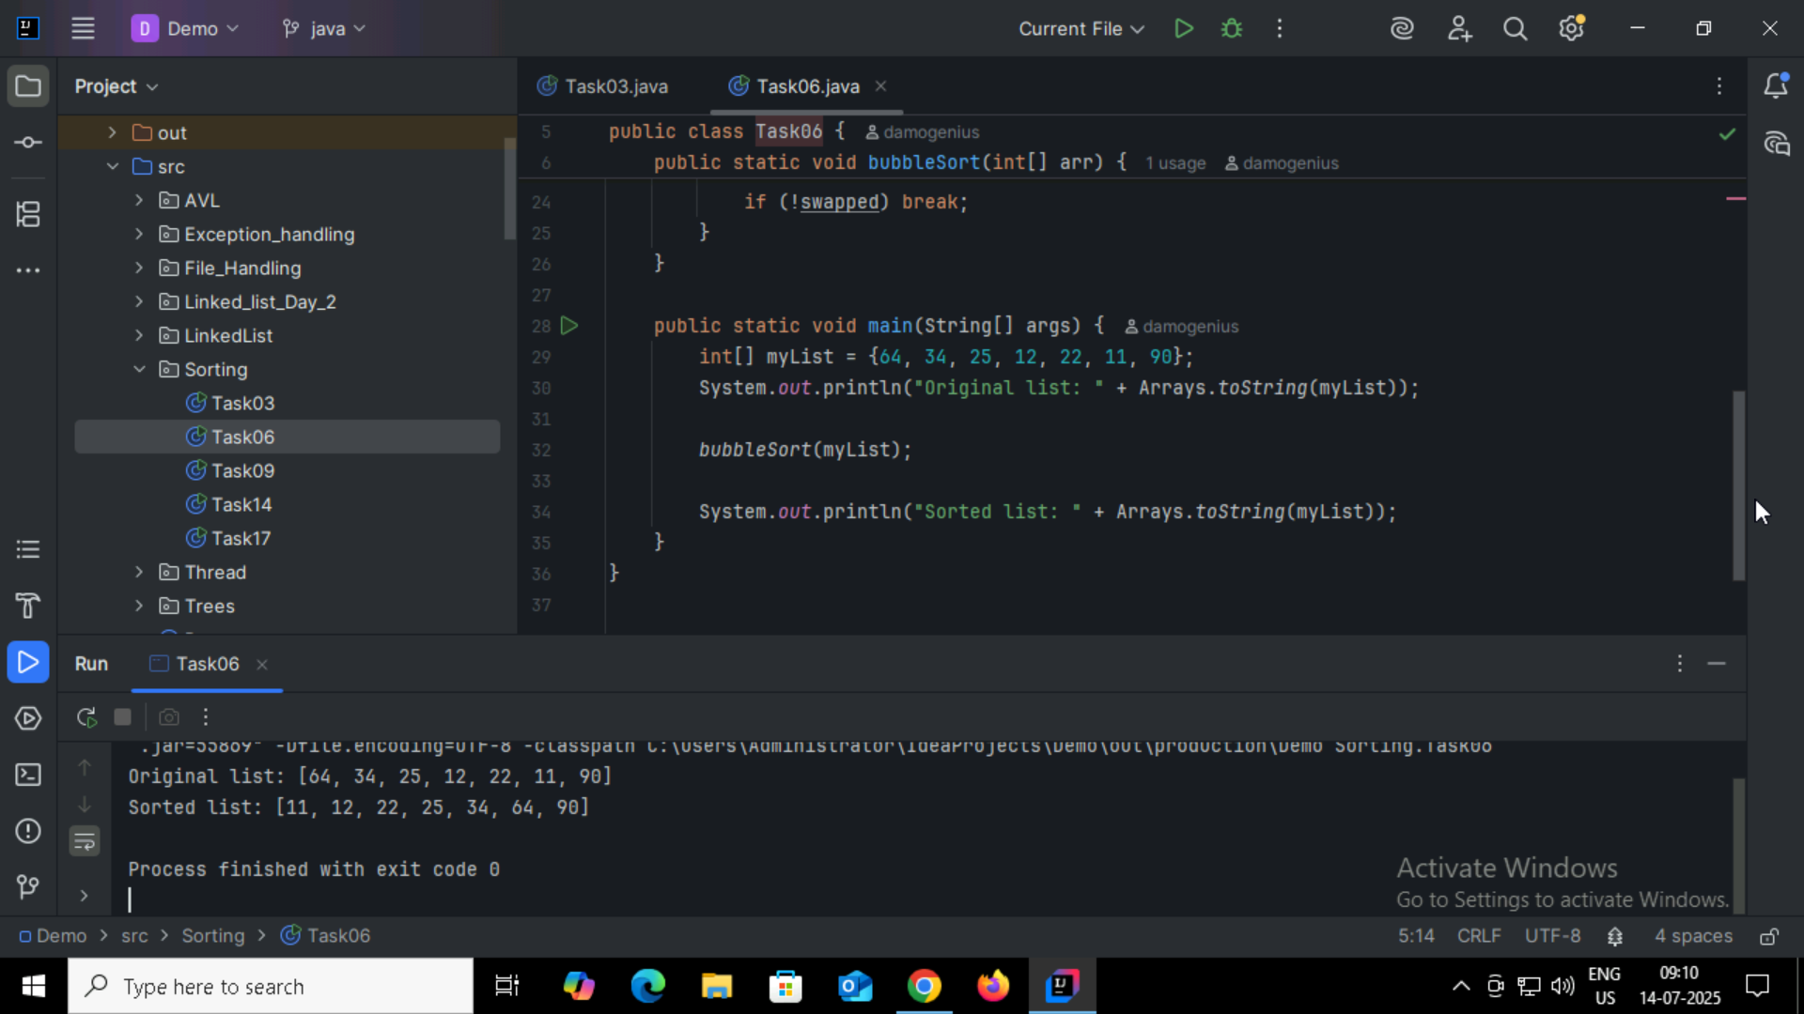

Task07:
Algorithm: Insertion Sort (Ascending Order)
Step 1: Start
Step 2: Assume the first element of the array is already sorted.
Step 3: Take the next element from the unsorted part of the array.
Step 4: Compare it with elements in the sorted part of the array (from right to left).
Step 5: Shift all larger elements in the sorted part one position to the right.
Step 6: Insert the current element into its correct position in the sorted part.
Step 7: Repeat steps 3 to 6 until all elements are sorted.
Step 8: Stop

Task08:
procedure InsertionSort(A, n)
for i =1 to n - 1 do
key = A[i]
j = i - 1
while j ≥ 0 and A[j] > key do
A[j + 1] = A[j]
j = j - 1
end while
A[j + 1] = key
end for
end procedure

Task09:
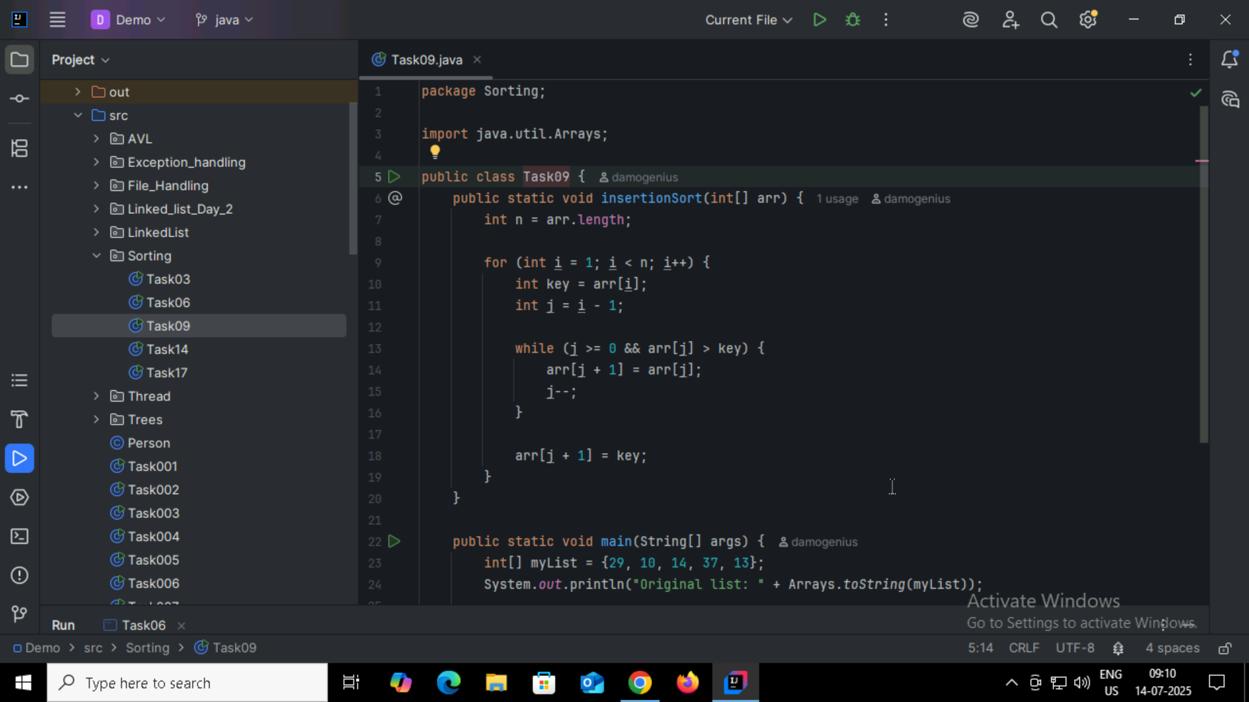
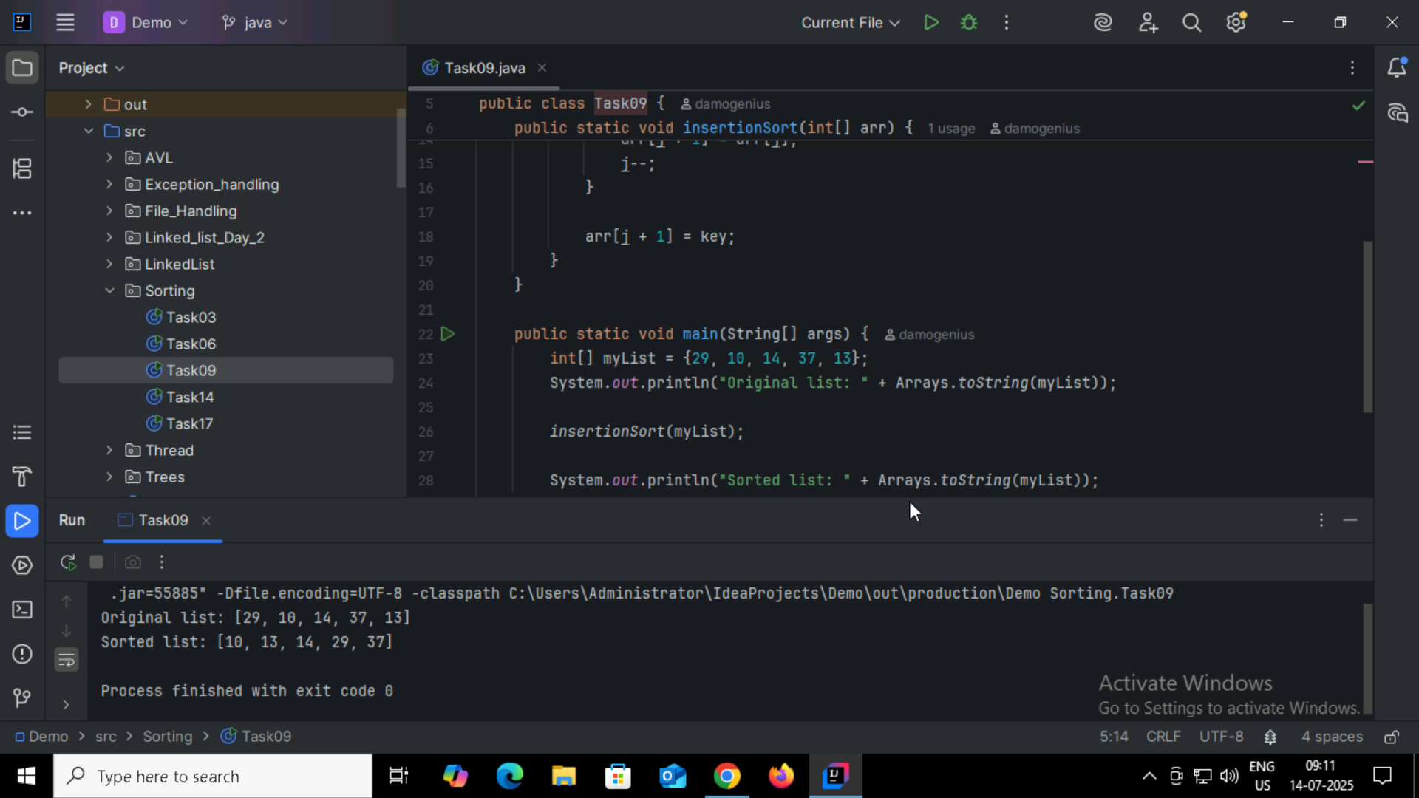
Task10:
Advantages:
Simple and Easy to Understand
The algorithm is straightforward and easy to implement for beginners.
In-Place Sorting
Requires no additional memory (space complexity is O(1)).
Stable Sort
Maintains the relative order of equal elements.
Good for Small Data Sets
Early Termination Possible

Limitations:
Poor time complexity (O(n²))
Too many unnecessary operations
Not scalable
Outperformed by almost all modern sorting algorithms

Task11:
If n is large ,recursion may still overflow the stack. In that case, use an iterative approach or a tail-recursive optimization.
public class RecLoop {
public int calc(int n) {
if (n == 0) return 0;
return n + calc(n);
}

Corrected Code:
public class RecLoop {

public int calc(int n) {
if (n == 0) return 0;
return n + calc(n - 1);
}

Task 12 :
Step 1: Start
Step 2: If the array has more than one element:
- Divide the array into two halves.
Step 3: Recursively apply Merge Sort to each half.
Step 4: Merge the two sorted halves into a single sorted array:
- Compare elements from both halves one by one.
- Insert the smaller element into the result array.
- Continue until all elements are merged in order.
Step 5: Stop when the entire array is sorted.

Task 13:
procedure MergeSort(A, left, right)
if left < right then
mid ← (left + right) / 2
MergeSort(A, left, mid)
MergeSort(A, mid + 1, right)
Merge(A, left, mid, right)
end if
end procedure

procedure Merge(A, left, mid, right)
Create temporary arrays L and R
Copy data into L and R from A[left..mid] and A[mid+1..right]
i ← 0, j ← 0, k ← left

while i < length(L) and j < length(R) do
if L[i] ≤ R[j] then
A[k] ← L[i]
i ← i + 1
else
A[k] ← R[j]
j ← j + 1
k ← k + 1

Copy any remaining elements of L
Copy any remaining elements of R
end procedure
Task14:
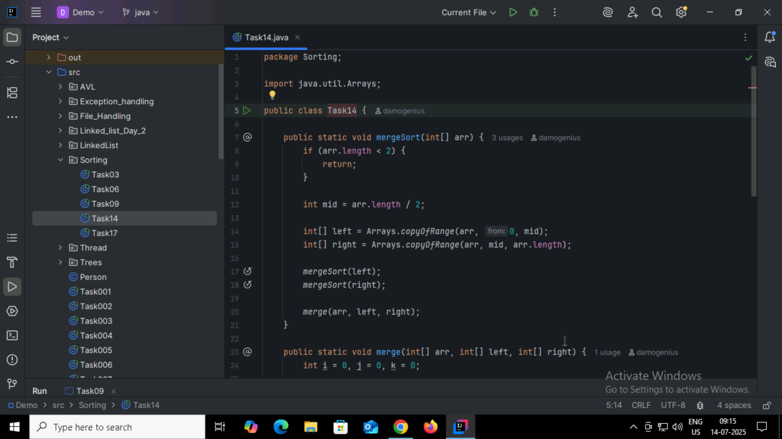
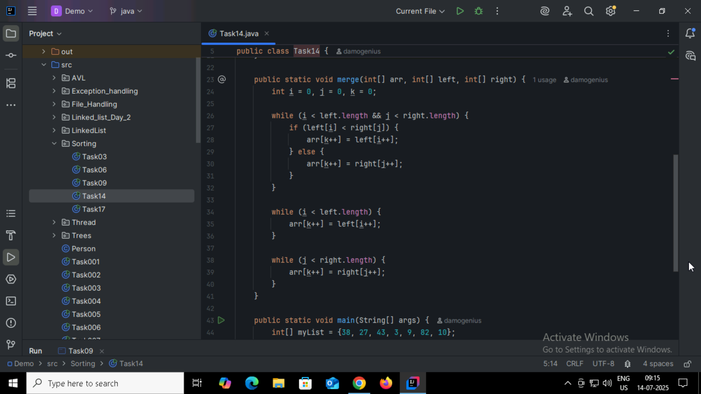
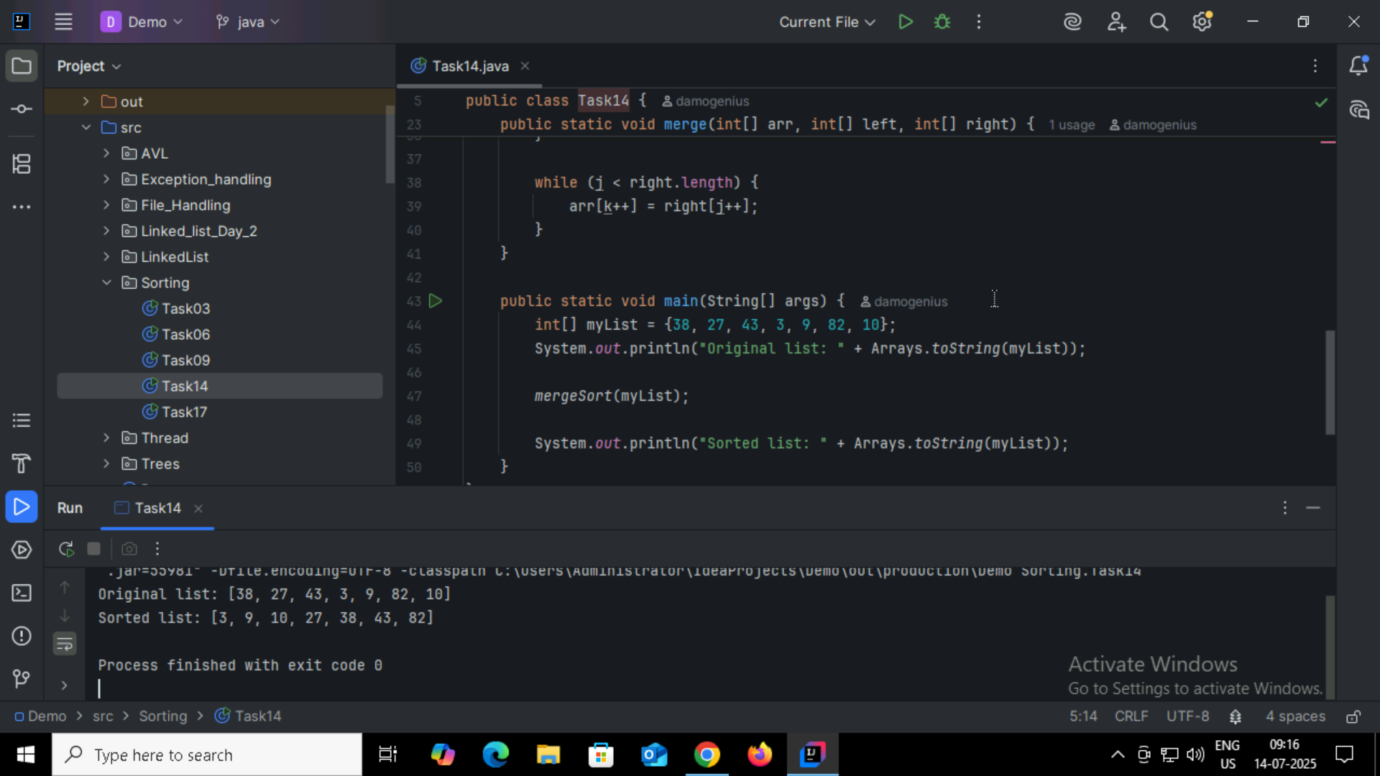
Task 15:
Step 1: Start
Step 2: Choose a pivot element from the array (commonly the first, last, or middle element).
Step 3: Partition the array:
- Place elements less than the pivot to its left
- Place elements greater than the pivot to its right
Step 4: Recursively apply Quick Sort to the subarrays:
- Left subarray (elements less than pivot)
- Right subarray (elements greater than pivot)
Step 5: Continue until each subarray has 0 or 1 element (base case)
Step 6: Stop – the array is now sorted

Task 16:
procedure QuickSort(A, low, high)
if low < high then
pivotIndex ← Partition(A, low, high)
QuickSort(A, low, pivotIndex - 1)
QuickSort(A, pivotIndex + 1, high)
end if
end procedure

procedure Partition(A, low, high)
pivot ← A[high]
i ← low - 1
for j ← low to high - 1 do
if A[j] < pivot then
i ← i + 1
swap A[i] and A[j]
swap A[i + 1] and A[high]
return i + 1
end procedure

Task17:
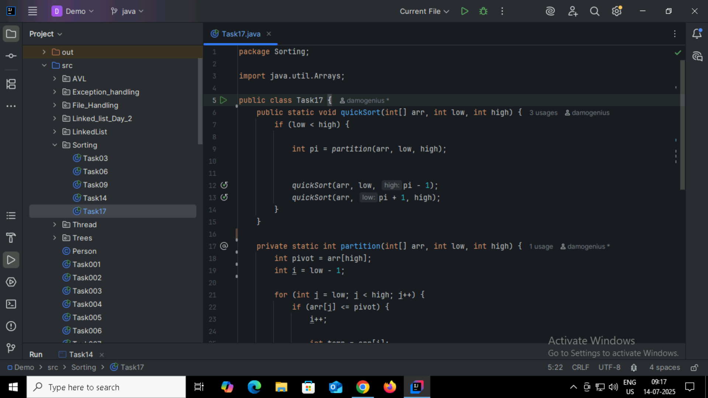
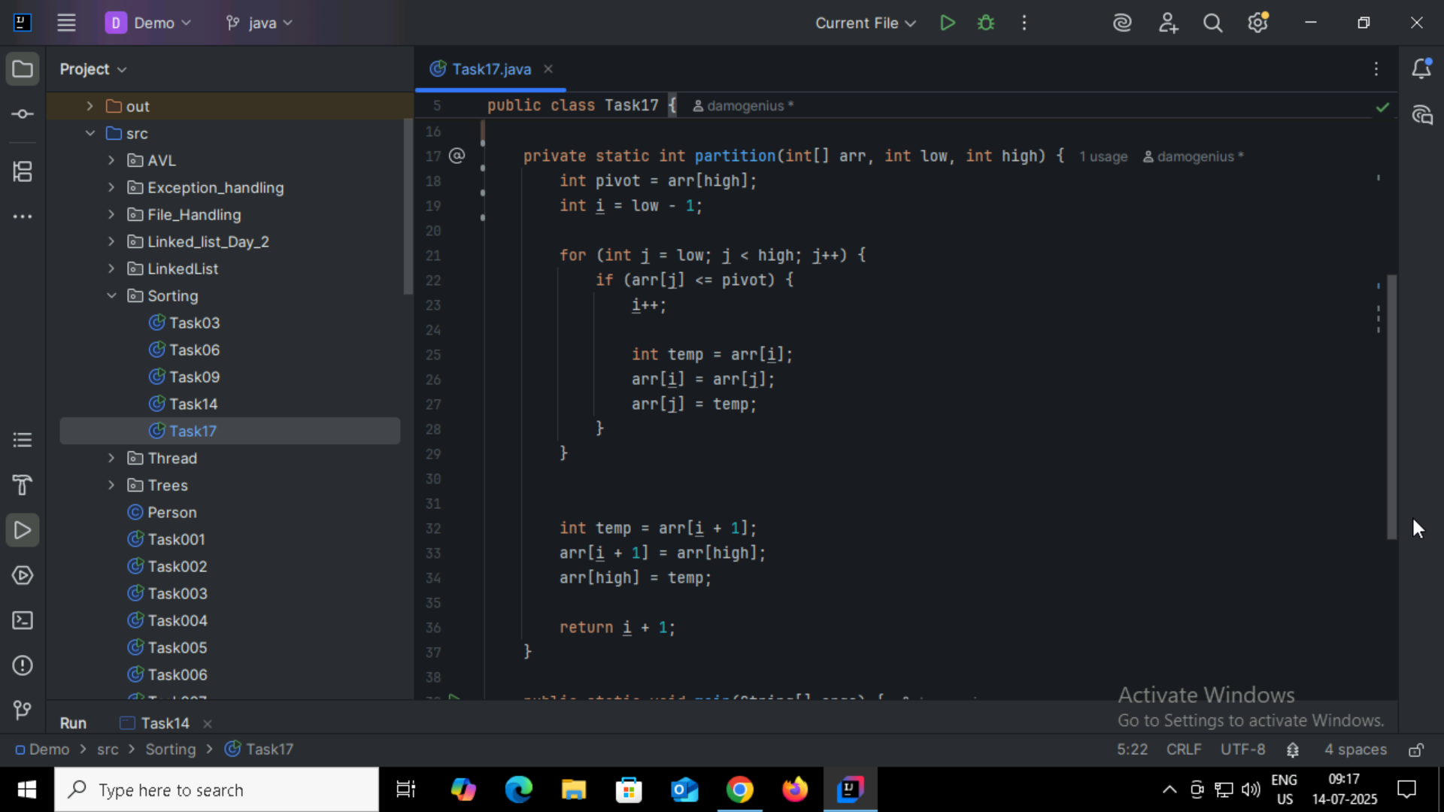
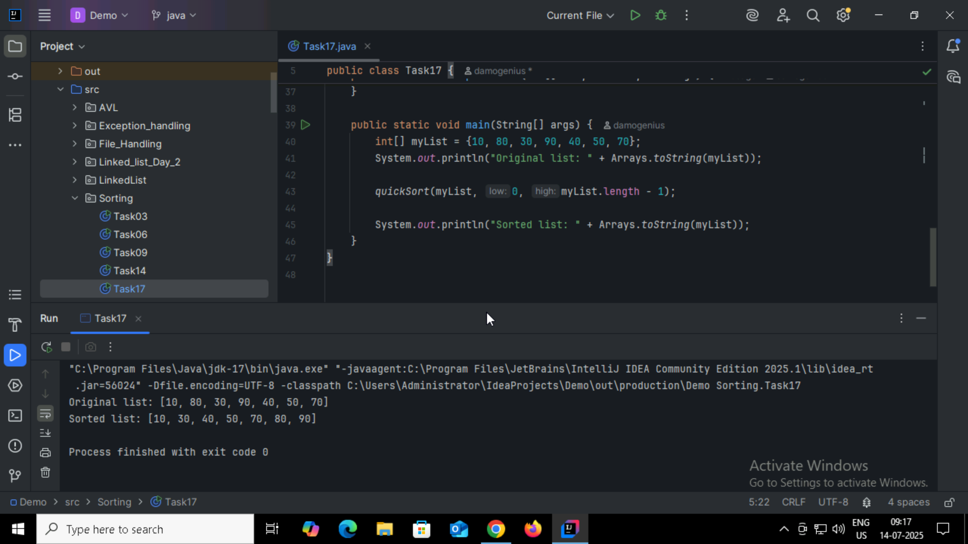

Home Task:
1:
Feature | Binary Tree | Binary Search Tree (BST)
Definition | A tree in which each node has at most 2 children. | A binary tree with elements arranged in sorted order.
Structure | No specific ordering of nodes. | Left child < Parent < Right child.
Data Order | Random or application-specific. | Follows strict ordering rules.
Search Efficiency | O(n) in worst case (no ordering). | O(log n) on average (if balanced).
Insertion Rule | No fixed rule. | Insert smaller values to the left, larger to the right.
Use Case | General tree problems (e.g., parsing expressions). | Fast searching, insertion, and deletion of ordered data.
Traversal Type | Preorder, Inorder, Postorder, Level order. | Same traversals apply, but inorder gives sorted data.
Duplicates Allowed? | Yes, depends on implementation. | Usually not allowed (or placed in consistent way).

2:
If you already have a sorted array, then BST is more efficient than linear search.
Binary Search Tree (BST)
- Approach: Tree-based structure; values organized so that left < root < right.
- Search Time: O(log n) on average (if balanced)
- Insert/Delete Time: Also O(log n) on average
- Advantage: Good for dynamic data — where frequent insertions/deletions happen.

Linear Search in Array
- Approach: Go through every element one by one.
- Time Complexity: O(n)
- Efficiency: Slow for large data.
- Advantage: Works on unsorted data.
3:
Feature | Static Array | Dynamic Array
Size | Fixed at compile-time | Can grow or shrink at runtime
Memory Allocation | Done at compile-time | Done at runtime (heap)
Resizing | Not possible | Possible (automatically or manually)
Memory Usage | May waste space if not fully used | Efficient use of memory (adjustable size)
Performance | Faster (no resizing overhead) | Slight overhead during resizing
Ease of Use | Simple to declare and use | Needs memory management (in low-level)
Storage Location | Stack (usually) | Heap (usually)
Flexibility | Less flexible | More flexible for dynamic data needs
4:
Which is more preferred for shortest path in an unweighted graph?
BFS (Breadth-First Search) is preferred.
Reason:
- In unweighted graphs, the shortest path is the one with the fewest number of edges.
- BFS explores nodes level by level:
  - It visits all nodes at distance 1 from the source, then distance 2, and so on.
  - As soon as it reaches the destination node, it has found the shortest path.
5:
