Task 1
Strategy Design Pattern

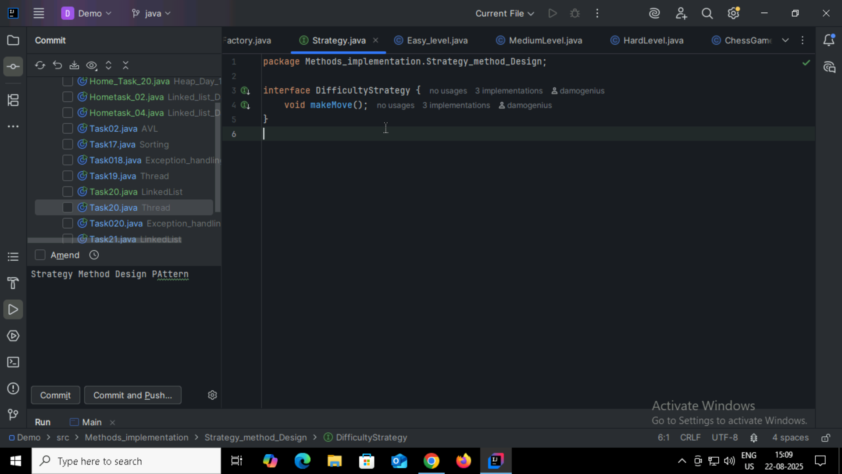
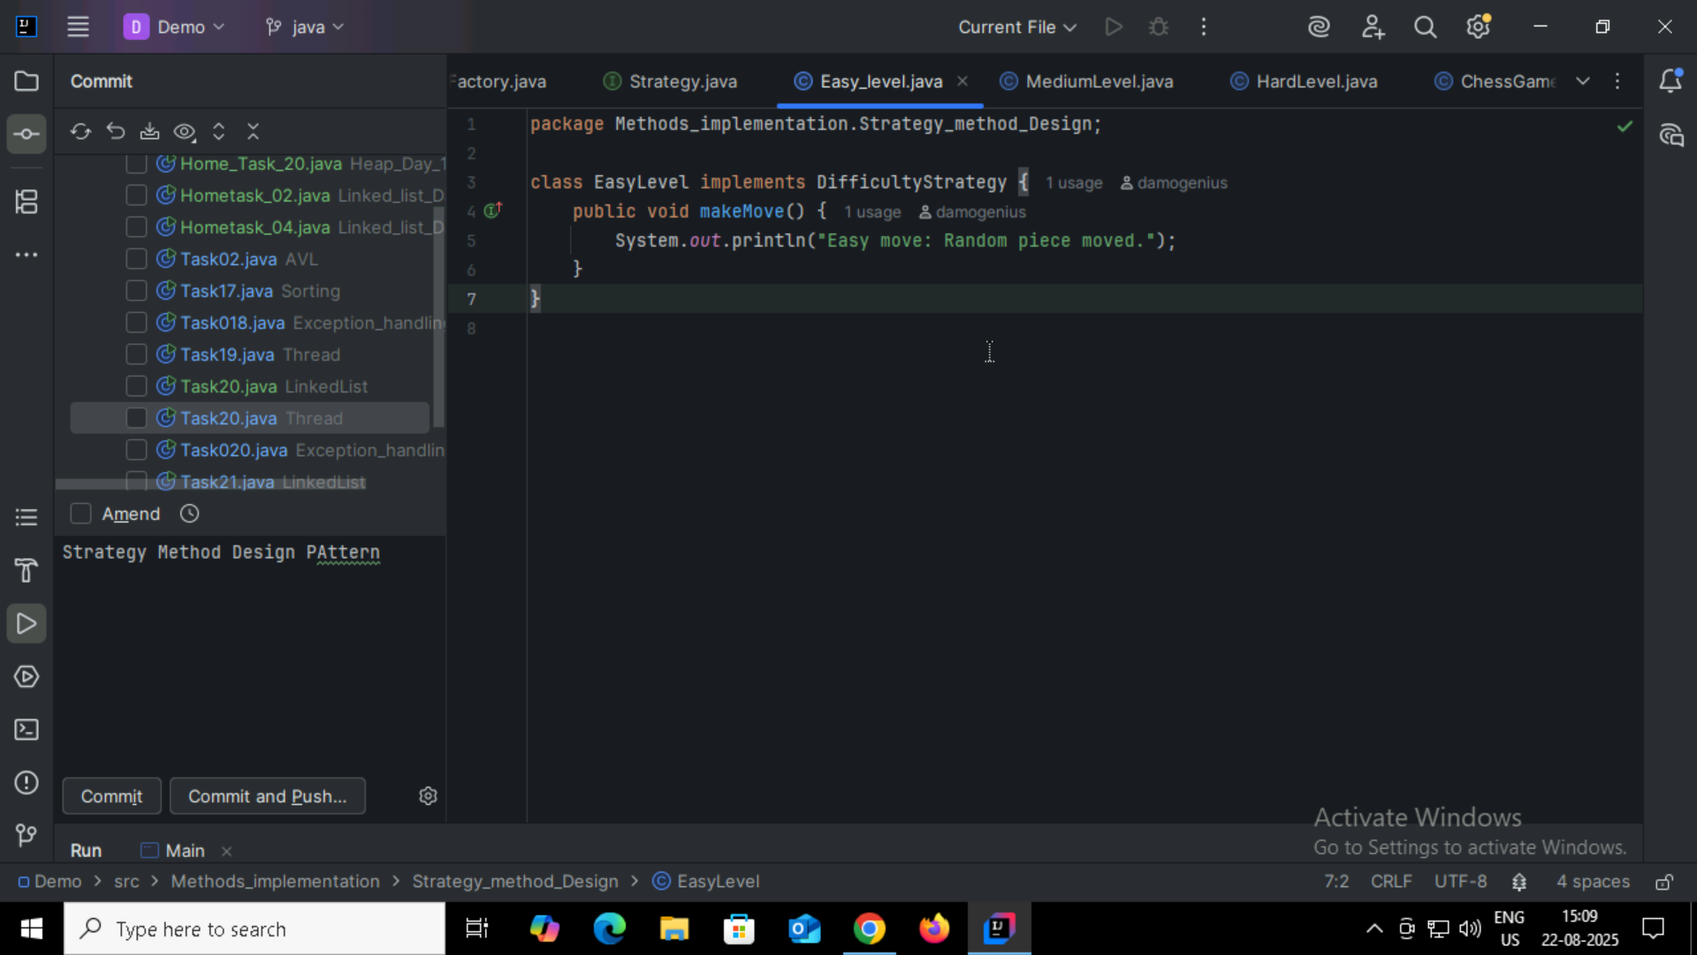
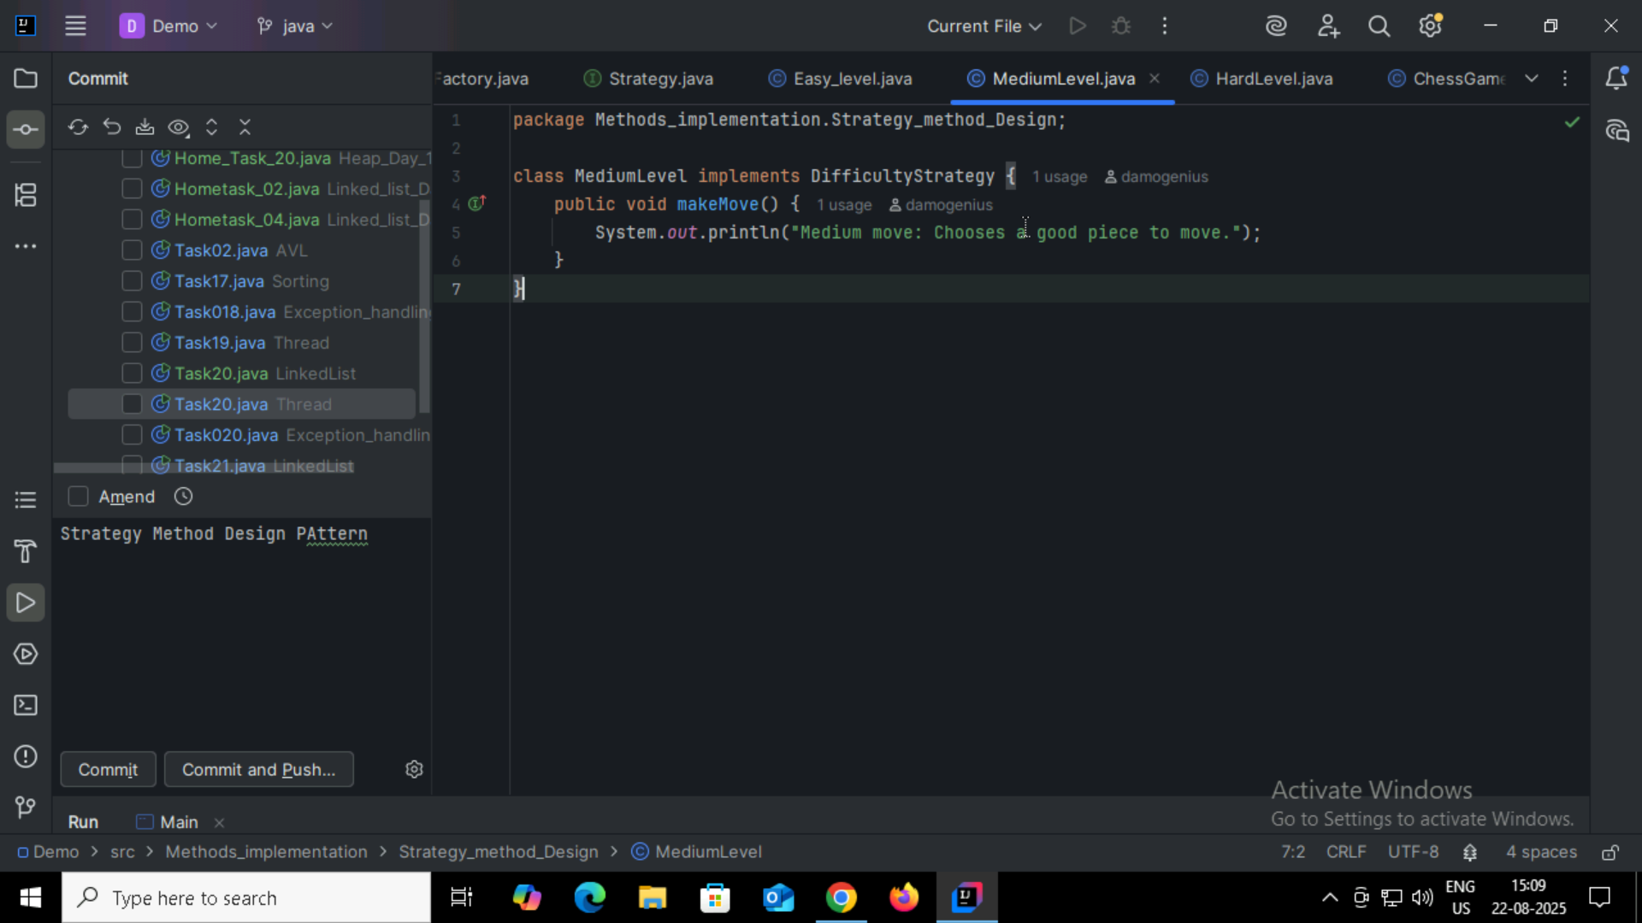
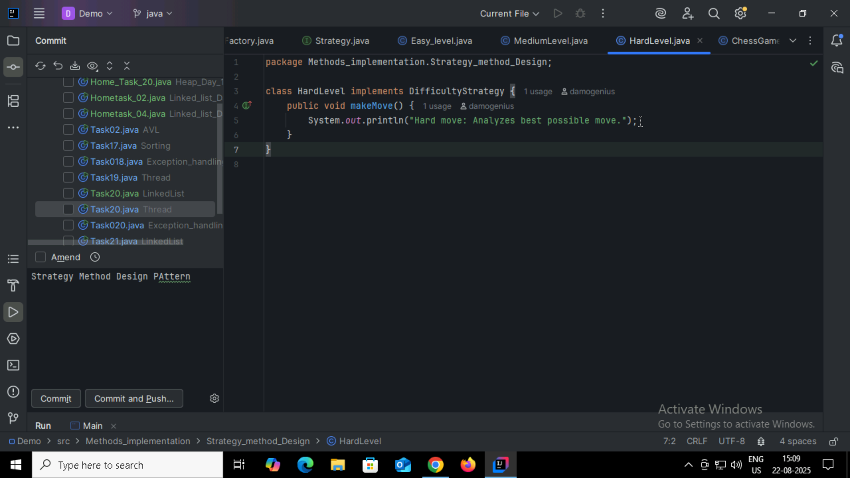
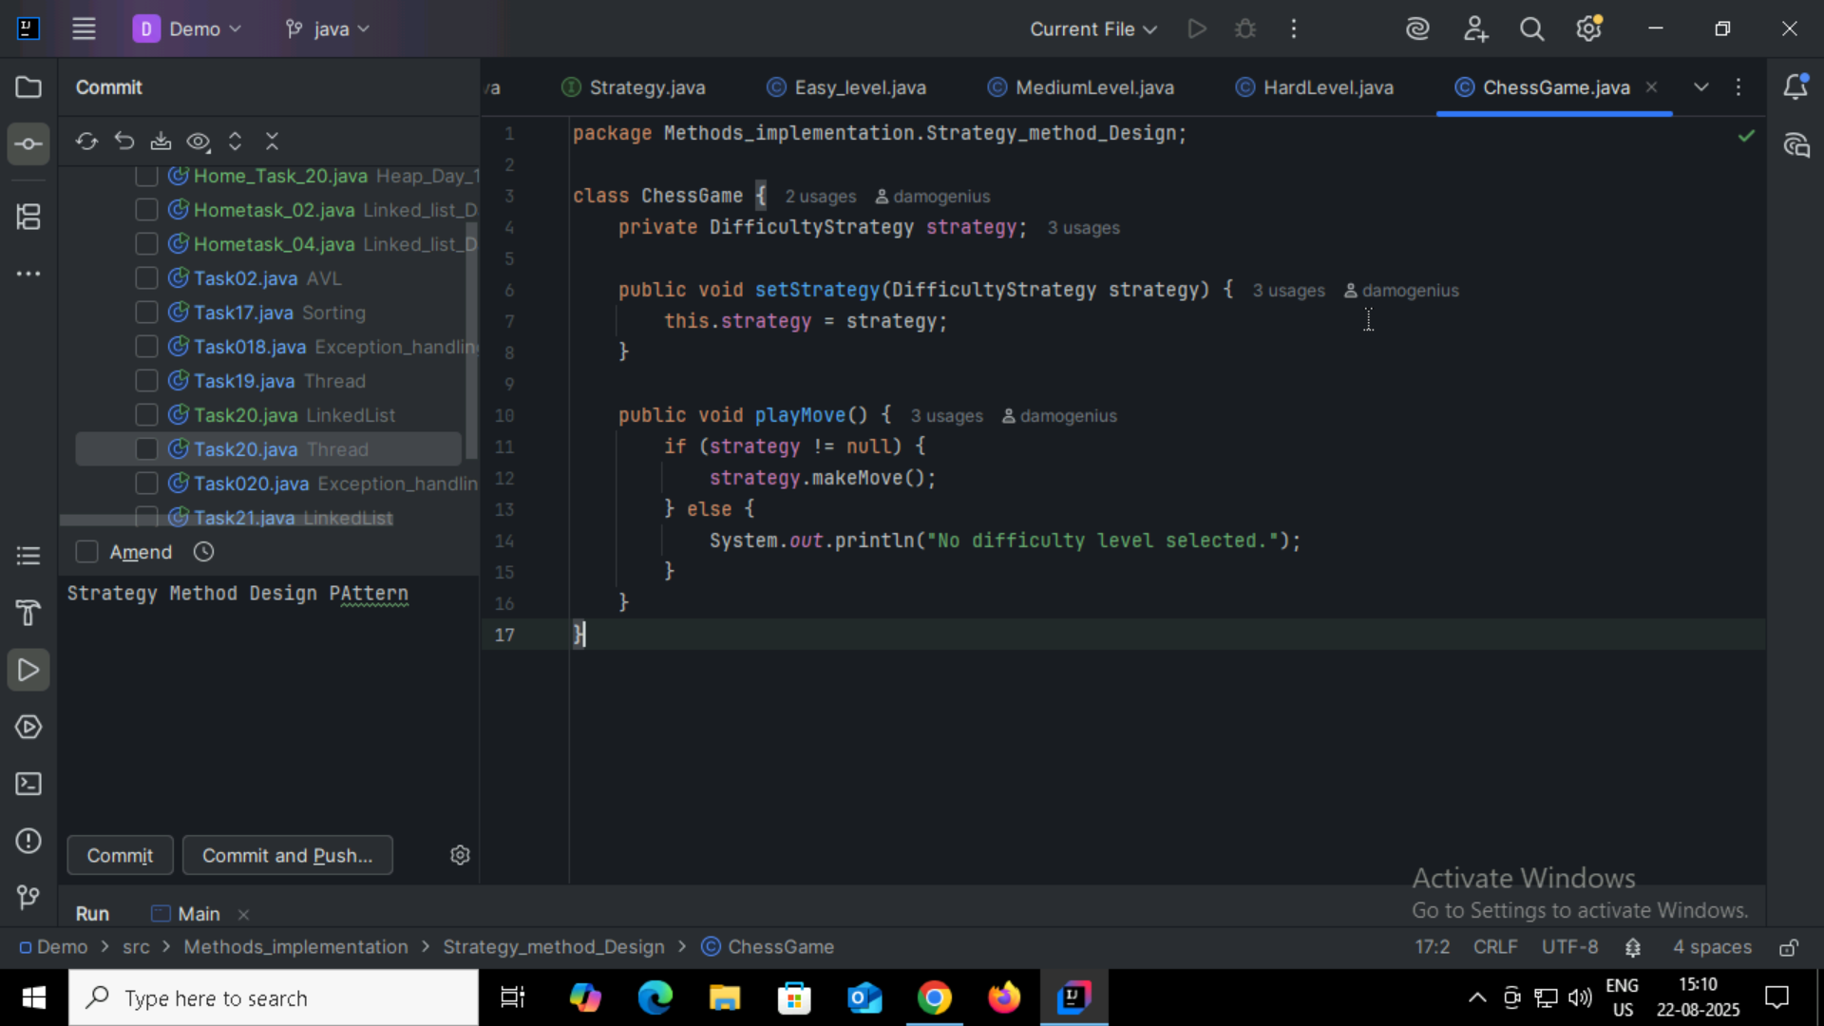
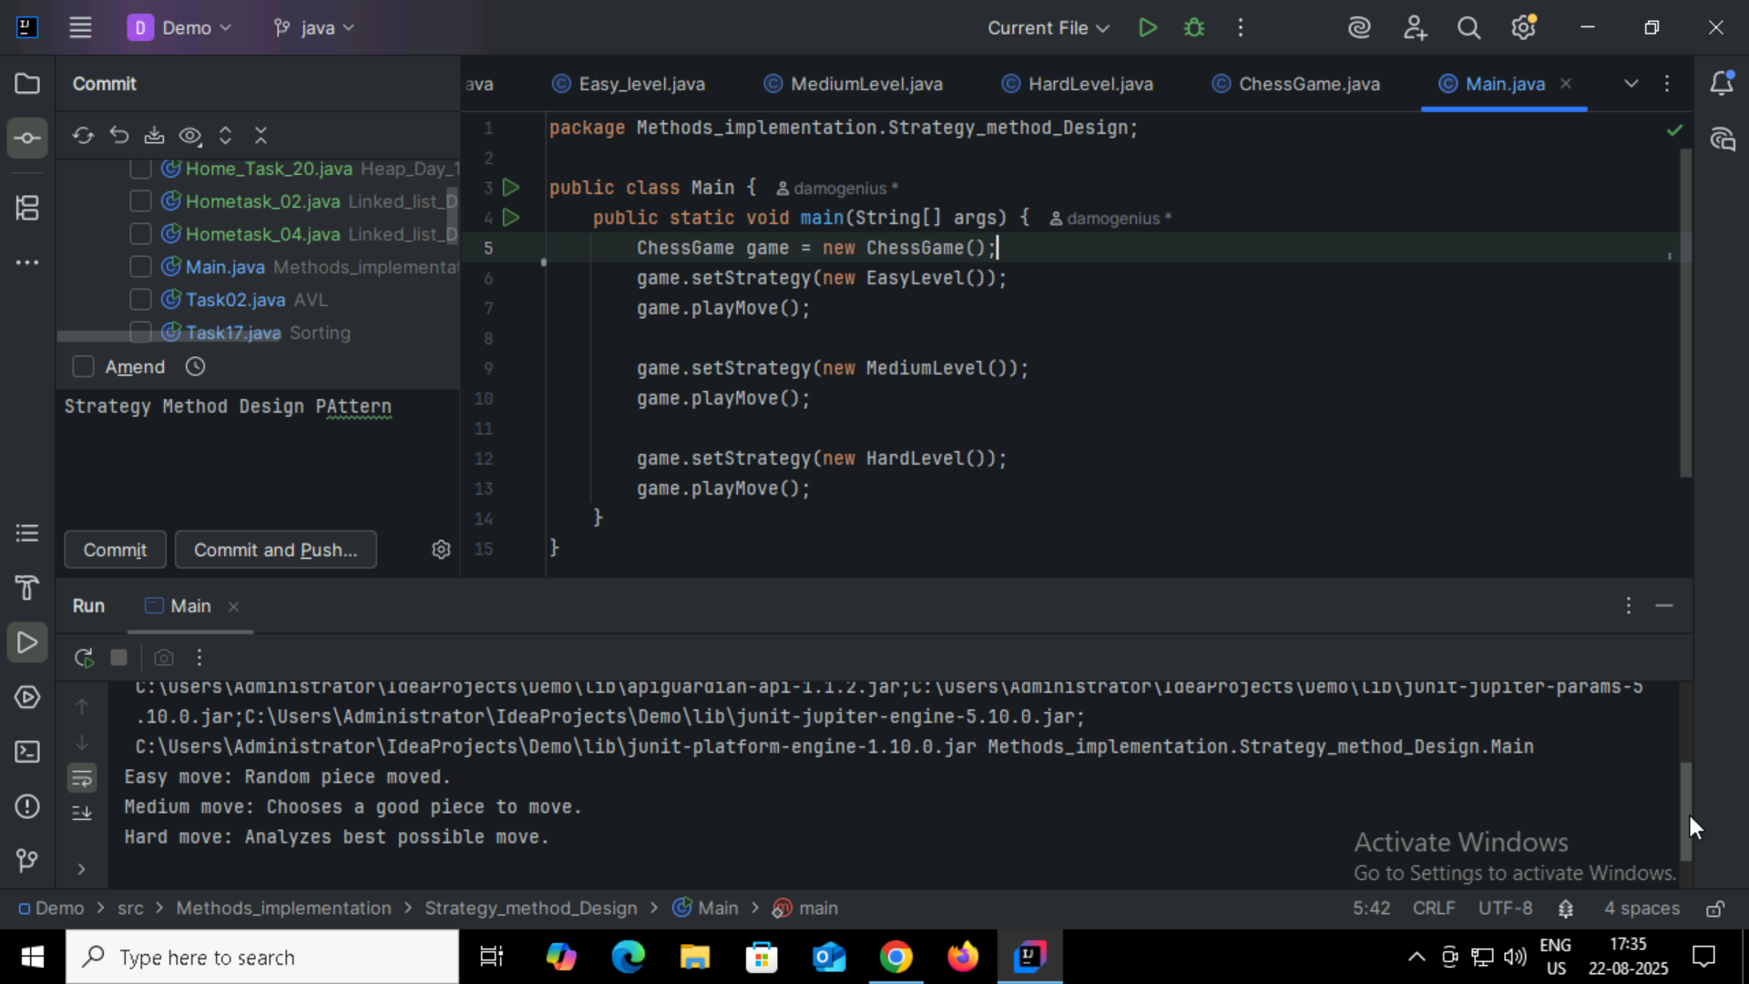

Task 2:
What do you know about Design Work Flow?
Design Workflow generally refers to the structured sequence of steps followed to design a system, product, or solution ensuring that requirements are understood, design is consistent, and implementation is smooth.

Task 3:
What do you know Persistent objects?
A persistent object in programming (especially in Java and databases) is an object whose state (data) exists beyond the lifetime of the process that created it.
- Normally, when a program ends, all objects in memory are lost.
- A persistent object can be stored (persisted) in some non-volatile storage (like a database, file, or disk) and later retrieved with its state intact.

Task 4 :
Which of the following components is not typically part of the Command pattern?
a) Invoker
b) Receiver
c) Abstract Factory
d) Command (interface/abstract class)

Task 5:
What role does the Invoker play in the Command pattern?
a) It knows how to perform the operations associated with a request.
b) It encapsulates the request as an object.
c) It asks the command to carry out the request.
d) It defines the interface for executing an operation.

Task 6:
A key benefit of using the Command pattern is its ability to support:
a) Lazy initialization
b) Undo/Redo functionality
c) Singleton instance creation
d) Compile-time polymorphism

Task 7:
In the Strategy pattern, what role does the "Context" play?
A. It defines the interface for the algorithms.
B. It implements a specific algorithm.
C. It maintains a reference to a Strategy object and delegates the task to it.
D. It creates the Concrete Strategy objects.

Task 8:
In which of the following mechanisms, types of all variables and expressions are fixed at compilation time.
a) Strong Typing
b) Weak Typing
c) Static Binding/ early binding
d) Dynamic Binding/ late binding

Task 9:
In which pattern does a class represent the functionality of another class, providing a simplified interface to a complex subsystem?
a) Decorator Pattern
b) Facade Pattern
c) Proxy Pattern
d) Composite Pattern
Task 10:
Which of the following statements about Persistence is correct?
a) It is the enforcement of the class of an object, such that objects of different types may not be interchanged, or at the most they may be interchanged only in very restricted ways.
b) It is the property of an object through which its existence transcends time and/or space.
c) It is the property that distinguishes an active object from one that is not active.
d) All of the mentioned

Task 11:
What is that concept in type theory in which a single name may denote objects of many different classes that are related by some common super class referred to ______
a) Monomorphism
b) Type Checking
c) Polymorphism
d) Generalization

Task 12:
Which of the following patterns is used to create a single instance of a class and provide a global point of access to it?

a) Factory Pattern
b) Singleton Pattern
c) Builder Pattern
d) Prototype Pattern

Task 13:
The Adapter pattern is a type of ______ pattern.
a) Creational
b) Structural
c) Behavioral
d) Concurrency

Task 14:
Which design pattern defines a one-to-many dependency between objects so that when one object changes state, all its dependents are notified and updated automatically?
a) Strategy Pattern
b) Command Pattern
c) Observer Pattern
d) Mediator Pattern

Task 15:
The Model-View-Controller (MVC) is an example of a ______ pattern.
a) Creational
b) Structural
c) Behavioral
d) Architectural

Task16:
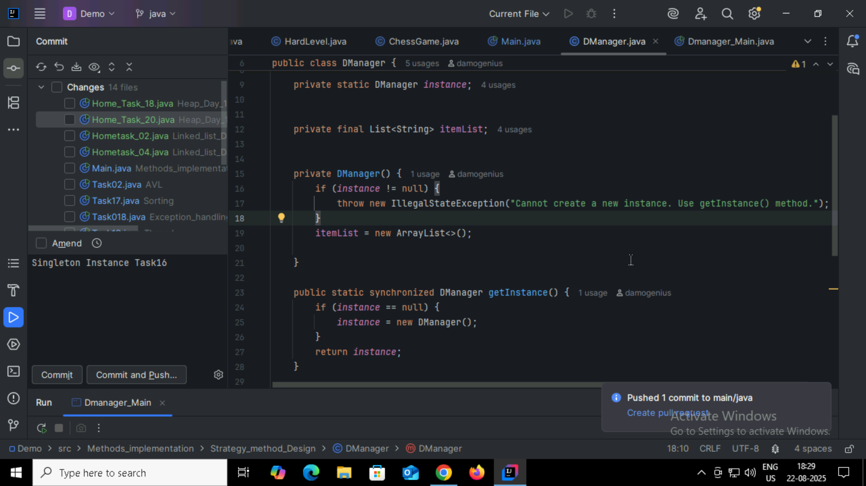
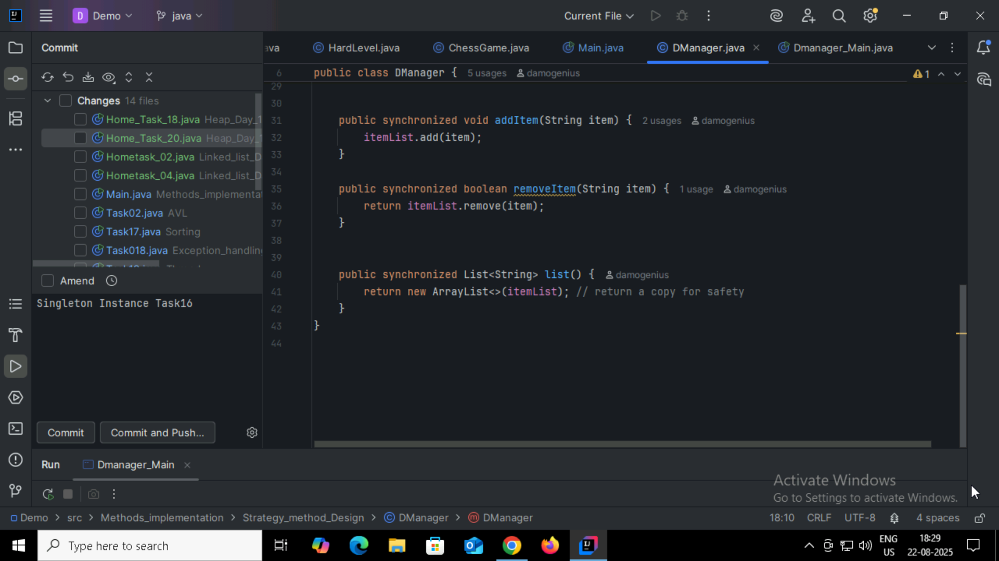
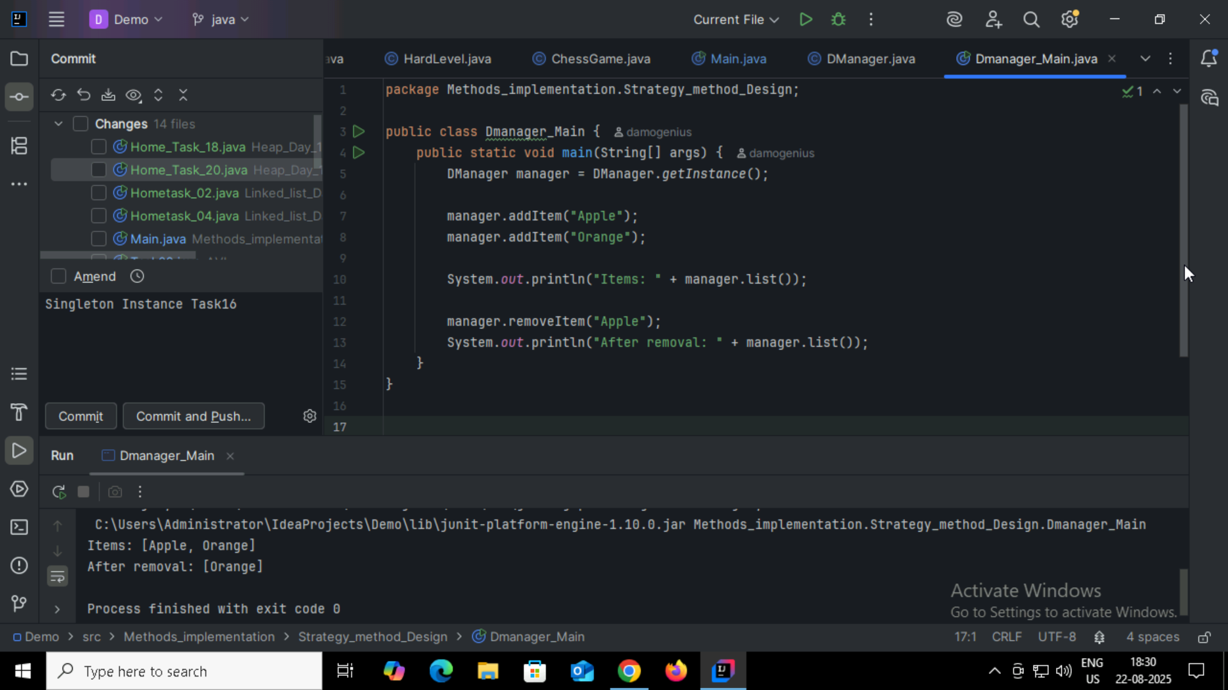

Home Tasks:
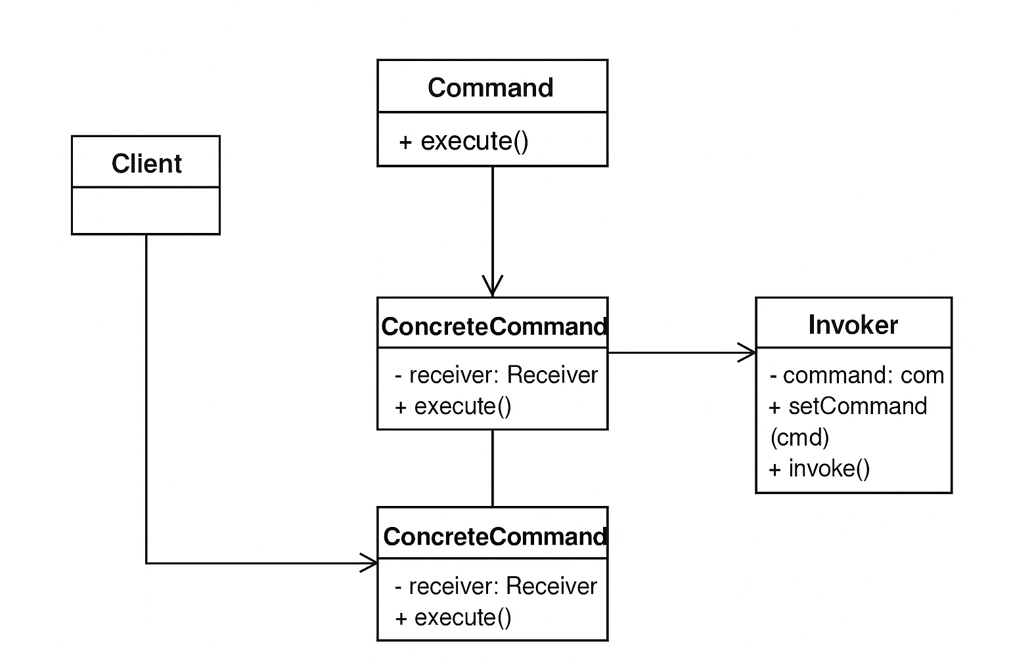

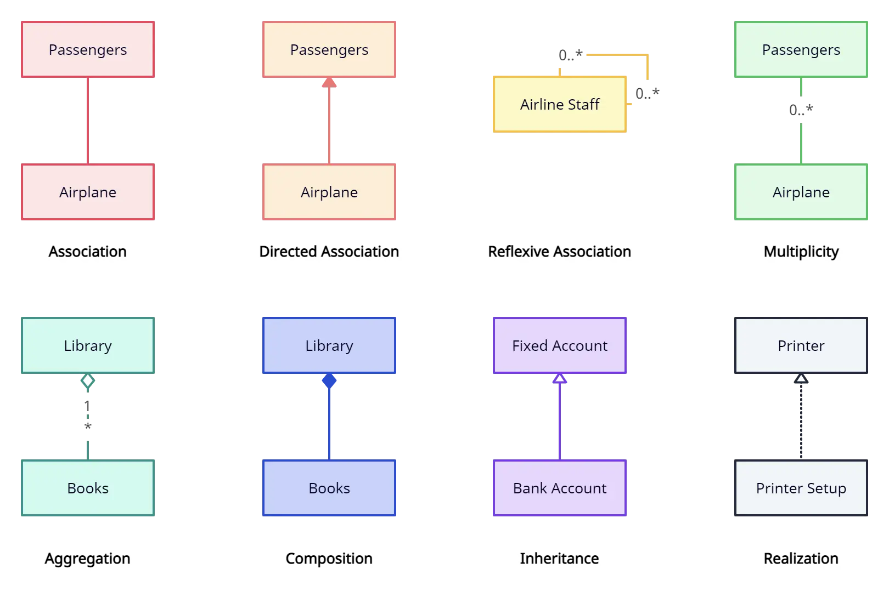

Singleton Pattern:
// Singleton class
public class Logger {
// Step 1: private static instance
private static Logger instance;

// Step 2: private constructor to prevent instantiation
private Logger() {
}

// Step 3: public method to get the single instance
public static Logger getInstance() {
if (instance == null) {
instance = new Logger();
}
return instance;
}

public void log(String message) {
System.out.println("Log: " + message);
}
}

// Test Singleton
public class SingletonDemo {
public static void main(String[] args) {
Logger logger1 = Logger.getInstance();
Logger logger2 = Logger.getInstance();

logger1.log("This is a log message.");

// Verify both instances are the same
System.out.println(logger1 == logger2); // true
}
}

Strategy Pattern:

// Step 1: Strategy interface
interface PaymentStrategy {
void pay(double amount);
}

// Step 2: Concrete strategies
class CreditCardPayment implements PaymentStrategy {
public void pay(double amount) {
System.out.println("Paid $" + amount + " using Credit Card.");
}
}

class PayPalPayment implements PaymentStrategy {
public void pay(double amount) {
System.out.println("Paid $" + amount + " using PayPal.");
}
}

// Step 3: Context class
class ShoppingCart {
private PaymentStrategy paymentStrategy;

// set strategy at runtime
public void setPaymentStrategy(PaymentStrategy paymentStrategy) {
this.paymentStrategy = paymentStrategy;
}

public void checkout(double amount) {
paymentStrategy.pay(amount);
}
}

// Test Strategy Pattern
public class StrategyDemo {
public static void main(String[] args) {
ShoppingCart cart = new ShoppingCart();

// Pay using Credit Card
cart.setPaymentStrategy(new CreditCardPayment());
cart.checkout(250);

// Pay using PayPal
cart.setPaymentStrategy(new PayPalPayment());
cart.checkout(400);
}
}

