Task 10
RMDIR
removes Blank Directories alone
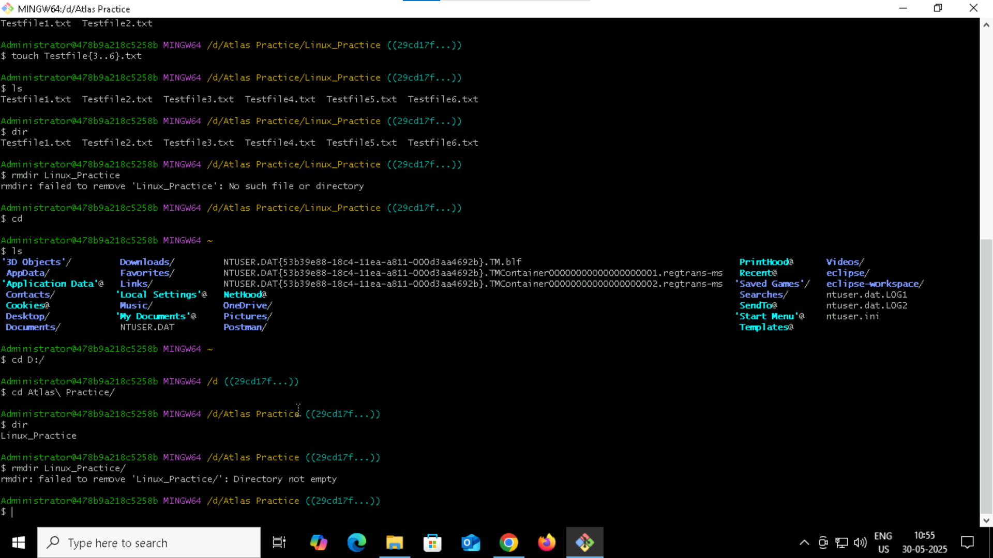

Rm
Removes the mentioned files and directories even if they are not empty
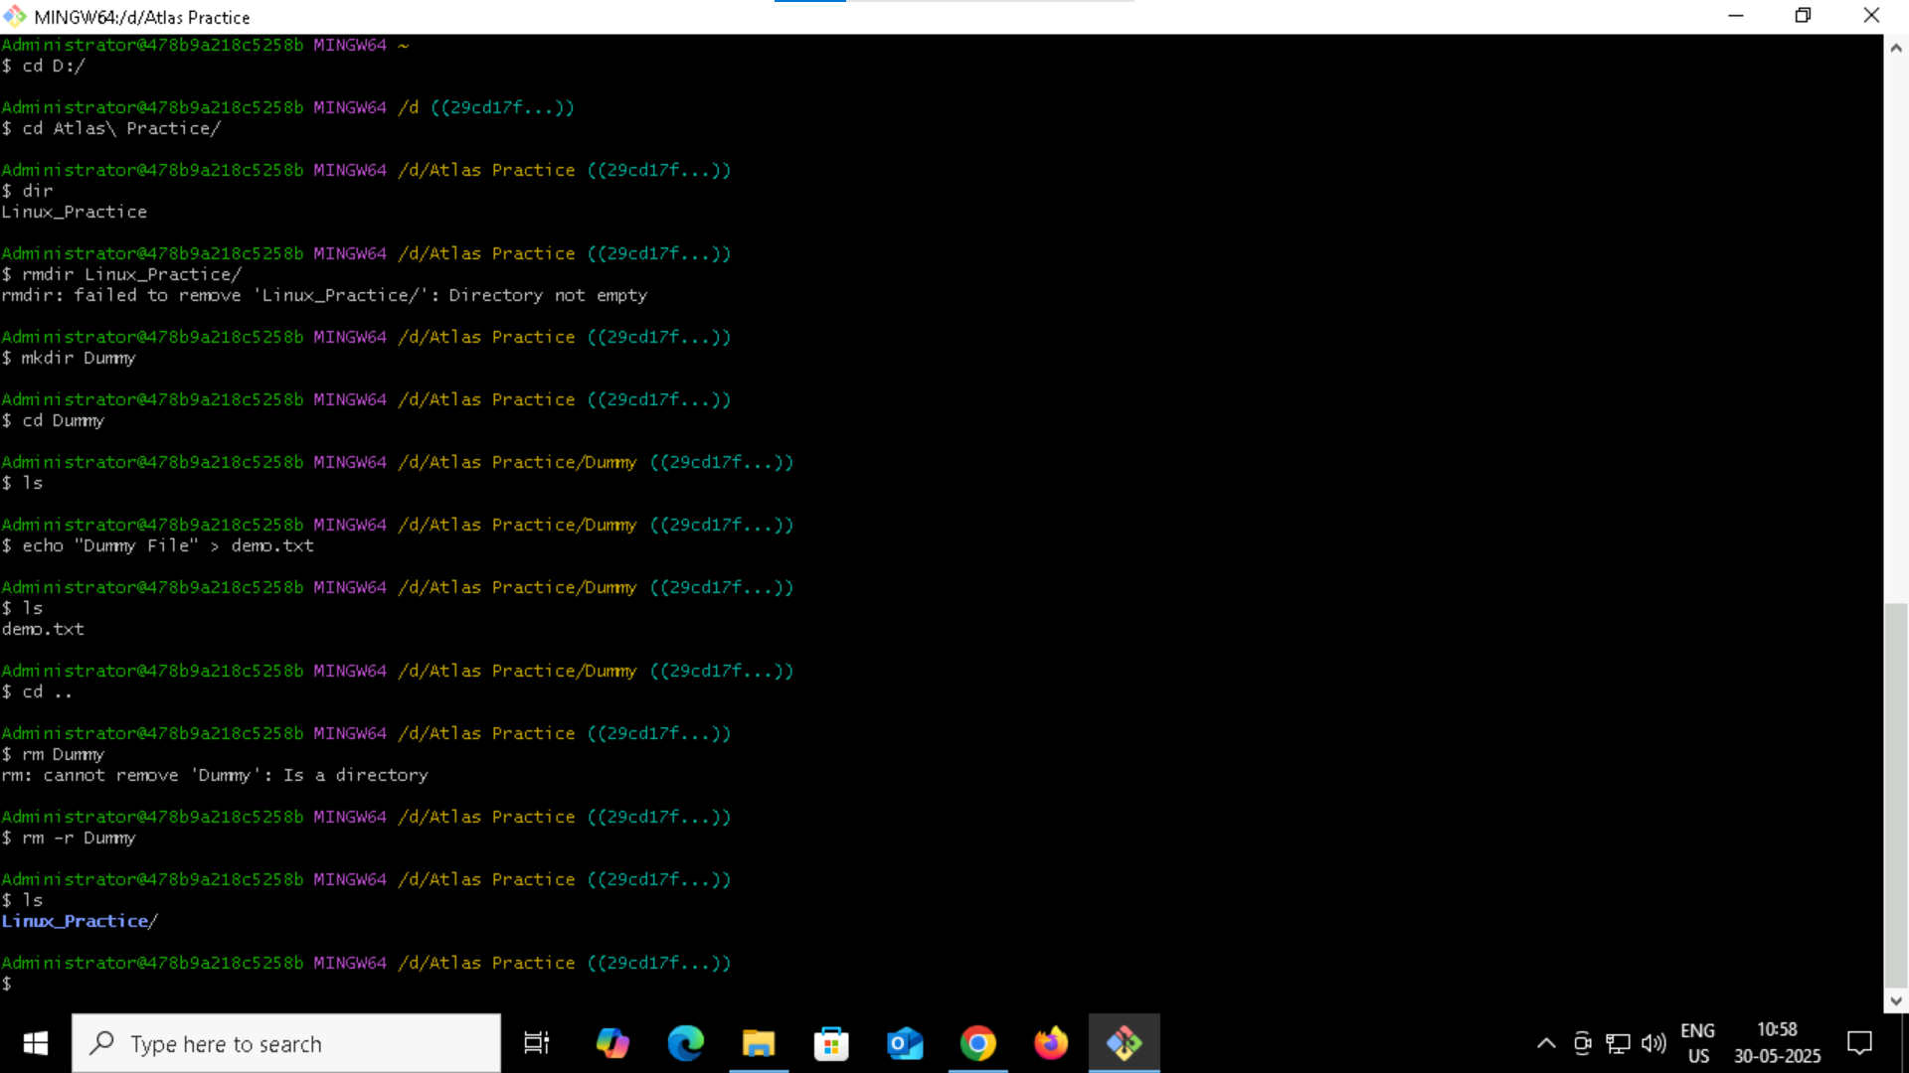

Escape Sequences -e
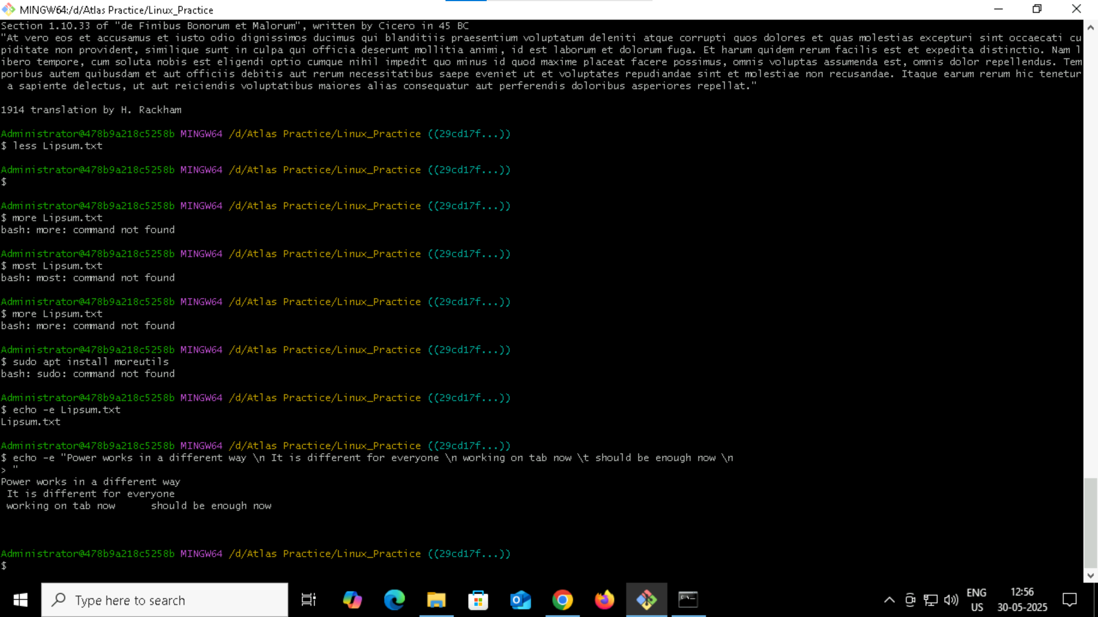

Ls displays the files
ls -l displays the read and write permissions as well for the files
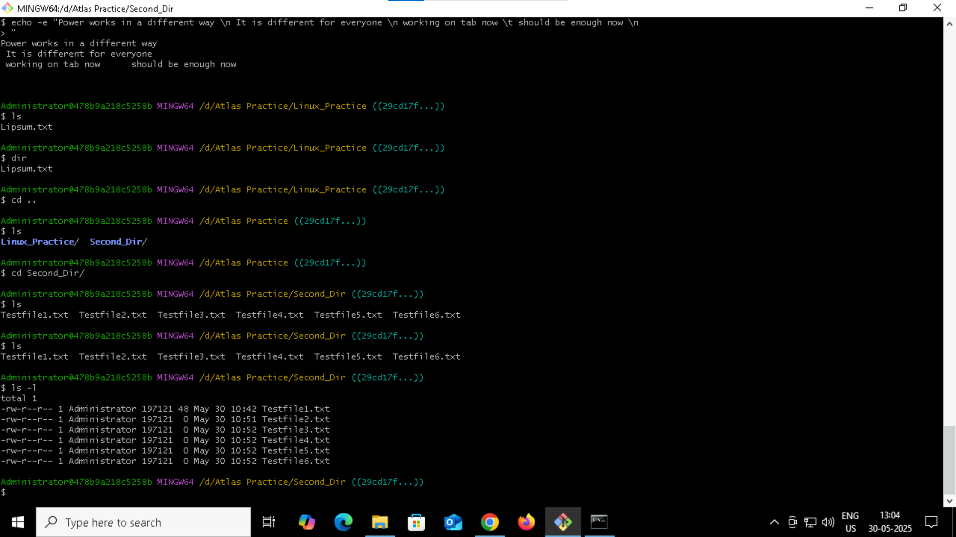
Task 20 :
Go back 1 directory at a time
cd ..
Task 27

Cd . stays in the same directory
Cd .. Move up one level( to the parent directory)

Task 28 :
