Infer the Topic Resources
Note to Teacher: Post the following resources around the room. Consider writing the text in large writing on chart paper to make it easy to see. Or, make copies of each resource for each group or station.

Resource 1
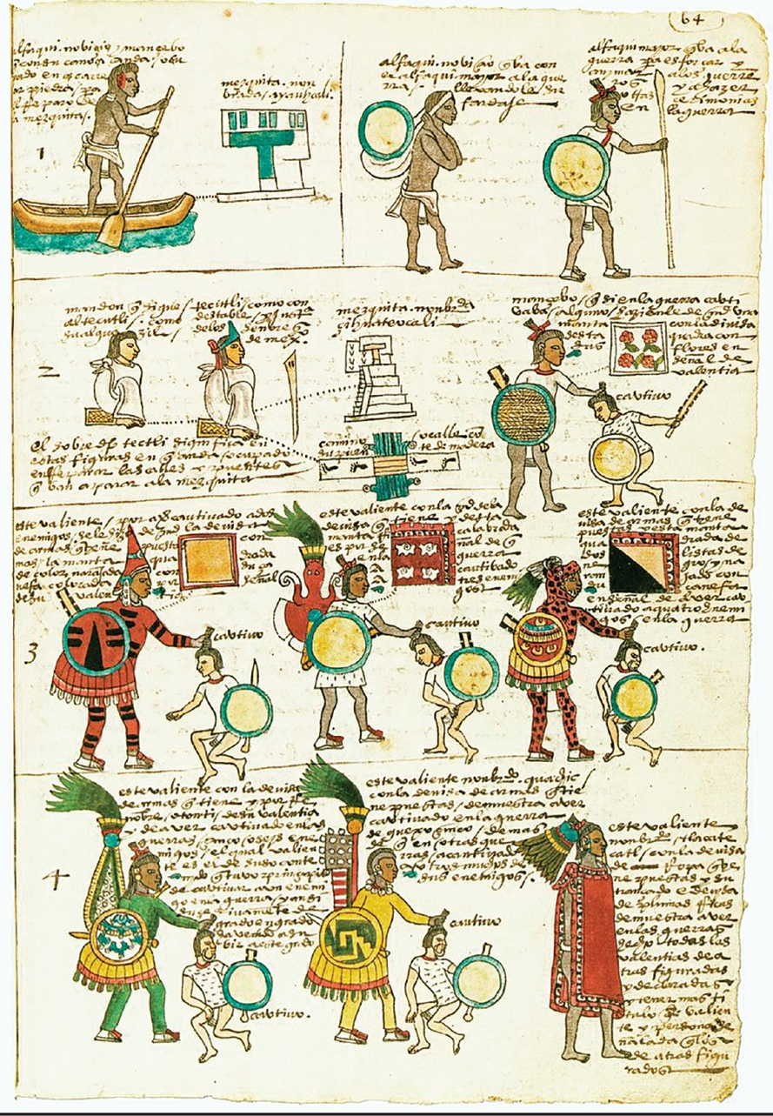
“Codex Mendoza.” Illustration. 16th century. Bodleian Library. Wikimedia. Web. Public domain.
Resource 2
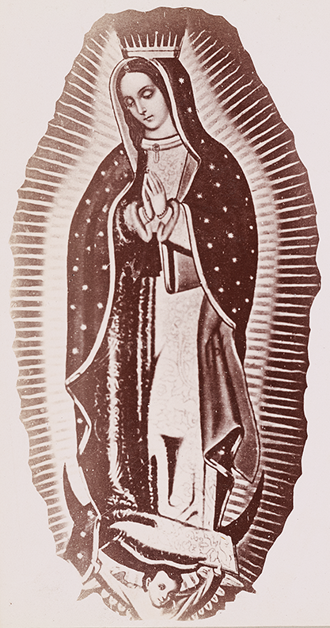
Mayo & Weed. “Virgin Mary.” Photograph. 1898. The Miriam and Ira D. Wallach Division of Art, Prints and Photographs: Photography Collection, The New York Public Library. The New York Public Library Digital Collections. Web. Public domain.
Resource 3
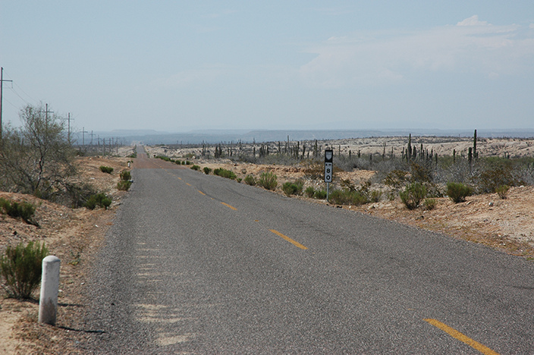
Wonderlane. “Endless desert highway 80, Baja California Sur, Mexico.” Photograph. Flickr. 21 May 2009. Web. Used under CC BY 2.0.
Resource 4
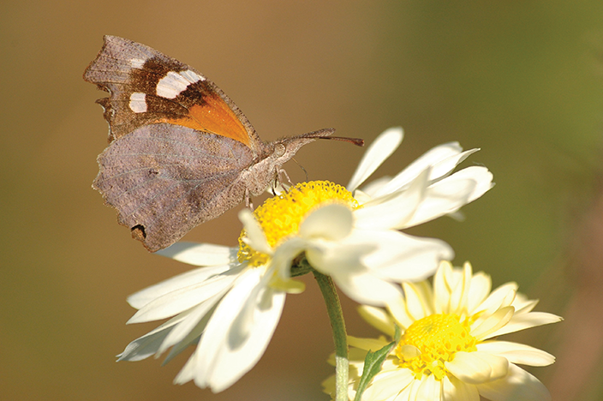
Ospr3yy. “American Snout.” Photograph. Wikimedia. 22 Nov. 2010. Web. Used under Free Art License 1.3.
Resource 5

Jonathan McIntosh. “Border Patrol Museum.” Photograph. Flickr. 15 Sep. 2009. Web. Used under CC BY 2.0.
Resource 6
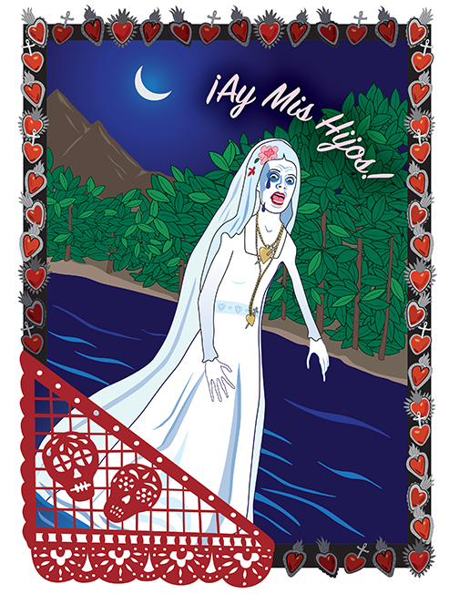

Stacey Posnett for EL Education.
Resource 7
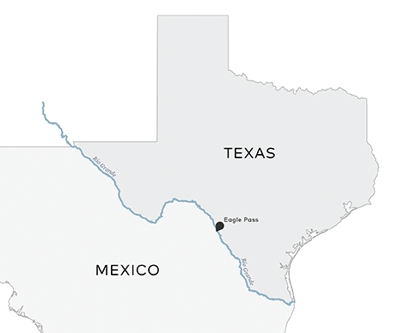

Scribe Concepts for EL Education.
Resource 8
“I have always been fascinated by the knowledge and wisdom of our ancestors, the Aztecas. Their culture, their scientific observations, their religion, their architecture, their language, their myths and legends—everything about them is extraordinary.”
McCall, Guadalupe Garcia. Summer of the Mariposas. Lee & Low, New York, 2017.

Resource 9
“I think of La Llorona in all her various mythological and legendary forms, and I feel sorry for her. As Malitzin, the Aztec slave girl given to Hernán Cortés, I find her to be one of our culture’s most controversial and misunderstood historical figures.”
McCall, Guadalupe Garcia. Summer of the Mariposas. Lee & Low, New York, 2017.

Resource 10
“‘My sisters are waiting,’ I said, trying to take my hand from hers so that I might escape if I had to.
La Llorona let go of my hand. ‘Please, try to have faith. I am here in your service, to guide and protect you,’ she said.
I put my hands under my arms to warm them. ‘Protect me? From what?’”
McCall, Guadalupe Garcia. Summer of the Mariposas. Lee & Low, New York, 2017.

Resource 11
“Everything is possible when you step into the magically real world of Latin American folklore—a buzzard can change places with a wife’s lazy husband; a hunter may hurl lightning bolts and thunder down on the tribesmen who cheated him of his share of the meat; . . . and the lizard a padre scoops off a dusty road may become an emerald when he hands it to a poor peasant who needs to buy medicine for his wife. . . . The folktales deal with timeless key human questions, and there are human truths in the magic they contain.”
Elswit, S.B. The Latin American Story Finder. McFarland and Company, Inc., Jefferson, NC, 2015.

