**Visit Kerry - "Your Natural And Unforgettable Escape"**

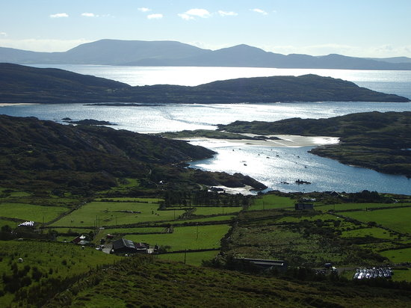

County Kerry, in the peninsular southwestern region of Ireland, is known for its striking landscape, spectacular coastline and charming villages and towns. Blessed with some of Irelands most iconic attractions, history, heritage, scenery and things to do, Kerry is undoubtedly among the best holiday destinations in Ireland. Kerry is the fifth largest county in Ireland yet is one least populated by area, helping to give you that remote, tranquil and peaceful sentiment throughout your visit.

With its abundance of historical attractions, many of which are remarkably well preserved and cared for, there is so much to see and do. Kerry claims some of Ireland's most dramatic scenery, including the world-famous Lakes of Killarney and the awe-inspiring landscapes of the Beara and Dingle peninsulas. If it's the people, music and atmosphere you’re looking for, take a trip to bustling towns of Killarney, Tralee, Dingle, Kenmare and Cahersiveen for a remarkable experience and enjoy the thriving restaurants, pubs, arts and crafts and much more!

**Places to see:** Killarney, Dingle, Tralee and Listowel

**Things to do:** Hillwalking, cycling, swimming and camping