1. Create a class list from the problem description on the next page.

**Step 1: Select all nouns/noun phrase.**

Project

Product backlog

Release

Product backlog features

Particular release

Project manager

Sprints

Release features / Feature

Due date

Developer

Required days (required to complete the feature)

Remaining work / days

The amount of work completed / The amount of work remaining

**Step 2: Refining the Candidate Class List**

Project manager (*attributes: <projects>; methods: reports()*)

Project (*attributes: backlog<features>; <releases>*)

Release (*attributes: <sprints>; releaseDate*)

Sprint (*attributes: releaseFeatures<features>; beginDate; dueDate*)

Feature (*attributes: developer; beginDate; requiredDays; remainingDays*)

Developer (*attributes: <features>; methods: estimate()*)

*Name<ABCs> which means a list of Class ABC named Name.*

|  |  |  |
| --- | --- | --- |
| Class | Attributes | Methods |
| Manager | <Projects>;  firstName;  lastName;  Id | +reports(); |
| Developer | <Features>;  firstName;  lastName;  Id | +estimate(); |
| Project | backlog<features>;  <releases>;  name |  |
| Release | <Sprints>;  releaseDate |  |
| Sprint | releaseFeatures<features>;  beginDate;  dueDate |  |
| Feature | developer;  beginDate;  requiredDays;  remainingDays |  |

2. You should submit hand-drawn UML classes with attributes, for each class you discover (or you can use a UML tool if you want).

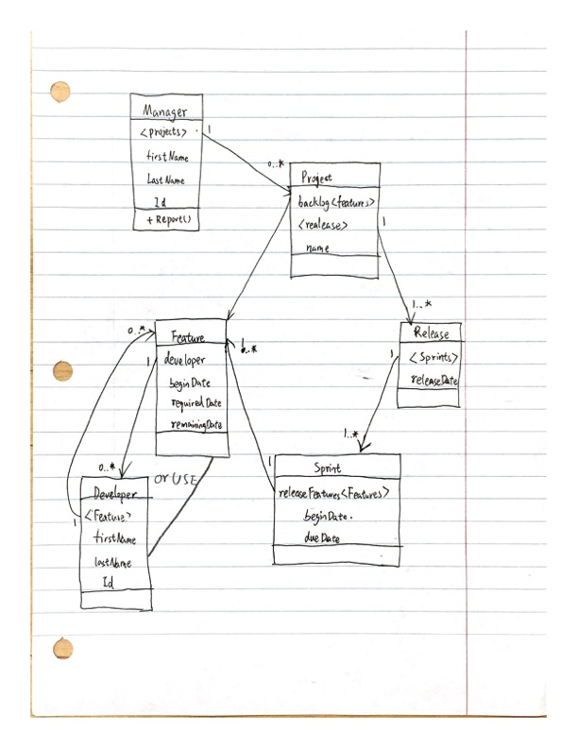

By tool

