BlaBla + Porter
Project plan and system architecture

1. What this app is
A two-sided mobility and logistics platform with two customer-facing services running on one shared trust and verification backbone:
- P2P Crowd-Shipping — travelers already going somewhere carry goods for senders heading the same direction, for a fee (BlaBlaCar + Porter model).
- Peer-to-Peer Lift/Ride Service — a Rapido-style ride option, with an enhanced safety layer for solo riders (especially women), built to stay reliable even when GPS/network drops mid-trip.
Both services share: user onboarding and KYC, OTP-based identity/handover verification, escrow payments, ratings, and the security layer.
Plan type: phased/incremental delivery — each phase ships a usable slice, not a big-bang release. This suits a first build where requirements (pricing tiers, dispute rules) are still being finalized — working software to test assumptions against, rather than a frozen spec.

2. User roles
Role | Description
Sender | Posts a parcel delivery request against a traveler's declared trip
Traveler / Captain | Registers a trip (destination + date/time), accepts parcel or ride requests along that route, earns money
Rider | Requests a lift/ride from one place to another
Trusted Contact | Non-app or app user designated by a rider/sender to receive safety alerts
Admin | Approves Traveler KYC, resolves disputes, monitors safety alerts

3. Feature set

3.1 Onboarding and KYC (shared)
- Passenger/Sender: OTP or social login, instant access
- Traveler/Captain: Aadhaar, PAN, Driving Licence, RC, Insurance, PUC upload + live selfie with AI liveness detection + OCR extraction, pending Admin approval
- Trusted contact registration (phone number, no app account required)

3.2 P2P Parcel Delivery Service
- Traveler declares trip: source, destination, date and time window
- Sender searches/matches travelers heading to the same destination within their required timeframe
- Sender sends a delivery request to a chosen traveler; first to accept gets it
- If the accepting traveler cancels, the request automatically routes to the next available traveler in that time slot
- In-app chat opens once a traveler accepts
- Handover verification (mandatory 3-point photo + OTP trail):
  - Pickup: sender hands off goods, traveler photographs the goods in-app, Pickup OTP confirms handover
  - In-transit: real-time GPS tracking
  - Delivery: traveler hands off goods to receiver, photograph in-app, Delivery OTP confirms completion
- Pricing: base fare by distance slab + value-based surcharge tier (see 3.4)
- Payment: escrow — charged to sender at booking, held, released to traveler only on Delivery OTP confirmation; auto-refunded to sender if traveler cancels
- Post-delivery rating (sender and traveler, both directions)

3.3 Ride/Lift Service
- Rider requests a lift from point A to B (on-demand, similar to Rapido)
- Enhanced Safety Mode (opt-in toggle, suggested by default for women riders, available to all):
  - Detailed live location sharing with a designated trusted contact
  - ETA is fetched from Maps at trip start and stored — trip runs on a locally-tracked countdown independent of live connectivity, so it still works in low-network zones
  - Buffer = max(5 min, 20% of estimated trip duration) — scales with trip length instead of a flat number
- Escalation ladder if the buffer is exceeded with no location update:
  - 1. Silent re-ping to rider's device
  - 2. In-app "Are you okay?" check-in prompt with a short response window
  - 3. If no response — alert sent to trusted contact with last-known location, timestamp, and route traveled so far
- Post-ride rating (rider and traveler, both directions)

3.4 Pricing and Payments (shared)
- Distance-based flat-slab base fare (not per-km precision, for simplicity)
- Parcel value surcharge in three tiers (thresholds to be finalized) — also intended to double as an insurance/liability cap later
- Escrow-based payment: hold at booking, release at confirmed completion, auto-refund on cancellation
- Weight-based pricing explicitly deferred to a later version once real usage data exists

3.5 Trust, Ratings and Disputes
- Two-way post-transaction ratings for both parcel and ride services, feeding into future match visibility/ranking
- Dispute evidence trail: pickup photo + delivery photo + OTP timestamps, used to adjudicate loss/damage claims (exact resolution workflow still to be defined)

3.6 Security Layer
Breaks into three independent workstreams:
- (a) App/data security: authenticated sessions, encrypted storage of KYC documents (Aadhaar/PAN/DL), secure OTP delivery, admin access controls
- (b) Physical safety during handovers/rides: the Enhanced Safety Mode described in 3.3, live location sharing, trusted-contact alerts
- (c) Platform integrity: fraud detection (duplicate KYC, fake trips), traveler background checks beyond document upload

4. System Architecture
Client apps (Sender / Traveler / Rider mobile apps + Admin web console) talk to a backend built as a set of services behind an API gateway.
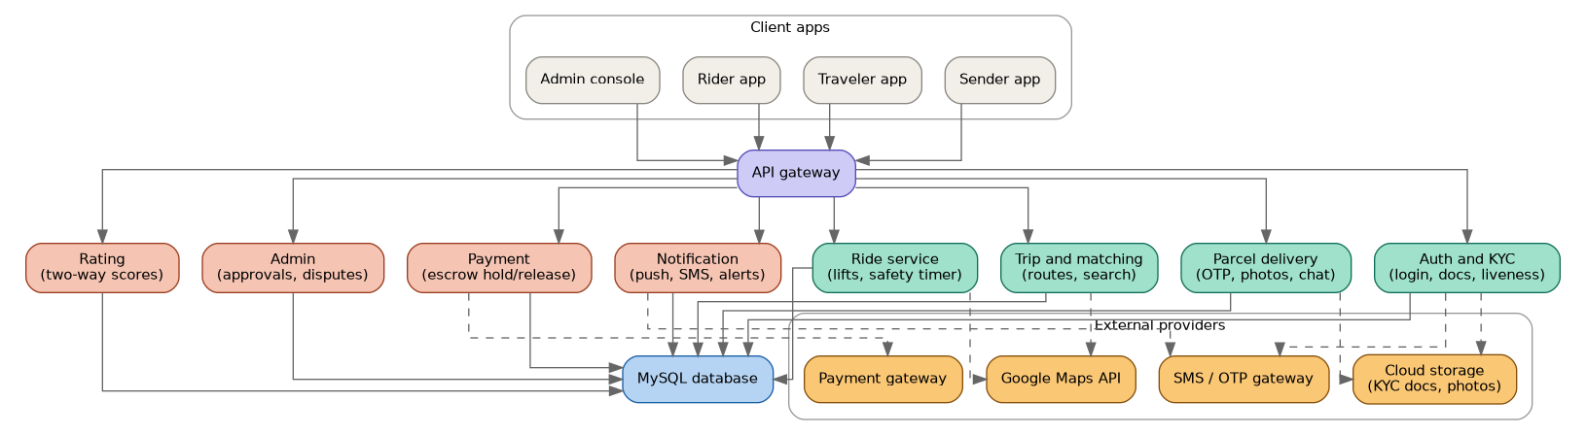

5. Core data entities (high level)
- User (role: Sender / Traveler / Rider / Admin, KYC status)
- TrustedContact (linked to a User, phone number)
- Trip (Traveler, source, destination, date/time window, status)
- ParcelRequest (Sender, Trip, goods description, declared value, status, pickup/delivery OTPs, pickup/delivery photos)
- RideRequest (Rider, source, destination, safety mode flag, ETA, buffer, status)
- Payment (linked request, amount, escrow status: held/released/refunded)
- Rating (from User, to User, linked request, score, comment)
- SafetyAlert (linked RideRequest/ParcelRequest, trigger reason, last known location, escalation stage)

6. Process flow — parcel delivery
End-to-end lifecycle of a parcel request, from trip registration through escrow release and rating, including the cancellation/reroute branch.
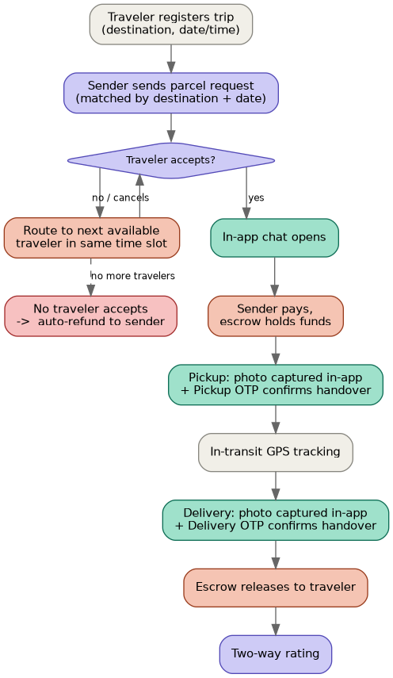

7. Process flow — ride safety escalation
How the Enhanced Safety Mode responds when a rider's location goes quiet mid-trip, from the buffer timer through to alerting a trusted contact.
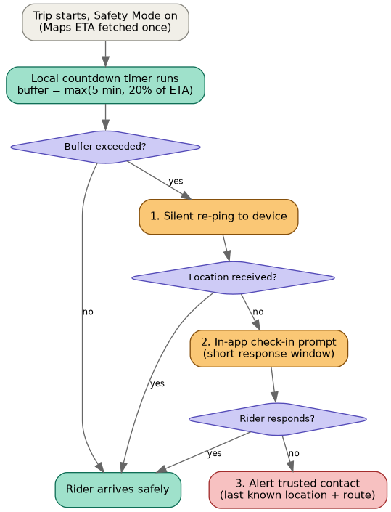

8. Requirements — what's needed to build this

Backend (extends the existing Spring Boot foundation)
- Spring Boot REST microservices (Auth, Trip/Matching, Parcel, Ride, Payment, Rating, Notification, Admin)
- MySQL — extended schema per Section 5
- API Gateway for routing between mobile clients and services

Mobile app
- Cross-platform framework recommended (React Native or Flutter) so Sender/Traveler/Rider apps can share one codebase with role-based views

Third-party services required
- Maps/Location: Google Maps API (ETA estimation, live tracking, geocoding)
- OTP/SMS gateway: for OTP delivery and trusted-contact SMS alerts (works for non-app-user trusted contacts)
- Push notifications: Firebase Cloud Messaging (or equivalent)
- Payment gateway: supports escrow/hold-and-release (e.g. Razorpay Route, Cashfree — needs evaluation)
- AI liveness detection + OCR: for KYC selfie and document verification
- Cloud object storage: encrypted storage for KYC docs and pickup/delivery photos (e.g. AWS S3 / GCP Storage with encryption at rest)
- Chat infrastructure: in-app messaging between Sender and Traveler (self-built or managed service)

9. Suggested phased roadmap
- Phase 1 — Foundation: Auth/KYC service, Traveler onboarding + Admin approval, basic Trip registration (destination + date/time)
- Phase 2 — Parcel MVP: Sender search & match, request/accept flow, in-app chat, Pickup/Delivery OTP + photo capture, escrow payment (parcel only)
- Phase 3 — Ride service + Safety layer: Ride request flow, ETA-based safety timer, escalation ladder, trusted contact alerts
- Phase 4 — Trust and polish: Ratings, dispute evidence workflow, fraud checks, pricing tier refinement

10. Still open — needs a decision before build
- Exact value-tier thresholds for parcel surcharge pricing
- Payment gateway choice (must support escrow/hold-and-release)
- Trusted contact: SMS-only, or does it require its own app account/invite flow?
- Dispute resolution workflow once photo/OTP evidence exists (who adjudicates, refund policy)
- Mobile framework choice (React Native vs Flutter) if not already decided

