ANDROID APP — AUTHENTICATION & ONBOARDING
Registration & Login Workflow
A complete module-by-module reference covering login, social and manual signup, role selection, and the User and Captain registration journeys.
Technical Design Document

Table of Contents

1. Introduction & Scope
This document describes the complete registration and login workflow for the Android application, covering both user types supported by the platform: riders (User) and drivers (Captain). It walks through every screen from first app launch to a fully authenticated session, and documents each functional module in enough detail to guide implementation.
The Captain registration journey is modeled on Rapido's captain onboarding process — a multi-step flow that collects identity, vehicle, and payout information, then gates account activation behind a document verification step. The User registration journey is intentionally lightweight, since riders are the demand side of the marketplace and every extra field increases signup drop-off.

1.1 Two account types
- User (rider) — books rides. Registration is minimal and self-serve; the account is active immediately.
- Captain (driver) — provides rides. Registration is multi-step and document-heavy; the account only becomes active after verification.

2. High-Level Flow Overview
The diagram below shows the full journey from app install through role selection, and where the User and Captain paths diverge.
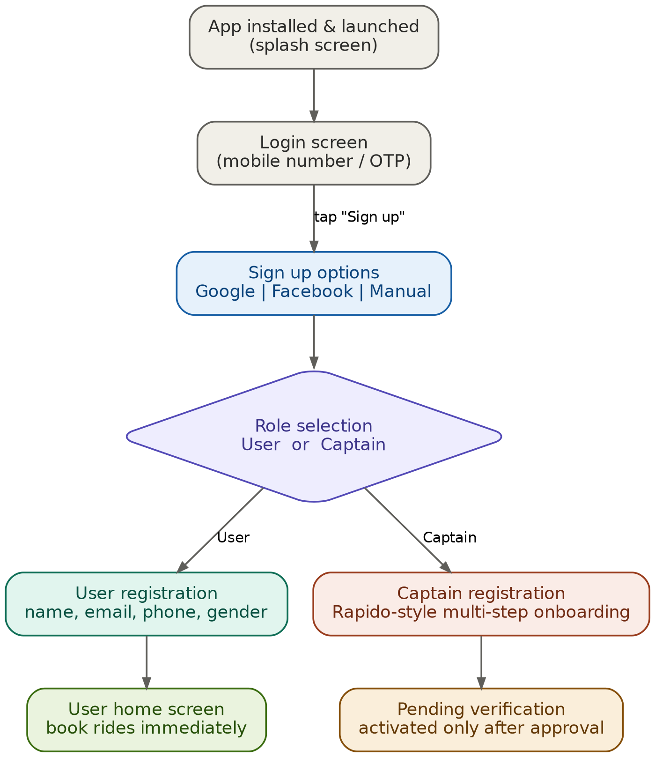
Figure 1 — App entry, signup, and role selection flow
Once a role is chosen, the two experiences share almost nothing: the User path ends in an active account within a few taps, while the Captain path continues into a much longer onboarding sequence that is detailed in Section 3.6.

3. Module Descriptions

3.1 Splash / App Launch Module
Purpose: initializes the app, checks for an existing valid session, and routes the user accordingly.
- If a valid session token exists locally, skip straight to the home screen for that role.
- If no session exists (first install, or the user logged out), route to the Login screen.
- Typical background work here: fetch remote config, check for a mandatory app update, warm up local caches.

3.2 Login Module
Purpose: authenticates a returning user via OTP or a linked social account, and routes them into the correct home screen based on their stored role.
- Fields: mobile number (primary), or a “Continue with Google / Facebook” button.
- OTP flow: enter number → receive a 6-digit code by SMS → enter code → server verifies → session issued.
- Social flow: OAuth token returned by the Google/Facebook SDK is sent to the backend, which verifies it directly with the provider before trusting any profile data.
- A “Sign up” link at the bottom is the only entry point into the registration flow — this keeps login and signup visually and logically separate.
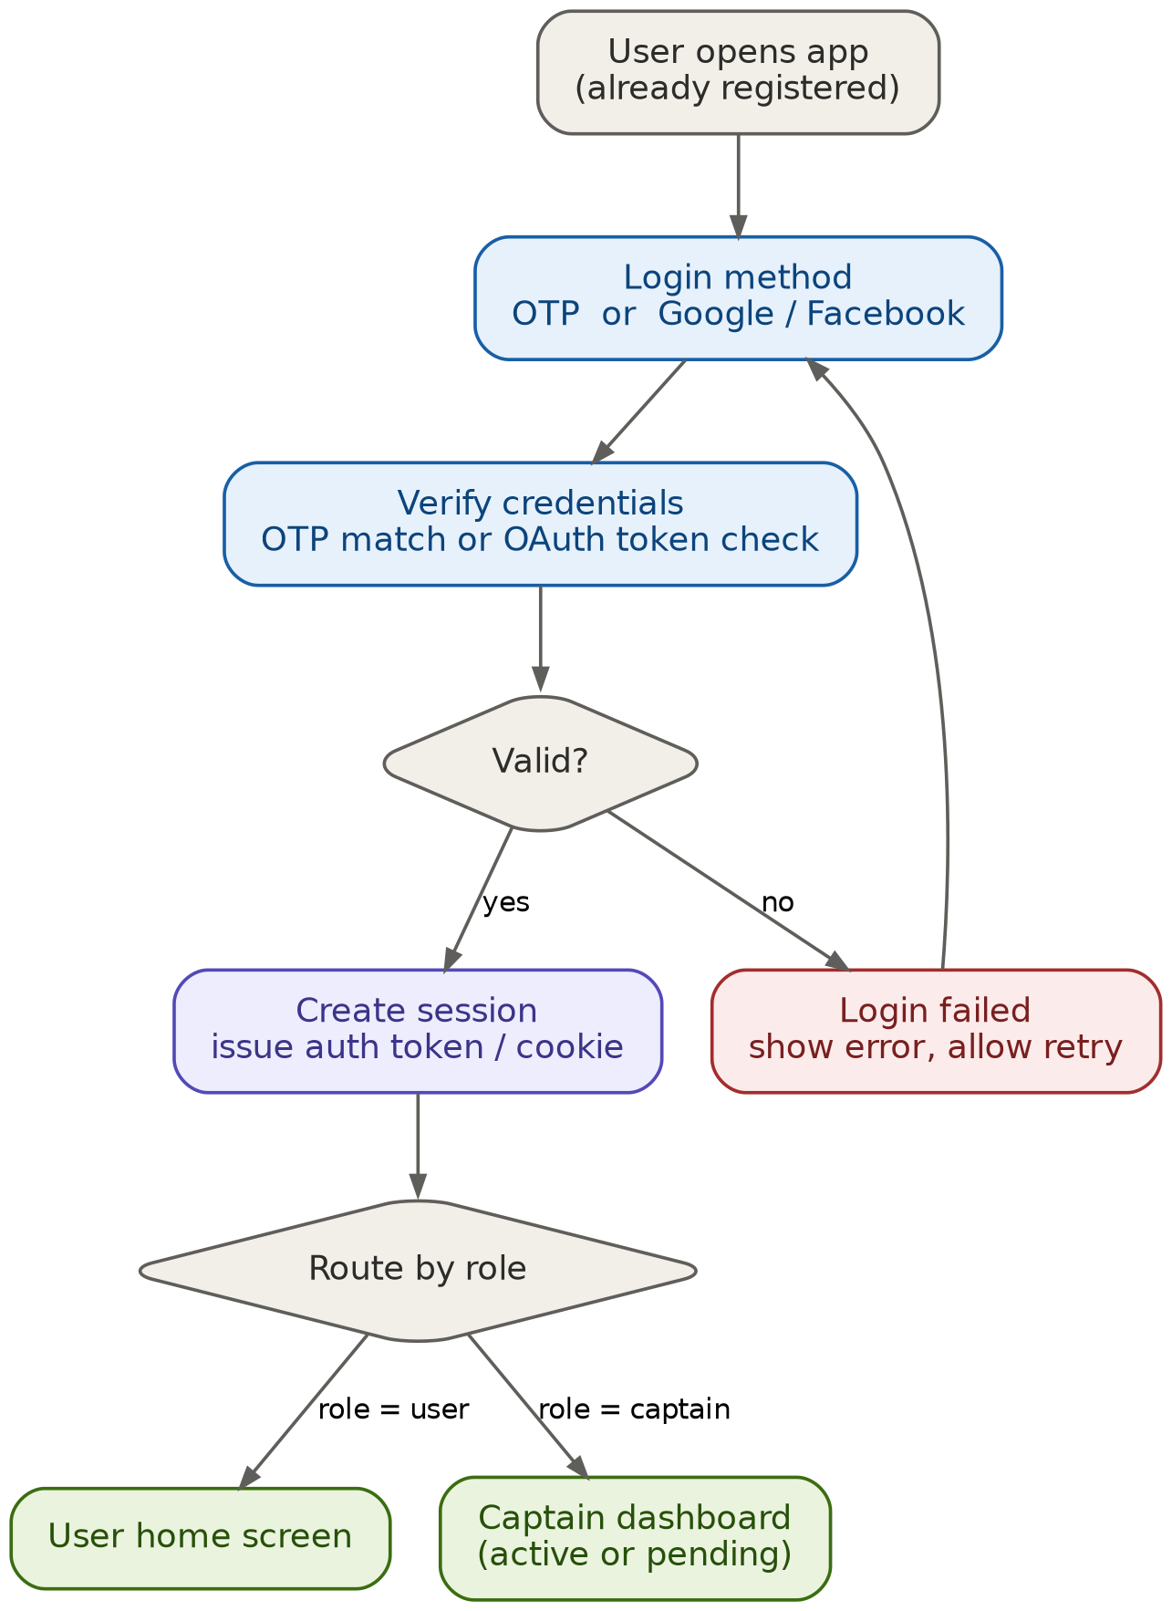
Figure 2 — Login and session routing flow

3.3 Signup Options Module
Purpose: lets a new user choose how they want to create an account, before any role-specific fields are collected.
- Google — one-tap OAuth; pulls name, email, and profile photo automatically. Fastest path.
- Facebook — one-tap OAuth via the Facebook SDK; pulls name and email on consent.
- Manual — mobile number + OTP, followed by name and email typed in by hand. Works without a linked social account.
Regardless of entry point, the backend normalizes into a single users table keyed by verified phone number or email, so the same person can later log in through a different method without creating a duplicate account.

3.4 Role Selection Module
Purpose: the single fork in the entire workflow. Every new account picks exactly one role, and that choice determines every screen that follows.
- User — “I want a ride.” Leads to the lightweight User registration module (3.5).
- Captain — “I want to drive & earn.” Leads to the multi-step Captain registration module (3.6).
This choice is stored as a role field on the account and should not be silently changeable later — a person wanting to switch roles (e.g. a rider who wants to also drive) should go through a separate, explicit “become a Captain” flow rather than editing the field directly.

3.5 User Registration Module
Purpose: get a rider from “new installer” to “can book a ride” in under a minute.
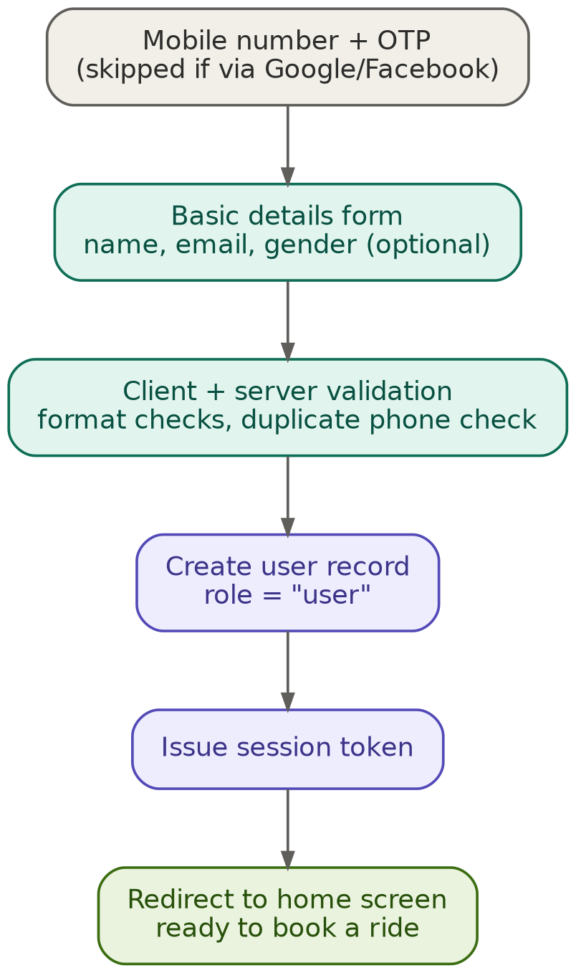
Figure 3 — User registration flow

3.5.1 Fields collected
Field | Required | Notes
Mobile number | Yes | Captured during signup; verified by OTP
Full name | Yes | 2–50 characters, letters and spaces only
Email | Optional | Auto-filled if signed up via Google/Facebook
Gender | Optional | Used for safety features, not shown publicly
Profile photo | Optional | Improves trust for the captain accepting the ride

3.5.2 On submit
- A record is created in the users table with role = “user”.
- A session token is issued immediately — no approval step.
- The user is redirected straight to the home / ride-booking screen.

3.6 Captain Registration Module
Purpose: collect everything needed to trust a Captain with passengers and payouts, modeled on Rapido's real onboarding sequence. Unlike User registration, the account remains inactive until every document is reviewed and approved.
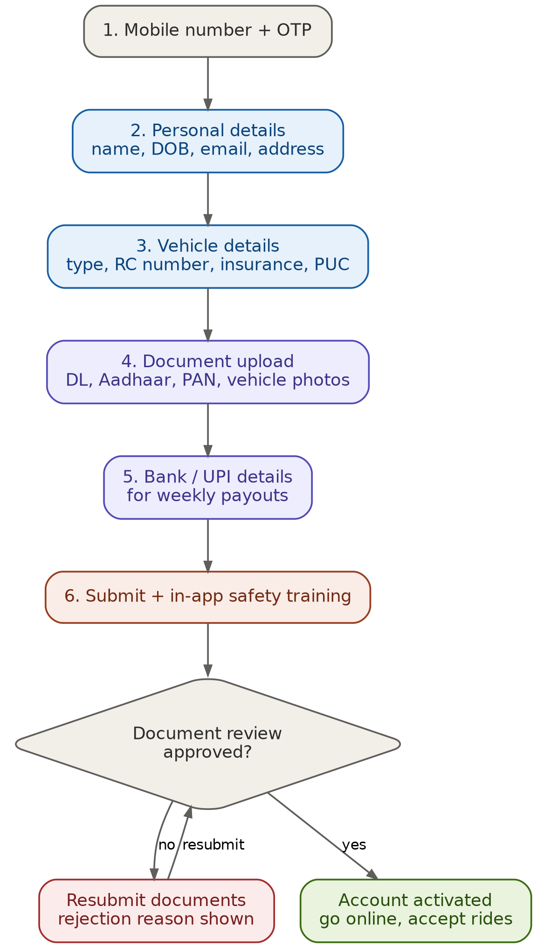
Figure 4 — Captain registration flow, including the verification gate

3.6.1 Step 1 — Mobile number + OTP
Same mechanism as login. This phone number becomes the Captain's unique login identity going forward.

3.6.2 Step 2 — Personal details
- Full name
- Date of birth
- Email address
- Home address
This information is used both for the Captain's profile shown to riders and for background checks during verification.

3.6.3 Step 3 — Vehicle details
- Vehicle type (bike, auto, or cab)
- RC (registration certificate) number
- Insurance validity
- PUC (pollution under control) certificate
Vehicle type determines which ride categories the Captain is eligible to accept once active.

3.6.4 Step 4 — Document upload
- Driving licence
- Aadhaar card
- PAN card
- Vehicle RC photo
- Insurance copy
- PUC certificate
- Vehicle photos (four angles)
Each document is captured via camera or gallery, checked client-side for obvious issues (blur, glare, wrong document type), then queued for review — manual, OCR-assisted, or a hybrid of both.

3.6.5 Step 5 — Bank / UPI details
- Account holder name — must match the name on the submitted ID
- Account number & IFSC, or a linked UPI ID as an alternative
- Bank proof — a cancelled cheque or passbook photo
These details drive the weekly ride-earnings payout and are collected before submission so payouts can start the moment the account is approved.

3.6.6 Step 6 — Submission & in-app training
A short in-app training module covers app navigation, passenger safety, and platform rules. The Captain must complete it before the profile can be locked and submitted for review.

3.6.7 Verification & activation gate
- Under review — document authenticity check, face match against the ID photo, vehicle ownership check, and a background check. Typical turnaround: a few hours to two days.
- If rejected — the Captain sees the exact reason (e.g. “RC photo unreadable”) and can re-upload just that document, without restarting the whole flow.
- If approved — account status flips to active, a push notification is sent, and the Captain can toggle “online” to start receiving ride requests immediately.
This gate is the defining difference between the two onboarding paths: a User is trusted by default; a Captain is trusted only after verification, because they are responsible for passenger safety.

4. Session & Authentication Handling
- On successful login or registration, the backend issues a session — either a signed JWT or a server-side session ID stored in a secure, httpOnly cookie.
- The token encodes (at minimum) the user ID and role, so the client can route to the correct home screen without an extra lookup.
- For a Captain, the token additionally carries the current verification status, so the app can show the “pending review” screen instead of the live dashboard until approval flips.
- Tokens should have a reasonable expiry with silent refresh, and be invalidated server-side on logout or password/OTP-based re-verification.

5. Data Model
A simplified relational schema covering both account types. Foreign keys are noted as (FK).
Table | Key columns
users | id, phone, email, role, auth_provider, created_at
captain_profiles | user_id (FK), dob, address, status
vehicles | captain_id (FK), type, rc_number, insurance_expiry
documents | owner_id (FK), doc_type, file_url, review_status
payout_accounts | captain_id (FK), account_no, ifsc, upi_id

6. Core API Endpoints
Endpoint | Purpose
POST /api/auth/otp | Send an OTP to a mobile number
POST /api/auth/verify-otp | Verify the OTP and issue a session token
POST /api/auth/social | Exchange a Google/Facebook token for a session
POST /api/users/register | Create a User profile
POST /api/captains/register | Create a Captain profile (draft status)
POST /api/captains/documents | Upload a document against a Captain ID
POST /api/captains/submit | Lock the profile and queue it for verification
GET /api/captains/status | Poll the current verification status

7. Security & Validation Checklist
- Never store plaintext passwords — hash with bcrypt/argon2 if a password option exists at all; OTP-only login avoids this entirely.
- Rate-limit OTP requests — cap attempts per number per hour to block SMS-bombing abuse.
- Verify OAuth tokens server-side — validate the Google/Facebook token against the provider before trusting the profile data it returns.
- Encrypt documents at rest — Aadhaar, PAN, and licence images are sensitive personal data; encrypt storage and restrict access by role.
- Separate draft vs. active Captain status — a Captain must never appear in ride-matching until status = approved.
- Mask sensitive fields in logs — phone numbers, bank details, and document URLs should never land in plaintext logs.

8. Summary
Login and signup stay visually separate, with signup itself branching into Google, Facebook, or manual entry. Role selection is the single fork in the journey — everything downstream depends on whether the account is a User or a Captain. User onboarding is optimized for speed, requiring only phone verification. Captain onboarding is optimized for trust: identity, vehicle, documents, and payout details are all collected up front and held behind a verification gate before the account can go live.

