Introduction to GIS: Lab 3

Select by Location & Vector Data Analysis

This week, we’ll begin editing and manipulating data using our spatial tools and capabilities. Thinking back to our selection steps from Lab Two, and considering the vector data concepts discussed in lecture, today we will make spatial decisions to solve a theoretical problem concerning the West Nile Virus.

First, we’ll practice a few components from last week and go through some new data manipulation skills you’ll use throughout this lab and the course.

While the lab production activity is what you will turn in to Moodle for a grade, please note that practice questions throughout to test your own understanding of the concepts are usefully noted in **bold**. These questions are very useful for testing your capacities, and will be helpful to complete the lab production as well!

This lab is divided into seven parts, which you should complete in order:

**Part A:** Joins and SQL Practice

**Objective:** Practice more with joining a table to a spatial layer and writing query statements to explore the data.

**Part B:** Select by Location

**Objective:** Learn another selection tool by selecting based on spatial location.

**Part C:** Exporting a New Shapefile

**Objective:** Create new shapefiles from data you’ve selected.

**Part D:** Analysis Tools: Clip

**Objective:** Use the clip tool and begin your first geospatial analysis tasks.

**Part E:** Analysis Tools: Buffer

**Objective:** Explore another analysis tool, the Buffer, to extend your analytical capabilities.

**Part F:** Other Analysis Tools

**Objective:** See the remainder of the simple analysis toolbox, while taking a brief dive into the Erase tool.

**Part G:** Lab Production: To Spray or Not to Spray: Solving a Public Health Problem with Spatial Analysis

**Objective:** Use your analysis skills to determine where to spray mosquitos for West Nile Virus after a dead bird has been found in a wetlands area.

# Part A: Joins and SQL Practice

1. First, open the \hazmat folder in Lab 3 and add all of the shapefiles:

* Hazmat
* Schools
* Towns
* Counties
* Blackstone_watershed
* Blackstone_streams

These spatial layers surround the Blackstone River watershed, which provides drinking water to Rhode Island.

1. The hazmat folder also contains an excel spreadsheet with town population in 2000.

**Practice:** Add the table to ArcMap and write a ‘select by’ query with SQL to answer the following question:

How many towns had a population of greater than 10,000 and an area of less than 50 km2?[1]

1. Clear your selection and we’ll move on to the next part of the lab.

# Part B: Select by Location

1. In addition to Select by Attributes, which you recall from last week, another option under the Selection menu is Select by Location. This tool allows you to select features from one shapefile that are within a specified distance of, or contained within another feature[2].
2. For example, let’s say we want a count of all the Massachusetts towns that intersect the Blackstone River Watershed. Go to the Selection menu and choose Select by Location.
3. You can think of this screen as a series of sentences which are forming your query. We want to use the method of selecting features from a layer, in this case, our towns layer. Since our selection will eventually choose towns, that’s the one we want to check.

1. Choose Blackstone_watershed as your “source layer” – this is the layer that you’ll be using to inform the selection.
2. Notice also that you have several options under Selection method – similar to Select by Attributes, you can create a new selection or add/remove from an existing selection.
3. Finally, notice that there are several spatial selection methods. The default is intersect. But, you can also select features within a specified distance of other features, or select features that only fall completely within other features. Check out the drop down menus to see your options.
4. Choose ‘Target layer(s) features intersect the Source layer feature’ and click OK.[3]

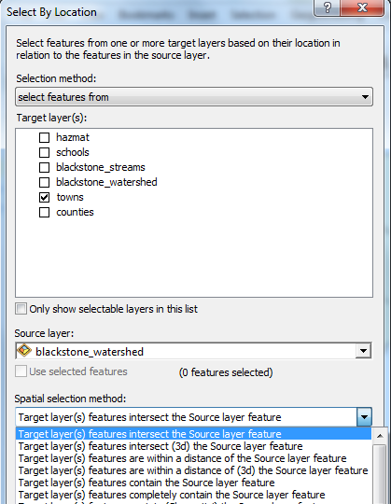

1. How many Massachusetts towns intersect the Blackstone watershed?

**Practice:** Using all of your selection skills – answer the following question: How many public schools (Type = ‘PUB’) are in the Blackstone watershed?[4]

**Hint:** Think about what selections you need to do (there are two separate ones). What are the processes to do them?[5]

**Practice:** How many hazmat sites are located within 100 m of one of the Blackstone streams?[6]

# Part C: Exporting a New Shapefile

1. Let’s say we’re only interested in towns that intersect the Blackstone watershed. Why bother to keep all of these extra towns? They’re just wasting space!
2. Use select by location to select all of the towns that intersect the Blackstone watershed (if they aren’t already selected)
3. Right click on towns and go to Data > Export Data

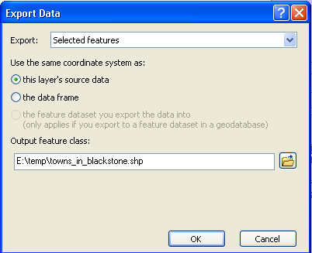

1. **When you have data selected, ArcMap will default to perform the chosen operation on ONLY the selected data**. So, export will default to exporting the selected features. Field calculator and calculate geometry operations in the attribute tables will also default to the selected features (some of you noticed this last week). The same will happen with analytical tools – so watch out for what you have selected!
2. Click the little folder button to save the output feature class to your Lab 3 folder on your USB drive.[7]

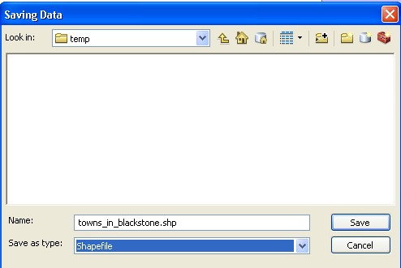

1. Click save and OK, and voila – a new shapefile that includes only the towns in the Blackstone watershed.[8]

**Practice:** What is the area of all the towns that intersect the Blackstone watershed?[9]

# Part D: Analysis Tools: Clip

1. You just calculated the area of all the towns that intersect the Blackstone watershed. But, what if we don’t want all the area that is outside of the watershed to be included? Take, for example, Shrewsbury. It is about half in the watershed and half out. How can we calculate the area of Shrewsbury that is inside the Blackstone watershed?

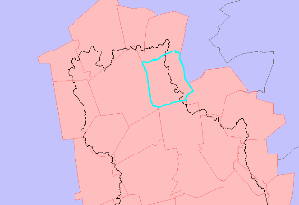

|  |
| --- |
| Note on finding tools  The easiest way to find tools is via the search window (The symbol for the search window in ArcMap. Click this icon in ArcMap to open the search window. )  In order to search for tools in the Search menu, you must either know what the tool is called or what operations it completes. If you don’t know the name of the tool, perhaps try using Google rather than ArcMap help to try to find it. Google has more flexibility in search terms – just make sure you include ArcMap or ArcGIS in addition to whatever you’re searching for. Or, better yet, ask one of us!  The more you use ArcGIS, the more familiar you’ll become with the different tool names. But, for now, consider keeping a notebook with some tool names that you can refer back to later.  When you do find what you’re looking for, clicking on the top link (Intersect (Analysis)) will open the tool itself, clicking on the bottom link (toolboxes\...) will open the path in ArcToolbox. |

1. One tool we have to cut off features based on another feature is the ‘clip’ tool. Clip functions like a cookie cutter, and takes from an input layer only the data that fits the clip layer (see below).

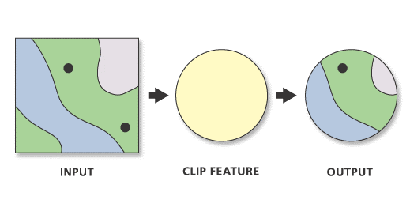

1. Click to open the Clip tool from either the search window or ArcToolbox[10]. The ‘input features’ at the top is the layer you want to clip, the ‘clip features’ below it is the shape you want to use (‘clip features’ is like the cookie cutter). Specify a new[11] output shapefile and save it somewhere in your Lab 3 folder.

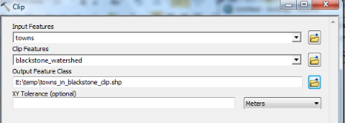

1. Click OK to execute the command.[12]

This screenshot image is an example of what you might see at the bottom of your screen indicating that the clip tool is executing the command. 

1. You’ll know it’s working if you see Clip in blue in the bottom right corner.[13]
2. Find Shrewsbury and see what it looks like now – it should only include the portion of the town that is inside the watershed.

**Practice:** What is the area of Shrewsbury inside of the Blackstone watershed?[14]

|  |
| --- |
| Warning: Calculate Area does not automatically update!!  If you found the answers to the reminder question above (good job!), then you probably opened your attribute table to find the area of Shrewsbury and saw 56.27 in the Area column. That number is the total area of all of Shrewsbury, not just the part in the Blackstone watershed. Any time you clip a shapefile (or perform any other analysis tools), calculations like area or perimeter (for polygons) and length (for lines) will not automatically update. They’ll retain the original information in that field. You will need to redo Calculate Geometry to find the correct area of Shrewsbury inside the Blackstone watershed. |

# Part E: Analysis Tools: Buffer

1. On to a new problem. Now, let’s say that we want to find the area of land within 100 m of a Blackstone stream in the town of Shrewsbury.
2. Blackstone streams is a line shapefile. These lines have no width or size, so we’ll need to calculate a new polygon that tells us an area. We can use the ‘Buffer’ tool to create a file showing the area ‘around’ a point, line, or polygon feature. Neat! Open the buffer tool by finding it in ArcToolbox or using search.

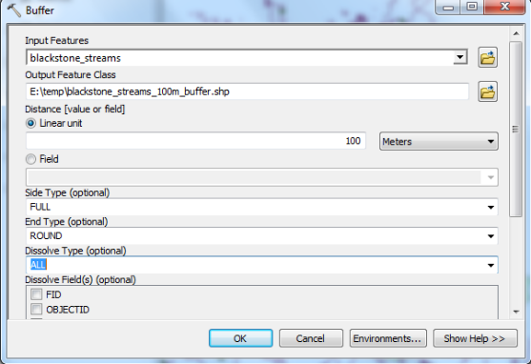

1. Input features should be blackstone_streams[15]. Save a new output shapefile somewhere in your Lab 3 folder. In this case, we want the buffer to be 100 m. You should also change the dissolve type to ALL (the default is NONE).
   1. With dissolve ALL, the output will be one single buffer feature surrounding all of the streams.
   2. If you use the default dissolve type NONE, you’ll get a separate buffer around every individual stream feature. Buffers around each individual stream will include some overlapping areas, so the area calculation would be incorrect.
2. Click OK to execute the buffer.
3. Now, clip your new stream buffer with the town of Shrewsbury.
   1. Remember how to Export Data? Select just the town of Shrewsbury in your watershed-only clipped towns file. Export that as a new layer, and use it as the clip feature. Data management score!

**Practice:** How much land area falls within 100 m of a Blackstone watershed stream in Shrewsbury?[16]

# Part F: Other Analysis Tools

1. There are lots of other analysis tools that you can explore in ArcToolbox. Below are a few examples. Chances are, if you can think of it, there’s probably a tool to do it…it’s just a matter of finding it!
2. You can read more about what tools do by clicking ‘show help’ once you’ve opened the tool.

This is a screenshot image of the "Show Help>>" button on ArcMap. 

1. Example analysis tools:

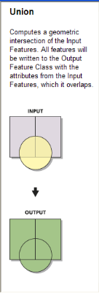 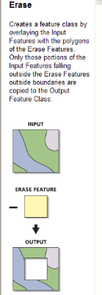 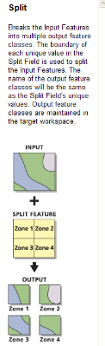 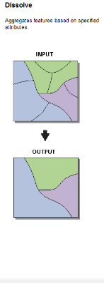

1. The ‘Union’ tool combines features into one file. If those features overlap, it retains their separate geometries, forming new shapes. Useful for when you have a lot of data of the same type in different files you need to combine, but want to see the separate components that make up those data.
2. Erase works like a big spatial subtraction tool. Taking some input, you can erase any feature from that input. Good when trying to remove features based on some exclusion principle.
3. Split carves up your data based on some pre-existing feature dataset. Using split can help manage your data into more manageable pieces, or separate data across some characteristic to run separate analyses.
4. Dissolve removes the ‘lines’ or the separations between components of your data. If you don’t need separate shapes in your layer file, dissolve allows you to unify components based on some commonality.
5. Let’s try one for fun. We’ll use Erase because it has some useful applications for the lab production activity.[17]
6. Let’s use our last two layers as an erase example. If we wanted to remove the river buffer from our clipped Shrewsbury file completely, we could use erase to ‘delete’ that portion of our file. Open up the Erase tool and you’ll see how it works.

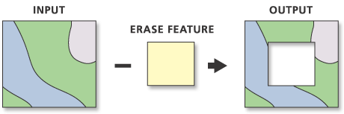

1. In our case, we have an input file of our clipped Shrewsbury town. We want to erase, or remove, the 100m river buffer so it doesn’t even appear in our town file. The output will be a new file showing the area of Shrewsbury in the watershed (our first clip) with the area within 100m of the river removed (our erase). Try it out!
2. Learning how and when to clip, erase, buffer, intersect, union, and so forth is a key spatial skill. We’ll practice some of these in lab today, and all of them moving forward throughout the semester.

# Part G, Lab Production: To Spray or Not to Spray

# Solving a Public Health Problem with Spatial Analysis

**Problem Statement**: The citizens and government in Middlesex County, Massachusetts are concerned by the recent discovery of a dead bird carrying West Nile Virus. The bird is believed to have lived in the local habitat, and the Centers for Disease Control (CDC) is considering whether to spray the surrounding are with a pesticide aimed at eliminating mosquitoes that may have contracted the disease. A representative from The CDC has arrived at your GIS lab and is asking you to help her evaluate whether or not CDCs current criteria for spraying a pesticide to eliminate the mosquitoes that carry the virus are likely to be effective. She has provided the spraying criteria below.

**The Spraying Criteria**: According to the CDC’s current criteria, spraying a pesticide by trucks must occur within a 2 kilometer radius around the site of any animal that has been found dead of the virus. However, it is known that pesticides sprayed by truck will only reach to 50 m on either side of roads. Further, the Environmental Protection Agency (EPA) has regulated that spraying must not occur within 100 m of any wetland because they don’t want to harm wetland biota.

**Data:**

To undertake the evaluation, you are provided with three layers in the Lab3 zip. The layers are:

1. *deadbird* containing the location of a bird that has been found to have died of the virus
2. *wetlands* representing wetlands as polygons
3. *roads* representing roads as lines

**Questions to be turned in:**

Given this spatial data and the spraying criteria, answer the following questions:

1. How much land area (units?) is available for pesticide spraying given the above wetland and road distance limitations?
2. What is the ideal spray area per the CDC guidelines (in square km) if there were no logistical or regulatory constraints?
3. What percentage of the recommended total spraying radius does this area represent?
4. In your opinion, how effective is this treatment likely to be?
5. Using a flow chart or through clear written instructions, explain the steps you used to complete this analysis.

**Map to be turned in:**

1. Create an 8 ½ x 11 layout/poster showing the potential spray area, along with the location of the dead bird, roads, wetlands, and any other spatial data that would help illustrate your results. *Make sure your map has a legend, scale bar, and north arrow as well as a title.* When you are finished, export the map as jpeg and insert it in a word document with your answers to the above questions.

1. Should be 11.
2. Remember when you were in elementary (or equivalent) school, and you learned words like ‘around’ ‘on’ ‘near’, and so forth? Think like that with spatial decisions.
3. You’ll note that this is just a retelling of the different selection options above.
4. Hint on next page.
5. (Answer should be 96 – make sure you know how to get that info)
6. (Answer should be 33)
7. If this fails, make sure you have write access to your flash drive.
8. Memorize this task order for future efficiency.
9. (should be 1381 km2)
10. Clip (Analysis) and Clip (Data Management) do the same thing with different data types. Are we using Raster or Vector here? Pick accordingly!
11. Clip and other analysis tools do not change your original data. Instead they make a new file based on the tool you use. Neat!
12. Get ready to stare at this bar longingly for the rest of the semester.
13. Other options include it not working.
14. (It should be 35.4 km2)
15. The file you want to buffer.
16. (Should be 14.4 km2)
17. HINT HINT HINT