For Mobile version, there are not many features yet. But I’m still working on it as long as it can help someone out.

We have login screen

You can manage your account or logout here.

You can view a list of tests and lessons on your home screen.

You can view a list of tests and view the detail test here.

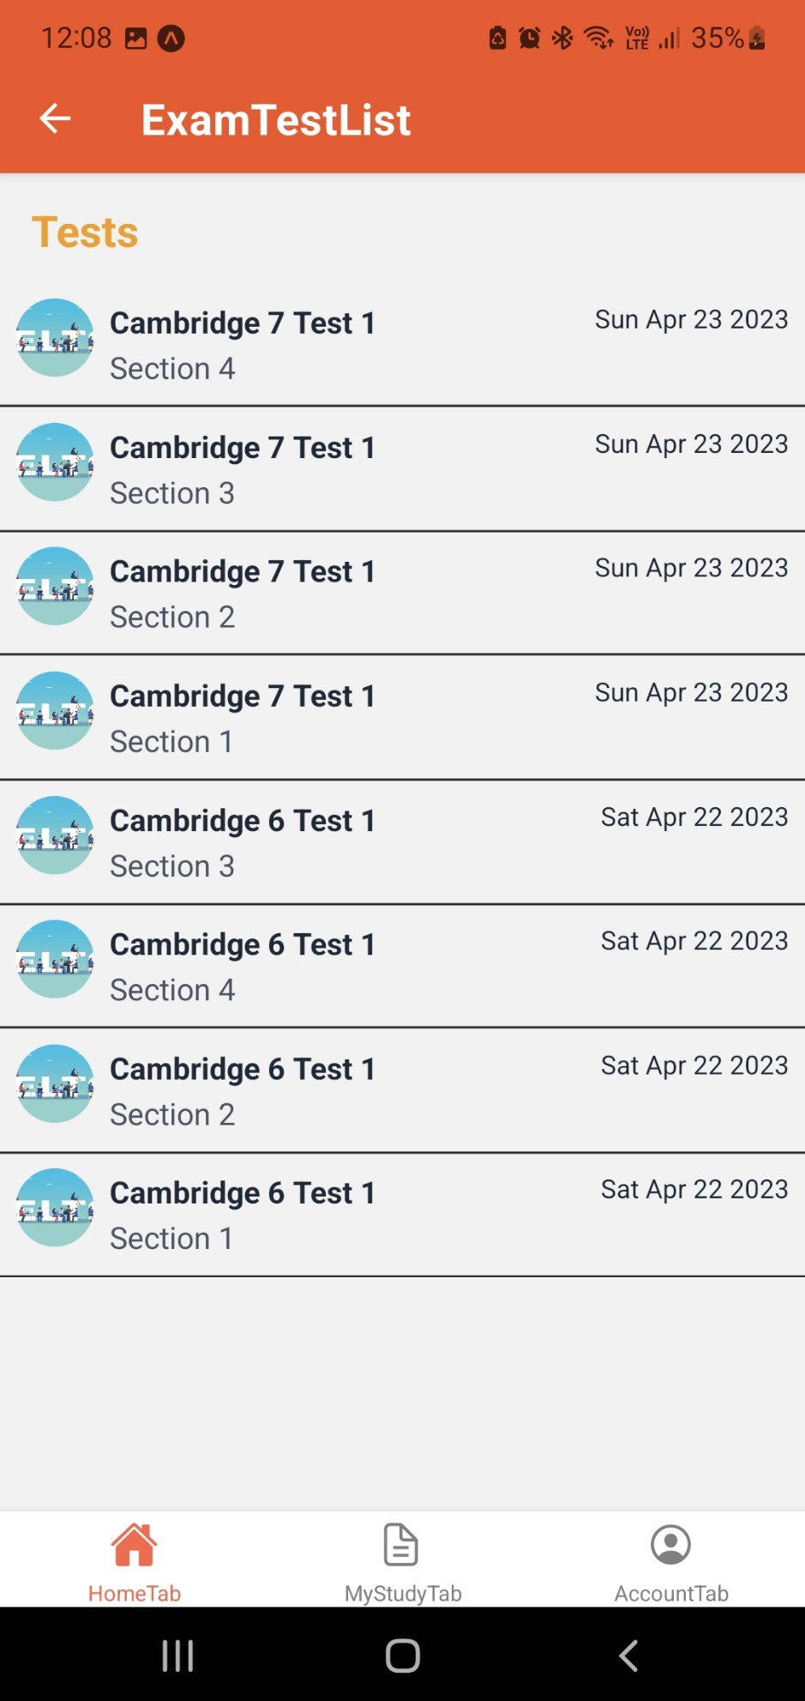

In this case a listening test

You can manage your study here, your favorite bookmarked assigned and done tests.

I haven’t had much time on this mobile version (just a couple of days) But I think I can add more functionality to it. Especially focus on Speaking and Listening, students can record their speaking lessons, focus on pronunciation. They might also practice their listening skill by utilizing the benefits of the smart phone, you can bring your phone with you while travelling and listen at the same time.