AT91SAM9261-EK BSP User Guide

DOC. No.: | REV.: 00 |  |  | PRODUCT: SL15
TITLE: Working with the BSP of T91SAM9261EK |  |  |  | Project: | SL15
Prepared by: | Alan Chen |  |  | Date: | 6/27/2008
Remark: | Approval:
Remark: |  | Department | Title |  |  | Signature
Remark: | 1 | Electronic R&D
Remark: | 2
Remark: | 3
Remark: | 4

Revision | Description of Change | Author | Date
00

1. Overview 3
1.1. Objective 3
1.2. Scope 3
1.3. Reference 3
1.4. abbreviations 3
1.5. Getting bsp code and committing changes to server 3
1.6. building boot loader and os image 3
1.7. downloading boot loader and os image 3
1.8. trouble shooting 3
Appendix 3

Overview

Objective
This document is aimed at helping the developer setup environment and enable WinCE OS run on AT91SAM9261.
This includes how to build boot loader and OS image, how to flash boot loader via SAM-BA, how to download OS image from Ethernet, which problems were encountered and how to solve them and so on.

Scope
This document is only for SL15 project development. Hardware platform is AT91SAM9261 (ARM9), Operating System is Windows CE 6.0.
To perform these operations, the following resources are required:
• A workstation with WinCE6.0, ActiveSync 4.5, SAM-BA 2.7 and TortoiseSVN. The PC should have at least:
o A Serial link available
o An Ethernet connection
o An USB cable
• The AT91SAM9261EK development board.

Reference
The reference documents include:
•《WinCE_demo.ppt》
•《AT91SAM9261EK CE6.0 Install Notes v1.0.3 A.pdf》
•《AT91SAM9261EK CE6.0 TDD v1.0.3 A.pdf》

Abbreviations
WinCE Windows CE
BSP Board Support Package
AT91SAM9261EK Atmel evaluation kit for AT91SAM9261 Product
PB Platform Builder
SAM-BA SAM Boot Assistant

Getting BSP Code and Committing Changes to Server

Code Location
The BSP Code is located in http://10.10.0.45/source/trunk/BSP/AtmelBSP/AT91SAM9261EK/ , http://10.10.0.45/source/trunk/BSP/AtmelBSP/ATMEL/ , and project file is located in http://10.10.0.45/source/trunk/BSP/AtmelBSP/AT91SAM9261EK_DEMO/.

To obtain a working copy you need to do a checkout from repository, the steps are as below:
1. WinCE 6.0 install in the default location: C:\WINCE600
2. Checking out folder AT91SAM9261EK to C:\WINCE600\PLATFORM\AT91SAM9261EK
3. Checking out folder ATMEL to C:\WINCE600\PLATFORM\COMMON\SRC\SOC\ATMEL
4. Checking out project folder AT91SAM9261EK_DEMO to C:\WINCE600\OSDesigns\AT91SAM9261EK_DEMO
5. Opening AT91SAM9261EK_DEMO.sln in AT91SAM9261EK_DEMO and building

Select a directory in windows explorer where you want to place your working copy. Right click to pop up the context menu and select the command “SVN Checkout …”, which brings up the following dialog box:

Figure 1.5.1 The checkout dialog
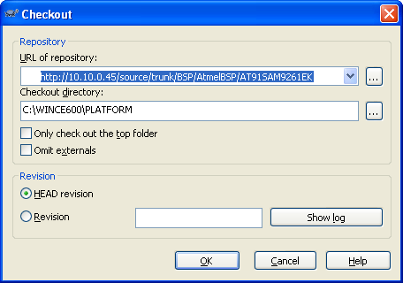

How to commit changes to SVN Server
When the source code is modified, you need to commit the changes you made to SVN Server. But before you commit you have to make sure that your working copy is up to date. You can either use SVN Update directly. Or you can use SVN Check for Modifications first, to see which files have changed locally or on the server.

If your working copy is up to date and there are no conflicts, you are ready to commit your changes. Select any file and/or folders you want to commit, then SVN Commit....
The figure-1.5.2 shows that how to commit the modified source file.

Figure 1.5.2 The commit dialog
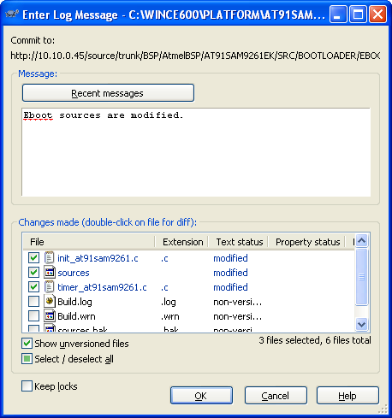

Note: The log messages must be longer than 10 characters.
If you don’t want a changed file to be committed, just uncheck that file.

Building Boot loader and OS image

Building OS image
• From the catalog window, choose the features to add (check in the corresponding boxes).
Features of the Windows CE OS are located in the “Core OS” directory of the catalog. Features of the AT91SAM9261EK BSP are located in the “Third Party\BSP” directory.
• From the Workspace window, choose the features to remove (check out the corresponding
boxes). Some features can not be removed if they are required by others features.
• To build the image, select the type of build (Debug or Release) and use Build → Advanced
Build commands → Sysgen. If you only change BSP source file, select Build → Advanced Build commands →Build current BSP and subproject.

The figure-1.6.1 below shows WinCE catalog window.

Figure 1.6.1 Catalog items view
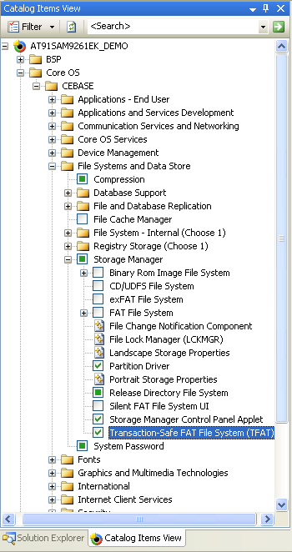

Building Boot loader
To build the boot loader source code
- At the command prompt, enter the following command:
build –c

Note: when building the boot loader, ensure that the build is run from the boot loader directory.
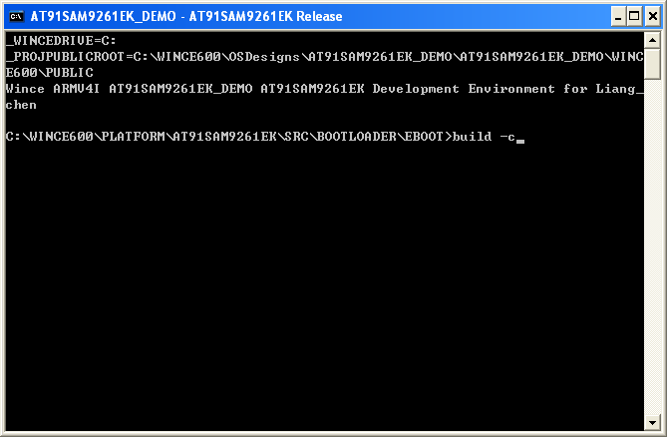

- Verify C:\WINCE600\OSDesigns\AT91SAM9261EK_DEMO\AT91SAM9261EK_DEMO\RelDir\AT91SAM9261EK_ARMV4I_Release\Eboot.exe was created.

Downloading boot loader and OS image

Download boot loader with SAM-BA
• Remove DataFlash Jumper (J21)
• Power up the board
• Connect the USB device interface (J19) to your PC using the USB cable
• If it is the first time an AT91 chip is connected to the PC, searching for the driver
• Start SAM-BA 2.7
• Choose USB Connection and select the AT91SAM9261-EK , and then click Connect. See Figure 1.7.1

Figure 1.7.1 Connection to AT91
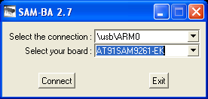

• Plug DataFlash Jumper(J21) back in position 1-2.
• Select DataFlash AT45DB/DCB Tab, Choose Enable Dataflash(SPI0 CS0) and press Execute. see Figure 1.7.2

Figure 1.7.2 Select DataFlash
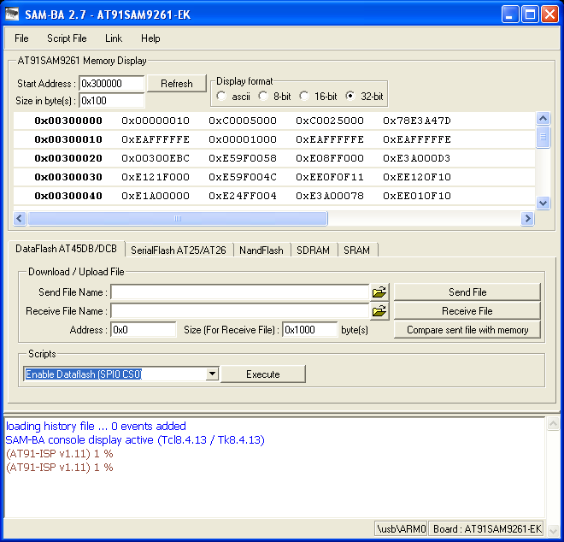

• Choose Send Boot File in scripts rolling menu and press Excute, see Figure 1.7.3

Figure 1.7.3 Send Firstboot.nb0

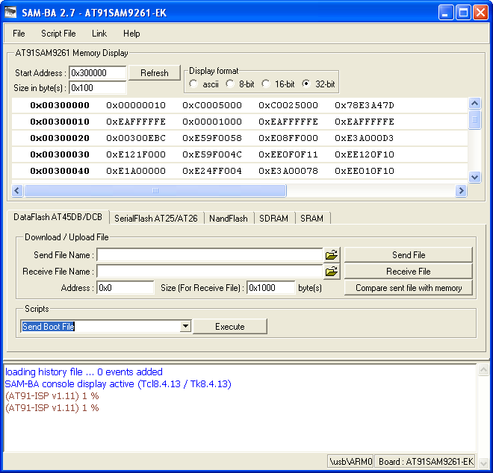

• Select file named firstboot.nb0 and press Open.
• Enter “0x5000” in Address text field, press on Send File name browse button , choose Eboot.nb0, press Send File button. See figure 1.7.4

Figure 1.7.4 Send Eboot.nb0
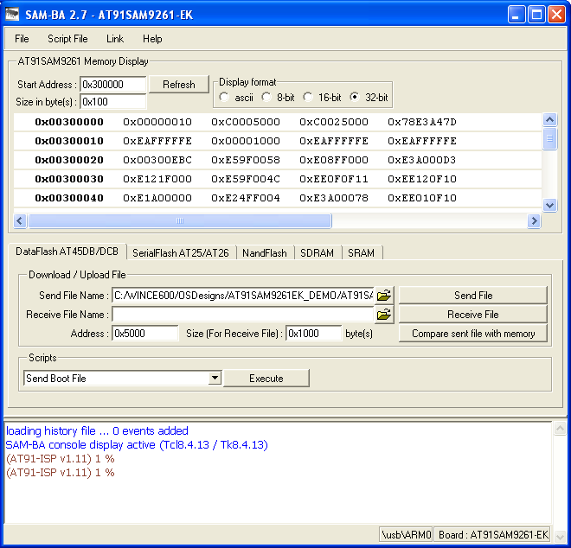

• Close SAM-BA, remove USB cable, reset the board.
When terminal displays the following information, the boot loader now is loaded in DataFlash and can work. Showed in figure 1.7.5

Figure 1.7.5 Boot loader main menu
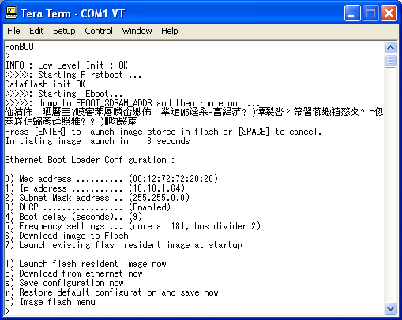

Download OS image through Ethernet from Platform Builder
Reboot the board, you should have the following log messages.

……
Press [ENTER] to launch image stored in flash or [SPACE] to cancel.
Initiating image launch in 7 seconds

Ethernet Boot Loader Configuration :

0) Mac address .......... (00:12:72:72:20:20)
1) Ip address ........... (10.10.1.64)
2) Subnet Mask address .. (255.255.0.0)
3) DHCP ................. (Enabled)
4) Boot delay (seconds).. (9)
5) Frequency settings ... (core at 181, bus divider 2)
6) Download image to Flash
7) Launch existing flash resident image at startup

l) Launch flash resident image now
d) Download from ethernet now
s) Save configuration now
r) Restore default configuration and save now
n) Image flash menu

In this menu, you can configure the Ethernet connection between the board and your network,
configuring the Mac and IP addresses. When using a static IP (if there is no DHCP server on the
network), AT91SAM9261EK target and workstation should be on the same subnet.

• To download the Windows CE image in SDRAM, press the key 6 until “Download image to SDRAM” appears and press the key 7 until “Download new image at startup” appears. To download the Windows CE image in Flash, press the key 6 until “Download image to Flash” appears and press the key 7 until “Launch existing flash resident image at startup” appears.

• Select the key D to download the image, the boot loader should display on HyperTerminal « Sending BOOTME to 255.255.255.255 ».

Once Eboot is reconfigured, follow these steps to update the CE image:
• Under visual studio enter download settings (Target → Connectivity Options). See Figure 1.7.6, Select Ethernet for both Download and Transport. Enter the configuration dialog (button Settings). You should see in the list SAM9261_xxxx. Select the SAM9261_xxxx target and click OK to return. See Figure 1.7.7. Click Apply and then Close.

• Start the download using Target → Attach Device. The CE image should be downloaded.
Once the image has booted, the Windows CE desktop is displayed on the screen.

Figure 1.7.6 Connectivity Options
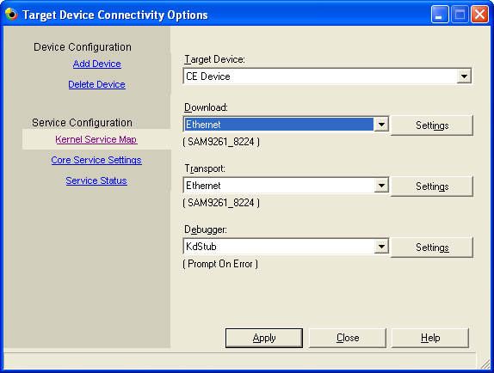

Figure 1.7.7 Download Setting
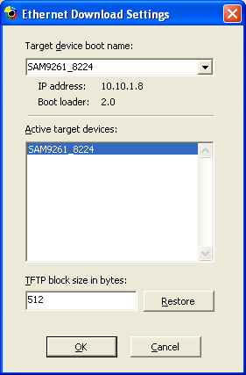

Download OS image with SAM-BA
• Open SAM-BA, select NandFlash Tab. See Figure 1.7.8.

Figure 1.7.8
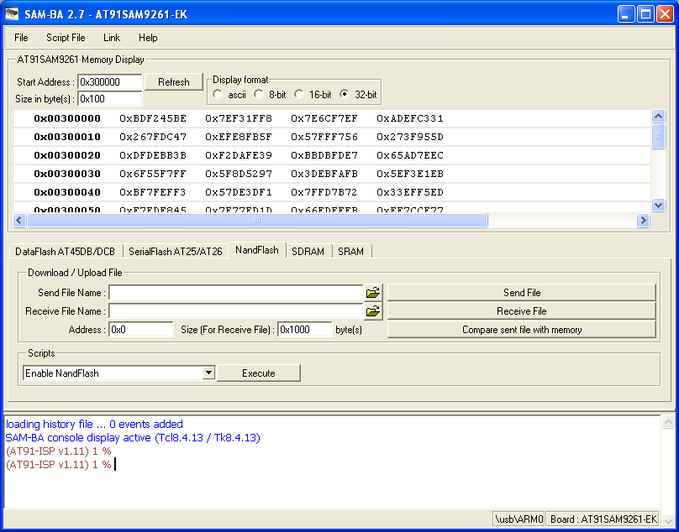

• Choose Enable NandFlash in scripts rolling menu and press execute.
• Press on Send File Name browse button , choose file named NK.nb0 and open.
• Press on Send File button (This will take a few moment): WinCE has been stored in NandFlash
• Close SAM-BA, remove USB cable.

Configure WinCE Boot:
• Connect the Serial Debug Port(J15) to your PC using the Serial cable.
• Start Tera Term session with the settings: 115200 8-N-1-N
• Reset the board
• Press “Space” key when the message “Initiating image launch in 5 seconds” is displayed to stop booting, the following menu is then displayed:
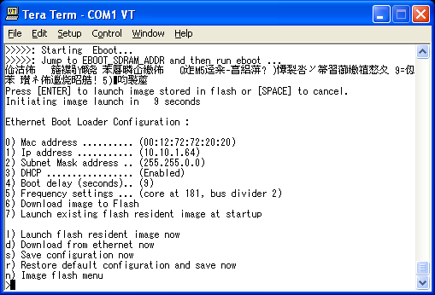

• Select option “5” to setup ARM and BUS frequency:
  - Enter new Core Frequency (old frequency is 200 MHz) 181
  - Enter new bus divider (old divider is 4) 2
• Select option “n”, enter Image flash menu, then display:
Image Flash Menu :
1) Erase all sectors
2) Enter manually the image parameters
3) Quit...
Select option “2” and set the following settings:
Enter the information found in the build report of the 'Make Image'. [entering 0 keeps present value]
Physical Start Address : (0x80059000) : 0x
Starting ip : (0x8005a000) : 0x
Total ROM size : (0xe9d0bc) : 0x
• Exit and reset the board.

Trouble Shooting

SAM-BA Error: “No valid processor ID found”
Problem: When trying to connect the board through serial cable using SAM-BA , it always replies “No valid processor ID found”. See Figure 1.8.1

Figure 1.8.1 SAM-BA Error
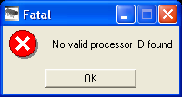
Solution: If a USB cable is connected to PC, it is not possible to connect via serial with SAM-BA boot. Because ROMBOOT first detects the USB and if it finds USB then SAM-BA tries to talk with USB. So the USB cable should be removed first.

Problem writing to NandFlash
Problem: when using SAM-BA to check and initialize Nand Flash , if the address access higher than 32M, it always displays message “bad block”.
Solution: The old version of SAM-BA has this bug, suggest using the latest version SAM-BA 2.7.

Cannot lanch WinCE6.0 OS on AT91SAM9261EK
Problem: After Using SAM-BA to flash WinCE image in the Nandflash, the WinCE image can not boot. It shows “jumping to starting address 0x2005a000” and never run properly.
Solution: Adeneo BSP is not compatible with SAM-BA 2.6 or earlier, you have to use the latest version SAM-BA 2.7 to flash WinCE image, it works fine in this version. The best way to flash a new NK.nb0 is to select option 6) “Download image to Flash” in the boot loader and then press D to download a new image and write it in the Nandflash.

The debug version of bootloader can not work
Problem: The bootloader is built as debug version, when it is downloaded in Dataflash, it can not boot.
Solution: Adeneo made some limitations that the debug version of bootloader can not work, you should program only release version of firstboot and eboot.

The debug version of CE image can not start
Problem: The CE image is built as debug version, when it is downloaded in Nandflash, it can not work normally.
Solution: Adeneo made some limitations that the debug version of CE image downloaded to Nandflash can not work, so you should build the image as release version.

The board resets every hour because of time bomb
Problem: This BSP is freely provided in a trial version. This version is limited in time. After 60 minutes, it will reboot. Because a time bomb is inserted in the evaluation BSP.
Solution: To remove this time bomb, disable the macro TIMEBOMB_INIT_ONCE and TIMEBOMB_CHECK and unset the environment variable OAL_TIMEBOMB in the source code.

Appendix

