USB2Ethernet Driver Integration

DOC. No.: | REV.: 00 |  |  | PRODUCT:
TITLE: USB2Ethernet Driver Integration |  |  |  | Project: | SL15
Prepared by: | Liang_chen |  |  | Date: | 2008-12-4
Remark: | Approval:
Remark: |  | Department | Title |  |  | Signature
Remark: | 1 | Electronic R&D
Remark: | 2
Remark: | 3
Remark: | 4

Revision | Description of Change | Author | Date
00

1. Overview 4
1.1. Objective 4
1.2. Scope 4
1.3. Reference 4
1.4. Abbreviations 4
2. USB2ethernet driver integration 4
2.1. View VID and PID of USB Device 4
2.2. Copy ax88772 chip driver to $(_TARGETPLATROOT)\FILES 5
2.3. Create driver-related register 5
2.4. Modify the setting of platform.reg and platform.bib 6
2.5. Make image 6

Appendix 7

Overview

Objective
This document shows that how to integrate a USB to Ethernet driver into WinCE NK.

Scope
The development environment is WinCE 6.0

Reference
《AX88772/AX88772A WinCE 6.0 Driver Installation Guide》

Abbreviations

USB2Ethernet Driver Integration

View VID and PID of USB Device
The detailed information of USB device can be detected and viewed through USBView.exe tool. Plugging the USB to Ethernet dongle into working computer (use Windows XP), then openning USBView.exe, detailed information about USB dongle will be showed below:

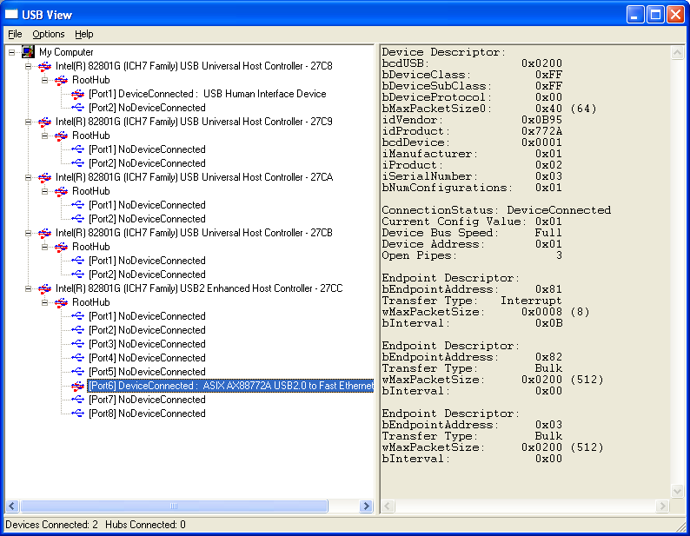
The information about ASIX AX88772A USB2.0 to Fast Ethernet Dongle is listed in detail, including some kinds of descriptors, idVendor(VID), idProduct(PID), e.g. For AX88772A, VID is 0x0B95, PID is 0x772A.

Copy AX88772 chip driver to $(_TARGETPLATROOT)\FILES
The AX88772 chip driver ax88772.dll must be copied to C:\WINCE600\PLATFORM\AT91SAM9261EK\FILES

Create driver-related register file
Here creating a file that is named usb2ethernet.reg, then adding below register settings into this file. Note that if the VID and PID don’t match this device , they must be replaced with the value through USBView.

[HKEY_LOCAL_MACHINE\Drivers\USB\LoadClients\2965_30496\Default\Default\AX88772]
"DLL"="AX88772.DLL"
"Prefix"="ASX"
[HKEY_LOCAL_MACHINE\Drivers\USB\LoadClients\2965_30506\Default\Default\AX88772]
"DLL"="AX88772.DLL"
"Prefix"="ASX"

[HKEY_LOCAL_MACHINE\Drivers\USB\ClientDrivers\AX88772]
"DLL"="AX88772.DLL"
"Prefix"="ASX"

[HKEY_LOCAL_MACHINE\Comm\AX88772]
"DisplayName"="ASIX AX88772 USB 2.0 Fast Ethernet Driver"
"Group"="NDIS"
"ImagePath"="AX88772.dll"

[HKEY_LOCAL_MACHINE\Comm\AX88772\Linkage]
"Route"=multi_sz:"AX887721"

[HKEY_LOCAL_MACHINE\Comm\AX887721]
"DisplayName"="ASIX AX88772 USB 2.0 Fast Ethernet Driver"
"Group"="NDIS"
"ImagePath"="AX88772.dll"

[HKEY_LOCAL_MACHINE\Comm\AX887721\Parms]
"BusNumber"=dword:0
"BusType"=dword:1
"ConnectionType"=dword:0
"FlowControl"=dword:3
"WakeUp"=dword:0
;======================================================
;the follow only for AX88772A chip
;======================================================
"WakeUpFrameType"=dword:3 ; 1 = "Ping"; 2 = "ARP"; 3 = "All";
"VlanEnable"=dword:0 ; 0 = "Disable"; 1 = "Enable";
"VlanId"=dword:0 ; 0 - 4095

[HKEY_LOCAL_MACHINE\Comm\AX887721\Parms\TcpIp]
; "EnableDHCP"=dword:0 ;Disable DHCP function
; "IpAddress"="xxx.xxx.xxx.aaa" ;Define your IP address
; "Subnetmask"="255.255.255.0" ;Define Submask IP address
; "DefaultGateway"="xxx.xxx.xxx.bbb" ;Define Gateway IP address
; "DNS"="xxx.xxx.xxx.ccc" ;Define DNS server IP address

"AutoCfg"=dword:1
"EnableDHCP"=dword:1 ;Enable DHCP function
"UseZeroBroadcast"=dword:0 ;Use zero for broadcast address?

Modify the setting of platform.reg and platform.bib
Add below setting into C:\WINCE600\PLATFORM\AT91SAM9261EK\FILES\platform.reg:
; -----------------------------------------------------------------------------
#include "$(_TARGETPLATROOT)\FILES\usb2ethernet.reg" ;USB2Ethernet driver
; -----------------------------------------------------------------------------

Add below driver file path and attributes into C:\WINCE600\PLATFORM\AT91SAM9261EK\FILES\platform.reg:
ax88772.dll $(_FLATRELEASEDIR)\ax88772.dll NK SHK

Make image
Choose “Make Run-Time Image” from the Build menu to build a new platform image (NK.BIN) to take effect the new settings.

Appendix

