WinCE OS Customization

DOC. No.: | REV.: 00 |  |  | PRODUCT: SL15
TITLE: WinCE OS Customization |  |  |  | Project: | SL15
Prepared by: | Liang_chen |  |  | Date: | 7/1/2008
Remark: | Approval:
Remark: |  | Department | Title |  |  | Signature
Remark: | 1 | Electronic R&D
Remark: | 2
Remark: | 3
Remark: | 4

Revision | Description of Change | Author | Date
00

1. Overview 3
1.1. Objective 3
1.2. Scope 3
1.3. Reference 3
1.4. Abbreviations 3
1.5. wince Core os features 3

Appendix 3

Overview

Objective
Windows CE offers a rich set of features that user can customize a platform. The document lists WinCE 6.0 detailed components for reference and evaluation for SL15 project, then deciding which component should be chosen.

Scope
This document is only for SL15 project development. Hardware platform is AT91SAM9261(ARM9), Operating System is Windows CE 6.0.

Reference
《Microsoft Visual Studio 2005 Documentation》

Abbreviations
OS Operating System
CE Windows CE
PB Platform Builder
BSP Board Support Package

WinCE Core OS Features
WinCE OS provides a set of features for building customized embedded OS based on Windows CE OS. The OS features could be chosen through the Catalog items in Platform builder. See Figure 1.5.1

Figure 1.5.1 Catalog Items
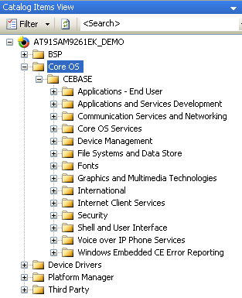

Application – End User
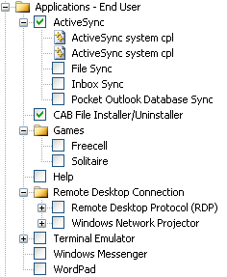

1) ActiveSync: ActiveSync provides support for synchronizing data between a Windows-based desktop computer and a WinCE-based device. (√)
2) CAB File Installer/Uninstaller: 该功能可以用于设备安装一个.CAB文件。这个变量同时带来一个UNLOAD.EXE应用用来卸载以前安装的基于CAB的应用程序。(X)
- Games: (X)
- Help: 一个基于HTML的系统帮助应用程序 (X)
- Remote Desktop Connection: The remote desktop protocol implementation for WinCE allows you to connect remotely to a desktop computer running Windows XP Professional. (X)
- Terminal Emulator: The Terminal Emulator enable user to create a terminal for remote host and setup telephony API device. (X)
- Windows Messenger: The Microsoft Windows Messenger for WinCE real-time communications software. (X)
- WordPad: a basic text handling tool. (X)

Applications and Services Development
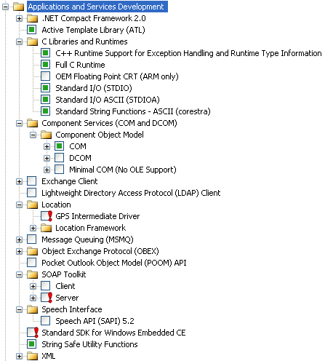

- .NET Compact Framework 2.0: The Microsoft .NET Compact Framework is a hardware-independent program execution environment for applications that target resource-constrained computing devices. (X)
- Active Template Library (ATL): Includes support for Active Template Library for Windows Embedded CE. (√)
- C Libraries and Runtimes: This catalog item includes support C libraries and runtime for WinCE image. (√)
- Component Services (COM and DCOM): The Component Objective Model (COM) is a platform-independent, object-oriented system for creating binary software components that interact with COM-based components. Our application need use COM components. (√)
- Exchange Client: The Exchange Client implementation provides programmatic access to contact, global address list (GAL), and free/busy information stored on an Exchange server. (X)
- Lightweight Directory Access Protocol (LDAP) Client: is used to access the membership directory that stores name, addresses, phone numbers, and the other type of information. (X)
- Location: is used to develop location based applications, such as GPS. (X)
- Message Queuing (MSMQ): The Message Queuing (MSMQ) implementation makes it possible for applications to communicate with other applications across networks and systems that might be temporarily offline. (X)
- Object Exchange Protocol (OBEX): an efficient, compact binary protocol that support for Bluetooth and Infrared application. (X)
- Pocket Outlook Object Model (POOM) API: POOM is COM-based library that provides programmatic access to Outlook Mobile Personal Information Management (PIM) data items and container objects. (X)
- SOAP Toolkit: The client-side SOAP Toolkit functionality in WinCE allows an application to invoke Web service operations, while the server-side functionality maps invoked Web service operations to Component Object Model (COM) object method calls. (X)
- Speech Interface: use for speech recognition application. (X)
- Standard SDK for Windows Embedded CE: The Standard Software Development Kit (SDK) for Windows Embedded CE Catalog item includes a common baseline of Windows Embedded CE technologies to make it easy to port applications. (X)
- String Safe Utility Functions: This catalog item includes string safe utility functions. (√)

Communication Services and Networking
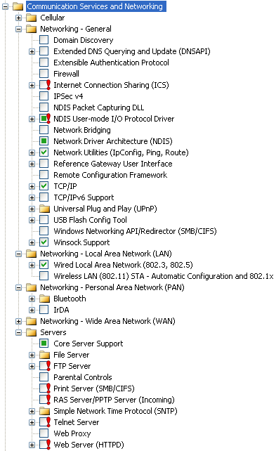

- Cellular: CellCore provides a basic set of wireless connection oriented services. This set of services includes the Radio Interface Layer (RIL), Short Message Service (SMS) support, Wireless Application Protocol (WAP) support, SIM card support. (X)

Networking - General
- Domain Discovery: enables a WinCE device to discover an active directory server to query. (X)
- Extended DNS Querying and Update (DNSAPI). (X)
- Extensible Authentication Protocol: The Extensible Authentication Protocol implementation allows third-party authentication code to interact with the implementation of the Point-to-Point Protocol (PPP) included in the Windows Embedded CE–based Remote Access Service (RAS). (X)
- Firewall: The IP firewall is typically used on an Internet gateway device, it helps protect the device. (X)
- Internet Connection Sharing (ICS): consists of a collection of technologies and services that make it possible to connect multiple computing and information devices on a network located in a home, a small business, or a corporate branch office to the Internet through a single Internet connection. (X)
- IPSec v4: enables two client devices on a network to establish peer-to-peer communication using the IP Security (IPSec) protocol. (X)
- NDIS Packet Capturing DLL: captures network traffic so that it can be read by the Microsoft Windows Network Monitor (NetMon). (X)
- NDIS User-mode I/O Protocol Driver: Protocol driver that sending and receiving Ethernet frames and OID query/set via stream device driver interface, ReadFile, WriteFile, DeviceIoControl. ActiveSync depents on it. (√)
- Network Bridging: connect multiple Ethernet network segments into a single subnet by forwarding frames from one segment to another. (X)
- Network Device Architecture (NDIS): many modules refer to this item, such as TCP/IP, ActiveSync. (√)
- Network Utilities: provide several tools that use to troubleshoot network connection. (√)
- Reference Gateway User Interface: This catalog item includes a set of .htm pages that can be used for a headless device. (X)
- Remote Configuration Network: provides the structure for creating Web-based user interfaces for headless device. (X)
- TCP/IP: Transmission Control Protocol and Internet Protocol, must be included in run-time image. (√)
- TCP/IPv6 support: IPv6 is the next generation of network layer protocols for the Internet. (X)
- Universal Plug and Play (UPnP): UPnP provides an architectural framework for creating self-configuring, self-describing devices and services. UPnP enables a device to dynamically join a network, obtain a IP address and convey its capabilities upon request. (X)
- USB Flash Config Tool: allows you to automate the configuration of wireless networks. (X)
- Windows networking API/Redirector: provides functions to establish and terminate network connections and to access remote file system on servers that supporting the Common Internet File System (CIFS). (X)
- WinSock support: WinSock for WinCE-based devices specifies a programming interface. (√)

Networking – Local Area Network (LAN)
- Wired Local Area Network (802.3, 802.5) : provides the access to Local Area Network, such as Ethernet(802.3), Token-Ring(802.5). (√)
- Wireless LAN(802.11) STA-Automatic Configuration: provides wireless access. (X)

Networking – Personal Area Network (PAN)
- Bluetooth: a wireless communication technology. (X)
- IrDA: Infrared Data Access. (X)

- Networking – Wide Area Network (WAN) (X)
26)Servers: provide various server functions such as FTP, FILE,Telnet and so on. (X)

Core OS Services
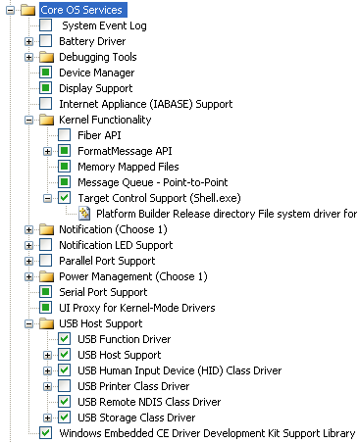

- System Event Log: This logging mechanism is intended to capture targeted events. (X)
- Battery Driver: add battery driver to image. (X)
- Debugging Tools: include Keyboard test application, remote display application. (X)
- Target Control Support (Shell.exe): Platform Builder Release directory file system driver for development use. (X)
- USB Host Support: (√)
- Windows Embedded CE Driver Development Kit Support Library. (√)

Device Management
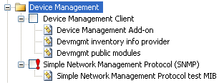

- Device Management Client: to enable target device configuration and customized management. (X)
- Simple Network Management Protocol (SNMP): Simple Network Management Protocol (SNMP) for WinCE is the Internet Standard protocol for network management and part of the TCP/IP protocol suite. (X)

File Systems and Data Store
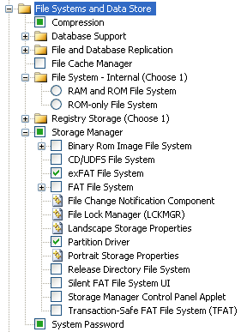

- Partition Driver: (√)
- exFAT File System: the exFAT File System encapsulates standard FAT and TFAT functionality. (√)

Fonts
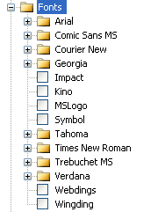

Graphics and Multimedia Technologies
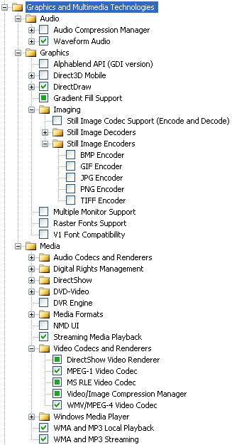

- Audio Compression Manager: The Audio Compression Manager (ACM) supports rum-time audio compression and decompression, manages Waveform Audio data.
- Waveform Audio: provides an application exact control over waveform audio input/output devices.
- AlphaBlend API (GDI version): The AlphaBlend function displays bitmaps that have transparent or semitransparent pixels. This item adds AlphaBlend functions to the Graphic Device Interface (GDI) and Graphic Primitive Engineer (GPE).
- Direct3D Mobile: an API that provides support for 3-D graphics application on WinCE platform.
- DirectDraw: DirectDraw API provides support for hardware-accelerated 2-D graphics.
- Imaging: provides support for BMP,GIF,JPG,PNG,TIFF image encoder and decoder.
- Multiple Monitor Support: provides support for connecting multiple screens to a WinCE-based device, can use these multiple screens as one large combined screen.
- Raster Fonts: support for raster fonts to image. A raster font is a font based on tiny bitmaps, each representing a single character and size.
- V1 Font Compatibility: provides font compatibility for applications written for versions of WinCE earlier than WinCE 2.0.
- Audio Codecs and Renderers: provides WMA, MP3, MPEG-1 audio codecs.
- Digital Rights Managements: used to protect audio and video content copyright on mobile and embedded devices.
- DirectShow: DirectShow is a middleware architecture that provides a pipeline for media playback and capture.
- DVD-Video: allow DVD playback by applications on WinCE devices.
- DVR Engineer: Digital Video Recorder Engineer provides the capability to create IP-STB.
- Media Format: includes AVI, MPEG-1 video format.
- NMD UI: Networked Media Device. A typical Networked Media Device is a hardware component in home theatre system.
- Streaming Media Playback: support for playing WMV or MPEG-4 file.
- Video Codecs and Renderers: provides MPEG-1, MPEG-4, WMV code and decode.
- Windows Media Player: a stand-alone Windows Media Player, Ceplayer.exe is added to image.
- WMA and MP3 Local playback: support for playing .wma and mp3 files from local storage.
- WMA and MP3 streaming: support for playing .wma and .mp3 files from streaming source.

International
Internationalization is made up of a collection of functionality that provides general locale services and locale-specific support for certain key capabilities, input method editor.

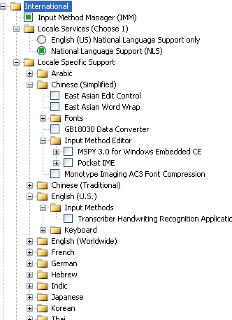

Internet Clients Services
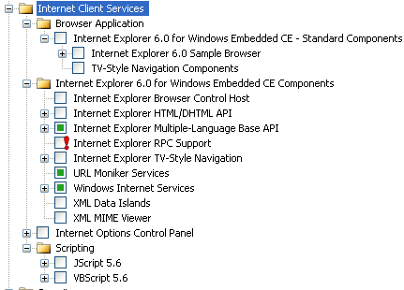

Internet Client Services provides support for browser applications, technologies that enable you to create custom browsers, and run-time engines for parsing and translating scripting languages.

Security
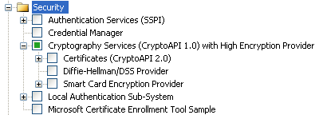

WinCE provid technologies to increase the security of WinCE devices or application.

Shell and User Interface
Shell: The shell provides the user with an interface to the objects necessary for running applications and managing the Windows Embedded CE operating system on a target device. These can be real objects on the target device, such as files and folders; virtual objects, such as the Recycle Bin; or remote objects accessed through a network.

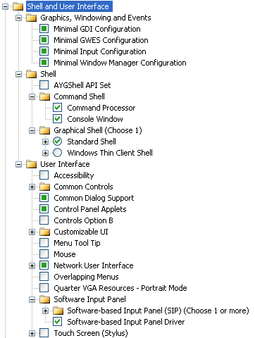

- Graphics, Windowing and Events: this module includes Win32 API, User Interface (UI) and Graphics Device Interface (GDI) libraries. (√)
- Command Processor. (√)
- Console Window. (√)
- Standard Shell. (√)
- Software-based Input Panel Driver. (√)

Voice over IP Phone Services
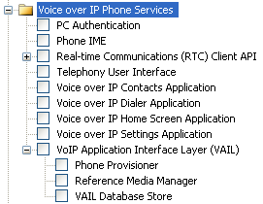

The Voice over Internet Protocol (VoIP) specifies the transmission and reception of audio over the Internet.

Windows Embedded CE Error Reporting
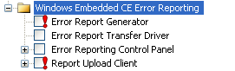

Windows CE Error Reporting is a set of technologies that captures key information about the state of the machine at the time of a program crash and allows users to report the collected information.

Appendix

