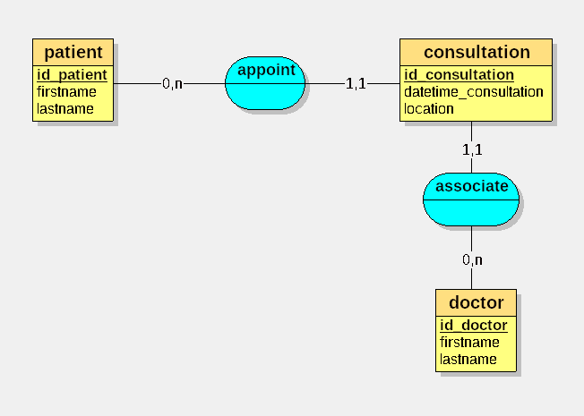

Modèle logique de données (MLD):

patient = (id_patient INT, firstname VARCHAR(50), lastname VARCHAR(50));
doctor = (id_doctor INT, firstname VARCHAR(50), lastname VARCHAR(50));
consultation = (id_consultation INT, datetime_consultation DATETIME, location VARCHAR(50), #id_doctor, #id_patient);

SQL:
CREATE TABLE patient(
id_patient INT,
firstname VARCHAR(50),
lastname VARCHAR(50),
PRIMARY KEY(id_patient)
);

CREATE TABLE doctor(
id_doctor INT,
firstname VARCHAR(50),
lastname VARCHAR(50),
PRIMARY KEY(id_doctor)
);

CREATE TABLE consultation(
id_consultation INT,
datetime_consultation DATETIME NOT NULL,
location VARCHAR(50),
id_doctor INT NOT NULL,
id_patient INT NOT NULL,
PRIMARY KEY(id_consultation),
FOREIGN KEY(id_doctor) REFERENCES doctor(id_doctor),
FOREIGN KEY(id_patient) REFERENCES patient(id_patient)
);

