

**ELECTRICAL AND ELECTRONIC ENGINEERING**

**ELECTRICAL DEPARTMENT**

**YEAR 3**

**LEVEL THREE**

**SEMESTER ONE**

**STREAM B**

**TOPIC: MINIPROJECT DISPLAYING WELCOME TO EEE DEPARTMENT USING LED AND LCD**

**Done by ;**

**Mujyanama jean d Amour**

**Umutoni jaquiline**

**I.ABSTRACT**

This project is designed and implementation of displaying welcome to EEE department using led and lcd. Making machine talk to human is quite easy using light indicators or other illumination devices. The most common way of providing information is through a visible light source. The ability to make alphanumeric (number and letter) with multiplexers seven -segment led displays allows long messages to be displayed easily. The lcd eliminates both heat can be packaged to create characters.

A liquid crystal display, or LCD, is a video display that utilizes the light modulating properties of liquid crystals to display pictures or text on a screen. Since their invention in 1964, LCD screens have grown to be used in a very wide variety of applications, including computer monitors, televisions, and instrument panels. One way to utilize an LCD is with an Arduino microcontroller. By wiring an Arduino microcontroller to the pins of an LCD display it is possible to program the microcontroller to display a desired text string or image on the screen.

**II.PROBLEM STATEMENT**

The main purpose of this project “displaying welcome to EEE to department using led and lcd”. The 16x2 LCD is most popular lcd in electronics projects. In upcoming project we need this display in our project.

The object of this application note is to demonstrate how an Arduino microcontroller

can be used to interface with an LCD screen

**III.BLOCK DIGRAM**

16*2 LCD

**Arduino Uno**

**potentiometer**

**IV. DESCRIPTION**

The block diagram contains three electronic component such as lcd, Arduino uno board, potentiometer, dc supply.

Lcd is a video display that utilizes the light modulating property of liquid crystal text on a screen. One way to utilize an LCD display is with an Arduino microcontroller. By wiring an Arduino microcontroller to the pin of an LCD it is possible to program the microcontroller to display a Desire text string on the screen. The Arduino Uno is an open-source microcontroller board based on the microchip ATmega328P microcontroller and developed by Arduino.cc. The board is equipped with sets of digital and analog input/output (I/O) pins that may be interfaced to various expansion boards and other circuits.

A potentiometer is a manually adjustable variable resistor with 3 terminals. Two of the terminals are connected to the opposite ends of a resistive element, and the third terminal connects to a sliding contact, called a wiper, moving over the resistive element.

**V. CIRCUIT**

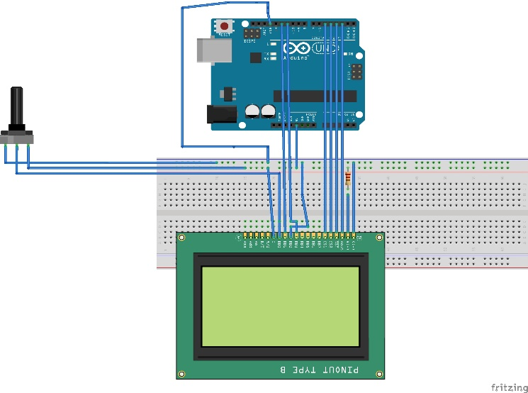

**VI. SIMULATION IN PROTEUS**

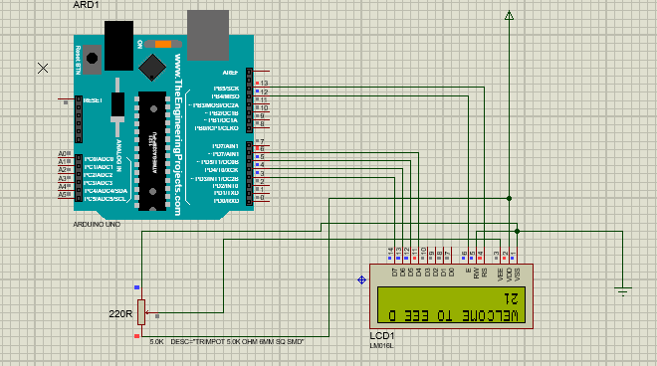

**VII. SOURCE CODE**

