**Section 2:**

This section covers relational algebra (50 points).

(A) Consider the following schema:

Suppliers (sid: *integer,* sname: *varchar(20)*, address: *varchar(50)*)

Parts (pid: *integer*, pname: *varchar(20)*, color: *varchar(15)*)

Catalog (sid: *integer*, pid: *integer*, cost: *real*)

* The key fields are underlined
* Domains of each field are listed after field name
* The Catalog relation lists prices charged for parts by Suppliers

Write the following queries in relational algebra (30 points):

1. Find the *names* of suppliers who supply some blue part

* πsname(π­­sid (­(πpidσcolor=’blue’ Parts) ⋈ Catalog) ⋈ Suppliers)

1. Find the *sids* of suppliers who supply some blue or red part

* ρ(tempParts, ­(πpidσcolor=’blue’ Parts) $∪$ (πpidσcolor=’red’ Parts))

πsid(πsid(tempParts ⋈ Catalog) ⋈ Suppliers)

1. Find the *sids* of suppliers who supply some blue part and some red part

* ρ(tempParts, ­(πpidσcolor=’blue’ Parts) $∩$ (πpidσcolor=’red’ Parts))

πsid(πsid(tempParts ⋈ Catalog) ⋈ Suppliers)

1. Find the *sids* of suppliers who supply every blue part

* π­­sid(­((πpidσcolor=’blue’ Parts) ⋈ Catalog) ⋈ Suppliers)

1. Find the pids of parts supplied by every supplier at less than $50. (If a supplier either does not supply the part or charges more than $50, the part is not selected.)

* πpid((πpidσcost < 50 Catalog) ⋈ Parts)

1. Find the *sids* of suppliers who do not supply a red part

* πsid((σcolor ≠ ‘red’ Parts) ⋈ Catalog ⋈ Suppliers)

(B) Consider the following schema:

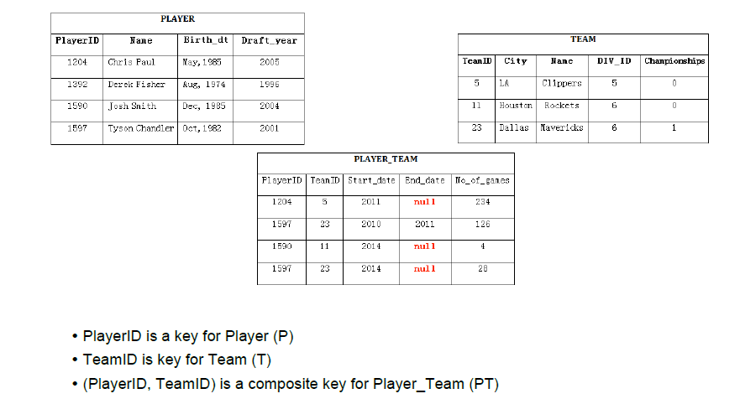

Show the results of the following Relational Algebra expressions (20 points):

1. π P.name, T.name (P⋈T⋈PT)

|  |  |
| --- | --- |
| P.name | T.name |
| Chris Paul | Clippers |
| Tyson Chandler | Maverick |
| John Smith | Rockets |

1. π P.name (P ⋈ PT ⋈ σ city="Dallas" or city="Houston" T)

|  |
| --- |
| P.name |
| John Smith |
| Tyson Chandler |

1. ρ (PP (1 → playerid1, 2 → draftyear1, 3 → playerid2, 4 → draftyear2), (π playerid, draft_year P) × (π playerid, draft_year P)) (π playerid P - π playerid1 σ draftyear1 < draftyear2 PP) ⋈ P

|  |  |  |  |
| --- | --- | --- | --- |
| playerid1 | draftyear1 | playerid2 | draftyear2 |
| 1392 | 1996 | 1204 | 2005 |
| 1590 | 2004 | 1204 | 2005 |
| 1597 | 2001 | 1204 | 2005 |

1. π P.name ((σ no_of_games > 100 PT) ⋈ T ⋈ P)

|  |
| --- |
| P.name |
| Chris Paul |
| Tyson Chandler |