DecodeLabs Project 3 - SQL Data Analysis Report

1. Project Title
DecodeLabs Project 3 - SQL Data Analysis
2. Objective
The objective of this project is to analyze a sales dataset using SQL queries and extract useful business insights. This project focuses on SQL fundamentals such as selecting data, filtering records, sorting data, grouping results, and performing aggregations.
3. Dataset Description
The dataset used in this project is `Product-Sales-Region.csv`.
The dataset contains sales transaction details including:
* Date
* Region
* Product
* Quantity
* Unit Price
* Store Location
* Customer Type
* Discount
* Salesperson
* Total Price
* Payment Method
* Promotion
4. Tools Used
* Microsoft SQL Server Management Studio 19
* SQL Server Express
* SQL
* CSV Dataset
* GitHub
5. Database Details

Database Name: `DecodeLabs_Project3_SQLAnalysis`
Table Name: `sales_data`

6. SQL Concepts Used
The following SQL concepts were used in this project:
* SELECT
* WHERE
* ORDER BY
* GROUP BY
* COUNT
* SUM
* AVG
* MIN
* MAX
* TOP
* YEAR
* MONTH
7. SQL Analysis Summary
Query 1: View First 10 Records
This query was used to check whether the CSV dataset was imported correctly into SQL Server.
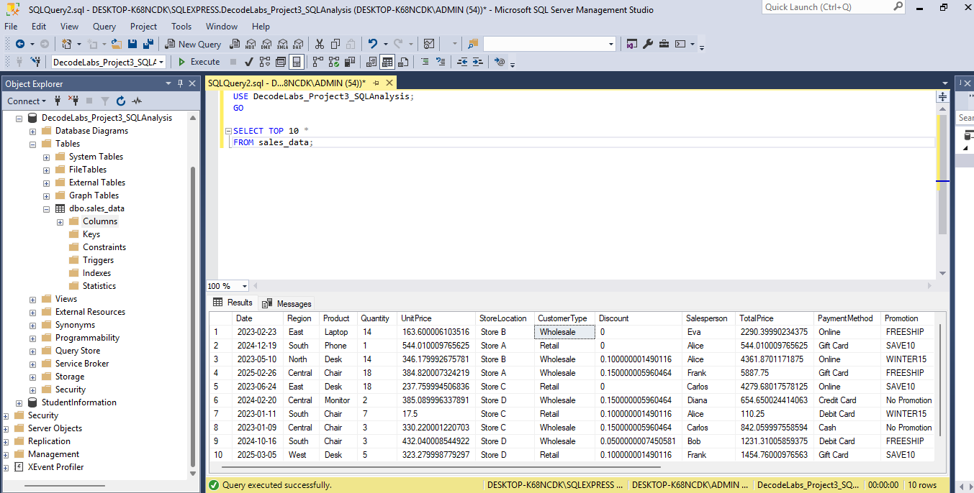
Query 2: Count Total Records
This query was used to find the total number of records available in the dataset.
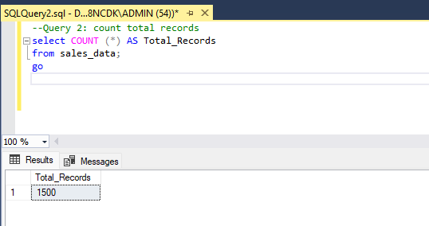
Query 3: Total Sales by Region
This query calculated total sales for each region using `SUM()` and `GROUP BY`. It helped identify which region generated the highest sales.
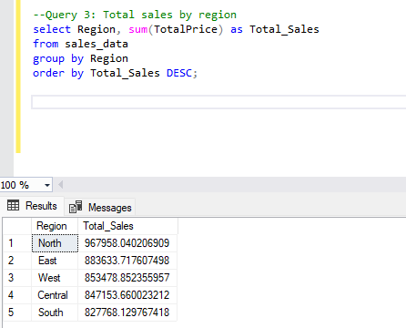
Query 4: Filter Sales Records from East Region
This query used the `WHERE` clause to filter sales records only from the East region.
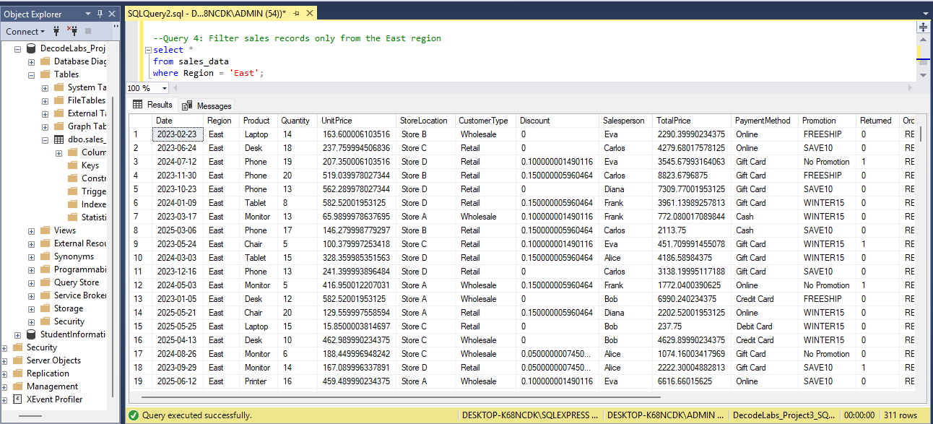
Query 5: High-Value Sales
This query identified orders where the total price was greater than 1000. It helped find high-value transactions.
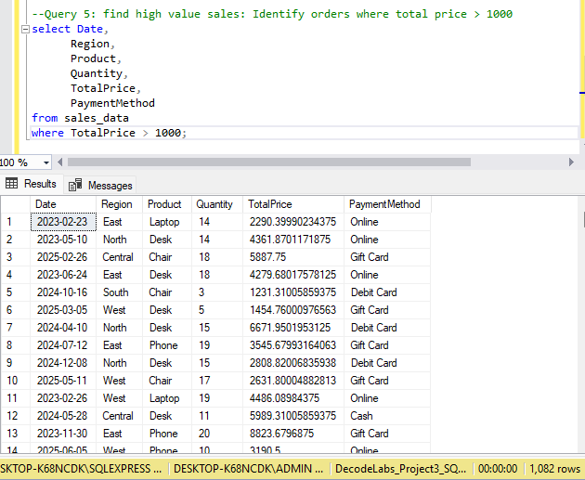
Query 6: Sort Sales from Highest to Lowest
This query sorted sales records in descending order based on total price using `ORDER BY`.
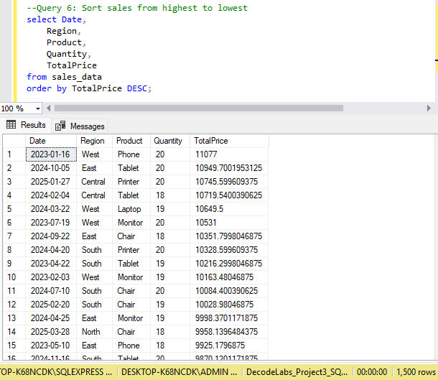
Query 7: Top 10 Highest Sales Transactions
This query displayed the top 10 highest sales transactions using `TOP 10` and `ORDER BY`.
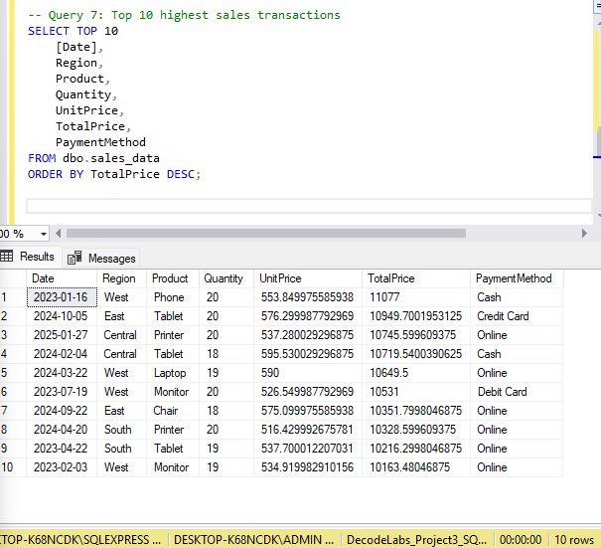

Query 8: Total Sales by Product
This query calculated total sales for each product. It helped identify the best performing products based on sales value.
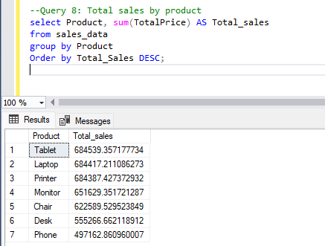
Query 9: Average Sales by Customer Type
This query calculated the average sales value for each customer type using `AVG()` and `GROUP BY`.

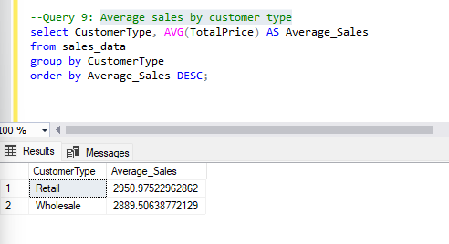

Query 10: Sales by Promotion Type
This query analyzed order count, total sales, and average sales for each promotion type.
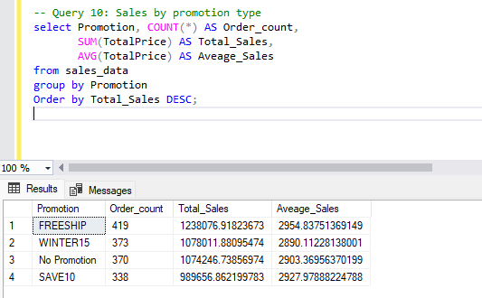

Query 11: Region and Product Wise Sales
This query analyzed product performance within each region using multiple columns in the `GROUP BY` clause.
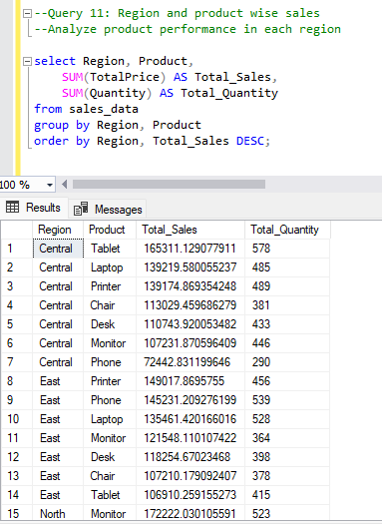
Query 12: Monthly Sales Analysis
This query analyzed sales by year and month using `YEAR()` and `MONTH()` functions.
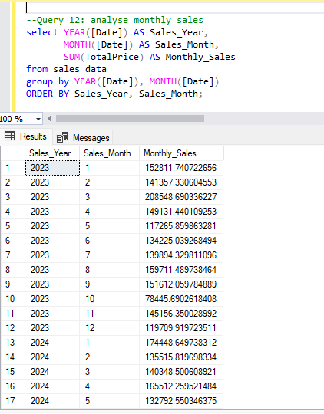
Query 13: Overall Sales Performance Summary
This query provided an overall summary of the dataset, including total orders, total sales, average sales, minimum sale, and maximum sale.
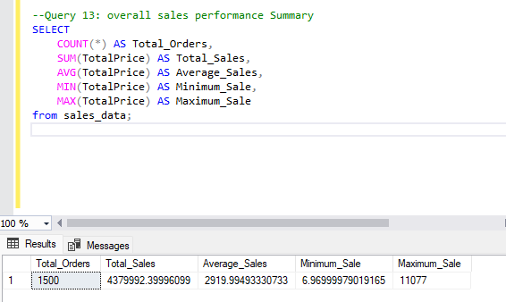

8. Key Insights

* Total sales by region helped identify the region with the highest sales.
* Product wise sales analysis helped identify the best performing products.
* High-value sales filtering helped find large sales transactions.
* Average sales by customer type helped compare customer groups.
* Promotion wise analysis helped understand the effect of promotions on sales.
* Monthly sales analysis helped observe sales trends over time.
* Overall sales summary provided a quick understanding of total sales performance.

9. Conclusion

This project helped me improve my SQL data analysis skills using a real world sales dataset. I practiced writing SQL queries to select, filter, sort, group, and aggregate data. Through this analysis, I was able to extract meaningful insights such as total sales by region, product performance, customer type behavior, promotion wise sales, monthly trends, and overall sales performance.

