GUI Testing

Test One

“Username” – Text box should allow entry of any data.

Steps:

1. Navigate to Login GUI
2. Enter any character or special character.

Expected result: User should be able to enter any character or special character.

Actual result: User is able to enter any character or special character.

Test Two

“Password” – Text box should allow entry of any data without characters being visible (\*\*\*\*\*\*)

Steps:

1. Navigate to Login GUI
2. Enter any character or special character.

Expected result: User should be able to enter any character or special character. Characters are not visible to be read (\*\*\*\*\*)

Actual result: User is able to enter any character or special character and entry is not able to be read.

Test Three

“Domain” – Drop down menu should allow selection from the options, Staff, Admin and Guest

Steps:

1. Navigate to Login GUI
2. Navigate to “Domain” drop down menu.
3. Select option.

Expected result: The user should be presented with all available options. The chosen option should remain selected.

Actual result: The user is presented with all available options. The chosen option remains selected.

Test Four

“Do you agree to LSEPI” check box – Check box should initialise unselected until checked by the user.

Steps:

1. Navigate to Login GUI
2. Click check box.

Expected result: The checkbox initialises as blank and remains so until manipulated by the user.

Actual result: The checkbox is initialised but is not blank. Clicking the check box changes the check icon.

Comments: At initialisation, having the check box already marked may confuse the user.

Test Five

“View LSEPI document” – Hyperlink should be displayed correctly as a hyperlink and directs user to LSEPI document page found on URL –

<https://github.com/Dan-17736382/HR-System/blob/main/Team1/lsepi.pdf>

Steps:

1. Navigate to Login GUI
2. Click “View LSEPI document”
3. View in browser.

Expected result: Hyperlink should be displayed in blue indicating itself and should also direct the user to the above stated URL.

Actual result: Hyperlink is displayed in blue indicating itself and directs the user to the above stated URL.

Test six

“Submit” – button should be available to click.

Precondition – Execute Test one, two and three with valid data.

Steps:

1. Navigate to Login GUI
2. Click “Login” Button.

Expected result: Button should be clickable once all required information has been entered.

Actual result: Button is clickable.

Appendix:

Test one:

Displaying “Username” text box accepting any character.

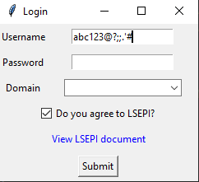

Test two:

Displaying obfuscated data in the “Password” text box

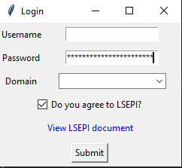

Test three

Option selection from the “Domain” drop down menu.

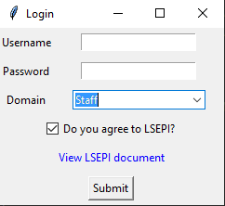

Test four

The following image shows the “do you agree to LSEPI” check box at initialisation.

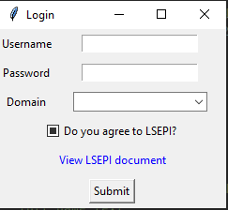

The following image shows the “do you agree to LSEPI” check box after being clicked by the user.

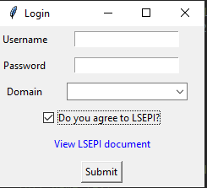

The following image shows the “do you agree to LSEPI” check box after being clicked by the user a second time.

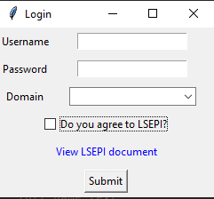

Test Five:

Following the “View LSEPI document” Hyperlink

