Team Members:

Daniel Rozhanskiy

Dillon Jackson

Color Balance and Fusion for Underwater Image Enhancement

Topic of Interest: Object Detection

Problem Being Solved
Underwater images can make object detection difficult, especially at deeper depths of water due to light degradation. We will take a curated approach to this problem, by taking into account the fact the shorter wavelengths on the color spectrum (i.e. red) degrade first, followed by orange, yellow, etc.

Previous Work we’ve found
Link to paper: https://ieeexplore.ieee.org/document/8058463. The paper was published to IEEE in 2018 by Codruta O. Ancuti , Cosmin Ancuti, Christophe De Vleeschouwer , and Philippe Bekaert. The paper has 731 citations, especially by people using this as a preprocessing technique for Convolutional Neural Network training.

Algorithms/Methods we’ll be using
Their work basically applies white balancing Gray World color balancing with a few assumptions added on specific to the underwater medium. This helps us recover color information from hazy images. This is followed by deriving a gamma correction version and sharpened version of the white balanced image, then applying multiscale fusion to get the final result.

Data
Inputs will be sample images from the paper

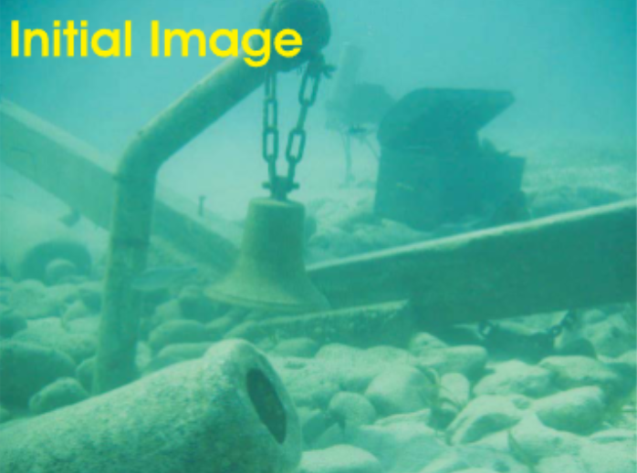
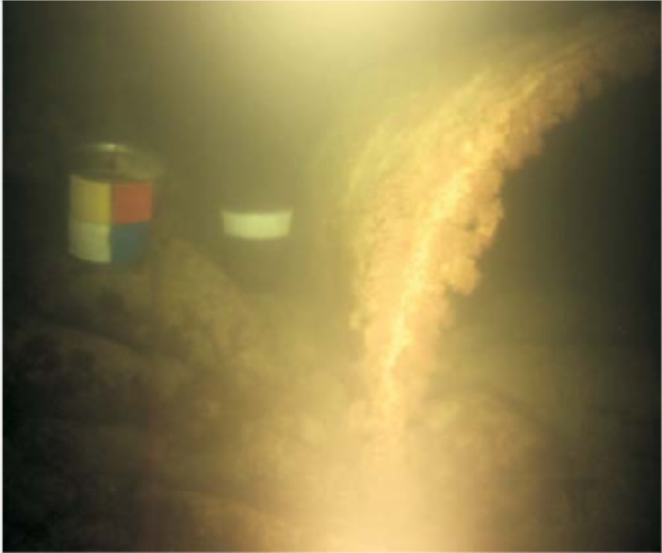

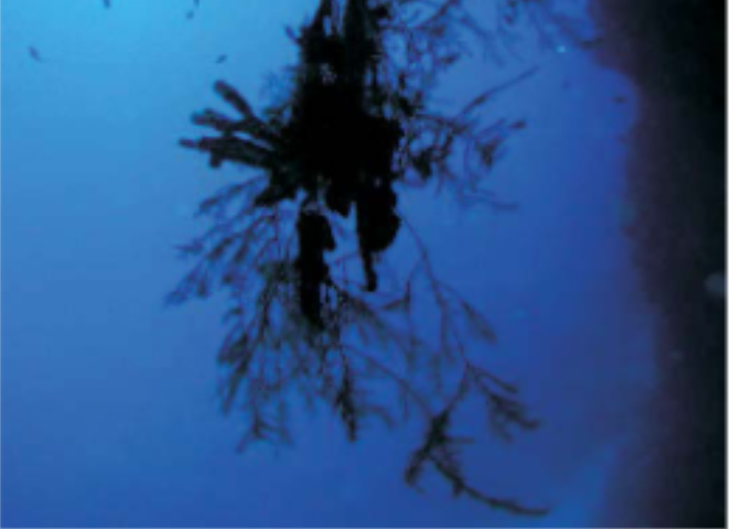
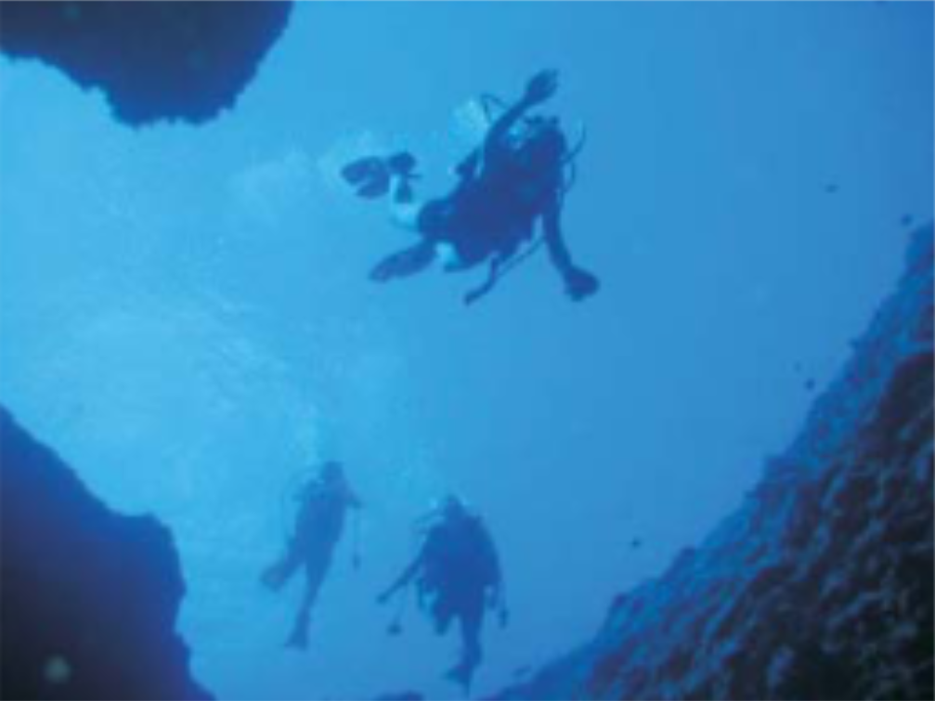

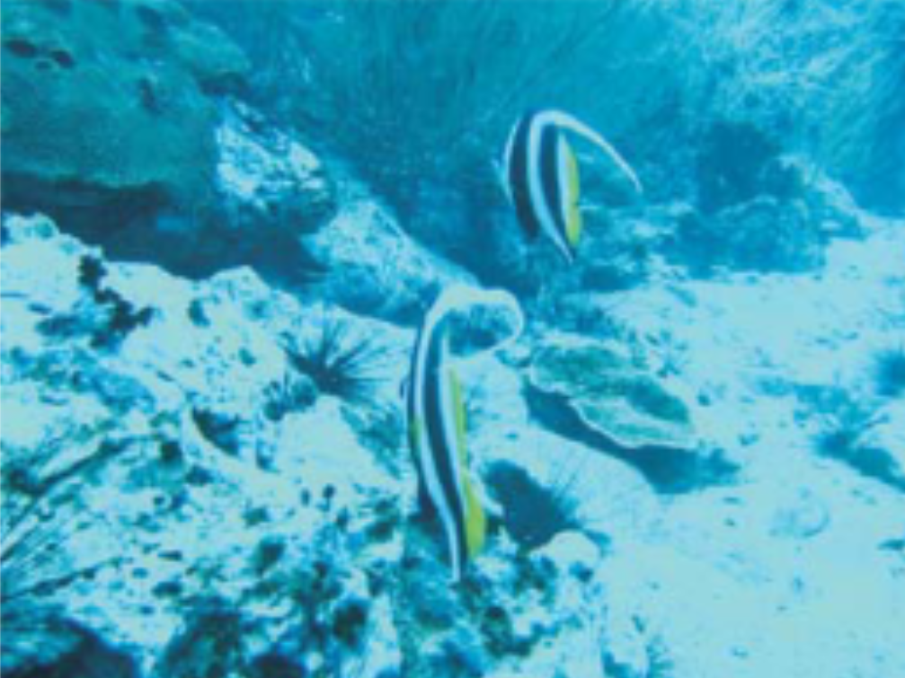
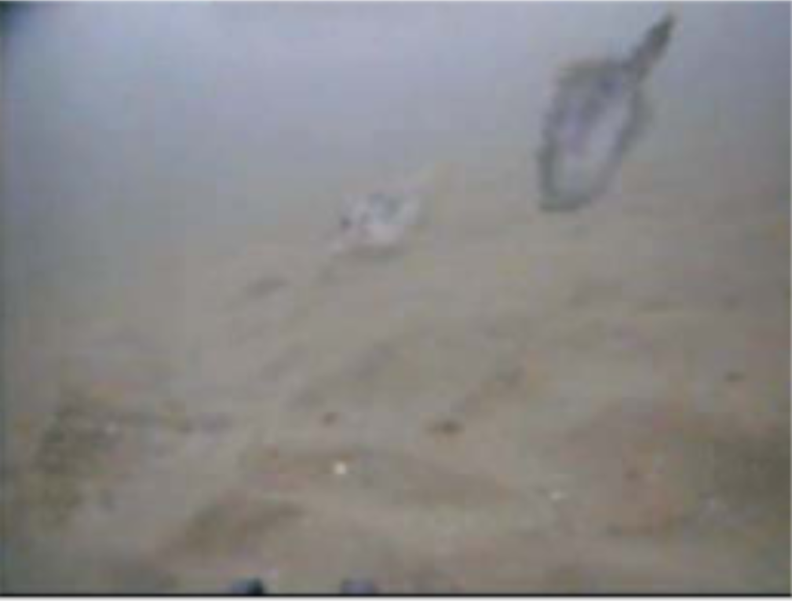

as well as images we find from the internet which are labeled for their depth underwater. The output images will be the color corrected images, as well as a binary mask which represents the output of the object detection algorithm applied to the color corrected image.

How we plan to test our methods
We will test our methods by applying an object detection algorithm to each of the input methods without the color correction, and after color correction, and comparing accuracy of both cases.

