

SCHOOL OF TECHNOLOGY

BEACHELOR OF SCIENCE IN SOFTWARE DEVELOPMENT

UNIT CODE: BSD 3106

ADMISSION: 21/04706

NAME: DUNCAN MUNENE MURIUKI

NAME OF THE SUPERVISOR: WINNIE OKONG’O

PROJECT TITLE: RESOURCE SCHEDULING AND OPTIMIZATION WEB APP

SYSTEM DESIGN SPECIFICATION

Contents

CHAPTER 1 2

1.0 Introduction 2

1.2 Project Objectives 2

1.3 System Scope 3

1.3.1 Main Inputs: 3

1.3.2 Outputs: 3

1.4 Design Considerations & Constraints 4

1.5 Architectural Design: 5

CHAPTER 2: SYSTEM DESIGN 7

2.0 CONTEXT DIAGRAM 7

2.1 LOGICAL DESIGN 7

2.1.0 Login Flowchart 7

2.1.0.1 Admin Login Flow 7

2.1.0.2 Project Manager Login Flow 8

2.1.0.3 Resource Scheduling Flowchart 9

2.2 DATABASE MODELING 10

2.2.0 Data Normalization 10

2.2.1 Entity-Relation Diagram 12

2.2.3 DATA DICTIONARIES 13

2.3 USER INTERFACE DESIGN 13

2.3.1 Project Manager Login 13

2.3.2 Project Manager Registration 14

2.3.3 Project Management Dashboard 15

CHAPTER 3 15

3.0 Interface Design Rules 15

CHAPTER 4 17

4.0 Physical Design 17

4.0.1 Architecture 17

4.0.1.1 The Database Layer 17

4.0.1.2 The Application Layer 17

4.0.1.3 The Client Layer 18

CHAPTER 5 18

5.0 DATA FLOW DIAGRAMS 18

5.0.1 LEVEL 0 19

5.0.2 LEVEL 1 19

5.0.3 LEVEL 2 20

CHAPTER 6 20

6.0 Expected Software Response 20

6.0.1 User Registration: 20

6. 0.2 Login: 20

6.0.3 Project Search and Resource Allocation: 21

6.0.4 Resource Allocation Request: 21

6.0.5 Payment Processing: 21

6.0.6 Allocation Confirmation: 21

6.0.7 Modification and Cancellation of Allocation: 22

6.0.8 Allocation and Payment History: 22

6.1 Performance Bounds 22

CHAPTER 7 23

7.1 The identification of Critical Components 23

7.0.1 User Interface (UI): 23

7.0.2 Search and Scheduling Engine: 23

7.0.3 Payment Gateway Integration: 23

7.0.4 Database and Data Management: 23

7.0.5 Authentication and Authorization: 23

7.0.6 Notification and Communication: 23

7.0.7 Performance and Scalability: 23

7.0.8 Security Measures: 24

7.0.9 Integration with External Systems: 24

7.0.10 Error Handling and Logging: 24

References 24

# CHAPTER 1

## 1.0 Introduction

This paper presents the specifications of the FastPro Resource Scheduling and Optimization Web Application and acts as the blue print in the development of the system and its processes. The purpose of this document is both to describe how the system is built and how the different components of the system work together and how resources are depicted in order to facilitate scheduling and optimization. Here is a system designed to give the project managers and the organizations an efficient structure to budget resources, time, and measures the overall achievements on the projects.

It is a young company which is based in 2022, and its specialization presents project management services for resources and their scheduling as for the requirements of various industries. As the requirements of projects continue to advance, it has become more important to have an order way of controlling these resources. This is why the FastPro Resource Scheduling and Optimization Web Application was developed to meet this need as is affirmation to help in the scheduling and optimization of a resources as well as keep track of project and conduct analysis as well.

The login application of this web application incorporates a complex resource management facility, by which users can monitor the resource status, allocate work, and analyze timelines for a project. One of the most important features of the application is that it is very easy to use due to an integrate user interface where users can record and track the project associated details such as team allocation, time line and costs of resources. Accurate data on the consumption of resources enables the managers to get vital information, enhance project control and productivity.

The application targets project managers, team members, and administrators, where each of them will be bestowed with unique features to improve the project process. Thus, being an organization that implements digital solutions FastPro is ready to contribute to better management of resources within organizations and meeting schedule-related challenges, as well as enhancing the results of projects.

## 1.2 Project Objectives

In light of this, the primary goal of this project is to design a digital platform that supports all Resource Scheduling and Optimization functions at FastPro. The specific objectives are as follows:

1. In order to assess resource scheduling needs for obtaining precise data for improvement of the scheduling.
2. The goals were set to optimize the identified resources and design the convenient web application.
3. To assess the applicability of the proposed solution in satisfied various scheduling and optimization requirements.

## 1.3 System Scope

The Resource Scheduling and Optimization Web Application is designed to transform manual operations of FastPro l to automatic in the management of resources in an effort to increase proper resources distribution, minimize conflicts in scheduling and advancing the business.

Key functions of the system include:

1. Design of a system that will enable efficient management of timelines for different projects, assigning of resources to undertake those projects, and tracking of the performance of those resources.
2. Installation of the application on a secure servers for organizational users.
3. New systematic implementation training for the users on how to use the new system.
4. Incorporation of a post implementation administrator to take care of the system.

## 1.3.1 Main Inputs:

**Project Information**

1. Project Name
2. Project Start and End Dates
3. Assigned Resources

**Resource Information**

1. Title of the resource/s such as human resource, material, mechanical etc.
2. Availability and work schedule liven consistent
3. the experience.
4. Cost per Resource

**Scheduling and Optimization Requests**

1. Project Deadlines
2. Employee’s Resource Allocation Preferences
3. Constraint (s) affecting this optimization include, time or budget.

**Banking, Financial and Performance information**

1. Resource Utilization Rates
2. Project Progress Metrics
3. Cost tracking and the update of the prices 6 Relevant and Appropriate Cost Information

## 1.3.2 Outputs:

**Project Management**

1. Add or Update Project Details
2. Check project schedules and resources Engagement and Allocation
3. Need to Set Targets and Anticipated Project Completion Dates

**Resource Management**

1. Add resources/ Update when they are available
2. Co-ordinate Resource Assignments among Projects
3. Maintain Resource Consumption and Expense

**Scheduling Optimization**

1. Maximize Resource Use on Current Projects
2. Sufficiently Developed Suggested Schedules Based on Constraints
3. Track Optimization Metrics

**Performance and Analytics**

1. Produce Resource Utilization and Cost Reports
2. Check Insights on Project Delivery
3. Go to the scheduling pattern analysis and other related reports on resource constraints.

## 1.4 Design Considerations & Constraints

Design and implementation of FastPro Resource Scheduling and Optimization Web Application involves several key considerations to ensure a high level of functionality, performance, and usability:

* User Experience (UX) Design: The system will be user friendly and its design will include interfaces for adding up projects and scheduling or even monitoring performance of resources. The UX should also allow for multiple devices as well as accommodating to people with particular disabilities.
* Real-Time Data Synchronization: Real-time availability of the resources and on-demand scheduling adjustments is an appropriate feature to have. It should be able to share accurate information on resources and the project timelines and properly coordinate simultaneous updates to the information.
* Security and Data Privacy: Since resource and financial data are so important, proper protection is required. Security patterns for the protected data should be implemented as well as the protection of the information through encryption, secure login and authentication procedures.
* Scalability and Performance: Since the system will have to deal with multiple projects and resources at any one time, issues to do with load balancing, database tuning, and caching should be solved to ensure that the system stays efficient even when under huge usage.
* Data Analytics and Reporting: Analytics tools should enable the administrators to produce trends, adequacy of resource, and efficient scheduling based on existing information. Figures to be reported should range from use of resources, performance of projects and measures of optimality.
* Maintainability and Modularity: The system should be easily maintainable, upgradable as well as should be provided with easy modularity to incorporate new features. Proper documentation and basic modular design prove simple to perform future enhancements, bug corrections and changing the system progressing.

## 1.5 Architectural Design:

Architectural design entails definitions of components and the interrelationships that exist between them. It also shows the design components involved, major subsystems within the application and the interactions illustrated below:

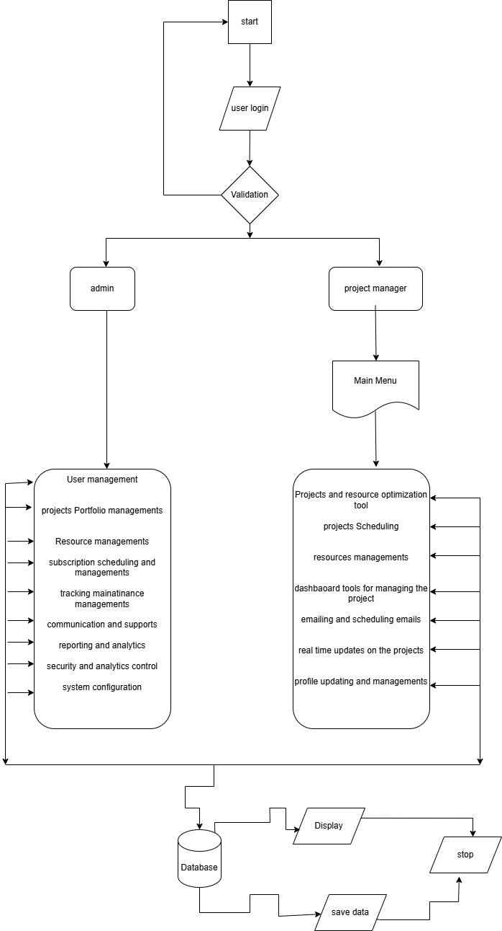

# CHAPTER 2: SYSTEM DESIGN

## 2.0 CONTEXT DIAGRAM

The context diagram indicates all the users, other systems and environment of the FastPro Resource Scheduling and Optimization Web Application. Although this high-level view concentrates on the input, process, and output inside the system.

In the FastPro application, project managers have access to account logins for the creation, and management of projects/ resources and the ability to analyze the project schedule. They can upload data, look at the distribution of the resources and also keep track of the progress of the projects. The system offers recommendations regarding the optimization of the system, graphical representations of resource timelines, and analytical reports. Users can access only those parts of the system that are available to them under their account type, which is controlled by administrators, who also define system settings, user roles as well as permissions. Resource managers, in contrast, manage discrete resources, such as resource assignment and resource workload, with change permission.

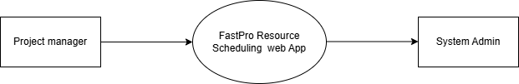

## 2.1 LOGICAL DESIGN

### 2.1.0 Login Flowchart

The login flowchart depicts the user authentication process, where each user type has specific login steps and access rights.

### 2.1.0.1 **Admin Login Flow**

The Admin flowchart outlines the steps an administrator follows to access system controls, including managing users, overseeing project data, and configuring system settings.

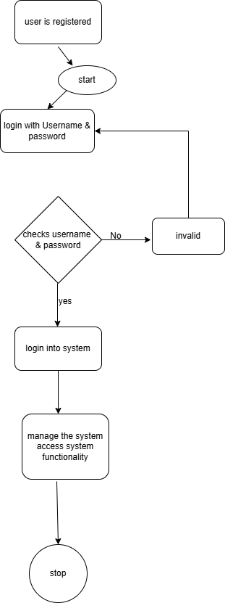

### 2.1.0.2 **Project Manager Login Flow**

The Project Manager login flow shows the steps required to access the project dashboard, manage resource assignments, upload project data, and view optimized schedules.

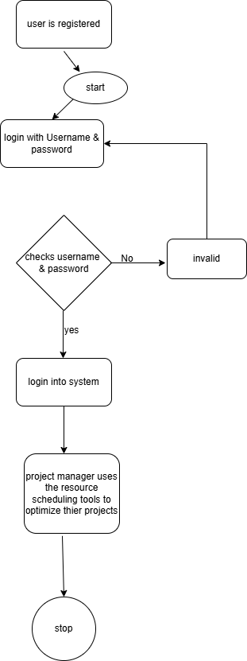

### 2.1.0.3 **Resource Scheduling Flowchart**

This flowchart details the process a project manager follows to upload data, run optimization, and download or view resource scheduling results and recommendations.

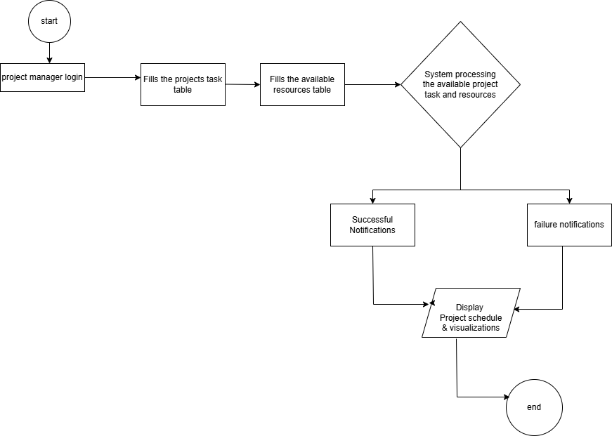

## 2.2 DATABASE MODELING

The FastPro database model defines the extent of the database and elements involved including the main entities, attributes and relations. This means that this model provides efficiency in the manner in which data is stored and accessed in order to support or determine the performance. Data modeling techniques employed include:

* Data Normalization
* Data Dictionary

### 2.2.0 Data Normalization

A data normalization is a systematic way of arranging the database in order to eliminate the data duplication and enhance data credibility. To eliminate case of insertion, update and deletion anomalies, each of the tables follows fundamental norm of normalization.

Key Terms:

UNF: Unnormalized Format

NF: Normalized Format

PK: Primary Key

FK: Foreign Key

Database structure that will be achieved from UNF to 3NF

|  |  |  |  |
| --- | --- | --- | --- |
| UNF | 1 NF | 2 NF | 3 NF |
| ProjectID | Project owner | Prect task | Location | StartDate | EndDate | ProjectAmount | TeamName | MemberName | Member email | MemberSkills | MemberEmail  ResourceID | ResourceName | ResourceLocation | ResourceCost |  AdminID | AdminName | AdminContact |  PaymentID | TenantID | LandlordID | PaymentDate | Amount |  PaymentTypeID | TypeName | | **ProjectManagement**  Project owner | Prect task | Location | StartDate | EndDate | ProjectAmount | TeamName | MemberName | Member email  **Team Member**  TeamName | MemberName | Member email | MemberSkills | MemberEmail | ProjectID |  **Resources**  ResourceName | ResourceLocation | ResourceCost | | ProjectID |  **Admin**  AdminName | AdminContact |  **Payments**  ProjectID | ResourceID | PaymentDate | Amount |  **PaymentTypes**  TypeName | | **ProjectManagement**  ProjectID | Project owner | Prect task | Location | StartDate | EndDate | ProjectAmount | TeamName | MemberName | Member email | MemberSkills | MemberEmail  **Tenants**  | TeamID | TeamName | MemberName | Member email | MemberSkills | MemberEmail ProjectCost | ProjectID |  **Resources**  | ResourceID | ResourceName | ResourceLocation | ResourceCost |ProjectID |  **Admin**  | AdminID | AdminName | AdminContact |  **Payments**  | PaymentID | TenantID | LandlordID | PaymentDate | Amount | | **ProjectlManagement**  ProjectID (PK) | Project owner | Prect task | Location | StartDate | EndDate | ProjectAmount | TeamName | MemberName | Member email | MemberSkills | MemberEmail  **Tenants**  | TeamID (PK) | TeamName | MemberName | Member email | MemberSkills | MemberEmail ProjectCost | ProjectID(FK) |  **Landlords**  ResourceID (PK) | ResourceName | ResourceLocation | ResourceCost | |ProjectID (FK)|  **Admin**  | AdminID (PK) | AdminName | AdminContact |  **Payments**  | PaymentID (PK) | TenantID | LandlordID | PaymentDate | Amount | |

### 2.2.1 Entity-Relation Diagram

ERD shows how the entities identified in this section are mapped into tables of the database for the Courier Management system software

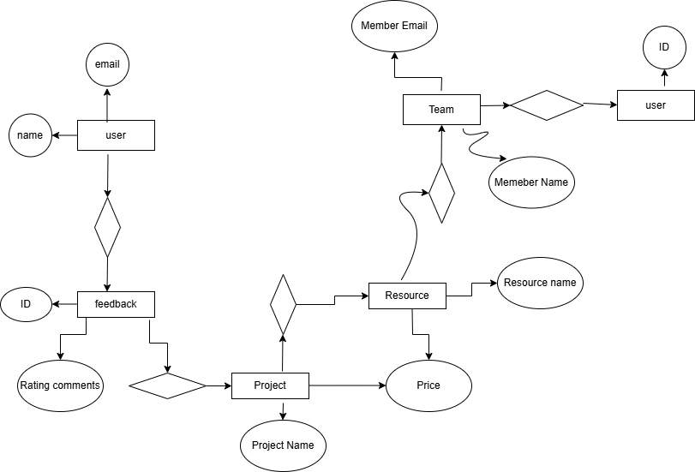

2.2.2 DATABASE SCHEMA

Derived from the ERD, the database schema details the fields, data types, and constraints for each table.

Example:

Projects Table

* ProjectID: INT, Primary Key, NOT NULL
* ProjectName: VARCHAR(50), NOT NULL
* StartDate: DATE, NOT NULL
* EndDate: DATE, NOT NULL
* ManagerID: INT, Foreign Key, NOT NULL
* Budget: FLOAT, NOT NULL

### 2.2.3 DATA DICTIONARIES

**Projects Table**

|  |  |  |  |
| --- | --- | --- | --- |
| COLUMN | TYPE | NULL | SIZE |
| ProjectID | INT | NO | 11 |
| ProjectName | VARCHAR | NO | 50 |
| StartDate | DATE | NO |  |
| EndDate | DATE | NO |  |
| ManagerID | INT | NO | 11 |
| Budget | FLOAT | NO | 20 |

**Resources Table**

|  |  |  |  |
| --- | --- | --- | --- |
| COLUMN | TYPE | NULL | SIZE |
| ResourceID | INT | NO | 11 |
| ResourceName | VARCHAR | NO | 50 |
| Skillset | VARCHAR | YES | 30 |
| Availability | BOOLEAN | NO |  |
| CostPerHour | FLOAT | NO | 20 |

## 2.3 USER INTERFACE DESIGN

The user interface (UI) for FastPro aims to provide an intuitive experience for project managers, resource managers, and administrators.

### 2.3.1 Project Manager Login

Displays a login form for project managers with fields for username and password. Upon successful login, the user is directed to the project dashboard.

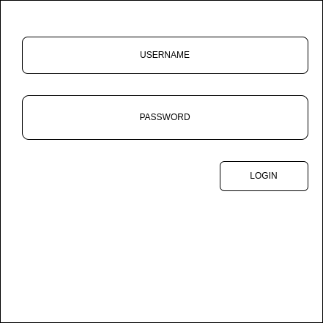

### 2.3.2 Project Manager Registration

A registration form allowing project managers to sign up for the system by providing personal and contact information.

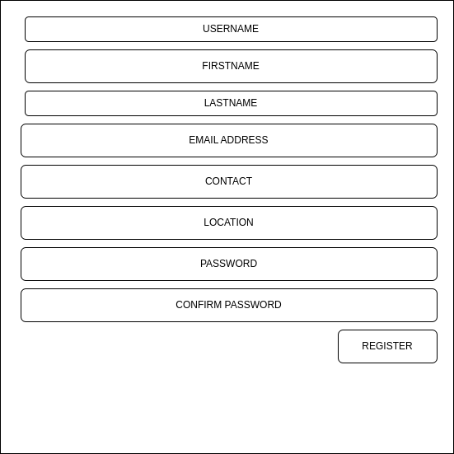

### 2.3.3 Project Management Dashboard

The dashboard includes sections for project creation, resource assignment, and optimization results. It also provides insights and visualizations for ongoing projects and resource utilization.

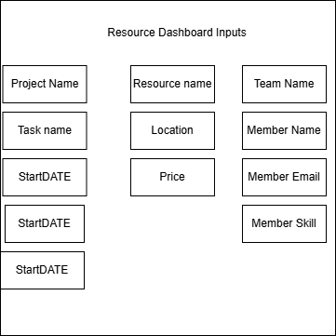

# CHAPTER 3

## 3.0 Interface Design Rules

The following design rules to interface of any software application like FastPro Resource Scheduling and Optimization Web App should be followed in order to develop an application that has an effective, easy to use and pleasant look. Here are some interface design rules to consider:

Keep it Simple and Intuitive:

1. The first rule of design is simplicity: design for simplicity, not for complexity and do not overload.
2. All the icons used and labels or terms covering the different interfaces should be easily understandable to the users.
3. It provides the structure to arrange information logically and intuitionally in a manner of consistent user interactions.

Consistency and Standards:

1. Maintain the coherence of the interface within the app: recreate the elements, which work in a similar way, on different screens.
2. Stay consistent with other tools in terms of layout and layout structures so people feel comfortable using a tool.

Clear Hierarchy and Visual Hierarchy:

1. Organize the displayed information with references to grouping that shows the difference between levels of primary, secondary, and tertiary importance of the elements.
2. Employ spatial properties, including size and color contrast with other elements that are irrelevant so as to control the user’s sight, as well as typographical formatting.

Responsive and Adaptive Design:

1. Lay out for the general compatibility with different screen sizes and resolutions so you can design for a desktop, tablet or mobile.
2. Large items should first be developed for the base scale to fit comfortably in a small window and perform the primary tasks effectively.

User-Friendly Navigation:

1. In this case, the Web-based applications should make use of the graphic interface having effective navigation methods like menus, or bread crumbs and/or even search tools.
2. Use active icons or other graphics to show the user where they are in the app either at the bottom of the page or in the toolbar.

Feedback and Validation:

1. Provide users with feedback each time they complete an action like clicking a button, or submitting a form.
2. Check the user inputs in the real time, and display proper message or prompt in case user made any mistake or left some required field blank.

Readability and Legibility:

1. Choose font type, font size, and color which makes the text as clear as possible.
2. Proper line spacing, paragraph division, as well as using a hierarchy help sorting texts for easy reading and scanning, more extended texts in particular.

Visual Aesthetics:

1. Design delightful user interfaces on screen using good contrast of color schemes, good font styles and appropriate graphics or icon sets.
2. Subtlety, do not overemphasize on visual design since this will detract the user or even make the site less user friendly.

Accessibility Considerations:

1. Implementation for accessibility, that will allow the users with reduced capabilities to operate the application.
2. It makes use of such elements as the actual text description for images, provision of tab access, and compliance with accessibility standards.

User Testing and Iteration:

1. User testing and feedback should be conducted in the course of designing to check choices and find drawbacks.
2. Revise the design when people have provided their comments or observations, to make it prevent usability problems.

# CHAPTER 4

## 4.0 Physical Design

### 4.0.1 Architecture

The proposed system has a multi-tier web based architecture where every tier implemented is a tier up from the lower tiers. This approach isolates the user interface, the application logics, the data storage mechanism and the data access one on different, well-defined layers enhancing thus maintainability, scalability and performance.

### 4.0.1.1 The Database Layer

The database of the FastPro Resource Scheduling and Optimization Web App is implemented using MySQLi on a MariaDB server. This layer offers reliable communications, reliable connections, and manageability facets, if graphical user interface apps are used. The system can support either the customer or predefined stored procedures, meaning data operations can be more adaptable.

### 4.0.1.2 The Application Layer

Ui is in application layer and business rules and data-access components are also in the same layer. It leverages a combination of technologies, including:

* HTML, CSS, and JavaScript: For defining the structural and stylistic options of the app’s interface as well as its behavior.
* Dynamic HTML (DHTML): Combines HTML, JavaScript, and CSS to the Document Object Model (DOM) to design interactivity and animation in illuminating web-bases modifications.
* DJANGO: Utilized for dynamic server side programming to create and show interactive web pages. The new features implemented in DJANGO are improvements in compatibility with other languages used in the same project in terms of resources usage efficiency scheduling.
* SQLite: Together allows for the creation and administration of databases to include processes and substrates of the web application, user data storage management among others.

### 4.0.1.3 The Client Layer

For this web app, the users do not require any additional software or hardware just an internet connected device such as a PC, a tablet, or a smart phone. It works best on Windows 10, 11 or 7, Mac OS, or Linux Ubuntu. Users have an option of browsers such as google chrome, firefox, or safari to enable them access the system. Since it is an internet based application, most computing takes place on a server; therefore, it is platform independent for the clients providing compatibility with Linux, UNIX and Mac Operating Systems for the client devices.

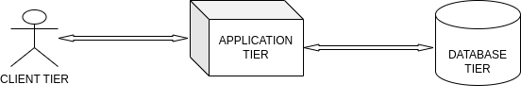

# CHAPTER 5

## 5.0 DATA FLOW DIAGRAMS

### 5.0.1 LEVEL 0

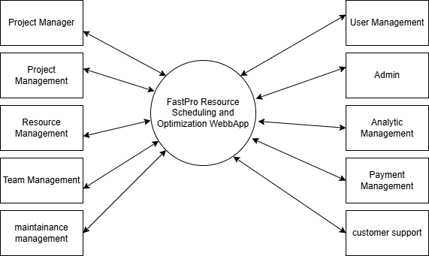

### 5.0.2 LEVEL 1

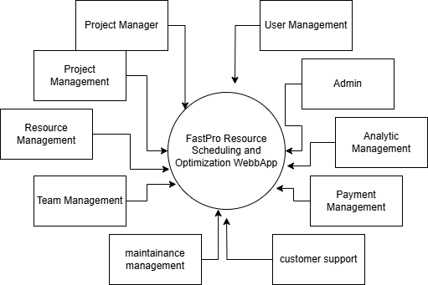

### 5.0.3 LEVEL 2

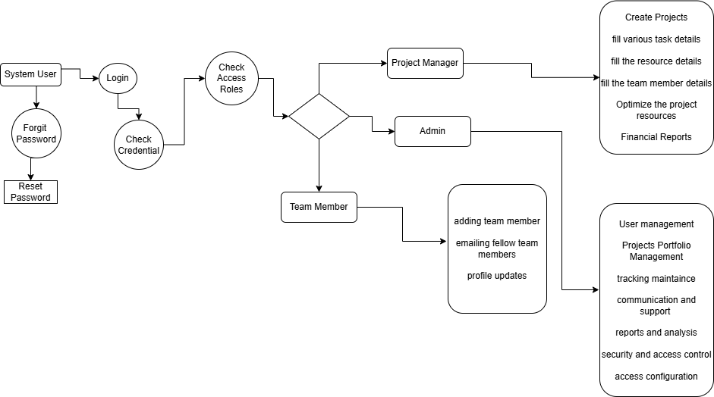

# CHAPTER 6

## 6.0 Expected Software Response

### 6.0.1 User Registration:

Notification for any registration done successfully.

1. System: Welcome to FastPro Resource Scheduling and Optimization, for your registration we appreciate your intellect. To join us and create an account, please follow these steps numerous, The process is complete, your account has been created.
2. Message the user receives when they fail to register through providing incorrect info, or system failure.
3. System: "Registration failed. All the information submitted should be accurate and therefore it is advised to try again. If it still continues, please get in touch with support.”

### 6. 0.2 Login:

Acknowledgment for a successful login.

1. System: "Welcome back, [User]. Log into Arts’-You have successfully logged in.
2. How to create an error message for incorrectly entered username and password?
3. System: "Login failed. If you generate an incorrect username/password, you are advised to check it again and try again.”
4. Password reset button in the case the user cannot remember their password.
5. System: "Forgot your password? Click here to reset it."

### 6.0.3 Project Search and Resource Allocation:

show projects that are available and posted in the database matching a certain search query.

1. System: For the projects matching your search input appended below are the details.
2. A message is provided if there are no projects matching the keywords entered for the particular search.
3. System: If for any reason there are no projects matched your search terms, Please adjust your filters."

### 6.0.4 Resource Allocation Request:

Acknowledgement message with its reference number once resource is successfully allocated in a project.

1. System: "Congratulations! Regarding the allocation of resources for [Project] we have got the following: You have been assigned [Reference Number] as Your allocation reference number.
2. Such message can be produced if the allocation fails due to the unavailability of the resource or technical problems.
3. System: "Allocation failed. This is a status code for the situation when the user has requested a certain resource and this resource is currently out of their reach. To opt for other resources or to seek help, please go through the link below Click Here

### 6.0.5 Payment Processing:

Online payment solution to deal with service charge collection.

1. System: Gladly we have processed your payment in a secure manner. We now go ahead to confirm the resources to allocate to your projects.
2. Verification of payment as successful.
3. System: "Payment successful. The allocation is confirmed.”
4. String to be displayed to the user in the case that the payment fails or experiences some problem.
5. System: "Payment failed. Kindly confirm your payment details and please try again.

### 6.0.6 Allocation Confirmation:

Generation of a confirmation document.

1. System: Subject: Access to your resource allocation confirmation for [Project]
2. Clear identification of allocated details some of which include project name, dates and money paid.
3. System: The following is the breakdown of your allocation For more information please visit [insert link here].
   * Project: [Project]
   * Allocation Period: [Start Date] to [End Date]
   * Amount Paid: [Amount]
4. Choice of the ways in which a confirmation could be printed — either to download, print or e-mail it.
5. System: ”Below are the actions you can take regarding your allocation confirmation; download, print or email.”

### 6.0.7 Modification and Cancellation of Allocation:

Desirable flexibility in regards to the allocation changes, including such options as editing dates or resources.

1. System: “Maintenance of your resource allocation has been accomplished appropriately.”
2. Delivery of confirmation of the changes or actual removals or additions as the case maybe.
3. System: This message is sent to the inventory to inform that specific allocation has been successfully cancelled by the computer.
4. Standard message that is given to a user if modification or cancellation cannot be done because of policy reasons or because of some other technicality.
5. System: Change or cancellation was unsuccessful. It says either review the policy restrictions or contact support.”

### 6.0.8 Allocation and Payment History:

The permissions acquired include the use of the user’s resource allocation and payment details.

1. System: The following is what it has allocated throughout the history of our usage:
2. Monitoring of current state of resources which has been allocated like confirmed, pending, canceled and so one.
3. System: “Currently your allocation status Is [Status].”
4. The ability to view the previous confirmations printed on the screen or produced on paper.
5. System: You can check your confirmations under the allocations history section and then print them.

## 6.1 Performance Bounds

1. Response Time: FastPro should be able to respond in few seconds to user interactions such as search for a resource, task scheduling and resource allocation among others.
2. Scalability: FastPro should respond well to a large number of concurrent users as well as multiple transactions at once. It should horizontally scale by using another server or instance most preferably of the same rank.
3. Throughput: There should be efficiency in managing the schedules and resources with throughput that shows the app can provide for large numbers of clients at one time.
4. Availability: FastPro should be available most of the time to enable users to be able to access the system when they want. Redundancy and fault tolerance should reduce the problems arising from hardware or software failure.
5. Scalable Database: A database used by FastPro should be able to withstand read and write stresses in order to stock information promptly and to provide resources immediately and without pause.
6. Security and Data Protection: The system should also be secure for the user, this concerns every information that the user will enter in to the system such as personal data and payment information. Performance parameters are factors such as the time that it takes to encrypt or decrypt a message, or even handling of secure data without necessarily lowering the performance level.
7. Load Testing: Emulating the maximum loads is crucial for determining FastPro’s potential and problematic areas, as well as its operability under high concurrent activity.

# CHAPTER 7

## 7.1 The identification of Critical Components

To prioritize reliability and address potential issues, key components of the FastPro Resource Scheduling and Optimization Web App include:

### 7.0.1 User Interface (UI):

* Testing Focus: Make the projects easily accessible and optimised for use on both mobile and desktop digital devices and browsers notably for searching projects, assigning resources and setting up a project.

### 7.0.2 Search and Scheduling Engine:

* Testing Focus: Assure that a project search will display accurate results of projects the user is interested in, a availability of resources and a smooth scheduling for the users.

### 7.0.3 Payment Gateway Integration:

* Testing Focus: It also has to guarantee protected and efficient payment transactions for any sales made. Common checkout features and elements include— Multiple payment-method confirmation, Encryption of the Payment Method, Payment Method Error Handling.

### 7.0.4 Database and Data Management:

* Testing Focus: Ensure data accuracy, confirm data access and archiving for the projects/resources/transactions and the optimize the large volumes of data.

### 7.0.5 Authentication and Authorization:

* Testing Focus: Confirm account and password authentication, user sign-up, password protection and rights provided in terms of system operation and resource management, and timetabling.

### 7.0.6 Notification and Communication:

* Testing Focus: Deliver constant confirmations, alerts, and updates to the users through e-mail, SMS and push notifications, and ensure that content of the notifications is correct.

### 7.0.7 Performance and Scalability:

* Testing Focus: Under heavy load conditions, fill system with heavy traffic to record how well it is going to cope with the incoming traffic, transactions and resource contention.

### 7.0.8 Security Measures:

* Testing Focus: Security Audit, Vulnerability testing and Compliance scanning. Confirm how data is protected by encryption, firewalls and for its capability in detecting intrusions.

### 7.0.9 Integration with External Systems:

* Testing Focus: Every time integrate with the other system like project management APIs, or use the third-party services to ensure that data sync, API compliance, and error handling are in place.

### 7.0.10 Error Handling and Logging:

* Testing Focus: Make sure error handling is highly useful and that logging is carried out properly. Use the system to see how well the errors are handled, how detailed information is recorded and how the user is informed of their mistakes.

# References

1. Agyekum, K. O., & Addae, E. (2023). Factors influencing the adoption of resource scheduling systems in project management: A case study. Journal of Project Management, 24(1), 1-17.
2. Al-Momani, A. M., & Sawalmeh, A. H. (2020). Cloud-based resource scheduling systems: Features, benefits, and challenges. International Journal of Information Management, 52, 102129.
3. Al-Rasyid, R., & Gunawan, I. (2018). Designing secure and scalable resource scheduling systems. International Journal of Computer Network and Information Security, 10(8), 100-106.
4. Airbnb Engineering & Data Science Blog: [Airbnb Engineering](https://airbnb.io/) (Articles on scalable architecture).
5. Cretech: [Property Tech News](https://www.cretech.com/news/) (Insights on property tech).
6. Capterra: Resource Management Software (Comparative reviews).
7. Greene, D. (2022). The complete guide to resource scheduling and optimization. Independently Published.
8. Kleppmann, M. (2017). Designing Data-Intensive Applications: The Big Data Architecture Guide.
9. Xu, A., et al. (2022). System Design Interview: An Insider's Guide to Cracking the Code.
10. Newman, S. (2015). Building Microservices: Designing, Deploying, and Scaling Microservice Architectures.
11. The Netflix Tech Blog: [Netflix Tech](https://netflixtechblog.com/) (Insights into large-scale systems).
12. Google Research: [Google Research](https://research.google/) (Research papers on system design).