

SCHOOL OF TECHNOLOGY

BEACHELOR OF SCIENCE IN SOFTWARE DEVELOPMENT

UNIT CODE: BSD 3201

ADMISSION: 21/04706

NAME: DUNCAN MUNENE MURIUKI

NAME OF THE SUPERVISOR: WINNIE OKONG’O

PROJECT TITLE: RESOURCE SCHEDULING AND OPTIMIZATION WEB APP

USER MANUAL

Contents

1.0 Introduction 3

Benefits 3

For Users 3

For Administrators 3

System Requirements 3

Getting Started 4

Login 4

Process Overview 4

Forms 4

Internet Connectivity 5

Use Cases: 5

Reports 5

2.0 FEATURES 5

USER FEATURES 5

Project Management Dashboard 5

Resource Allocation Pipeline 6

Team & Task Management 6

Billing & Subscription Management 6

Real-Time Notifications & Alerts 6

AI-Powered Chatbot Support 6

Administrator Features 7

Admin Dashboard & Access Control 7

Project & Resource Management 7

User & Team Management 7

Order & Billing Oversight 7

Chatbot Configuration & Monitoring 7

3.0 COMMON USER ACTIONS 8

Create a Project 10

Allocate Resources 10

Manage Tasks & Team Assignments 10

Track Project Progress 10

Billing & Subscription Management 10

Get Real-Time Notifications 11

Chatbot Assistance 11

Below is Visual Graphics for GUI/UI Pages 11

Signup 11

Pricing 12

Project and Task Pipeline 12

Resource and Team Pipeline 13

Billing 14

Dashboard 14

My-Work 15

# 1.0 Introduction

The FastPro web application functions as a scheduling system which helps users optimize their project resource management and tracking operations. The user manual serves as a guide which both users and administrators need to use to optimize FastPro functionality.

## Benefits

### For Users

* You can easily recognize resources in different categories followed by making decisions about scheduling options.
* Users can use an easy-to-understand dashboard to obtain real-time views of their projects together with their updates.
* Users benefit from secure resource request and payment handling performed within encrypted payment systems.
* Complete quick customer support using the built-in messaging system.

### For Administrators

* The platform includes user-friendly management tools for handling resources, users and project scheduling activities.
* The system enables administrators to produce meaningful reports which reveal how resources should be allocated and optimized.
* A customer-friendly AI chatbot system should be implemented to enhance communication flow and support customer interactions.

### System Requirements

Device: Desktop, laptop, or mobile device.

Internet Connection: A stable and reliable network connection.

Browser: Compatible with modern browsers such as Google Chrome, Firefox, Safari, or Microsoft Edge.

### Getting Started

User Registration (For Users and Administrators)

* Visit the FastPro web application.
* New accounts can be created through a click on the "Register" button.
* Fill in the required details:

1. Users: Username, email, phone number, and password.
2. Administrators must create credentials that receive specific privileges according to their role-based functions.

* Check the provided box to accept the terms and conditions.
* After finishing registration through "Sign Up" you will gain access to all app features.

### Login

1. Navigate to the "Login" page.
2. Use your previously registered email along with your password.
3. Click the Sign In button to reach your customized dashboard view.

### Process Overview

The backend operations of FastPro provide straightforward scheduling and optimized functionality through the execution of received data to produce exact results.

Key Steps:

* The program accepts data inputs including project IDs and resource requests.
* Check all input data against the active system database records.
* The system retrieves the scheduling data alongside optimization information needed for the process.
* The system receives updates about modifications (for example project status modifications made by an admin user) through this process.

### Forms

FastPro utilizes forms as a vital tool for obtaining and managing user-related information.

**Key Forms:**

Users need to complete the Resource Scheduling Form to add project specifications along with essential resource needs.

Terminal Users Can Modify Resource Adjustments While Updating Project Conditions and Monitoring Alterations Through the Admin Update Form.

Registration/Login Form: Authenticate users and grant appropriate access levels.

A Feedback Form exists to collect user information that enhances system performance.

### Internet Connectivity

Internet access stability provides necessary conditions for data access through smooth communication channels.

### Use Cases:

The system retrieves present updates regarding projects from the server in real time.

Customers will get automatic email or SMS messages from the system.

External APIs work together with the system in order to provide improved scheduling and optimization functions.

### Reports

Records deliver significant data about how system resources are utilized and operational performance works.

Types of Reports:

* Monthly Resource Utilization Reports (Assigned vs. Available Resources).
* The average project duration along with delay occurrences can be analyzed through Project Timeline Analysis.
* User Feedback Reports (Suggestions and Issue Tracking).

Implementation:

* The system generates reports through SQL queries and FPDF (PHP) and Chart.js visualization tools for visual data evaluation.

# 2.0 FEATURES

## USER FEATURES

### Project Management Dashboard

* Use the dashboard to oversee all project activities which group projects according to their types while prioritizing different tasks.
* The system allows users to sort projects according to their current state or due dates or assigned personnel divisions.
* View important project information which includes description together with timeline and assigned resources and cost estimation data.

### Resource Allocation Pipeline

* Through this dashboard the user can control three categories of resources by adding new personnel along with needed equipment and budget allocations.
* Track resource utilization and availability in real time.
* Resource allocation functions at its maximum efficiency level under guidance from smart recommendation systems.

### Team & Task Management

* The team leader should distribute work assignments to their employees with clear schedules and rank-ordering of responsibilities.
* Task administrators can track progress alongside completion status using an interactive display.
* Task updates and overdue assignments and completed tasks notification system is available to users.

### Billing & Subscription Management

* The platform lets users inspect and handle payment records for project spending costs.
* Projects can be paid using local credit cards in combination with PayPal and alternative payment methods available.
* Instant payment confirmations can be received through both email and within the dashboards.

### Real-Time Notifications & Alerts

* Projects will be better managed through notifications that display task deadlines and project developments as well as resource allocation updates.
* Project alerts notify users about necessities for approval actions while showing new assignments and pressing changes to existing work.

### AI-Powered Chatbot Support

Users can access instant support through the integrated chatbot during all operations to achieve the following objectives:

* Users should ask projects management questions to learn about resources and optimization strategies.
* The system allows users to monitor the advancement of their projects together with the availability of their resources and tracking of task status updates.
* Users can request help on billing matters or account subscription or billing support through the platform.

## Administrator Features

### Admin Dashboard & Access Control

* Secure login with admin credentials for system management.
* The system allows administrators to control user system access levels and permissions systems.

### Project & Resource Management

Manage projects by creating new ones or making modifications and removing existing ones with efficient resource distribution.

The system enables users to modify project schedules together with team members and optimization control variables.

The system enables users to observe and enhance resource management to maximize results.

### User & Team Management

* System users have the ability to view a complete list that contains all registered users together with all teams.
* Employ the platform to handle user profile changes together with password resets while having the ability to suspend accounts when required.

### Order & Billing Oversight

* Continued observation of all payments and subscriptions that run through the platform exists.
* The system enables users to produce billing reports that show financial transactions together with project costs.

### Chatbot Configuration & Monitoring

* A system exists for chatbots to generate preprogrammed answers to typical user questions.
* Staff members should evaluate chatbot interaction records to enhance the response quality.
* Complex or unmatched user inquiries require a human response through manual proceedings.

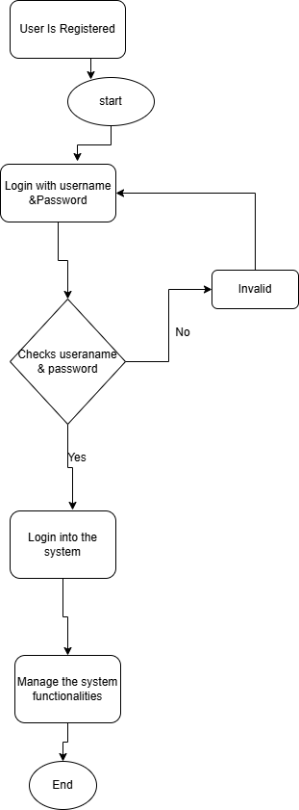

3.0 COMMON USER ACTIONS

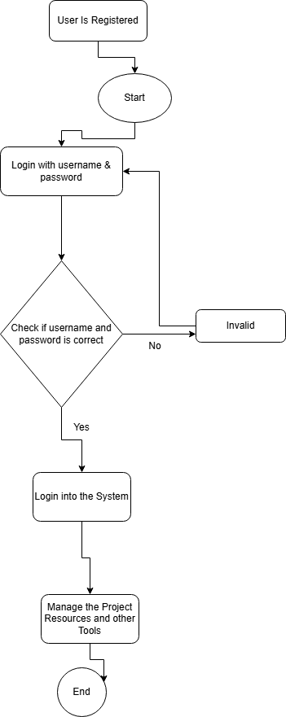  
Sign Up

* Visit the registration page.
* Provided details in the sign-up form by selecting "Sign Up."
* Your account requires an activation process through email verification.

## Create a Project

* Navigate to the project dashboard.
* Click "Create New Project."
* Users should provide project details like name and description with deadline settings and member assignments.
* Saving the project will begin your ability to manage tasks along with resources.

## Allocate Resources

* User can access tasks by selecting one of their available projects from the provided dashboard.
* You can distribute personnel together with equipment and budget as resources to the project.
* Perform additional adjustments to resource assignments which help achieve the best possible allocation of resources.

## Manage Tasks & Team Assignments

* Open the task pipeline that belongs to the chosen project.
* Users can enter tasks through the interface which enables them to set both deadlines and assignment teams and priority levels.
* The system enables changes to tasks along with moving employees between assignments or switching task progress indicators according to team needs.

## Track Project Progress

* Go to the project dashboard.
* Project status together with task completion rates and resource utilization data can be viewed at this screen.
* The detailed project progress reports become visible after selecting one currently under analysis.

## Billing & Subscription Management

* Navigate to the billing section through the user dashboard screen.
* Users can find all subscription information as well as see their payment transaction record.
* Users can select their preferred payment method while conducting secure transaction processing through the system.

## Get Real-Time Notifications

* The system delivers updates about projects together with information about task requirements and resource schedules.
* Users can activate notifications to immediately perform vital tasks or inspect the stated content.

## Chatbot Assistance

Use the chatbot for:

* Project management inquiries.
* Task and resource tracking.
* Subscription or payment-related support.

# Below is Visual Graphics for GUI/UI Pages

Signup  
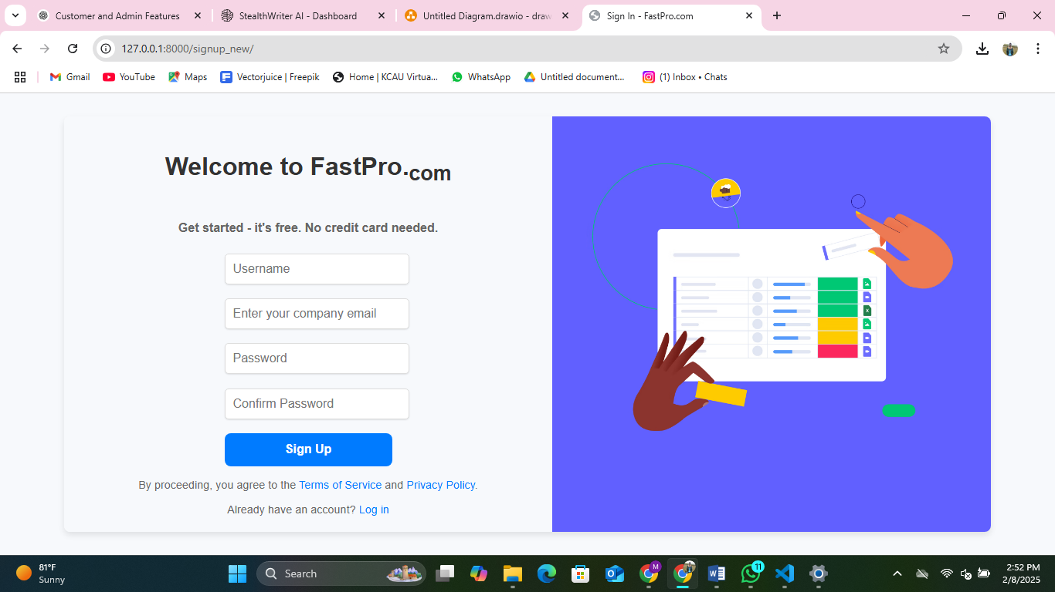

Pricing  
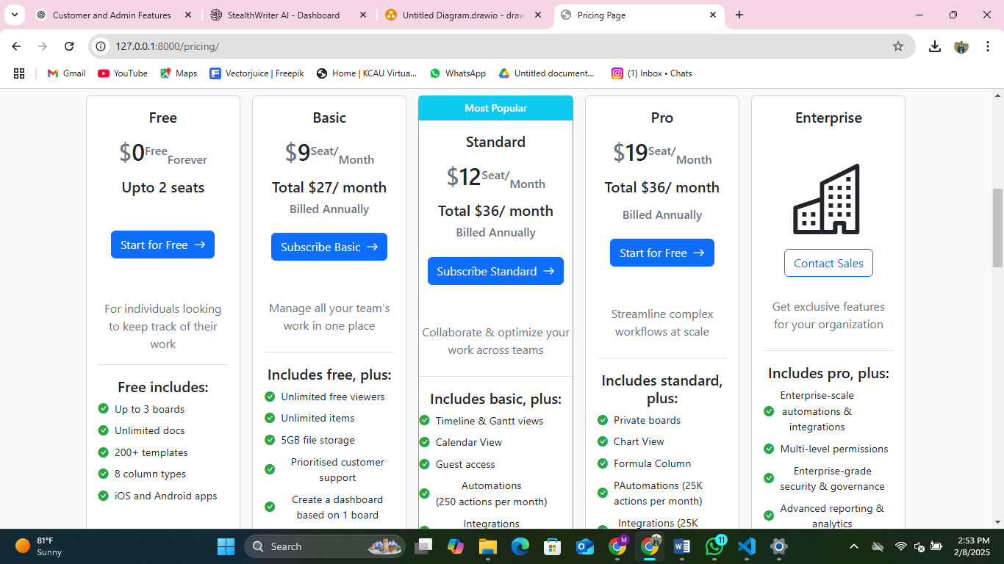

Project and Task Pipeline  
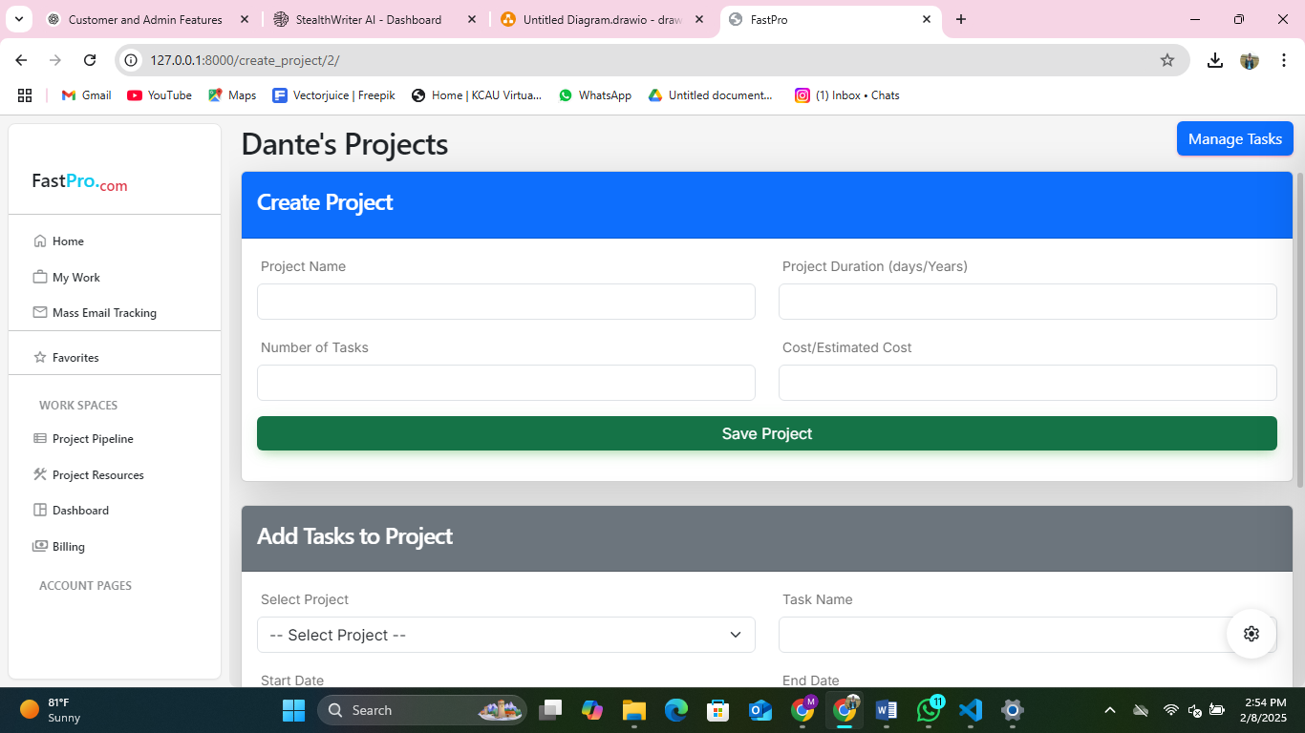

Resource and Team Pipeline  
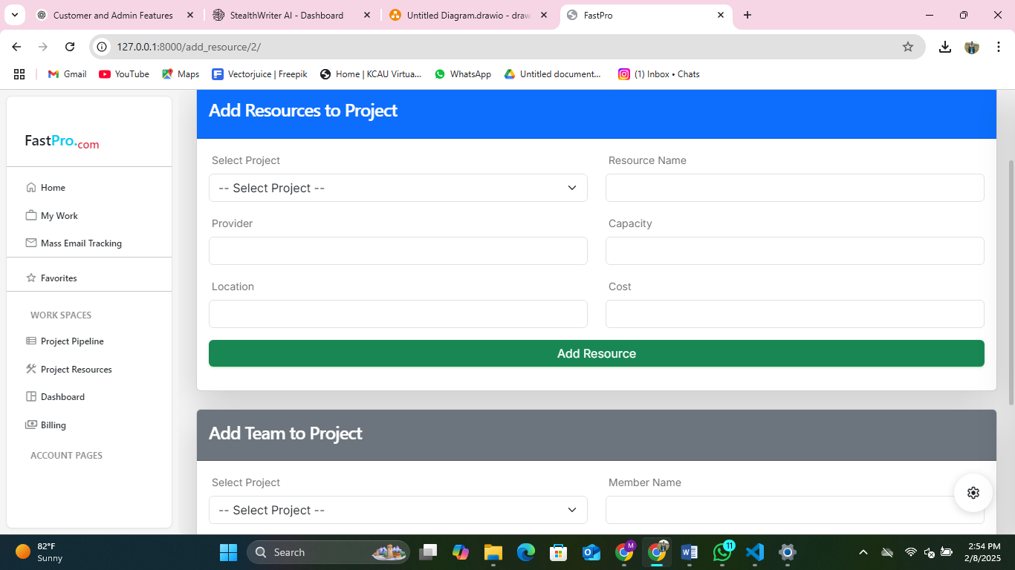

Billing  
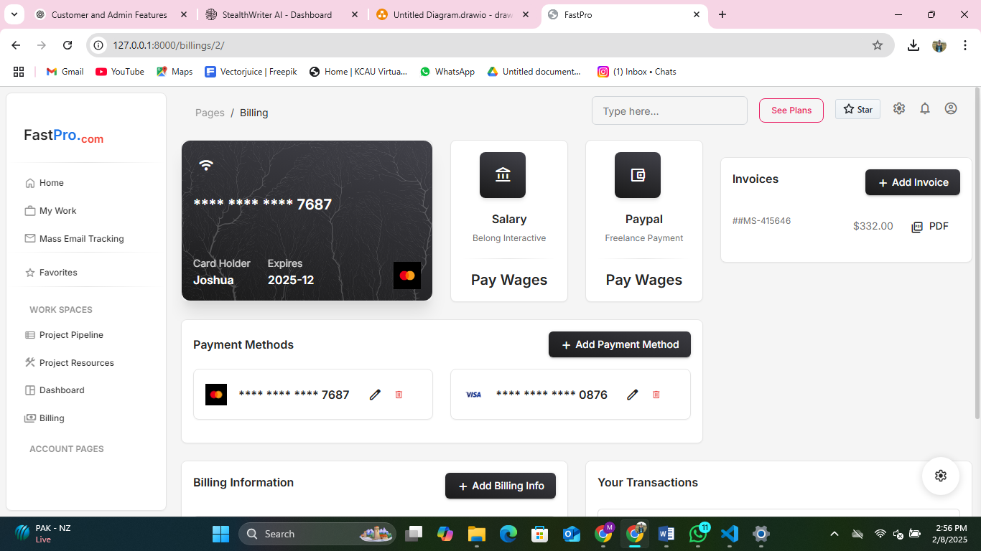

Dashboard  
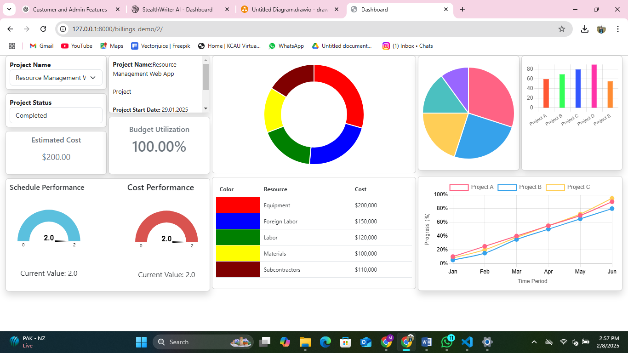

My-Work  
