I. Summary
The project is to create two or three applications with wireframe and working prototype with the help of Adobe XD

II. UI

User Interface: Is an interaction between a Human and a computer. The goal between the human and the computer interaction is for the machine to do the human’s needs and wants for example programming your microwave and old video recorder.

III. UX

User Experience: Is an interaction between a client and company and manipulation of human behavior. The process applies by manipulation of human behavior and continue updates of usability, example a company web-app that clients use every day needs to be updated for better experience use of the client.

III. WIREFRAME
Wireframe: is a screen blue print of a device or a visual guide that represent the skeletal of an application.

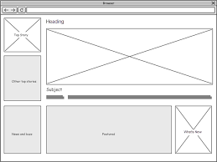

V. Mock-Up

Mock-up: is a scale or full-size model of a design or device.

VI. Target Group

Target audience: is a defined group of people who are interesting as recipients of marketing. A target group can be children - for example, when toys are marketed on TV.

I. Prototype

Prototype: is an early sample, model, or release of a product built to test a concept or process

II. Labrinth

The Labrinth Game forms a maze built of both fixed and moving pieces. The players rearrange the maze to their advantage by moving a row of pieces in turn. Each player has one token, which they move in the maze. The player's goal is to collect treasures in the labyrinth and then return to their own starting position.

- The game levels were built to target a specific group from people from 17 to over because of the creatures and FX in the game.

- Color: The colors are vibrant suitable for 17 and over.
- Graphic: The Graphics are stoning with fantasy rims suitable for 17 and over
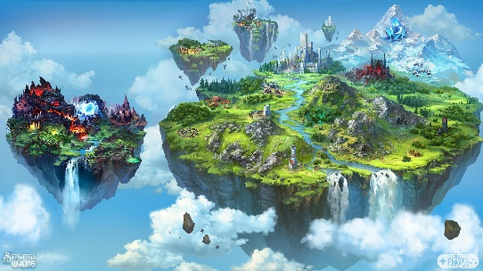

Thoughts and decisions

My thought was to create a fantasy Labrinth game that is targeting a specific group from 17 over because of the contents in the game. For a example in the hall of Ayeley contains visuals that are not suitable for age under 17. I want to create a game that has a good story line and great visuals that will be an iconic Labrinth game blinded with fantasy and a true mystical an ancients event. I choose Fantasy Labrinth game because the human mind on quite state goes the fantastical worlds.

II. FLUX

Flux: is fashion App for selling great cloth online. The App gives the use the possible to register, buy, wish for, edit account and send a gift. The buyer can track purchased history and chat with flux service about ongoing transactions.

- The Flux App built to target all walk of life. It is very smooth and user friendly
- Color: The colors are vibrant suitable for everybody.

Thoughts and decisions
My thought was to create an Application that is user friendly and extremely easy to use. The interface is quite neat and every object is vivid.
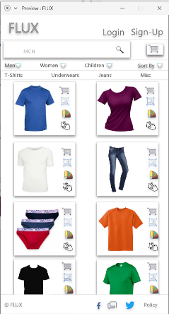

II. Time Tracker

Time: is time tracking App for tracing working activities.The App gives the use the possible to login using the authentication provided by a system administrator. The use can edit account and send a send time stamps.

- The Time Tracker App built to target employer and employees. It is very smooth and user friendly
- Color: The colors are vibrant suitable for everybody.

Thoughts and decisions
My thought was to create an Application that is user friendly and extremely easy to use. The interface is quite neat and every object is vivid.

