Online-Aptitude-Test

Table of Contents

* **ACKNOWLEDGEMENT**
* **PROBLEM DEFINITION**
* **ALGORITHMS**
* **TASK SHEET**
* **SCREENSHOTS**
* **PROJECT REVIEW AND MONITORING REPORT**
* **FINAL CHECK LIST**
* **ACKNOWLEDGEMENT**

I would like to appreciate God Almighty for seeing me through the process of executing this project. He has always been faithful.

I also want to thank my parents for their support so far, I pray that the Lord would reward them abundantly. My sincere gratitude also goes to the entirety of Aptech Computer Education, Abeokuta – right from the faculty to my colleagues for their timely professional advice and support.

I appreciate the efforts of everyone that contributed to the success of this project. God bless you all!

Aptitude Test:

The Aptitude test is divided three parts:

* **General Knowledge**
* **Mathematics**
* **Computer Technology**

The test is supposed to be conducted in the linear way, only one link must be active at a time. Each question should carry marks (marks can be decided by the developer from 1 to 5) Steps to be followed:-

* **General Knowledge** link must appear which should contain 5 questions. User will click start button for starting the test. It will have a specific time bound for completion, once the time out, it will check the questions attempted. If the user complete the test before the timer out, then they can click on complete/submit button for proceeding further. *Note: when the candidate logs in they can view all three link of test but only General Knowledge one should be active.*
* Once the first part of the test gets completed then it should follows the second link i.e. **Mathematic**s one. The Mathematics section will also follows the same rule as above. *Note: Candidate cannot move back on the previous once it is completed and submitted by them.*
* The last part of the test would be of **Computer Technology section** where again the same rule is to be followed as for the above two but as it is the last step then the candidate will have to click on complete my test button (you can choose the appropriate name also). After clicking on this button the result of the candidate should be calculated and must produce on the screen of the candidate machine. Where if they have cleared it should prompts that “*You have cleared this round, next round would be HR Round”* else no message should be prompted.

# Client Requirements:

Client has put forwarded all the list of data’s, he/she required in the application which is stated below:

* MANAGER: Manager will have the authority to enter the details of the candidates appearing for the interview. Details to be maintained like Education details, Personal details, Work Experience. After this Manager will allocate the Username and Password for the candidates.
* Manager can even view the list of all the candidate who is or has appeared along with the result (if achieved)
* If the candidate passes the test, then their names are transferred for next round (HR) round. In the transfer process the data of the candidate must be transferred in the new table (Transfer/ Apti-clear Table) which will be referred by the concern person.
* Manager even will have the responsibility to edit, update, add, save the test question. For doing this the manager has go in the test section available on its profile and can change the question accordingly by clicking the edit button and then saving the new question.
* Report section must be added for viewing the generalized data which can be filter by date, week or month.
* CANDIDATE LOGIN: Each candidate will have their login details provided to them by the Manager. These details must be entered in the candidate’s login section.
* Candidate will start the test then as per the schedule, time allocated for the test. They are supposed to follow the linear mode and once the answer is submitted then it can be changed.
* After finishing the test the candidate will have to click on “Complete my test” and then log out the session.

Note : While entering the data of the job seeker a constraint validation must be provided on the fields to accept the proper data type information.

* Task Sheet

Below is the task sheet for the project planning and execution of the **File-Saving** project. The project was completed some days prior to the time allotted for it.

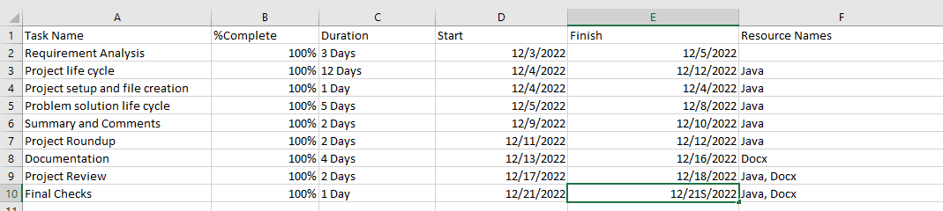

* **ALGORITHMS**

**A while loop looping through the third file to get the length of characters in it (third file)**

* **FLOW CHART**

Below is the Flow Chart for the project planning and execution of the **File-Saving** project.

* **PROJECT REVIEW AND MONITORING REPORT**

During the review of the project, there were some issues which were later fixed , all algorithm checks and executions were successful and the work flow was smooth in the end.

The monitor’s report is that although there were a few issues during the construction of the project- which were resolved, the flow and understanding of the project’s functionality was good, and the project completed.

**FINAL CHECK LIST**

The project has been completed and the final checklist below is created to check the functionality, order and to ensure proper maintenance of the project:

* **If first and second file exists, read data from them (check)**
* **Create third file to store first and second files concatenated data (check)**
* **Create fourth file to store square of third file (check)**
* **Create length file to store number of characters in third file (check)**
* **Print out data in first file (check)**
* **Print out data in second file (check)**
* **Print out data in third file (check)**
* **Print out length of characters in third file (check)**
* USER GUIDE

The user should have visual studio 2013 installed on his/her laptop.

The user should open the “Semester 3 project.sln” on visual studio.

Once the file is opened ither part of the project will install into the visual studio 2013

At the top of the visual studio ide there is a play button in which you can select your choice of browser to preview the website.

Lastly, you can login as admin or user to perform any operation on the website.

* Screenshots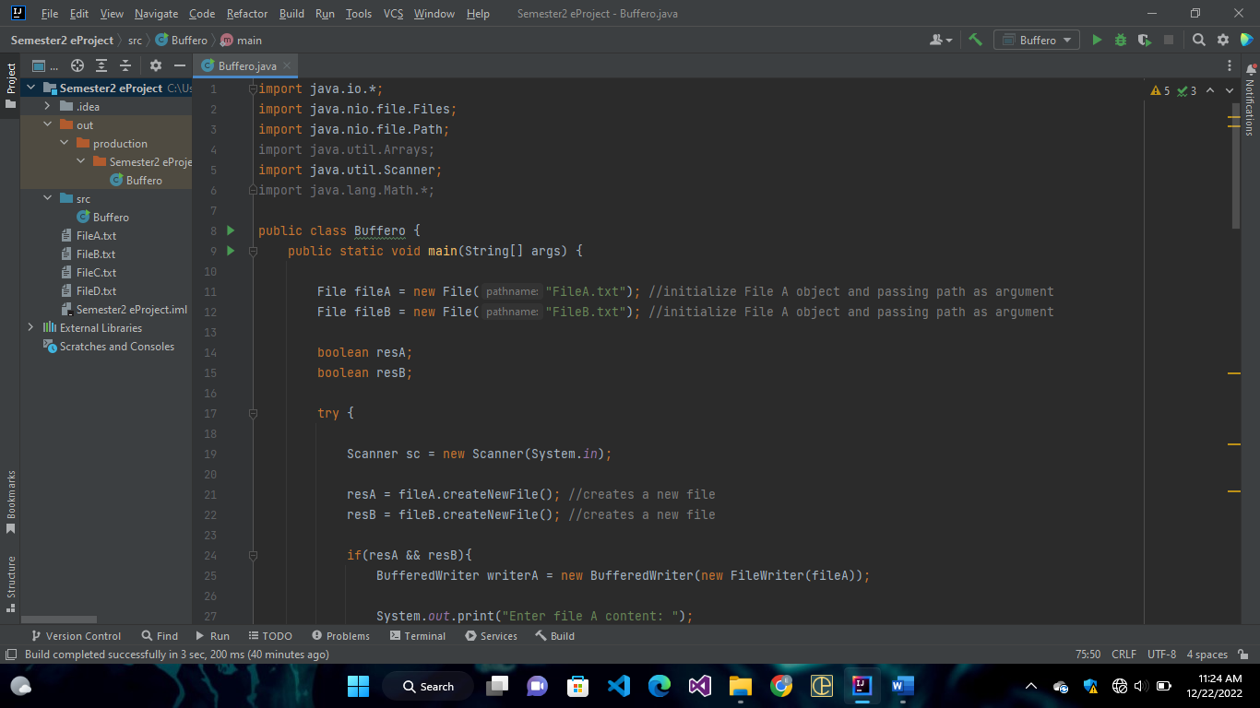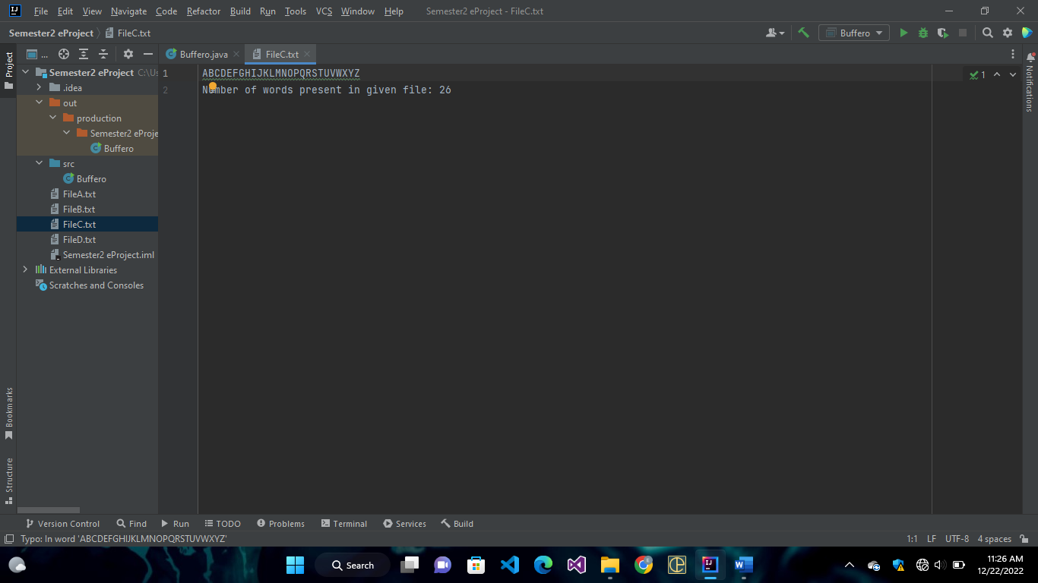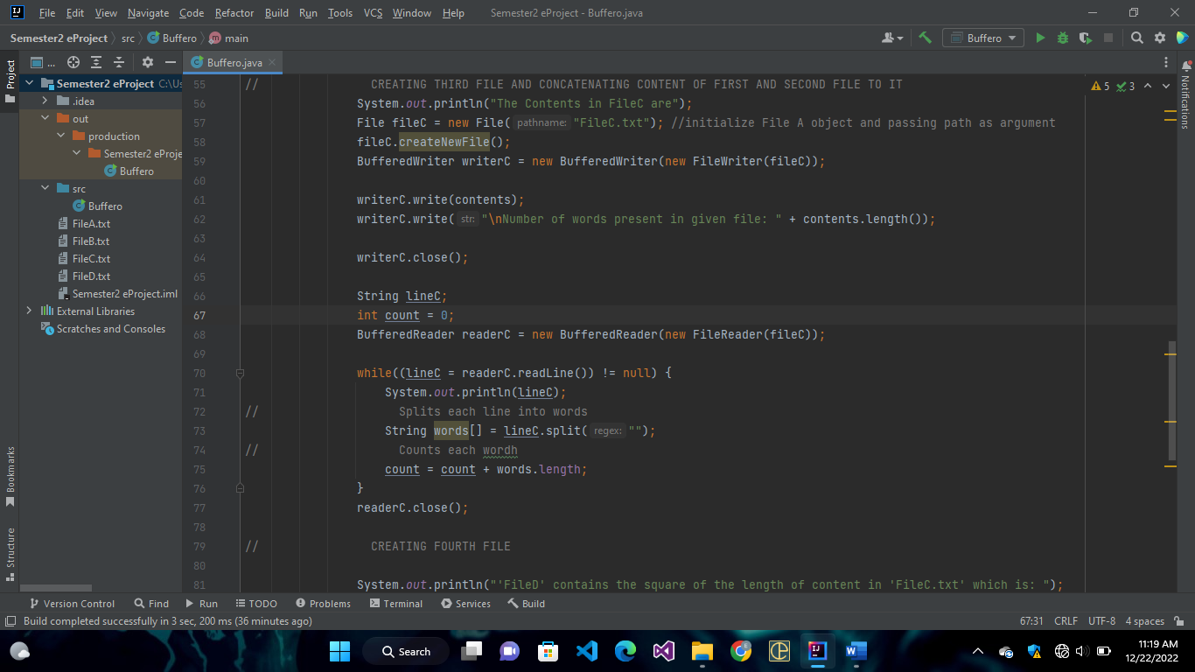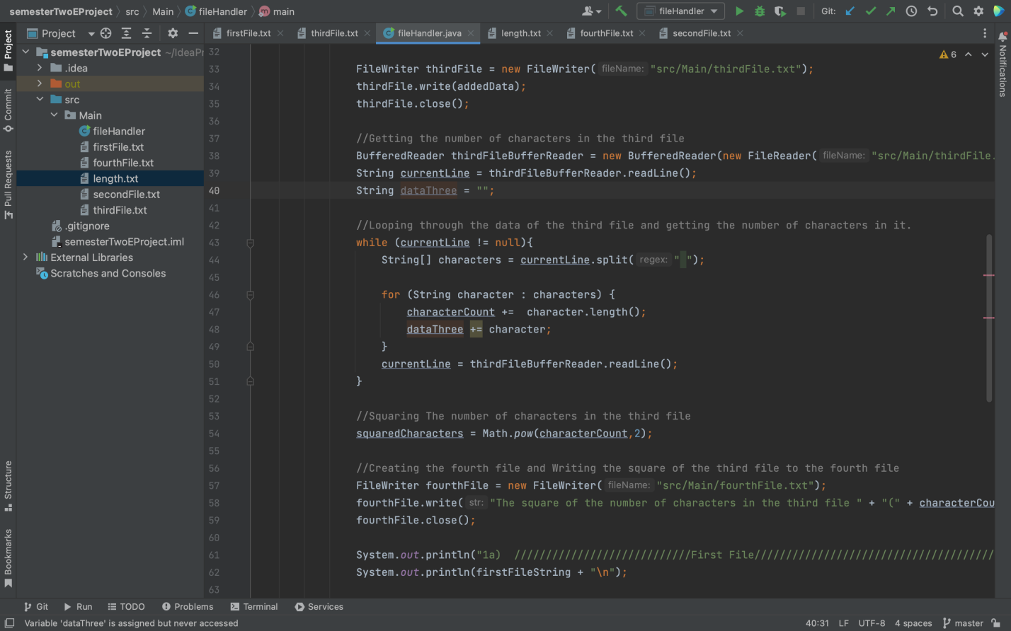
* SYSTEM REQUIREMENTS
* Operating system: Windows 7 or higher OS.
* GET THE WEBSITE RUNNING.
* Host the website on a server.
* Access the website by typing in the domain name in any HTML 5 and JavaScript supporting browser.
* Navigate the website using the user-friendly navigation menu and links.

**Software**

**Either or combination of the following Software’s are to be used:**

* Visual Studio .Net / ASP
* IIS server
* .Net Framework
* Java Virtual Machine/ J2EE server
* Notepad/Java editor
* j2sdk1.4.1_02 (or later).
* EJB Dev Kit
* Java enabled web server
* JSP / Servlets Dev. Kit
* Hardware:
* A minimum computer system that will help you access all the tools in the courses is a Pentium 166 or better
* 128 Megabytes of RAM or better