Fall detection

Using deep learning MLP to detect fall



Dan Lund

NBI/Handelsakademin

Examensarbete- OPA23

202503

# Abstract

In this study the SisFall data set was used for classifying the event of a normal e.g. walk or fall case, i.e. separating an normal event from an adverse event. The study show that a deep learning multiple layered perceptron (MLP) with kernels can be trained and successfully predict outcome. A sliding window of the the acceleration in in 3D was used, enabling real time predictions.

This approach shows the an accuracy of 98% can be obtained using the MLP. Further more, in this study a simple mobile app (PhyPhox) has been integrated and tested, demonstrating real time predictions.

Innehållsförteckning

Abstract 2

1 Introduction 1

1.1 Daily situations 1

1.2 Fall situations 3

2 Theory 4

2.1 Image recognition by deep learning 4

2.1.1 Using Kernels 4

2.1.2 Dropout rate 4

3 Method 5

3.1 Dataset and Preprocessing 5

3.2 Sliding window 5

3.3 Train, validation and test 6

3.4 Network parameters 6

3.5 Interactive monotoring 6

4 Result och Discussion 7

4.1 Discussion 8

5 Conclusion 9

References 10

# Introduction

Falls are a major cause of injury in older adults, with 20% resulting in serious outcomes such as fractures (CDCP, 2020). Age-related declines in muscle mass, balance, and conditions like osteoporosis significantly increase the risk of falls and fractures (Montero-Odasso et al., 2020). Preventive strategies, including physical activity, adequate vitamin D and calcium intake, and hazard-free living environments, can reduce these risks, improve quality of life, and relieve healthcare burdens (NIH, 2020).

**Objective**

The goal is to from acceleration measured in 3D (x, y, z), obtained from a mobile device (e.g. Phyhox app), and predict the possible outcome of a fall. The dataset is obtained from the SisFall study (Sucerquia A, López JD, Vargas-Bonilla, 2017) which also contain measurements of ordinary (daily) situations.

Unlike previous studies on predictions (Sucerquia A, López JD, Vargas-Bonilla, 2017), which have used preprocessed data e.g. low-pass filtering, amplitude summation, orientation to axis, area to axis etc., to predict the outcome of a fall by classifiers (random forest, CNN), the raw data will be used by image recognition approach to predict the outcome. Using the curve of x,y,z, acceleration and a sliding window it seems reasonable that when a fall occurs that this would be present in the window of data. The use of a sliding window offers the possibility of real-time monitoring.

Main parameters here are the window size, topology of the network, and possible feature extraction needed. It might also be necessary to do a Fourier transformation or PCA (principle component analysis) to reduce the complexity.

## Daily situations

The data contain recordings of daily situations, see Table 1. These situations include tasks that are typical for an subject (person) daily life. Included are walking, jogging, sitting/getting up, walking in stairways, standing movements, stumbling but not falling, and jumping.

Table 1: Table 1: The daily situations measured

|  |  |  |
| --- | --- | --- |
| **Activity** | **Trials** | **Duration** |
| Walking slowly | 1 | 100s |
| Walking quickly | 1 | 100s |
| Jogging slowly | 1 | 100s |
| Jogging quickly | 1 | 100s |
| Walking upstairs and downstairs slowly | 5 | 25s |
| Walking upstairs and downstairs quickly | 5 | 25s |
| Slowly sit in a half height chair, wait a moment, and up slowly | 5 | 12s |
| Quickly sit in a half height chair, wait a moment, and up quickly | 5 | 12s |
| Slowly sit in a low height chair, wait a moment, and up slowly | 5 | 12s |
| Quickly sit in a low height chair, wait a moment, and up quickly | 5 | 12s |
| Sitting a moment, trying to get up, and collapse into a chair | 5 | 12s |
| Sitting a moment, lying slowly, wait a moment, and sit again | 5 | 12s |
| Sitting a moment, lying quickly, wait a moment, and sit again | 5 | 12s |
| Being on one’s back change to lateral position, wait a moment, and change to one’s back | 5 | 12s |
| Standing, slowly bending at knees, and getting up | 5 | 12s |
| Standing, slowly bending without bending knees, and getting up | 5 | 12s |
| Standing, get into a car, remain seated and get out of the car | 5 | 12s |
| Stumble while walking | 5 | 12s |
| Gently jump without falling (trying to reach a high object) | 5 | 12s |

## Fall situations

The fall situations are common falls produced in a simulated environment, using the adults, Table 2. The elderly study subjects where omitted from the simulated falls with one exception. One elderly subject performed the simulated fall cases.

*Table* 2. The simulated fall situations.

|  |  |  |
| --- | --- | --- |
| **Fall situation** | **Trails** | **Duration** |
| Fall forward while walking caused by a slip | 5 | 15s |
| Fall backward while walking caused by a slip | 5 | 15s |
| Lateral fall while walking caused by a slip | 5 | 15s |
| Fall forward while walking caused by a trip | 5 | 15s |
| Fall forward while jogging caused by a trip | 5 | 15s |
| Vertical fall while walking caused by fainting | 5 | 15s |
| Fall while walking, with use of hands in a table to dampen fall, caused by fainting | 5 | 15s |
| Fall forward when trying to get up | 5 | 15s |
| Lateral fall when trying to get up | 5 | 15s |
| Fall forward when trying to sit down | 5 | 15s |
| Fall backward when trying to sit down | 5 | 15s |
| Lateral fall when trying to sit down | 5 | 15s |
| Fall forward while sitting, caused by fainting or falling asleep | 5 | 15s |
| Fall backward while sitting, caused by fainting or falling asleep | 5 | 15s |
| Lateral fall while sitting, caused by fainting or falling asleep | 5 | 15s |

# Theory

## Image recognition by deep learning

Image recognition is basically a classification problem. Deep learning implies that the network can learn **hierarchical features,** from simple to complex, such that complex patterns (images) can be classified.

Deep learning in the context of a Multilayer Perceptron (MLP) involves training a neural network with several hidden layers to automatically learn complex patterns and representations from data. Each layer transforms its input through weighted sums and non-linear activation functions, enabling the network to capture hierarchical features—from simple to complex—as data moves deeper through the network. This layered structure is the core of deep learning, allowing MLPs to solve complex tasks like image and speech recognition, among others.

### Using Kernels

To improve the ability to learn complex features, each layer in the network have kernels. These kernels can be compared to image filters revealing different features. Each kernel detects a feature, the more kernels the more features can be detected.

### Dropout rate

Dropout rate is the probability to eliminate nodes in the hidden layers such that the network has a greater generalizing ability, i.e. find patterns from training data that can be used to generalize on unseen data. If too many nodes are present in the hidden layers it increases the networks risk of specializing on the training data, i.e. not being able to generalize on unseen data.

# Method

## Dataset and Preprocessing

The SisFall , which is publicly available, was initially downloaded from <https://github.com/BIng2325/SisFall/releases> . The data was then preprocessed by normalization, necessary for obtaining acceleration (omitting gravity) due to the sensor used in the study.

${acceleration}_{dim}=\frac{2∗sensorrange}{2^{Sensorresolution}}∗sensor{value}_{dim}$

The *dim* refers to the acceleration in the dimension, i.e. x, y, and z.

## Sliding window

The data was initially converted to numpy arrays representing the images.

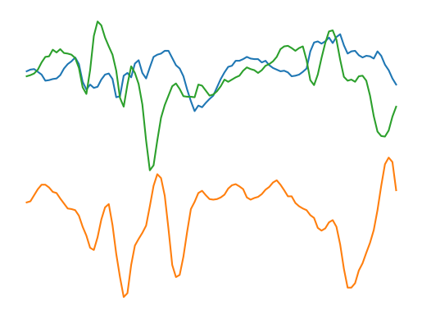

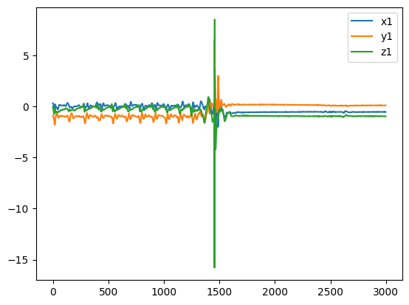Figure 1: Illustration of the sliding window technique. The sliding window is the part used for the deep learning of the MLP. The graph shows normal walking and then falling caused by a slip.

The data in each sliding window was reduced with respect to the amount of data points, using effectively only half of the data points without loosing resolution. The data was plotted and saved as an JPEG file with standardized Y-scale (-13 to 13 m/s^2). Since the values of the RGB (red, green, blue) in a jpeg file, for a pixel, is 0-255, all values was normalized in the RGB channel between 0 and 1.

Different sliding window sizes where initially tested, ranging from 5s down to 0.05 seconds.

## Train, validation and test

The data was divided into train, validation and test datasets. This was done by random. To keep the fall cases and the normal cases from being unbiased the normal cases was heavily reduced to become approximately 5% of original cases and using all the test cases.

The resulting training set contained 2639 samples, the validation set contained 661 samples and the test set contained 827

## Network parameters

The deep learning ANN parameters was as follows: learning rate 0.001, dropout rate 0.5 and the kernel size was 3 (3x3). The activation function for the kernels and hidden layers was set to *relu* function with initializers as *he_normal*.

The output layer activation function was a *softmax* activation. Further more, optimizer function *adam* was used, the epoch size was set to 200 and an early stopping function was used. In a total this resulted in1,290,946 parameters to be adjusted.

## Interactive monotoring

By integrating an API to the PhyPhox app, an app available for most mobile phones, the deep learning MLP has been initially tested. Although further testing is necessary, the result show that it possible to predict the outcome of an daily situation in terms of normal or fall.

# Result och Discussion

Training the network using the training dataset and the validation dataset, Figure 2.

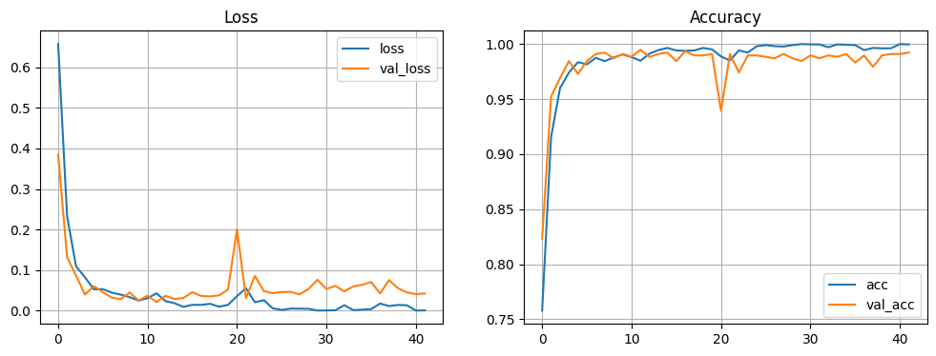Figure 2: graph showing the training of the multi layered perceptron using train data and validation data.

The resulting model was then tested with the test dataset resulting in the following confusion matrix, see Figure 3.

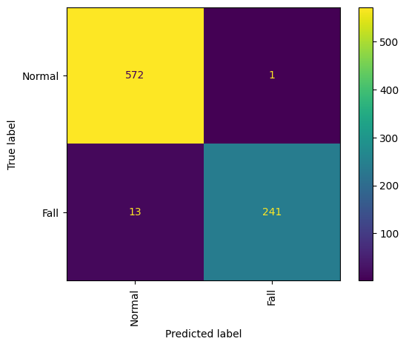Figure 3: the results using the test dataset.

## Discussion

The goal was to from acceleration measured in 3D (x, y, z), obtained from a mobile device (e.g. Phyhox app), and predict the possible outcome of a fall. The results show demonstrates that this can be done by a deep learning approach.

With respect to the the misclassified data when using the test data set, one possible explanation for this is that is might be difficult to state exactly what constitutes a fall. The sliding window might contain the initial phase of a fall, i.e. the stumble, while next sliding window contain the fall, and later on the initial part of the window will only have the ending part of the fall. Ideally only the window that covers the entire fall, from beginning to end, is a true fall. The other two, covering initial or ending parts should be flagged as a “normal” state. The problem is that it is not clear when a fall starts and how to determine when its over.

With respect to sliding window size, the tested approaches here seems to concur that a size of 100 data points (or 200, since the resolution is decreased) is sufficient for the training, validation and test data. A larger window results in that to much is included prior to the fall, i.e. the normal case, and smaller makes it difficult to capture the fall since only a fragment of the fall is present in the window.

Another feature that may have impact on the result is that the training data was made on B/W images, without axis and legend. Although this prevents detection in which direction the acceleration occur, it seems like the deep learning approach carefully maps out the pattern of a fall.

For further investigation there is also the preventive action, i.e. is it possible to forecast which study subjects that have a risk of a fall? It might be expressed in a different situation e.g., the way the subject sits down, walks or enters a vehicle (car).

# Conclusion

The goal was to from acceleration measured in 3D (x, y, z), obtained from a mobile device (e.g. Phyhox app), and predict the possible outcome of a fall. This goal is reached, due to the fact that 98.3% (accuracy) is predicted correctly with the deep learning MLP.

The study also show that a simple mobile app (e.g. PhyPhox) can be used as a measuring device and provide with real time measurements for predicting the outcome.

# References

* Centers for Disease Control and Prevention. (2020). Falls and fractures in older adults: Causes and prevention. National Institute on Aging. Retrieved from <https://www.nia.nih.gov/health/falls-and-fractures-older-adults-causes-and-prevention>
* Montero-Odasso, M., van der Velde, N., Martin, F. C., Petrovic, M., Tan, M. P., Ryg, J., ... & Iliffe, S. (2020). World guidelines for falls prevention and management for older adults: A global initiative. Age and Ageing, 51(1), 1–33. https://doi.org/10.1093/ageing/afaa202
* National Institutes of Health. (2020). Falls and falls prevention: Lower your risk as you age. Retrieved from <https://pmc.ncbi.nlm.nih.gov/articles/PMC7093636/>
* Sucerquia A, López JD, Vargas-Bonilla JF. SisFall: A Fall and Movement Dataset. Sensors (Basel). 2017 Jan 20;17(1):198. doi: 10.3390/s17010198. PMID: 28117691; PMCID: PMC5298771.