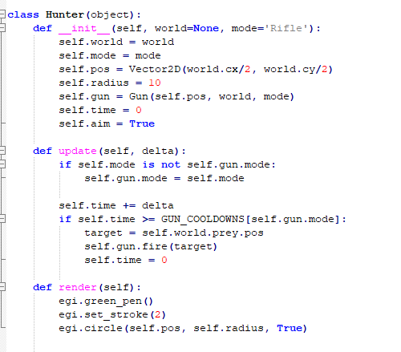**Spike:** Spike_9

**Title: Agent Marksmanship**

**Author: Daniel Newman**, 6449921

**Goals / deliverables:**

Develop a system that implements agent-targeting methods, predicting where the target is headed and using that to their advantage.

**Technologies, Tools, and Resources used:**

**Python 3.6.4**

**Python compatible IDE**

**Tasks undertaken:**

For this task we had to declare a few new classes to represent the different agent behaviours for this spike. We created a hunter class, who’s goal is to fire upon our prey class. The prey class is designed to simply wander around the world and provide a target for the hunter class. This was achieved by using the wander code we had developed earlier to create autonomous boids.

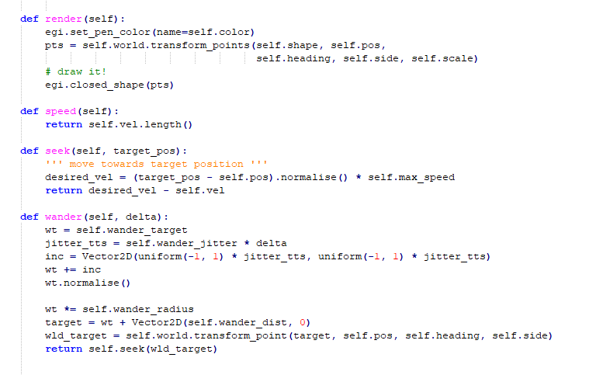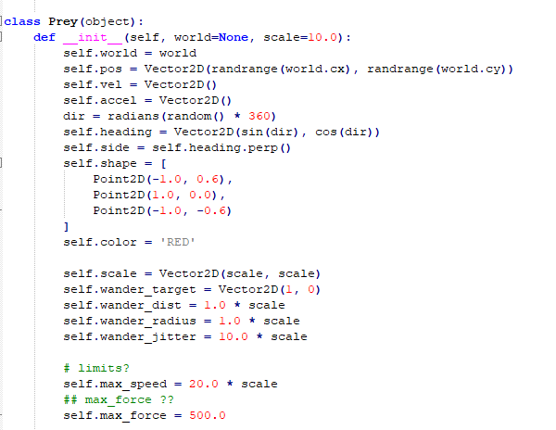

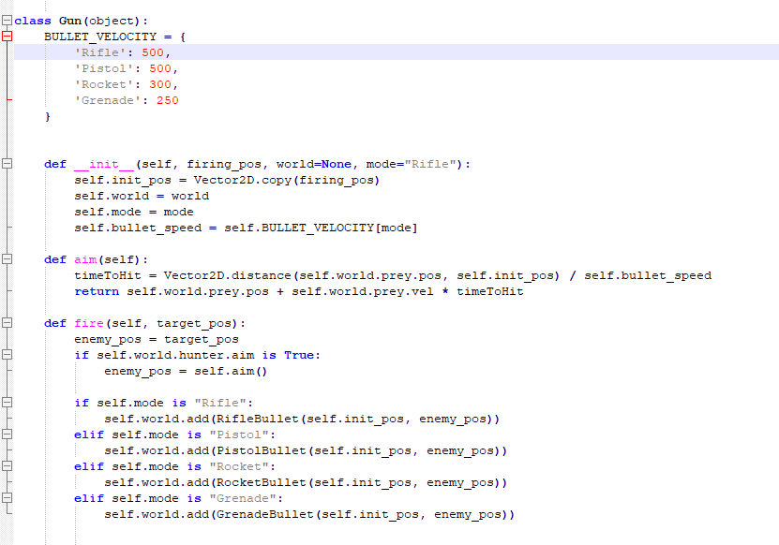

In order for the hunter to fire upon the prey, we had to give the agent a gun and in order to do that we had to first declare the gun class and assign the hunter an instance of the gun class.

The gun class is responsible for the different fire modes, aiming at the prey and firing upon it.

Our aim function is designed similarly to the earlier boids pursuit code, taking into account the prey’s position and velocity as well as the bullets velocity to predict where its future heading would be if the prey continued in its current direction.

The fire function simply instantiates the appropriate bullet based on the guns mode, passing the appropriate trajectory over to the bullet class to handle traversal and collision detection.

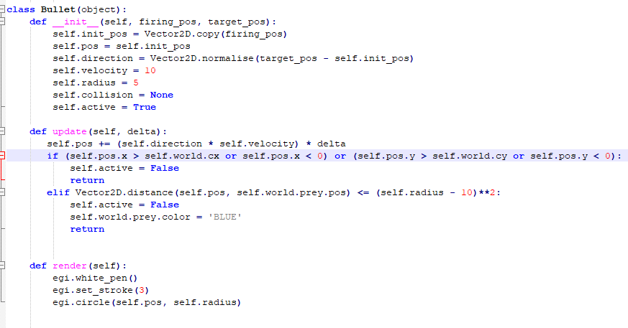

The Bullet class handles updating the position and rendering of the bullet.

In the update class, we check to see if there is any overlap between the bullet and the prey and if so, we remove the bullet from the world and change the prey’s colour to illustrate being hit

To demonstrate inaccuracies with certain weapons, we introduced some randomness into the target position so that not all bullets will hit the target if even if they are aiming for the prey.

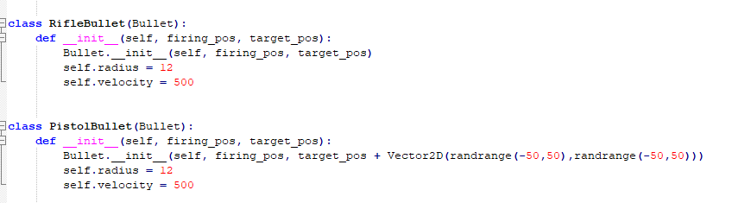

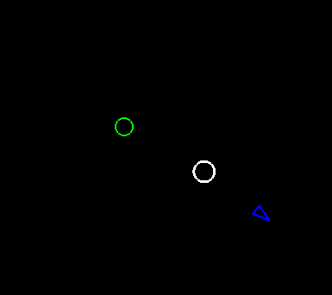

**What we found out:**

**From this spike we found out that we can create predictive behaviour using autonomous steering behaviours we developed earlier and adapt them to new situations. In this case our predictive behaviours allowed the hunter agent to behave in a realistic way and would be suitable for FPS non-player characters.**