# Generating Skeletal Structures with Magpie

An intricate internal lattice, shaped by local cell interactions with the mechanical environment, makes bones light-weight and strong. This inspired *Magpie*, a Grasshopper plug-in that relies on local interactions of ellipsoids with an input three-dimensional field to fill an arbitrary prescribed volume entirely with a light-weight and strong lattice structure. *Magpie* could be applied to design challenges on various scales, from foams to space frames via car chassis, particularly if low material use combined with high mechanical resistance to a single load case is a key design goal.

# How does Magpie work?

*Magpie* lattices are based on the packing of a prescribed geometry with locally-interacting ellipsoids whose shape is determined by a three-dimensional input field. A set of optional parameters can also be given as input. These parameters include the number of ellipsoids, the percentage of volume to be packed with ellipsoids, the minimum anisotropy (short axis divided by long axis) of the ellipsoids and the ratio of the smallest to the largest ellipsoid long axis as well as the weight of the alignment force. Examples are provided to give designers a feel for these parameters. The ellipsoid interactions are governed by intuitive engineering principles and are illustrated below.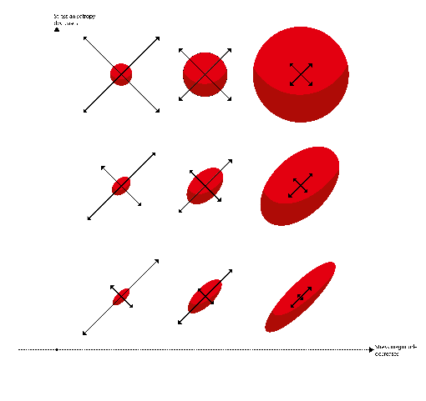

Figure 1: The relationship between the first two principal stress magnitude and directions (black arrows) at the ellipsoid centre and the local ellipsoid shape

## 

Figure 2: The align goal favours the arrangement of ellipsoid centres into a hexagonal grid.

*Magpie* is unique in that considers both magnitude and directionality of the forces the lattice is exposed to. The result is an elegant space-filling lattice consisting of modular struts and customised nodes.

*Figure representing how ellipsoids turn into a lattice*

**How good is *Magpie*?**

Computational structural analysis tests with GSA using *Magpie’s* default input parameters on a beam in bending showed less deflection and higher buckling factor compared to a traditional space frame geometry, despite using less material.

## Comparison figure

# Getting started

Here is quick start guide to Magpie. It is aimed at designer with either beginner (1. a) or intermediate (1. b) C# scripting skills. If you’d like to contribute to the development of *Magpie*, you can find the codebase (open-source) and documentation [in this github repository](https://github.com/Dan-Piker/MechanoAdaptiveGeneration/).

1. **Installing Magpie**:
   1. Make sure you are using the latest versions of Kangaroo and Kangaroo2 in the usual GH components folder.
   2. For some of the postprocessing parts, you’ll additionally need the [Sandbox Topology](http://www.food4rhino.com/app/sandbox-topology) GH plugin and [tetgen](http://wias-berlin.de/software/tetgen/) installed.
2. **Running Magpie:**

We have prepared two example GH files in the ./gh repository:

* 1. structural-ellipsoid-packing-with-magpie-examples.gh  
     This file demonstrates the basic use of the Magpie features: use the solver in a compiled form (simpler) and from a C# script (more customizable), saving and opening results, and visualising and creating input fields.
  2. postprocessing-magpie-example.gh  
     This file demonstrates how to postprocess the Magpie output and make it into a collection of curves representing an optimized space frame.

Please get in touch with Alessandro ([afelder@fosterandpartners.com](mailto:afelder@fosterandpartners.com)) or Daniel ([dpiker@fosterandpartners.com](mailto:dpiker@fosterandpartners.com)) with any questions or feedback. If you use Magpie in your research, please cite this paper.

# Why is it called Magpie?

MAG, the first three letters of Magpie, stands for Mechano-Adaptive Generation of space frames. PIE stands for everybody’s favourite food, pie. Magpies (the birds) are the only non-mammal species we know is self-aware. Apart from their predominantly black and white plumage (a reference to early GH plug-ins named after black and white animals), Magpies have many further fascinating characteristics.