May 2022

SCHOOL OF COMPUTING AND MATHEMATICAL SCIENCES, UNIVERSITY OF LEICESter

CO3201 Computer Science Project: Dissertation

LEGO: SET CHECKLIST CREATOR

DAN Booth

## Abstract

## Introduction

Ever since I was young, I have always loved building and playing with Lego, getting Lego sets regularly for Christmas and birthdays. Over time as I got more Lego sets, I had to take some older sets apart to make room for newer ones. The Lego pieces from these sets would be stored in separate containers so that if I wanted to rebuild a set, I could simply get that certain container. However, as I got more Lego sets these pieces became muddled so that it was no longer as simple as picking a container. This can be done using the list of pieces in the back of the Lego set’s instruction booklet and as I find the pieces tick them off this page. This can work when rebuilding the set for the first few times but after a while, it can become very difficult because there are ticks all over the page. Therefore, having a digital checklist for pieces in a Lego Set would help fix this issue as once you have built the set, the next time you go to rebuild it the checklist will be blank, and you can start all over again.

For example, you have a Lego set that you have taken apart and put all the pieces in a box along with other Lego pieces, and you would like to rebuild the set, you could do this easily using a digital checklist.

The target users for my project will be 18+ Lego builders, enthusiasts, and collectors (referred to as ‘Lego enthusiasts’ from now on for briefness) who are looking to build or rebuild a Lego set they own.

### Aim

The key aim of this project is to create a digital checklist for pieces in a Lego Set. Users can find and then select a Lego Set they would like to see the pieces for. They can then view all the pieces in this Lego set (like in the back of the instruction book), and they can check they have all the pieces when they are building the set again.

### Objectives

1. Write a program to connect to a Lego Set API and retrieve data
2. Learn how to turn JSON files into a class
3. Build an application using the Spring Model-View-Controller (MVC) framework
4. Design a cross-platform website (view) from which users can use the system
5. Implement a cross-platform website (view) from which users can use the system
6. Design a way for users to save progress on a checklist
7. Implement a way for users to save progress on a checklist

## Survey of Literature/Information Sources

### Preliminary Research

To begin with, I looked up the Rebrickable API [1] that contains data for Lego sets, that I am going to use, that can search through to find a Lego set and the pieces within this set. I also read the documentation for the API [2], finding out that it's a RESTful API (meaning I can use HTTP requests to access data) and to access the data I need an API key that is freely available with an account. Using the API you can request a Lego set directly using the Lego set unique number, or search using “A search term”, filter using “theme_id (a number associated with a Lego theme e.g. Star Wars, that can be retrieved also using API), min_year, max_year, min_parts, max_parts” and order by a certain “field” (“set_num”, “name”, “year”, “theme_id”, “num_parts”). Data is returned from the API in the form of JSON files, and a set returns “set_num”, “name”, “year”, “theme_id”, “num_parts” and “set_img_url”, but to retrieve a JSON of all the pieces in a Lego set another call to the API needs to be performed. This returns a list containing each part however this cannot be ordered using the API.

### Questionnaire Introduction

I then performed some data collection on what my target users would like from a digital checklist for pieces in a Lego Set, via an online questionnaire (see **Appendix A**). Using this I could identify their key requirements and features for the system, for example where they would like to use the system, how they currently check they have all the pieces for a Lego set, other tools they use for research, how important certain features would be to them and if they have any other ideas for features.

### Questionnaire Results and Further Research

My questionnaire received a reasonable number of responses (20 responses) and from the results of this questionnaire, I was able to decide on certain features and requirements for my project. (For full results to questionnaire see **Appendix B**).

Figure – Question 1 Results

Question 1 showed me that the majority of users (75% see Figure 1 above or **Appendix B**) would like to use the digital checklist on both PC/Laptop and mobile devices, which helped inform me that my digital checklist for pieces in a Lego Set should run on both these types of systems.

I also learnt from questions answers to 2 and 3 (see **Appendix B**) that Lego enthusiasts who use a digital tool use the website Bricklink [3]. I found that on Bricklink users can add pieces from a Lego set to a “wanted list” and from there tick of parts you have. This shows the user how many pieces they need and how many they currently have found. However, this number easily be changed by accident which could cause issues. For example, users could believe they have all the pieces for a set but they accidentally decreased how many pieces they needed so are missing one, or the opposite where they increase the number they need but have all of them. Users can’t filter pieces by colour or type making it difficult to find pieces, also when pieces are fully found they are not hidden from the list. Any pieces missing can easily show a list of possible locations to buy them. Most of these issues appear because the purpose of the tool is to buy pieces for a Lego set.

The answers from question 3 (see **Appendix B**) also show some people currently use the Rebrickable website [4]. On Rebrickable, which also provide the API I am going to use, users can find a Lego set by typing in the set number or searching by a text search (i.e. Set Name) and filter by a range of year released, range of the number of parts and also filter by themes. On the page of a set (e.g. this Lego Set [5]) users can see a list of all parts, the instructions, pictures of the Lego set, year released, number of parts etc. Here if the user has an account they can add the set parts to a List. On the list, the user added parts too, users can filter by piece colour, type (Category) and sort by colour, Hue, part, type (category) and price to buy the Lego piece. Users can see how many each piece is required as well as the colour and price to buy it but to check a piece off the list, the user has to delete it from the list meaning you can’t undo the change, also users can change the number of certain pieces needed but not see the original number (like BrickLink see above). This is primarily due to the fact the tool is meant to help users buy Lego pieces for a set, also the same as Bricklink, but can be used as a makeshift checklist.

Overall, the results of questions 2 and 3 (see **Appendix B**) has helped me find and research similar software and helped give me ideas on what would be useful to use from them.

Figure – Question 4 Results

The results of question 4 (see Figure 2 above or **Appendix B**) provided lots of useful information about how users would like to search for a Lego set. Some of the answers were very conclusion for example 19 people said that searching by ‘Age Range’ for a Lego Set was not need showing me that there is no demand for this search parameter. Likewise, all 20 respondents stated they would like to be able to search by ‘Set Number’.

The answers to the ‘Set Pieces’ section of question 4 (see **Appendix B**) are quite varied, with 8 responses saying it was ‘not needed’, which was one more the ‘Filter by’ (7 responses) and one less than ‘Sort by’ (9 responses). This shows filter and sort for ‘Set Pieces’ only just make up the majority of responses showing that maybe this is not a key requirement when searching for a set but would still be useful.

Overall conclusions that I can draw from question 4 is that overall users would like to search by ‘set number’ and ‘set name’ when trying to locate a Lego Set. They would also like to filter by the ‘year made’, ‘theme’ and ‘Set Pieces’ as well as sorting by ‘Theme’, ‘Year Made’ and ‘Set Pieces’.

The results of Question 5 (see **Appendix B**) show that most people find it important or very important that a digital checklist the Lego pieces can be sorted by colour and type of piece, showing this should be a key feature of my digital checklist. However, being able to filter by Lego pieces type and colour are shown to be not as important and therefore are not as key to people. Finally, having a link to buy a missing Lego piece and being able to scan Lego pieces in a set to see if they are there and then check them off, have very mixed answers showing they should be nothing more than optional for the checklist.

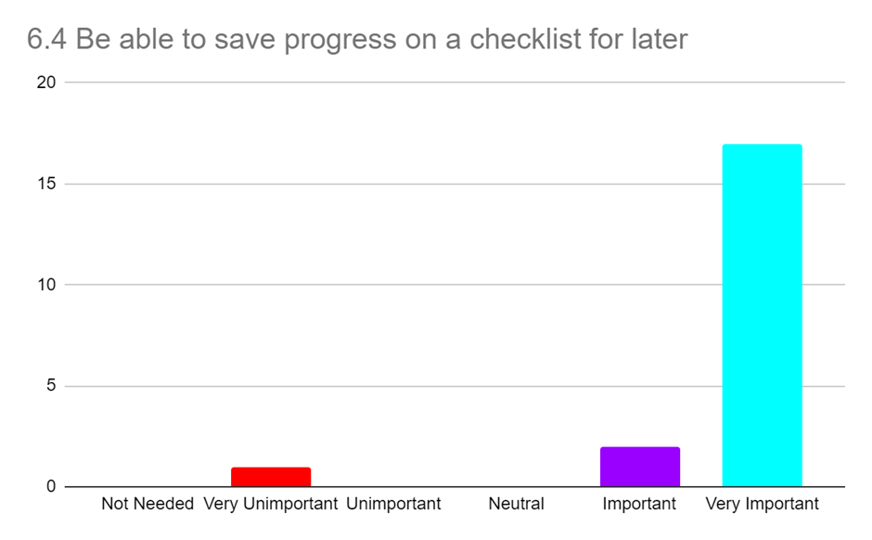

Figure – Question 6 part 4 (Be able to save progress on a checklist for later) Results

Question 6 results (see **Appendix B**) shows that it is very important to most people (17/20 see Figure 3 above) to be able to save progress on a checklist making this a key requirement for the system. Being to view and download instructions is also important to most users, as is being able to save Lego sets they own to a list meaning this is also key. The responses to having a favourites list for Lego sets are very mixed but mostly positive showing that it would be nice to have but not key.

From the responses to question 6 I went and found the Brickset API [6] that requires a free API key, and I can use it to retrieve Lego set instructions (as the current Rebrickable API cannot do this). These are returned as a list of instruction PDF links, in a JSON file. This API also allows users to search for Lego Sets, but I will only use this API for retrieving instructions as it does not contain data on pieces within a Lego set, which is a vital part of the project.

Figure – Question 7 Results

Finally, the results of question 7 (see Figure 4 above or **Appendix B**) where users are allowed to add any ideas for any other features gave some useful ideas. For example, being able to also scan bricks with a webcam as well as a mobile for PC/Laptop users. As well as if there are multiple Lego pieces of the same type and colour on the checklist being able to record the specific number of these found. Finally, another feature suggested was to import and export XML files like a Bricklink [3] wanted list. I took these suggestions into account when designing my requirements.

## Design and Implementation

### Requirements

#### Key Features:

* The system must be usable as a website on both mobile and PC/laptops
* The system must display a list of all Lego sets stored in Rebrickable API [1]
* The system must have a search feature that allows users to search a list of Lego sets. Can search by set number and text search (e.g. set name), and filter and sort by year made and set theme.
* Users must be able to ‘check’ piece off the checklist, showing how many more of that piece are remaining
* The system must show on the checklist (for Lego pieces in a set) a picture of the piece, with correct colour, as well as an alternative text description including piece name and colour
* Users must be able to sort a checklist by colour and type of a Lego piece
* The system must be usable with and without a user account
* Users must be able to save progress on a checklist

#### Nice to have Features:

* The system may have an additional search parameter to sort and filter by number of pieces in a Lego set
* The system may have an additional search parameter to sort alphabetically by Set Name
* The system may have a consistent and simple UI
* Users may be able to view instructions for a Lego set
* Users may be able to download instructions for a Lego set
* Users may be able to filter a checklist by the colour of a piece
* Users may be able to filter a checklist by type of a piece
* The system may have a link to buy a missing piece from a Lego Set
* Users may be able to create an account
* Users with an account may be able to save sets they own to a ‘Sets Owned List’, so they can easily find them later

#### Optional Features:

* Users with an account could create lists for Lego sets and save sets to them, so they can easily find them later (Sets can be in multiple lists)
* Users could search their ‘Sets Owned List’ and other lists for Lego sets, like the main search feature
* The system could save users progress on a checklist to the database
* The system could also be a mobile application
* Users could scan Lego pieces with a phone camera or webcam to check if the piece is in a Lego list
  + If it is in the set (and not already enough of them), there is an option to check pieces off the Digital Checklist
  + If in the set but already have all that type of piece needed, it will inform the user of this
  + If not in set it will inform the user of this
* Users could import and export a checklist as an XML file in the Bricklink [3] wanted list format

### High-level overview of the architecture of the system

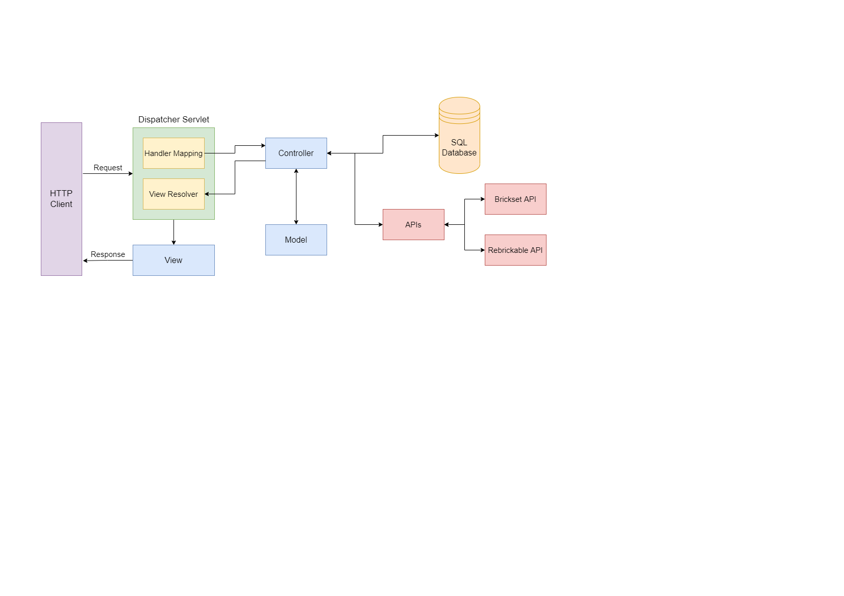

Figure – High-Level Overview

Figure 5 above shows a high-level view of the Spring MVC architecture that my website will use. Where the view will be the JSP that is displayed to the users on the HTTP client (their web browser). When the user interacts with the View, via the web browser, a request is sent to the Dispatcher Servlet. Here the Dispatcher Servlet will use the Handler Mapping to match the request URL to the correct Controller. The controller will then call APIs or interact with the SQL database to collect and edit information as needed, it will then update attributes in the Model, before returning the name of the next View to the View Resolver. View Resolver, which locates the correct View add adds in the Model attributes. This View is then sent back to the HTTP client as a response.

### APIs

#### Rebrickable API

The Rebrickable API [1] (as mentioned above see **Error! Reference source not found.** **Error! Reference source not found.**) stores all the data about all Lego sets and the Lego pieces in these sets, as well as all the Lego themes and which sets are in them. This API will be used to search for Lego sets and retrieve all the Lego pieces in a Lego Set.

#### Brickset API

The Brickset API [6] (as mentioned above, see **Error! Reference source not found.** **Error! Reference source not found.**) will be used to obtain PDF instructions for a Lego set so users can view and download these for a Lego set.

### Database

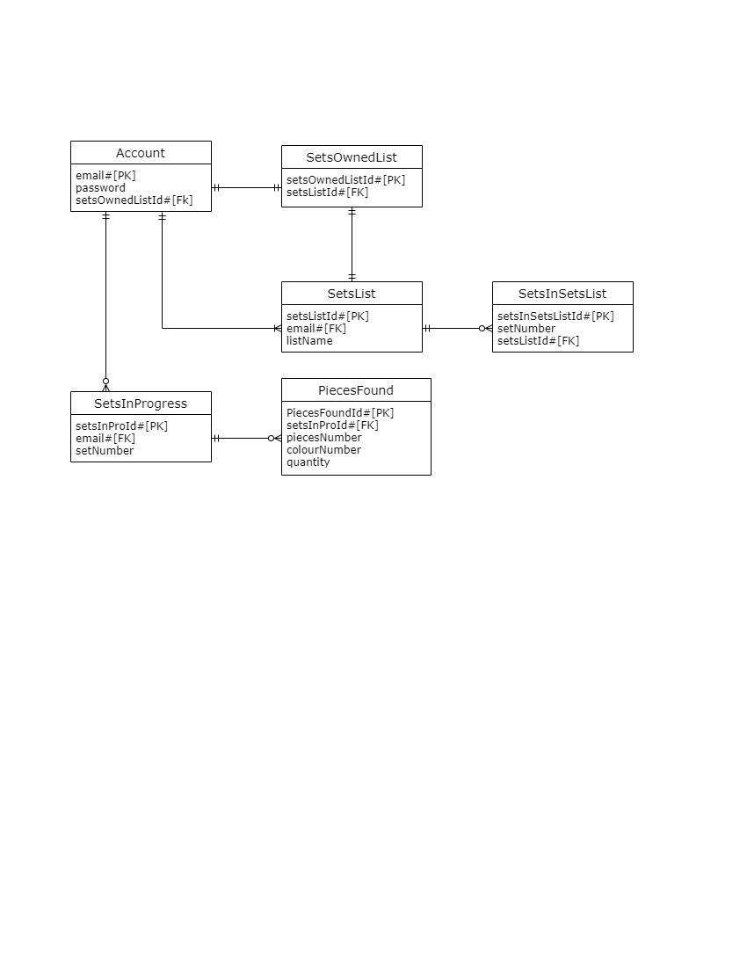

Figure – ER Class Diagram

I will use MySQL for my database, and Figure 6 above shows an ER class diagram for this database, that may change depending on the requirements completed. The database will have several tables called Account, SetsInProgress, PiecesFound, SetsList, SetsInSetsList and SetsOwnedList.

Account will be used to store user accounts, with their email as the primary key (as this is already unique), a password (that will be encrypted by hashing with salt) and a foreign key setsOwnedListId that links to the SetsOwnedList table which is explained later in this section.

SetsInProgress stores the sets that a user currently has a checklist in progress for, with the user’s email as the foreign key so it's easy to find which user it belongs to and the set number. Then the pieces that the already been found are stored in the PiecesFound table, which stores the pieces number, colour number and the quantity currently found (if 0 pieces have been found these won’t be saved to save database storage).

SetsList table will store lists the user has created, that contain Lego sets (called set lists). The table stores the name of the list and a unique id of the list that is used to find the sets that belong to the list in the SetsInSetsList table. SetsInSetsList stores the set numbers of a set saved to a list, with a unique id as the primary key for each set saved, a set number should not be used a set could be in more than one list.

Finally, when a user creates an account, they are automatically given an empty set list called Sets Owned List, and this list is stored in the SetsList table with other set lists. This list is linked to a user via the SetsOwnedList table that holds the id of the row in the SetsList table and a unique number called setsOwnedListId that (as mentioned above) is also a foreign key in the Account table. This is done so that a user’s Set Owned List can be easily found.

### Class Diagram

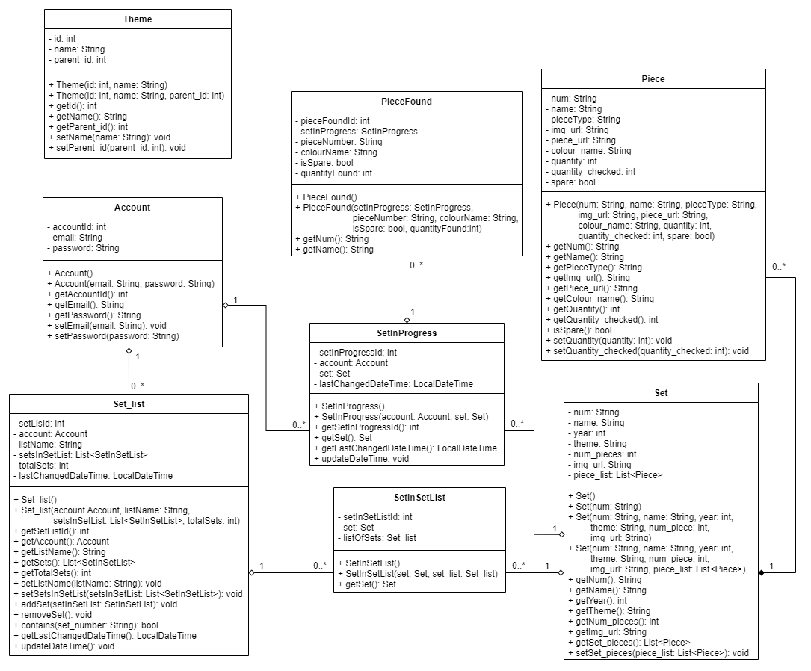

Figure – Class Diagram

Figure 7 above is a class diagram for my system, with several classes Set, Piece, SetInSetList, Set_list, SetInProgress, PieceFound, Account and Theme.

The Set class is used to store Lego set data from a JSON file received from the Rebrickable API [1]. This data includes the Lego Set’s Number (‘num’) which is a unique number that identifies the Lego Set, and this is a string because all set numbers contain a '-' that is followed by a version number that donates different versions of certain sets, with the standard being '-1'. It also contains the ‘name’ of the Set, the ‘year’ released, the ‘theme’ the set belongs to, the number of Lego pieces (‘num_pieces’) in the set, a URL for an image of the set (img_url). Finally, there is an attribute called ‘piece_list’ which is a list of the class Piece and is used to store a list of all Lego pieces in a Lego set.

The Piece class is used to store information about a Lego Piece from a JSON file received from the Rebrickable API [1]. This contains a piece number (‘num’) and this is a string as these sometimes contain letters, ‘name’ of the piece, a ‘pieceType’ which is the type of Lego piece the piece is, a ‘colour_name’ that’s the colour of the piece, ‘quantity’ which is the number of these pieces that are required to build the Lego Set, ‘quantity_checked’ which is the quantity the user has checked off this pieces and finally ‘spare’ which denotes if this piece is a spare provided with the Lego Set but not required to build the set.

The SetInSetList class is used to link the Set_list class and Set class, and is used for the database (using JPA annotations [7]) so that information on a Lego set does not have to be saved several times if in several set lists, and can just save a table that links to the set via the set’s number. It contains a unique auto-generated id (‘setInSetListId’) used as the primary key for the table in the database, ‘listOfSets’ is the set list the set is in and ‘set’ is the set that is in the set list.

The Set_list class is used to store a list of Lego sets retrieved from a user’s saved list of Lego sets form the database, this class is also used to create the database using JPA annotations [7]. It contains the name of a list (‘listName’), the user ‘account’ the list belongs to, ‘setListId’ is a unique auto-generated id used as the primary key in the database, the number of sets in the list (‘totalSets’), ‘lastChangedDateTime’ which holds the last date and time the class was changed and is used so that the last 3 used set lists can be displayed to the user on the home page and so that the last accessed list is at the top of the selector when selecting a set list to add a Lego set to. Finally, there is a List of type SetInSetList (‘setsInSetList’), that is used to store all the Lego sets in the list. It contains several functions with the ‘contains()’ that checks if a sets in the list, ‘updateDateTime()’ sets the ‘lastChangedDateTime()’ to the current date and time, ‘addSet()’ adds a set to the list and increases total sets by 1, and ‘removeSet()’ that decreases total sets by 1.

The SetInProgress class also uses JPA annotations [7] to generate a table that connects a user’s account to a set checklist that they have saved to the database. Similarly, to the SetInSetList class this links to the Set class so that in the database set information is not saved multiple times, by having a variable ‘set’ of type Set. This also contains the user ‘account’ the set in progress belongs to, ‘lastChangedDateTime’ which holds the last date and time the class was changed (used like Set_list to display last 3 last saved sets in progress), and ‘setInProgressId’ is a unique auto-generated id used as the primary key in the database. This also contains a ‘updateDateTime()’ which operates in the same way as in the Set_list class.

The PieceFound class is another class that is used to create the database (using JPA annotations [7]). This class is used to store pieces from SetsInProgress, and only contains information that makes each piece unique, the ‘pieceNumber’ which is unique, the piece’s colour (‘colourName’) and if it is a spare piece (‘isSpare’) and finally how many of this particular Lego piece have been found (‘quantityFound’). It also has a auto-generated primary key ‘pieceFoundId’.

The Account class is used to create the database table (with JPA annotations [7]) that holds an account user’s information. It has a user’s auto-generated primary key (‘accountId’), the users ‘email’ and ‘password’ that are used by a user when logging into the website.

Finally, the Theme class holds information about Lego Set themes received via a from a JSON file received from the Rebrickable API [1]. This class is separate from the other tables and is used to store all the themes so that each time a set is received from the Rebrickable API [1], the program does not have to call the API again with a theme number to retrieve that theme’s name. It contains a unique ‘id’ used to identify the theme, the theme’s ‘name’ and ‘parent_id’ which is id of the theme that this theme is a sub-theme for.

## Results and Discussion

## Critical Appraisal

## Conclusion

## References

1. "Rebrickable API | Rebrickable - Build with LEGO", *Rebrickable.com*. [Online]. Available: https://rebrickable.com/api/. [Accessed: 17- Nov- 2021]
2. "Rebrickable API Documentation | Rebrickable - Build with LEGO", *Rebrickable.com*, 2020. [Online]. Available: https://rebrickable.com/api/v3/docs/?key=15b84a4cfa3259beb72eb08e7ccf55df. [Accessed: 15- Nov- 2021]
3. "BrickLink - Buy and sell LEGO Parts, Sets and Minifigures", *Bricklink.com*. [Online]. Available: <https://www.bricklink.com/v2/main.page>. [Accessed: 17- Nov- 2021]
4. "Rebrickable | Rebrickable - Build with LEGO", *Rebrickable.com*. [Online]. Available: https://rebrickable.com/. [Accessed: 17- Nov- 2021]
5. "LEGO Set 75280-1 501st Legion Clone Troopers (2020 Star Wars) | Rebrickable - Build with LEGO", *Rebrickable.com*, 2021. [Online]. Available: https://rebrickable.com/sets/75280-1/501st-legion-clone-troopers. [Accessed: 17- Nov- 2021]
6. Huw, "API version 3 documentation", *Brickset.com*, 2021. [Online]. Available: https://brickset.com/article/52664/api-version-3-documentation. [Accessed: 17- Nov- 2021]
7. Mihalcea, V., Ebersole, S., Boriero, A., Morling, G., Badner, G., Cranford, C., Bernard, E., Grinovero, S., Meyer, B., Ferentschik, H., King, G., Bauer, C., Andersen, M., Maesen, K., Vansa, R. and Jacomet, L., n.d. Hibernate ORM 5.5.9.Final User Guide. [online] Docs.jboss.org. Available at: https://docs.jboss.org/hibernate/orm/current/userguide/html_single/Hibernate_User_Guide.html [Accessed 28 February 2022].
8. del

## Appendix A

Questionnaire for what user would want from a digital checklist for pieces in a Lego Set.

## Appendix B

Results from my questionnaire (see **Appendix A**).

Letter of Consent Result

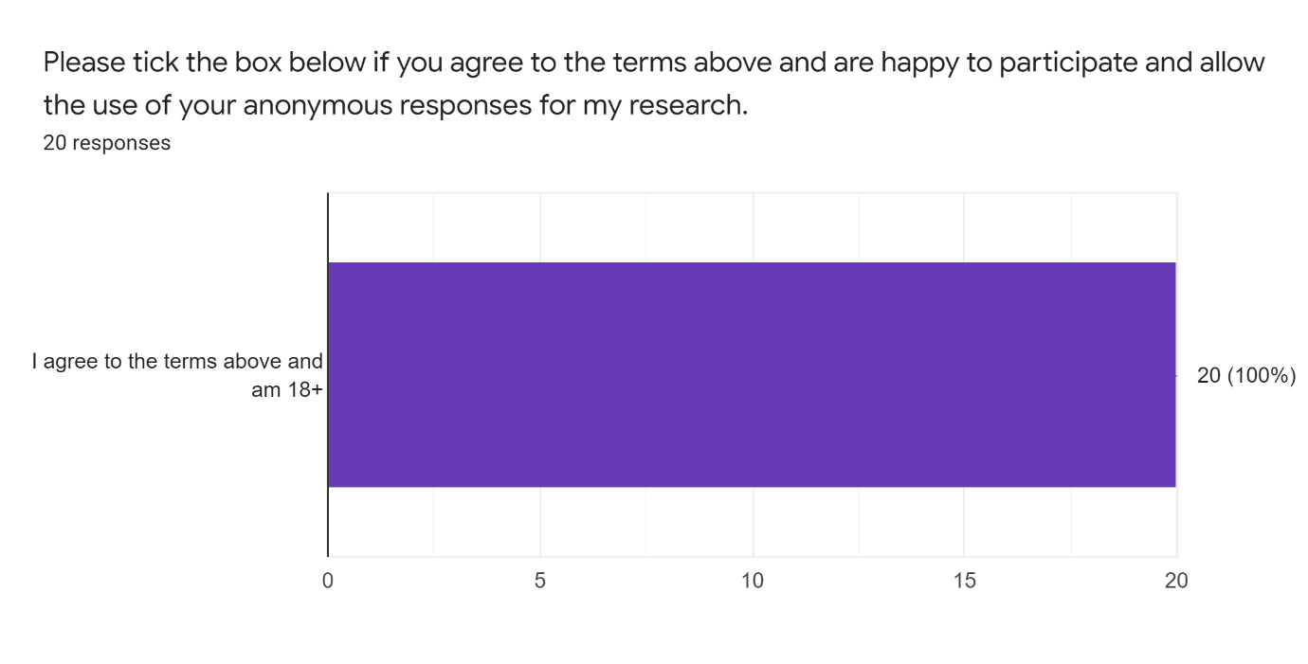

6. How important would the following features be to you in a Digital Checklist for Pieces in a Lego Set ?



