# **3. Application Showcase**

## **3.1. User Interface**

The user interface can be reached by simply accessing the website. It has multiple functionalities which the user can access like user registration, user log in, product browsing, a shopping cart and an order placement page.

**The home page**

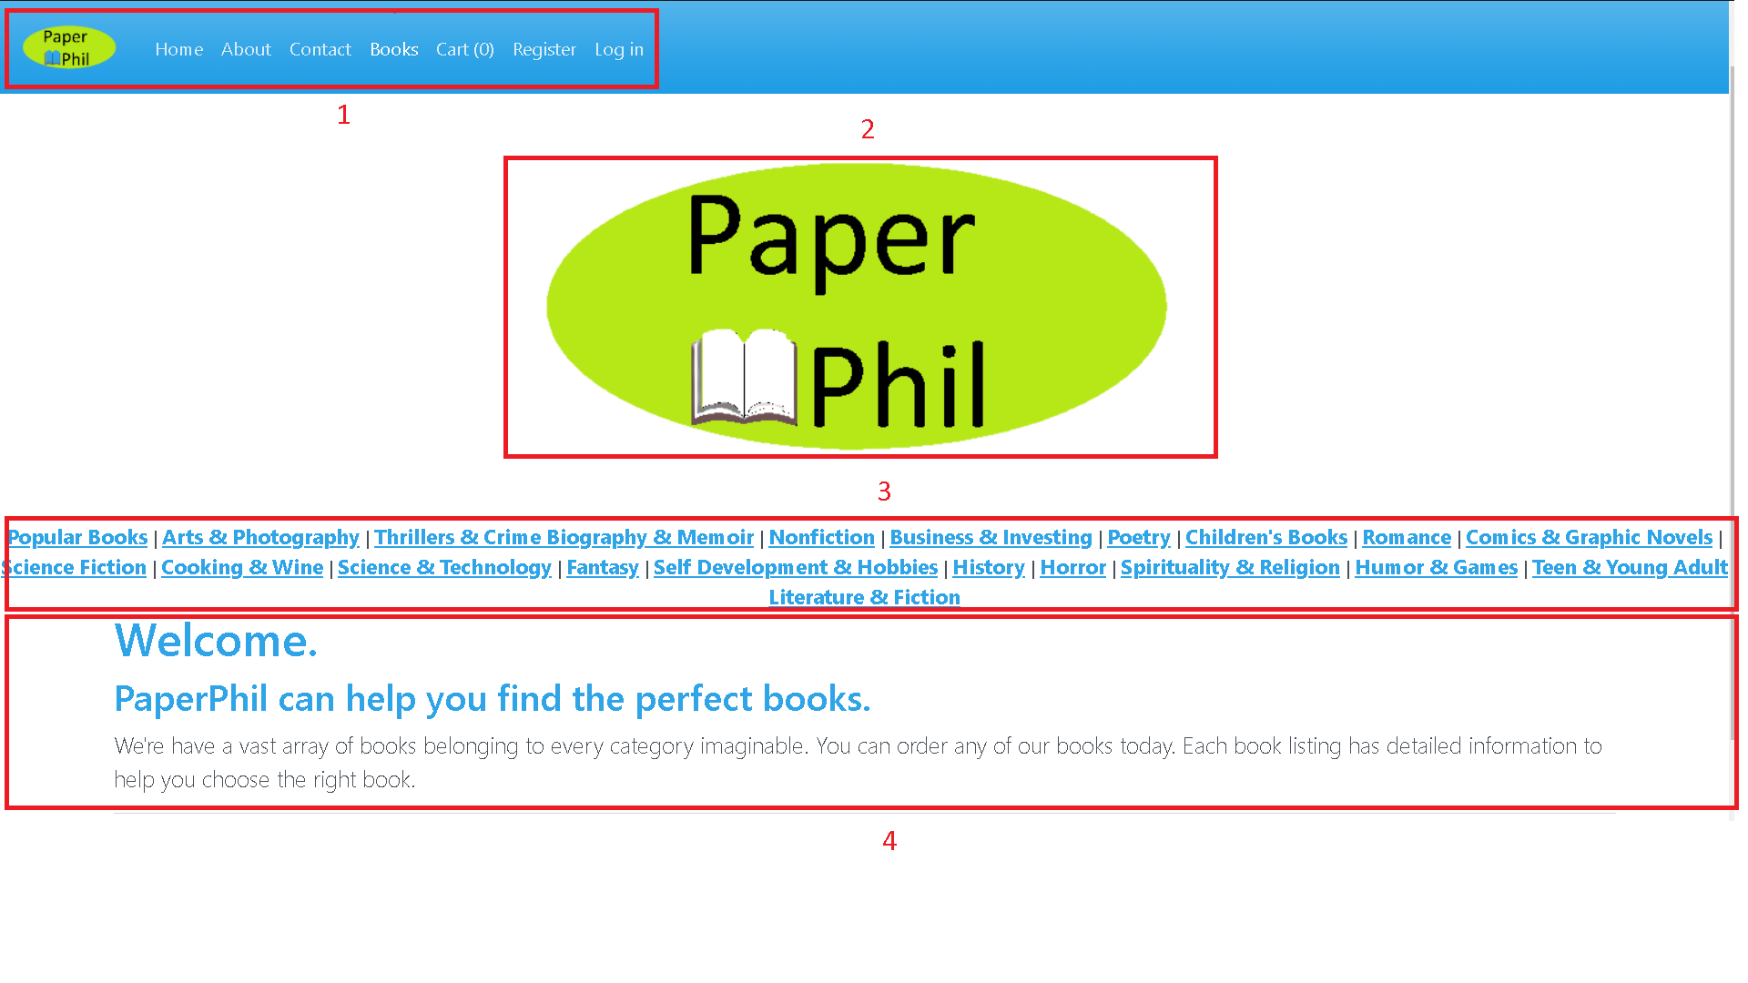

Fig. 16. Home Page

*Source: PaperPhil application*

1. This is the navigation bar. Each element of it leads to a different page in the whole assembly of the website. The logo to the far left of the navigation bar serves as a link that leads to the homepage of the website. An additional home link was added in order to prevent people that do not know how to use the Internet to not be able to navigate to it. The next link contains an “About” page which should serve to inform the user of details in regards to the company and of its different policies. The contact page can be accessed if the user wants to find out what the company’s contact details are. The “Books” page contains a list of all of the available books in the website’s database. The “Cart (0)” link leads to all of the products that the user has added to the cart, the number that is between the parentheses representing the amount of items that have been added to the cart. The “Register” link leads to a page where the user can create an account. The “Log in” Button leads to a page where the user can log into his account.
2. This logo acts as a button that also serves to lead the user back to the home page.
3. This is a list through which the user can navigate to different pages pertaining to the category name that was clicked on.

(1)(2)(3) The totality of these three elements constitutes the master page, which is used on every page of the application.

1. This section is filled with text that welcomes the user to the website

**The product list page**

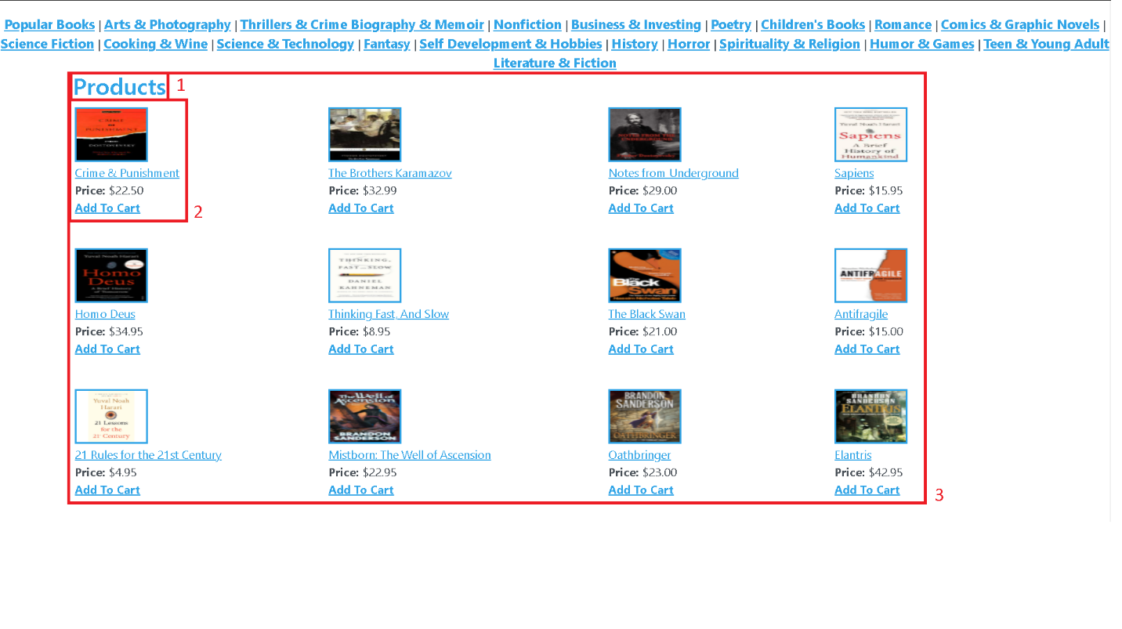

Fig. 17. Product list page

*Source: PaperPhil application*

1. This is the title of the section.
2. This element is based off of four components. The image helps the user better identify the desired product or a product which he might later buy based on the cover and it also acts as a link to a page which provides more details with regards to the chosen product. The name of the product also serves as a link towards the product details. The third element serves as an indicator of the product’s price. The “Add To Cart” button will add one unit of a product to the cart and it will redirect the user to the shopping cart page.
3. This section lists all of the products on the website on a single page.

**The product details page**



Fig. 18. Product details

*Source: PaperPhil application*

This page shows the exact details of a product. It starts off with the title of the product, then projects the image on the next row and continues exposing the release year of the product, its price, its ISBN, the author’s name, his website and nationality while it lastly lists the publisher’s name and its website.

**The about page**

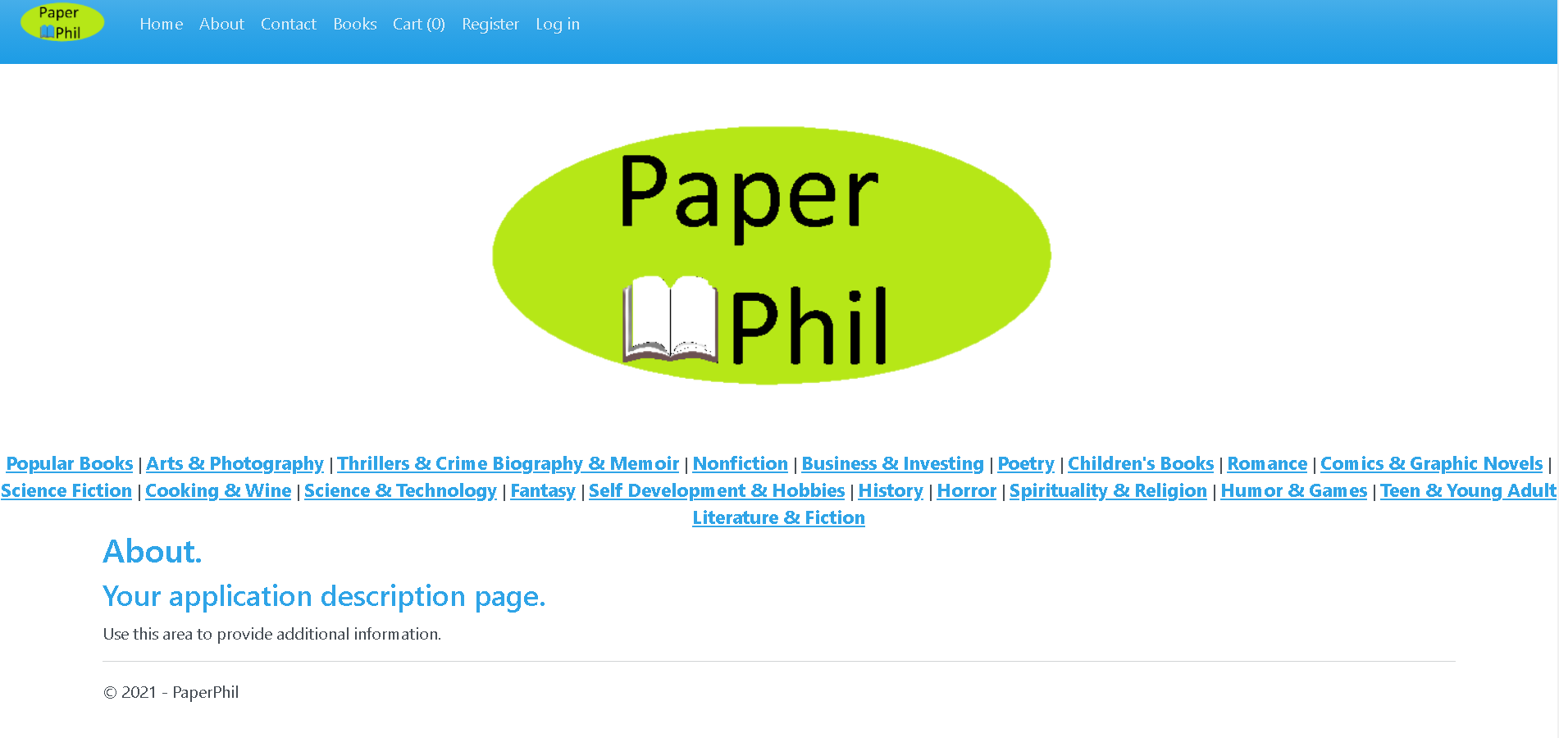

Fig. 19. About

*Source: PaperPhil application*

This is the about page. The administrator can edit and change their details in accordance to their needs.

**The contact page**

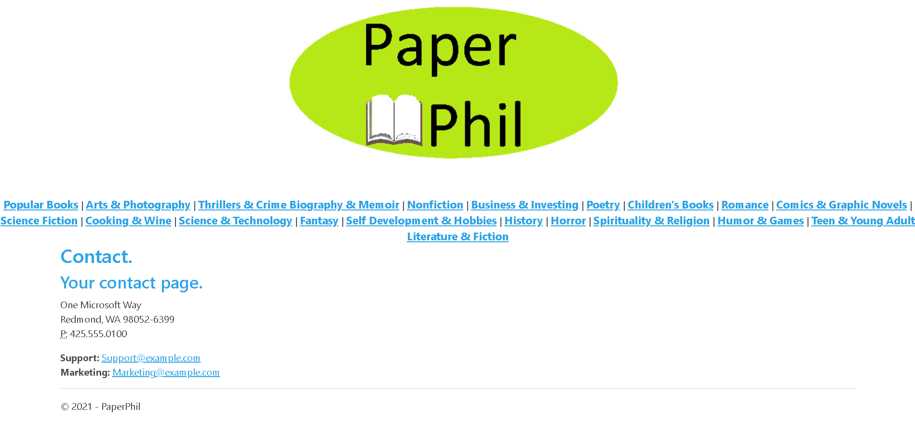

Fig. 20. Contact

*Source: PaperPhil application*

Similar to the about page, the contact page can be edited by the administrator in order to cater to their needs.

**The shopping cart page**

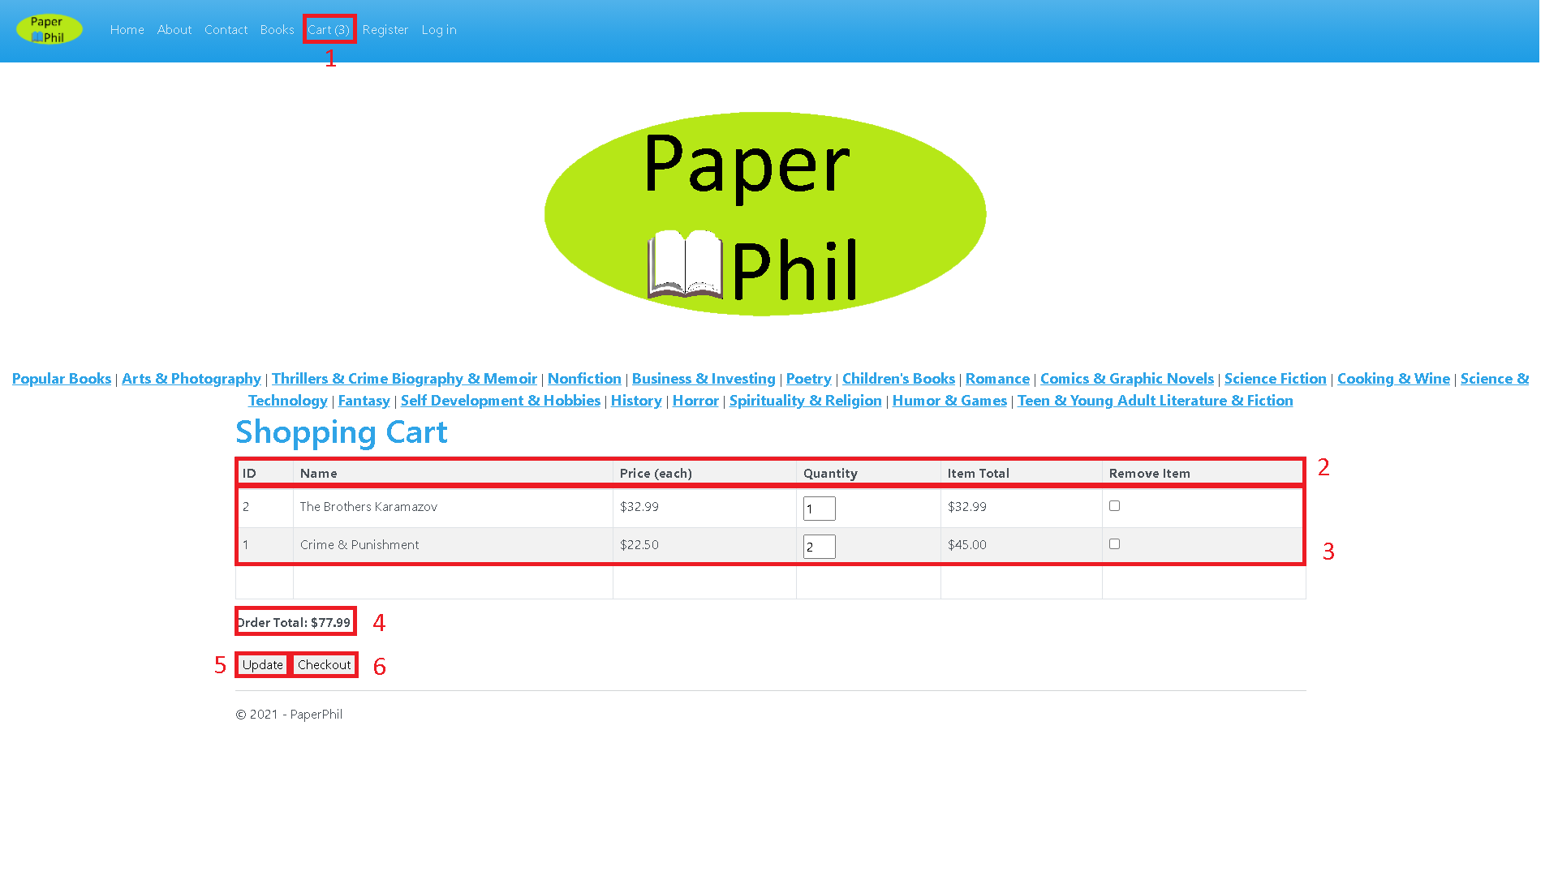

Fig. 21. Shopping Cart

*Source: PaperPhil application*

1. If the cart has products in it, the number between the parentheses increases by the quantity of products that have been added to the cart, three being the case in this image.
2. The top of the shopping cart table will indicate the certain category to which the product data belongs to, namely ID, name, price for each product, product quantity, item total and the option to remove a product from the cart.
3. The shopping cart’s items shall be listed below the title section. An example of a product in the shopping cart can be analyzed if we look at the third row. The product has an ID of “1” in the database, it is called “Crime & Punishment”, its price is $22.50, the quantity of products that have been added to the cart is 2 (it can be adjusted by typing a number in the quantity box and clicking the “Update” button), the total of all of the ordered “Crime & Punishment” copies is $45.00 and the item removal checkbox is unchecked, which means that we do not want to remove the product (by checking it and clicking “Update”, the product will be removed).
4. The Order Total represents the sum of the price of each product multiplied by its selected quantity. In this case, it is $77.99.
5. The “Update” button is used whenever we want to either modify the quantity of a product or remove a product.
6. The “Checkout” button will lead us to the Checkout page where we can complete the order.

**Empty shopping cart page**

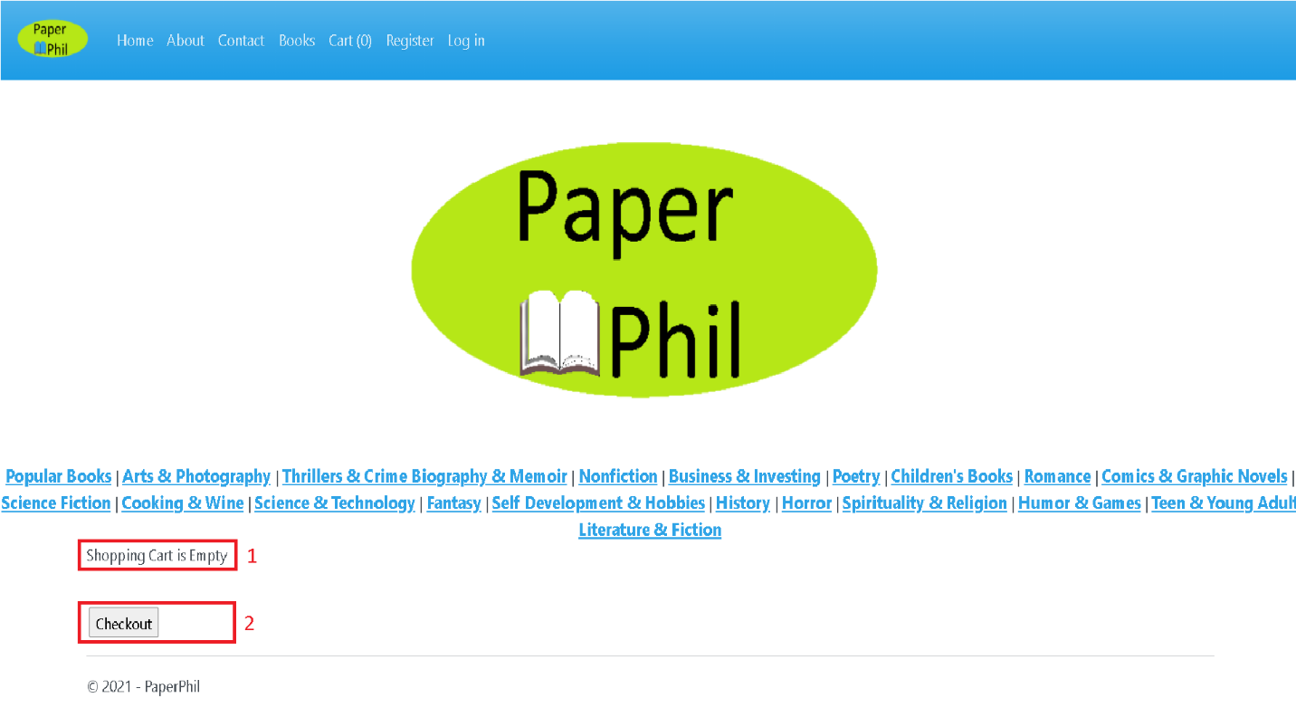

Fig. 22. Empty shopping cart

*Source: PaperPhil application*

1. This is the shopping cart page. If no products have been added to the basket, the message “Shopping Cart is Empty” will be displayed.
2. The user can still click the “Checkout” button. He will be met by an empty page, however.

**The checkout page**

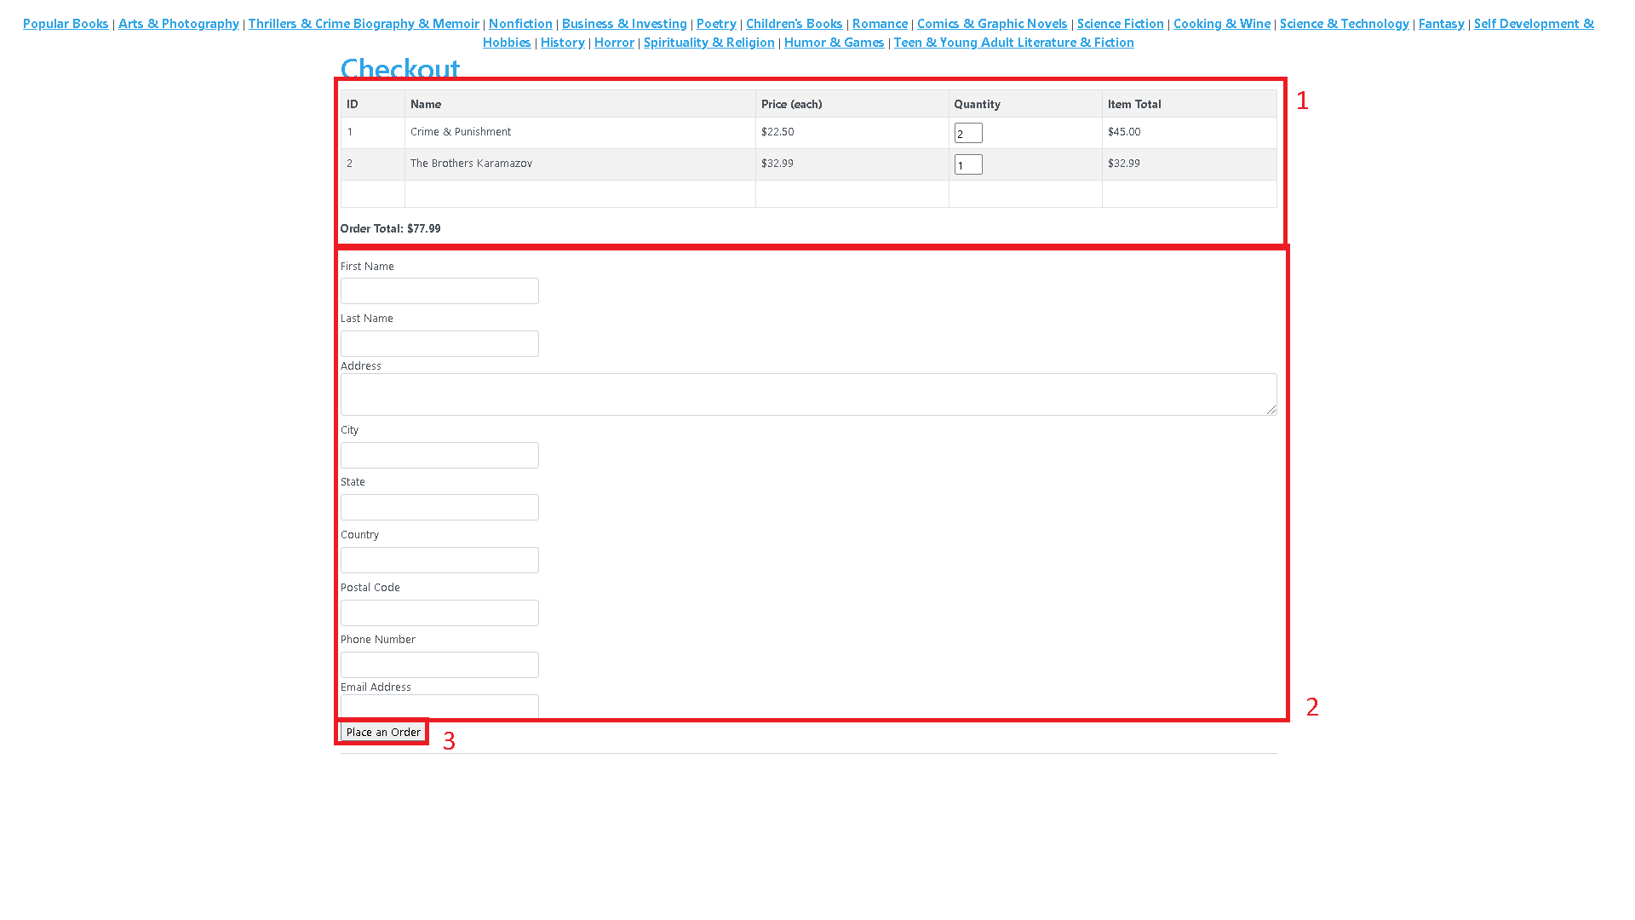

Fig. 23. Checkout

*Source: PaperPhil application*

1. The contents of the shopping cart are transmitted over in order to be reviewed, without the option to either change the quantity of products or remove them altogether.
2. The following data must be introduced in order to complete the order: The user’s first name, last name, address, city of residence, state, country, postal code, phone number and email address.
3. After the aforementioned data has been introduced, the user will click the “Place an Order” button in order to transmit the request while emptying the cart and redirecting the user back to the home page.

**The registration page**



Fig. 24. Registration

*Source: PaperPhil application*

The user can create a new account by introducing an email address, entering a password and a password confirmation, and clicking the “Register” button.

**The log in page**

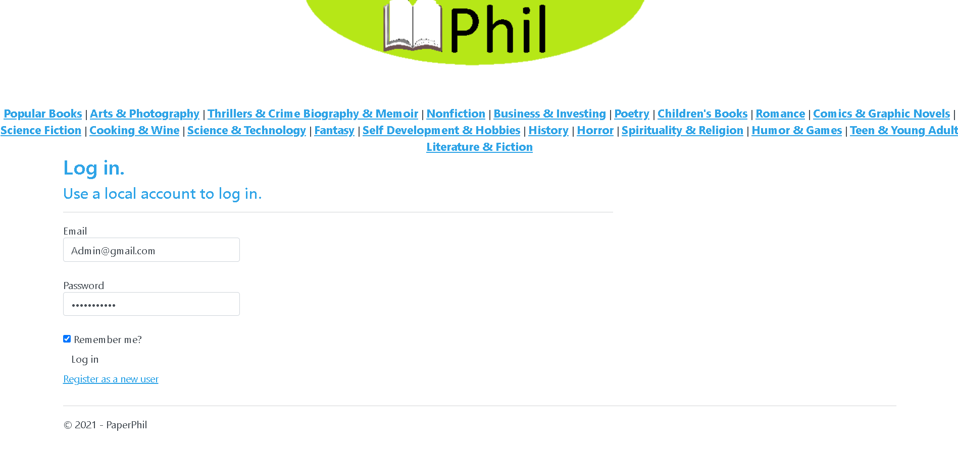

Fig. 25. Log in

*Source: PaperPhil application*

This is the log in page. After registering, the user can introduce their account credentials, namely email and password and log into their account after clicking the “Log in” button. They also have the option to tick the “Remember me?” checkbox and stay logged into their account on their computer for as long as they do not click the log off button located in the navbar. If the user has accessed the log in page without having an account, they can also click the “Register as a new user” link and be redirected to the registration page.

**The account management page**

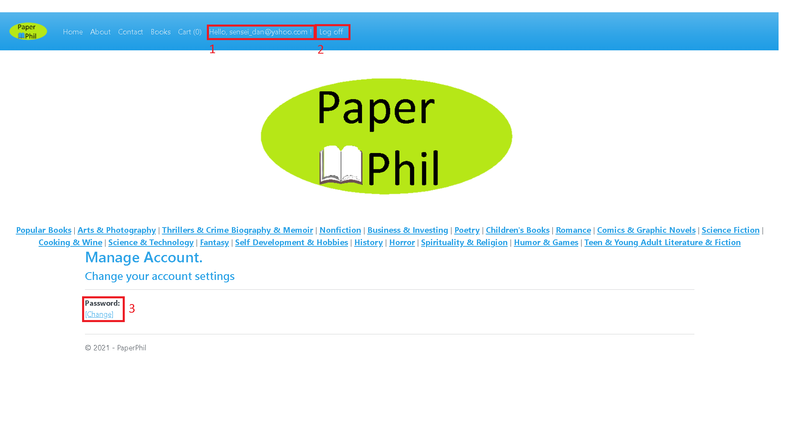

Fig. 26. Account management

*Source: PaperPhil application*

1. After logging in, the user will have two new elements in their navbar. The first link will lead to the account management page.
2. The second link will prompt the user to log off their account, with the option to log in at a later date.
3. The password change element has a link which will lead the user to a different page where they can change their account’s password.

**The password management page**

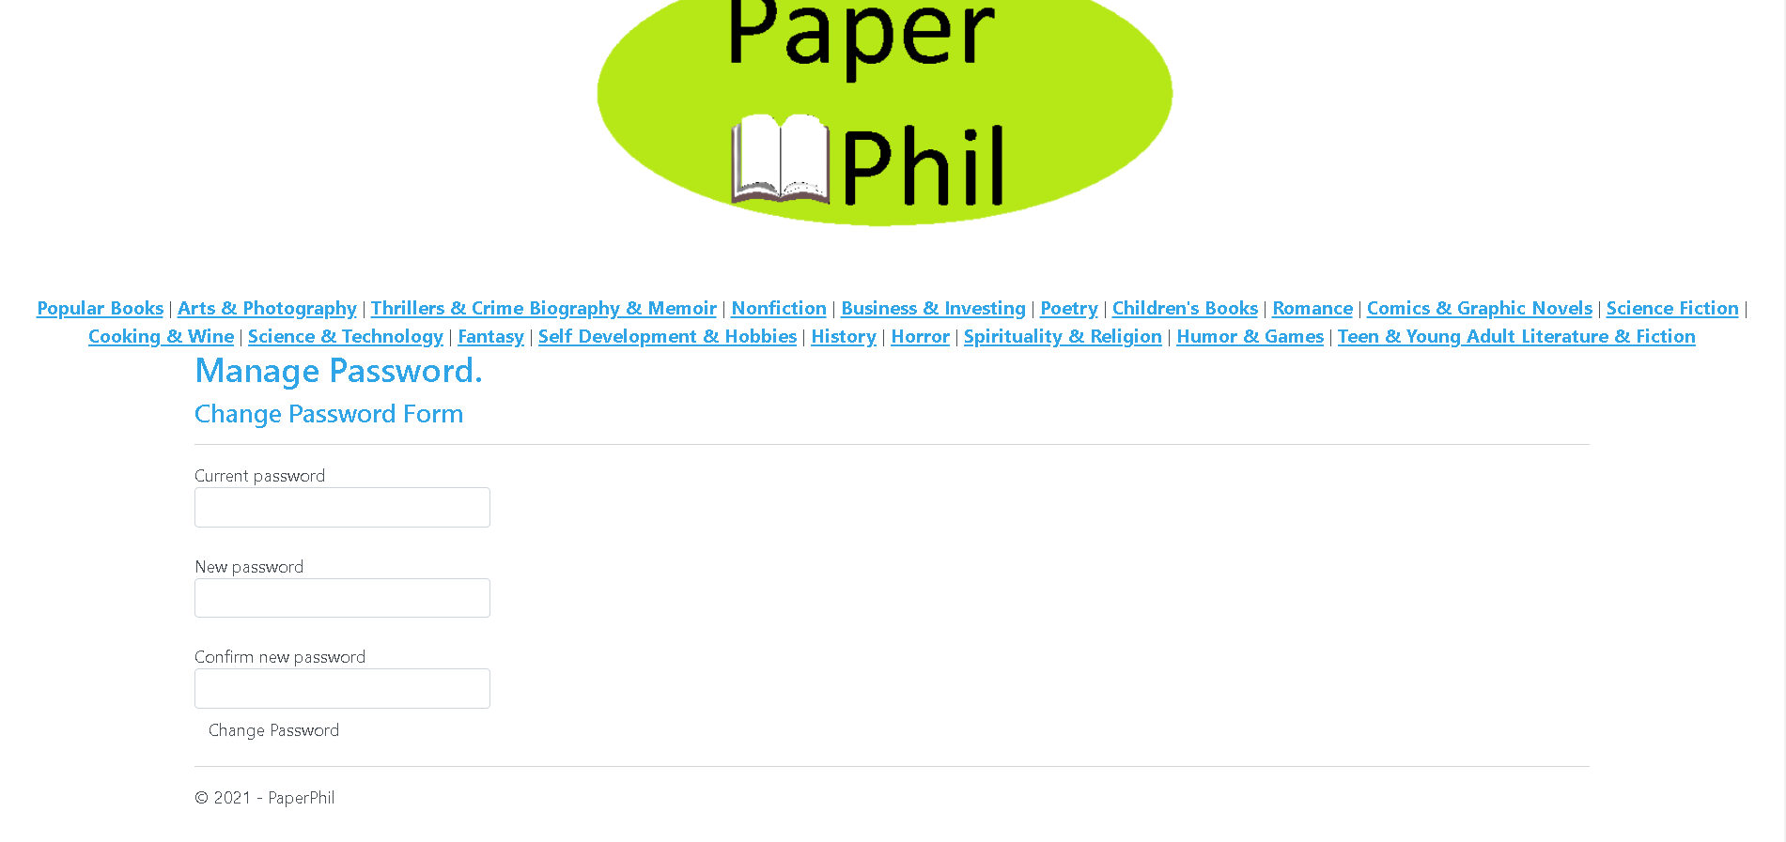

Fig. 27. Password management

*Source: PaperPhil application*

On this page, the user can change their password. In the first field, they have to introduce their account’s current password, followed by a field where they have to introduce the password that they want to replace their current password, followed by yet another field inside which the user has to confirm the previously introduced password. After filling in all of the fields, the user has to press the “Change Password” button

## **3.2. Administrator interface**

The administrator interface can be used to manage and edit the website’s orders and products through an administration account.

**The administrator navigation**

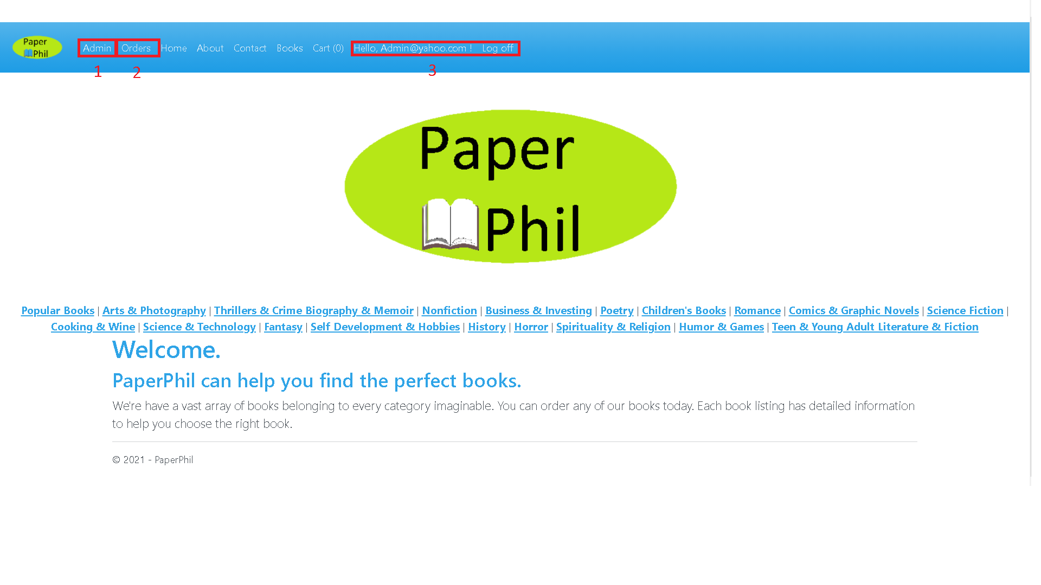

Fig. 28. Administrator navigation

*Source: PaperPhil application*

1. By accessing the “Admin” link, the administrator will be redirected to the product administration page where the administrator can edit the website’s products.
2. By accessing the “Orders” link, the administrator will be redirected to the order administration page where the administrator can edit the user orders.
3. The administration mode can be accessed by logging into the administration account with the credentials: Admin@yahoo.com for the username and Pa$$word for the password.

**The product administration page**

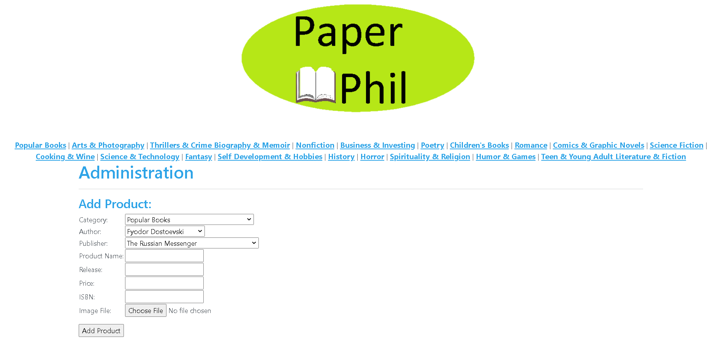

Fig. 29. Product administration I

*Source: PaperPhil application*

This is the first part of the administration page. The first section allows the administrator to add a product. The administrator must choose a from a list a category, an author and a publisher for the book. Afterwards, the administrator must type in the product’s name, release year, price and ISBN while choosing an image file for the product’s image display. After introducing the data, the administrator will have to click the “Add Product” button.

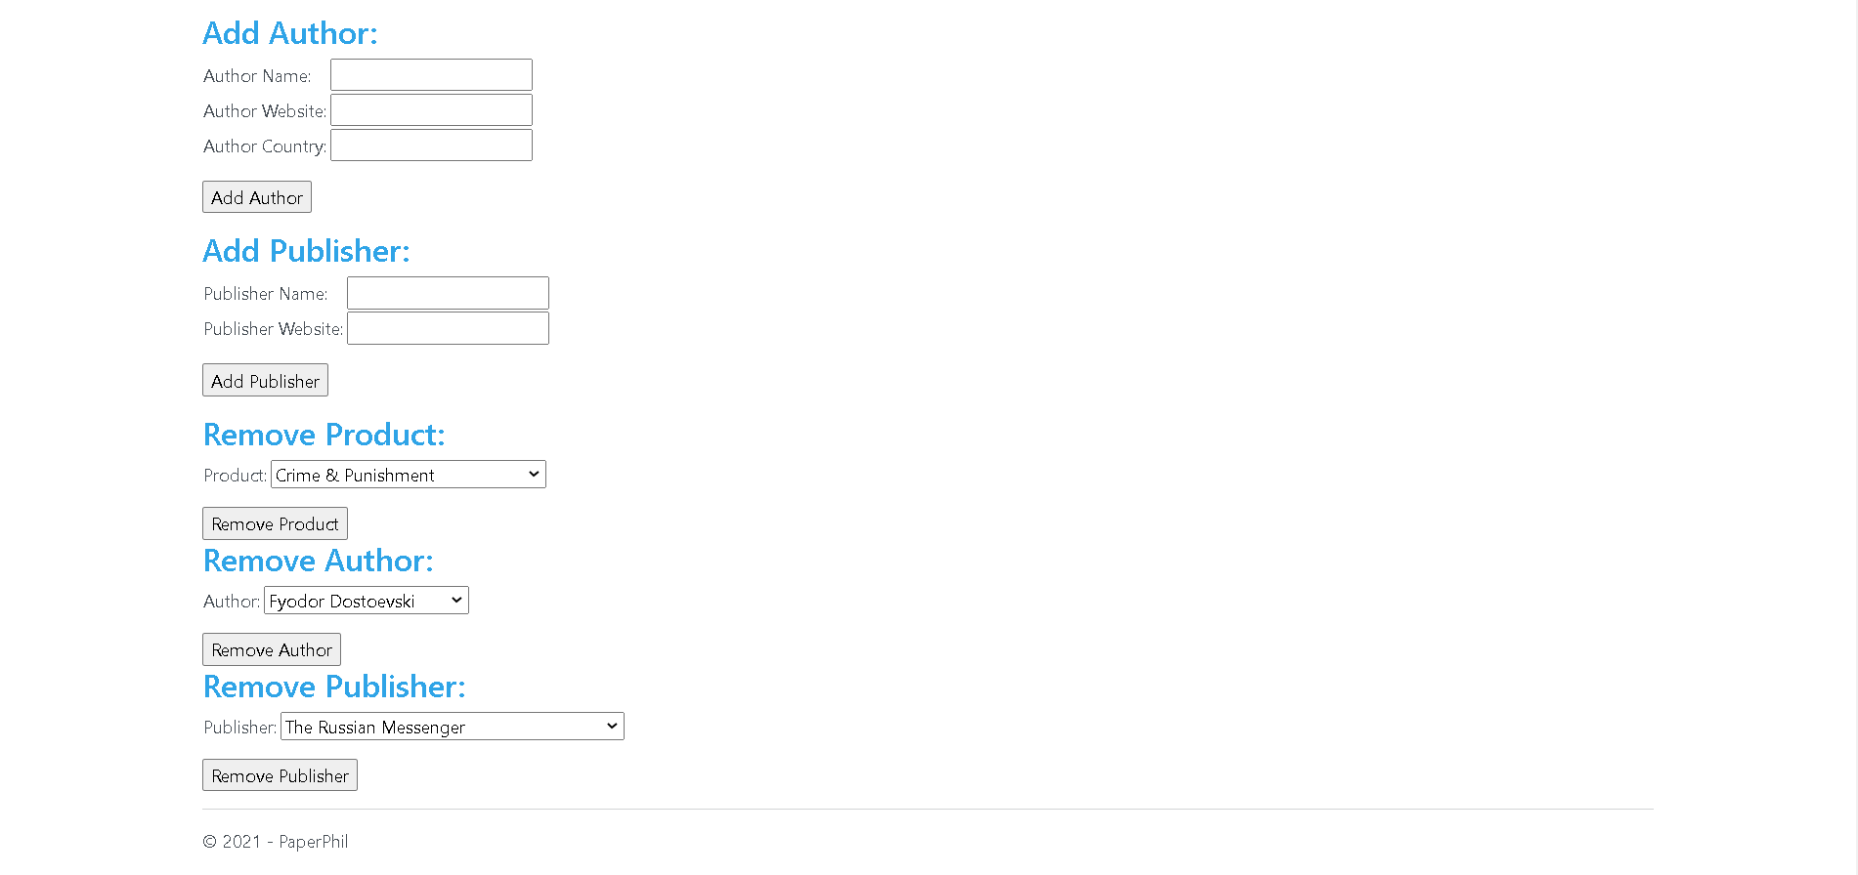

Fig. 30. Product administration II

*Source: PaperPhil application*

In the second part of the administration page, the administrator can add a new author by introducing his name, website and country, while being able to add a new publisher by entering its name and website. The newly added entries will appear in the product lists above. The administrator can also remove a product, an author or a publisher by selecting the respective product author or publisher in the list that he wants to remove and clicking the respective removal button.

**The pending orders page**

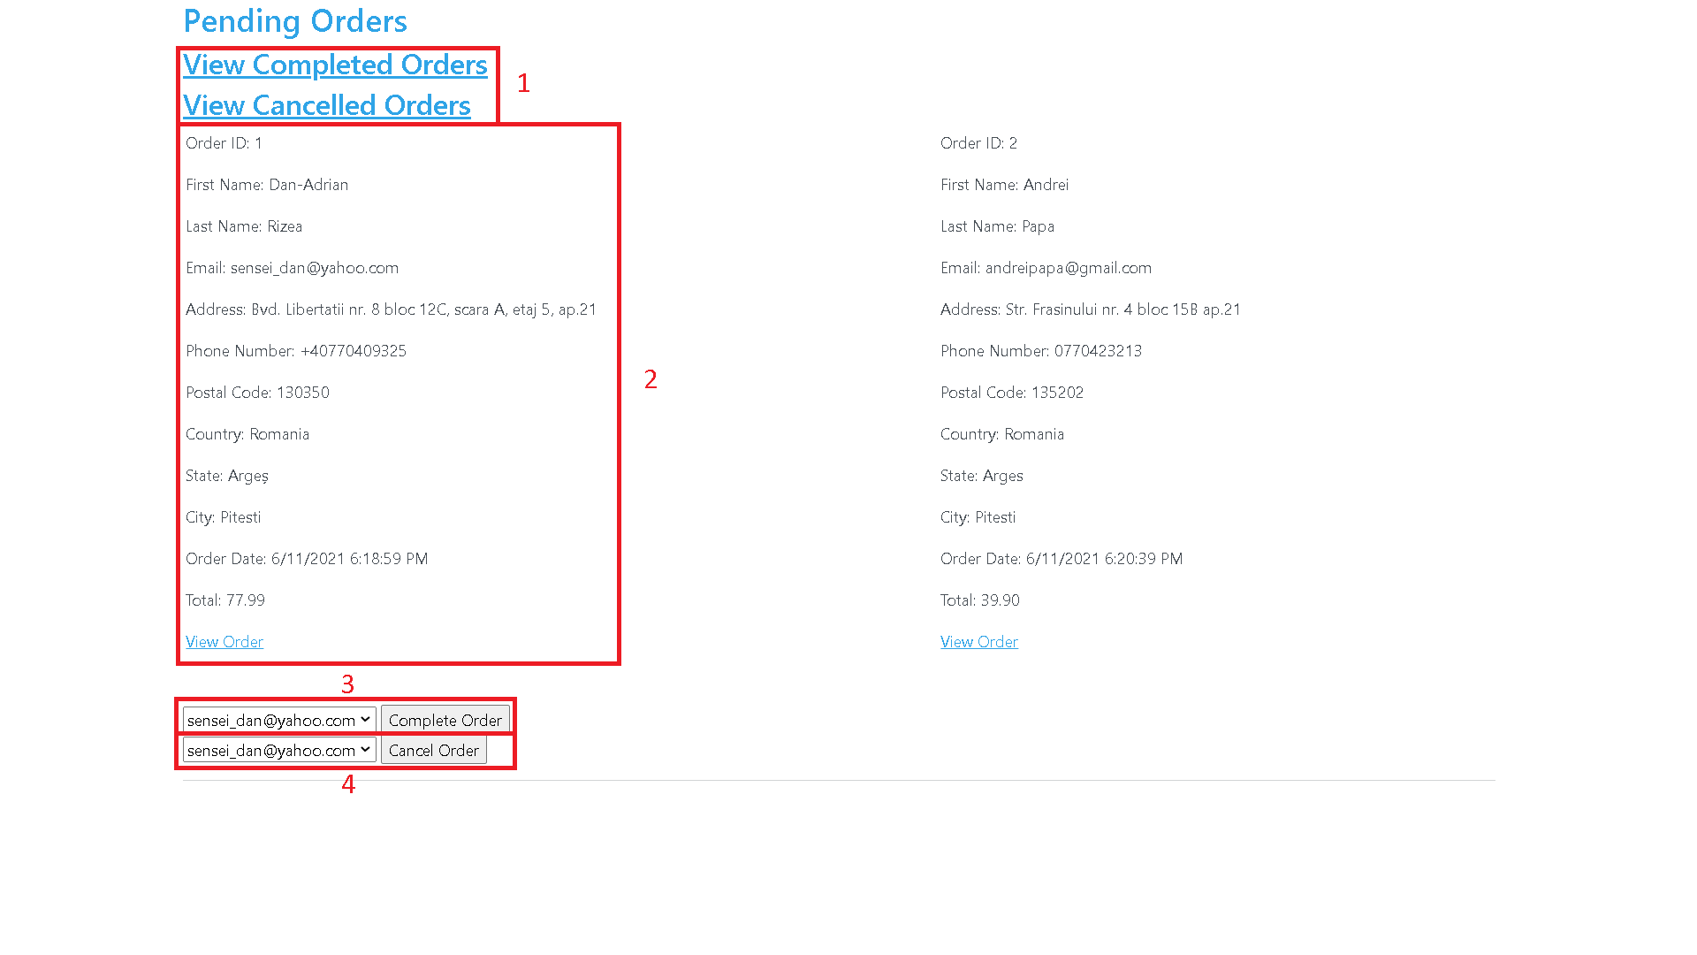

Fig. 31. Pending orders

*Source: PaperPhil application*

1. This page contains the orders that have yet to be processed by the administrator. The first two links lead to two different pages that display the orders that have either been completed or cancelled.
2. This section shows the administrator the shipping details which have to be processed. They consist of the order’s ID, the user’s first name, last name, email, address, phone number, postal code, country, state and city while retaining the order date and the order total. There is also an additional “View Order” link which leads the administrator to the actual products that have been ordered. It must be noted that these detail sections appear on this page only if the status of the order is pending.
3. This list allows the administrator to complete an order
4. This list allows the administrator to cancel an order.

**The completed orders page**

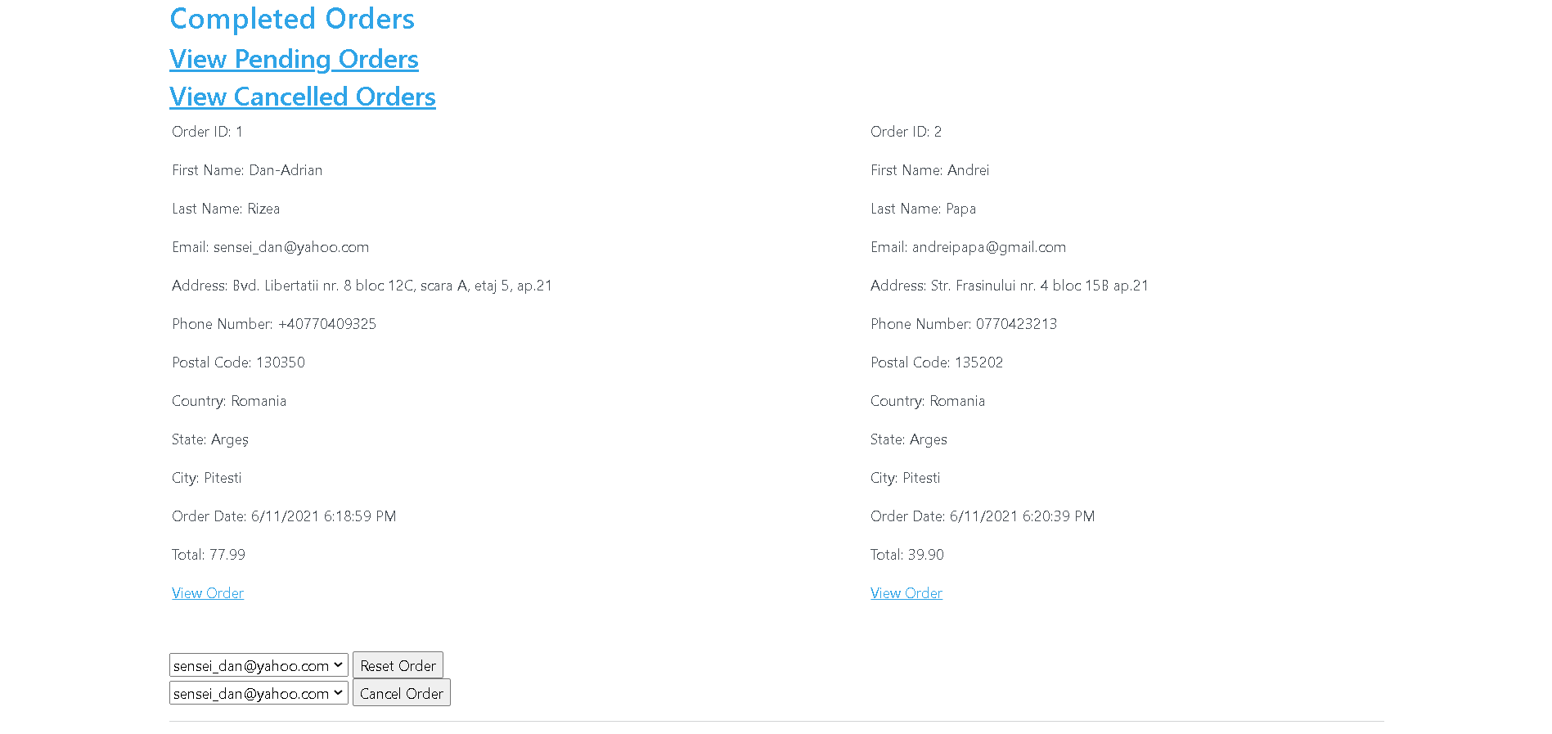

Fig. 32. Completed orders

*Source: PaperPhil application*

This page is similar to the pending orders page, with the exception that instead of being able to view the orders that have the order status equal to pending, this page displays the products that have the order status equal to completed while the options available to change the status of the order transition into resetting and cancelling the order.

**The cancelled orders page**

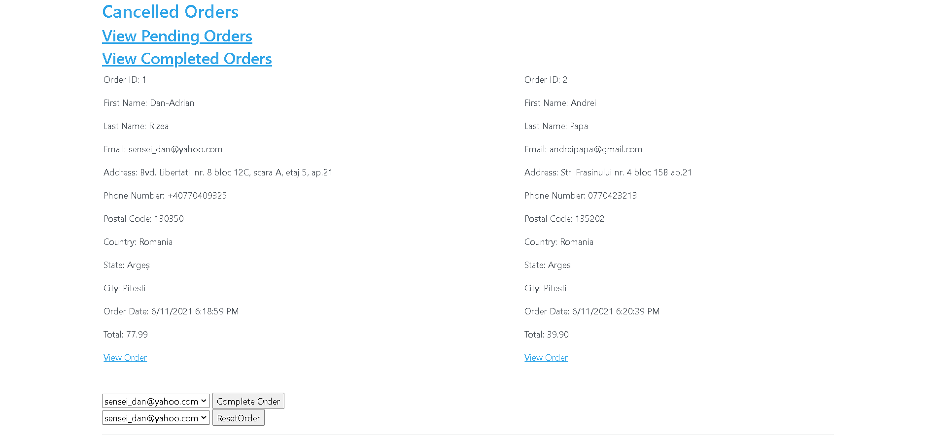

Fig. 33. Cancelled orders

*Source: PaperPhil application*

This page is similar to the pending orders page, with the exception that instead of being able to view the orders that have the order status equal to pending, this page displays the products that have the order status equal to cancelled while the options available to change the status of the order transition into completing and resetting the order.

**The full order page**

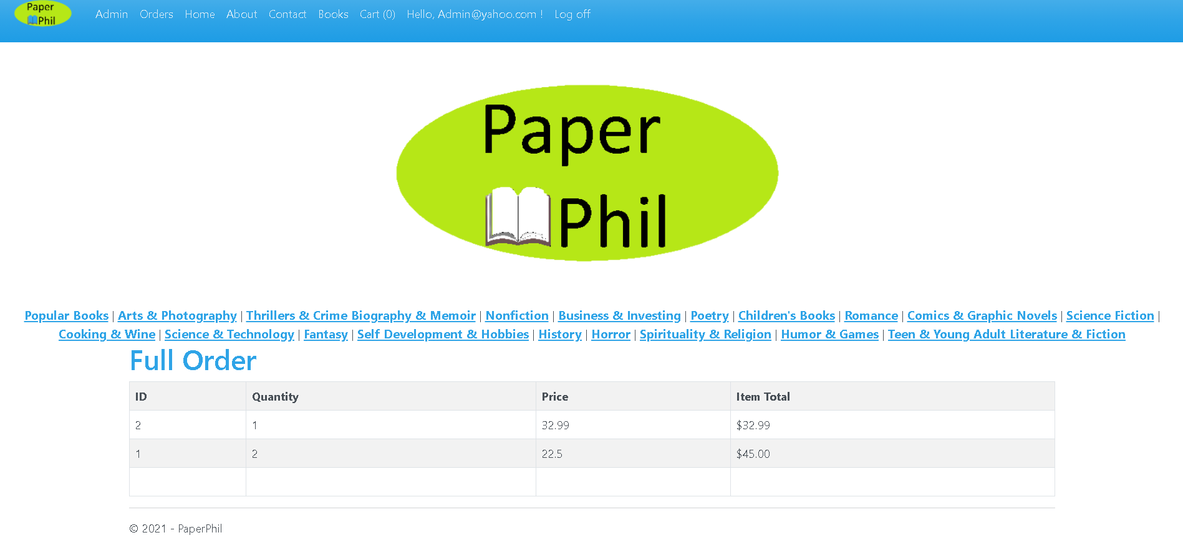

Fig. 34. Full order

*Source: PaperPhil application*

This page displays a certain order’s details, showing the item’s ID, the ordered quantity, their individual price and their total.

**The empty order page**

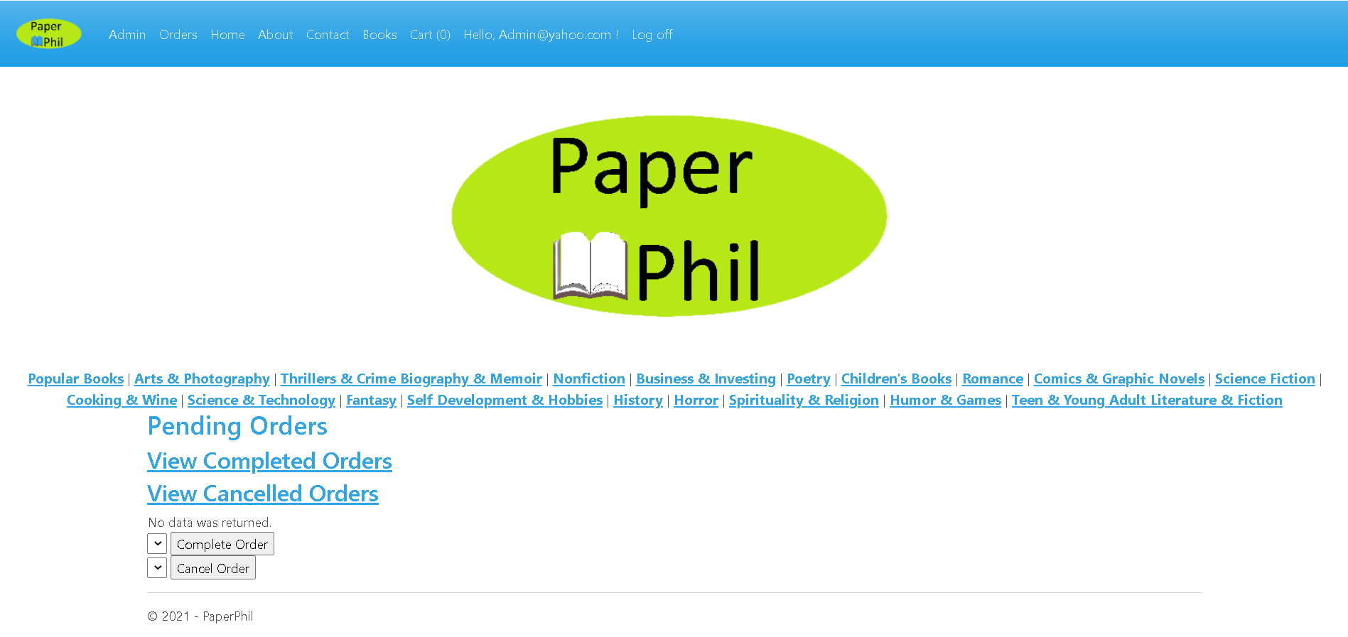

Fig. 35. Empty orders

*Source: PaperPhil application*

If the website does not contain any orders, in all of the given pages where the orders might be missing (pending orders page, completed orders page and cancelled orders page), a message that states that “No data was returned” will be prompted.