Analysis

# The problem

Using a square grid what is the shortest path between two points with obstacles/blockages in the way

Can python generate a map, then solve it?

# Research

To make the best experience for the end user using a window to display what the program is processing instead of being text based with the user having to read letters and numbers. There are two main modules to choose from for outputting to a display, tkinter and pygame. The tkinter module comes with python by default so will have the most compatibility with systems, however pygame offers more flexibility when updating what is being displayed and can offer better performance when updating the display multiple times per second. To generate a map for the algorithm to solve the random module is used to choose between making a square accessible or blocked from the route.

To generate a different map for the code to solve each time a random map has to be generated. Pythons random module can generate random numbers between any specified range, or to choose between a list of variables/numbers. This along with a few for loops can append values to a list which can then be displayed to the user in a pygame window.

# Objectives

1. A map must be randomly generated or designed by the user.
2. The algorithm must be able to solve the generated map.
3. The user can specify the dimensions and complexity of a generated map.
4. Simulation speed can be adjusted by the user.

# End user

Path finding algorithms are used all the time by people all over the world in everything from cell phones to military tech, and rocket guidance systems. Most commonly used is route planning by Google Maps which can filter specific paths depending on which transport mode is selected.

-Vehicle routing problems., Taxi/Uber, cars without built in satnav

-Route planning

-Geographer

-Pathfinding within games (RPG)

-Multi world exploration

-Generic algorithm that can be applied to multiple games

# Prospective users

Literally anyone who travels from A to B

# Modelling the problem

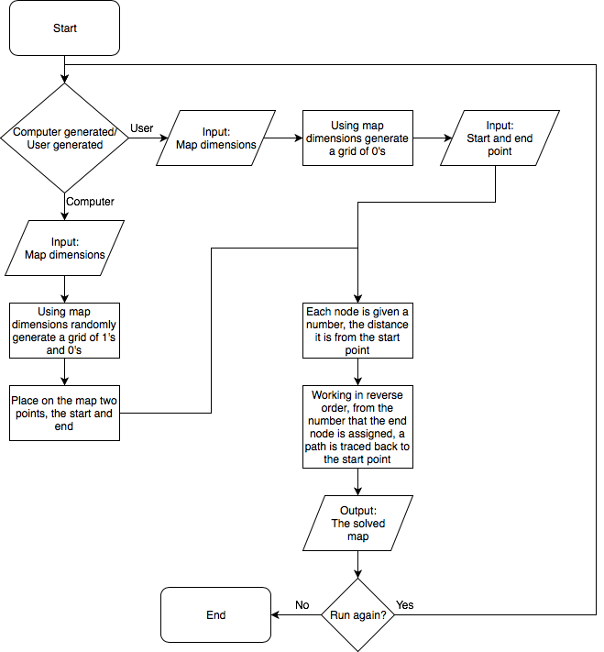

# Additional notes

Shortest path algorithms are optimisation algorithms

--Convex hull problem

Dijkstra’s algorithm finds the shortest path in a graph, it can be used for computer networking (Routing systems), Google maps (to find the shortest possible path from one location to another) and in Biology where it is used to find the network model in spreading of an infectious disease.

--Column generation

--Negative cycles – Bellman-Ford negative cycle detection

Floyd-Warshell algorithm, Suuballe’s algorithm.

Longest route/most area covered (but also the most efficient route to do this)?

Toolpath for 3D printers/ CNC routers/ Laser cutter (any CAD/CAM equipment)

Guidance systems for tractors (Farming lol, who would’ve thought?)