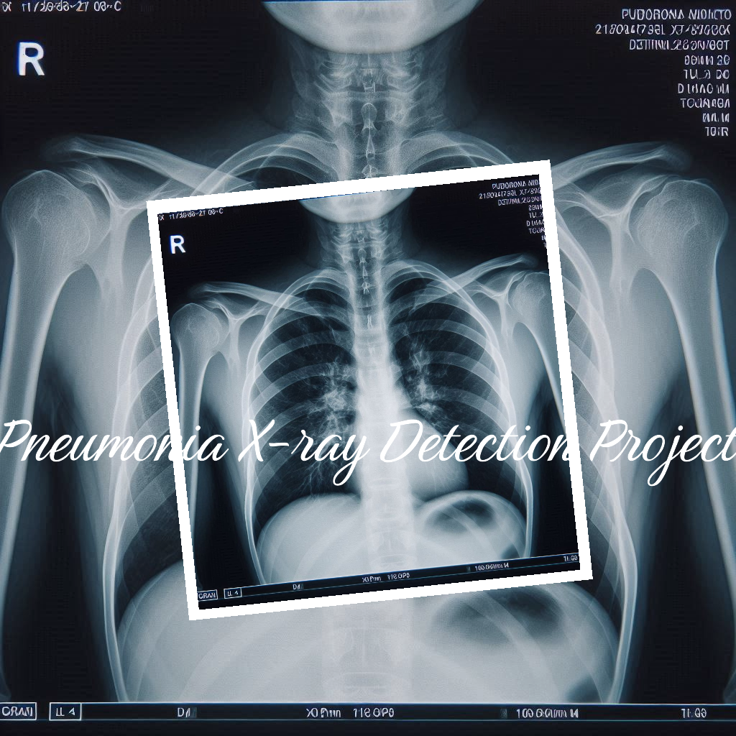***PNEUMONIA DETECTION IN X-RAY IMAGES***

**Pneumonia?**  In the **World Health Organization**  report, Pneumonia is a form of acute respiratory infection that is most commonly caused by viruses or bacteria. It can cause mild to life-threatening illness in people of all ages, however it is the single largest infectious cause of death in children worldwide. This respiratory illness is caused by a wide range of infections which vary from bacterial, viral or fungal diseases affecting the lungs.

**Pneumonia** could also be described as an inflammatory condition of the lung primarily affecting the small air sacs known as alveoli.

Pneumonia killed more than 800,000 children under the age of 5 in 2017, accounting for 15% of all children deaths under 5 years. It also puts adults above 65 years and people with underlying medical conditions at a very high risk of death.

To detect the presence of Pneumonia in a body, one has to undergo various tests which include X-ray imaging of the chest. In X-ray imaging, the persons are said to be affected by the illness if chest X-ray with a cloudy or infiltrated appearance is gotten from their chest.

**PNEUMONIA DIAGNOSIS**

- The are various ways to diagnose pneumonia in a patient if the doctor has suspicion that their patient is ailing Pneumonia, which include:

* **Blood test:** to identify the pathogen causing the infection. There is no precise identification.
* **Chest X-ray:** to detect pneumonia, determine extent and where in the lungs the infection has affected.
* **Pulse oximetry:** get the blood oxygen level. Pneumonia can prevent your lungs from moving enough oxygen into your bloodstream.
* **Sputum test**: A sample of fluid from your lungs is taken after deep cough and analyzed to help pinpoint the cause of the infection.

- Sometimes to obtain a more detailed image of your lungs the doctor may use CT scan.

- At times, **Pleural fluid culture**, a fluid is taken by putting a needle between your ribs from the pleural area and analyzed to help determine the type of infection.

**REASONS FOR CHEST X-RAYS**

1. The condition of your lungs: detect cancer, infection or air collecting in the space around your lung, which would cause the lungs to collapse.
2. Heart-related lung problems:  show changes or problems in your lungs that stem from heart problems. For example, fluid in your lungs can be a result of congestive heart failure.
3. Postoperative changes: monitoring your recovery after you’ve had surgery in your chest.

**SYMPTOMS OF PNEUMONIA**

* ­Cough
* Shortness of breath
* Fever, sweating and shaking chills
* Fatigue
* Chest pain
* Nausea, vomiting or diarrhea
* Confusion, especially in older adults.

**OBSERVATIONS MADE IN AN X-RAY IMAGE OF PNEUMONIA AFFECTED LUNGS**

- Radiologists look for **white spots** in the lungs, known as **infiltrates**, which indicate an infection.

- Complications relating to pneumonia are determined as well such as **abscesses or pleural effusions(**fluid surrounding the lungs.

- Pneumonia on a chest X-ray shows opacity restricted to one lobe, while atypical pneumonia may exhibit **diffuse, often subtle infiltrates.**

- Radiographic appearance can vary and terms like **bronchopneumonia, lobar pneumonia** and **interstitial pneumonia** describe different patterns.

**Why Computer Vision in Pneumonia Detection?**

- Computers can now be used to detect if an individual is ailing pneumonia or not, from X-rays and CT scan images, with very high precision.

- This makes pneumonia detection and treatment fast in the following ways:

1. **Early Detection**: Computer vision algorithms can identify subtle abnormalities even before symptoms manifest. Detecting pneumonia early allows for timely intervention and better patient outcomes.
2. **Efficiency**: Automating image analysis reduces the workload on radiologists. They can focus on complex cases while routine scans are processed by AI systems.
3. **Consistency**: Algorithms provide consistent results, minimizing human error and variability. Radiologists’ interpretations may vary, but AI maintains uniformity.
4. **Scalability**: As healthcare demands increase, computer vision can handle large volumes of images efficiently, ensuring faster diagnoses.
5. **Quantitative Assessment**: Algorithms quantify disease severity, aiding in treatment planning and monitoring progress over time.
6. **Research and Insights**: By analyzing vast datasets, AI can reveal patterns, risk factors, and treatment responses that inform medical research.

## **Types of Pneumonia:**

- Pneumonia can be classified based on several factors:

1. **Community-acquired pneumonia (CAP):** Acquired outside of healthcare settings, typically caused by *Streptococcus pneumoniae, Haemophilus influenzae,* and *Mycoplasma pneumoniae*.
2. **Hospital-acquired pneumonia (HAP):** Developed during a hospital stay, often caused by bacteria like *Pseudomonas aeruginosa* and Staphylococcus aureus.
3. **Ventilator-associated pneumonia (VAP):** Occurs in patients on mechanical ventilation, commonly due to *Pseudomonas aeruginosa* and Staphylococcus aureus.

-