History of the College of Science

Course offering of the Institute of Arts and Sciences – MECS Order No. 16. s. 1984 dated March 23, 1984
- BS Biology
- BS Guidance and Counseling
- BS Psychology
- BS Mathematics

College of Science, formerly known as the Institute of Arts and Science from 1984 to 2005.

Past and Present Deans of College of Science
- Dr. Carolina E. Valiente – 1984 to 1987
- Dr. Mercedes F. Timtiman – 1987 to 1995
- Dr. Corazon F. Soriano – 1996 to 2000’
- Dr. Valentina R. Catmunan – 2000 to 2003 and 2014 to 2017
- Dr. Apolinario F. Masinsin – 2003 to 2005
- Dr. Reneecilia B. Paz De Leon – 2005 to 2007 and 2009 to 2010
- Dr. Bella G. Constantino – 2007 to 2008
- Dr. Eduardo Lacap, Jr. – 2010 to 2011
- Dr. Mariam M. Estrabo – 2011 to 2014
- Dr. Niclie L. Tiratira – 2017 to 2025
- Dr. Jose E. Binaluyo, Jr. – 2020 to 2024
- Dr. Wilma R. Lomangaya – 2024 to Present

Board Resolution No. 04-11-97 dated September 27, 1997 offering BS Mathematics major in Computer Science until 2019.
BS Computer Science was offered through BOR Resolution No. 02 series of 2021

Level I thru the leadership Dr. Corazon Soriano
Level II thru the leadership Dr. Bella Constantino
Level III thru the leadership of Dr. Valentina R. Catmunan
Level IV Phase I – Dr. Niclie L.Tiratira and Dr. Jose E. Binaluyo, Jr.

History of the College of Science
The College of Science stands as a pillar of academic excellence and innovation, tracing its roots back to the establishment of the Institute of Arts and Sciences in 1984. Under the authority of MECS Order No. 16, s. 1984 dated March 23, 1984, the Institute began its journey by offering four foundational programs:
- 🧬 Bachelor of Science in Biology
- 🧠 Bachelor of Science in Psychology
- 🧮 Bachelor of Science in Mathematics
- 🧭 Bachelor of Science in Guidance and Counseling
From 1984 to 2005, the Institute of Arts and Sciences nurtured generations of scholars and professionals. In 2005, it was formally renamed the College of Science, reflecting its evolving identity and expanding academic scope.
🏛️ Leadership Through the Years
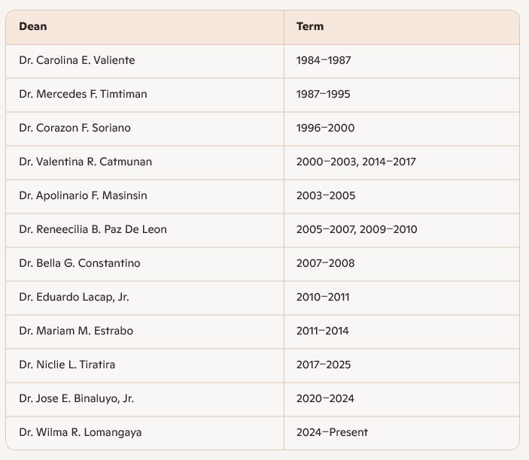
The College has flourished under the guidance of visionary deans whose leadership shaped its academic and institutional milestones:

Each dean contributed uniquely to the College’s growth, academic reputation, and institutional achievements.
💻 Curricular Expansion
In response to the growing demand for technology-oriented education, the College introduced the BS Mathematics major in Computer Science through Board Resolution No. 04-11-97 dated September 27, 1997. This program ran until 2019, laying the groundwork for a more specialized offering.
In 2021, through BOR Resolution No. 02, the College launched the standalone Bachelor of Science in Computer Science—marking a new chapter in its commitment to producing future-ready graduates in the digital age.
📈 Accreditation Milestones
The College of Science has steadily climbed the ladder of academic accreditation, thanks to the strategic leadership of its deans:
- Level I: Achieved under Dr. Corazon F. Soriano
- Level II: Secured through the efforts of Dr. Bella G. Constantino
- Level III: Reached under the stewardship of Dr. Valentina R. Catmunan
- Level IV: Attained through the joint leadership of Dr. Niclie L. Tiratira and Dr. Jose E. Binaluyo, Jr.
These accreditations reflect the College’s commitment to quality education, research, and institutional excellence.
The College of Science continues to evolve, guided by its legacy and driven by a vision for the future—where science, innovation, and leadership converge to empower the next generation of thinkers and changemakers.

The following is a brief history of the College of Science (COS), based on the information found in the provided sources.
Brief History of the College of Science (COS)
The College of Science (COS) is located within the University of Rizal System (URS) – Morong Campus. The URS Vision is to be the leading University in human resource development, knowledge and technology generation, and environmental stewardship. The University is committed to providing relevant and sustainable higher professional and technical instruction, research, extension, and production services.
The College of Science currently offers several degree programs, including the Bachelor of Science in Mathematics, Bachelor of Science in Biology, Bachelor of Science in Psychology, and Bachelor in Human Services.
The College aims to produce students who:
1. Exhibit capacity for innovative and critical thinking.
2. Conduct scientific research aimed at improving the quality of life and environmental sustainability.
3. Demonstrate the value of active participation in holistic community enrichment.
Deans and Their Achievements
The following individuals have been mentioned in the sources in relation to the deanship or academic management of the College of Science:
1. Dr. Niclie L. Tiratira
Dr. Tiratira served as the Dean, College of Science. Her tenure included institutional directives aimed at aligning the College's research output with national development goals.
Key Achievements/Contributions:
• Research Mandate Implementation: On February 13, 2018, as Dean, she issued College Memorandum No. 10, s, 08-2018, directing all concerned parties in the College of Science to adhere to the Harmonized National R&D Agenda (HNRDA) 2017-2022. This ensured that proposed researches would be based on the HNRDA to maximize economic and social benefit for the people.
• Instructional Material Development and Commercialization: She authored and copyrighted the instructional material titled, "Worktext in Psychological Assessment" (Registration #O2017-3589). This material was utilized in three URS campuses (Morong, Pililla, and Taytay) and generated an income of Php 10,200.00 for the University, campus, and faculty members during the First Semester of School Year 2018-2019.
• Published Research: She has published works relevant to the psychology program, including:
◦ “Improving Students’ Performance with the Use of the Worktext in Psychological Assessment” (published December 2020 in PalArch’s Journal of Archaeology of Egypt/Egyptology).
◦ “Comparison of Classroom Performance and Review Performance as an Indicator of the Psychometrician Board Examination” (published May 2022 in Journal of Positive School of Psychology).
• Extension Work: She was involved as a project implementer in the ongoing extension program, "College of Science In Action (Adopt-A-Community Program) - Project SMILE - Save a Meaningful Interaction in Living Efficiently" (August 2022 to August 2024 in Morong, Rizal). She also copyrighted the "Psychological Intervention Program/Module and its Effect to Flood Survivors" (Reg. #O2017-3591).
2. Dr. Jose E. Binaluyo, Jr.
Dr. Jose E. Binaluyo, Jr. is identified as working within the College of Science/BS Mathematics Program, and has contributed to research activities. The current status of the College is viewed positively under its academic leadership:
Key Achievements/Contributions (Related to Academic Unit Management and Research):
• Effective Management: The College of Science Accomplishment Report for 2023 serves as evidence that the College is being efficiently and effectively managed.
• Research Engagement: He is actively engaged in scientific inquiry, specifically listed as conducting the research "On Statistical Inference from Random Consumption of Input-Output Leontief Model" (In progress).
General Achievements of the College of Science
The operation and academic performance of the College of Science show several areas of success and institutional support:
• Curriculum Development and Relevance: Curricula undergo a meticulous approval process, including presentation to the Academic Council Committee and eventual approval by the Board of Regents. The BS Psychology program notes its goals are achieved through outcomes such as Psychometrician licensure exam results.
• Research Dissemination and Incentives: The College actively encourages scholarly work. Research results are disseminated through oral/poster presentations, journal publication, and library exchange. Faculty researchers receive incentives for paper presentation (up to P25,000.00 for international presentation outside the country) and publication (up to P70,000.00 for Level B - International/Scopus/WOS indexed journals).
• Extension and Community Service: The COS implements community programs, such as the multi-disciplinary extension program "COS in ACTION" in Purok Pulo, Bgy CCL. Community involvement is emphasized in the planning and implementation of these projects.
• Publication: The College publishes its own Research Journal (available via digital folders).
• Faculty Quality: Faculty training is supported through the Individual Development Plan (IDP). The university pursues collaboration, such as signing a Memorandum of Agreement with Maejo University in Thailand, to enhance faculty capabilities through webinars and other linkages.
• Student Support: The College publishes a newsletter, The Essence, as part of the broader campus publication system. Students are also supported through the Student Welfare Assistance (SWA) fund for accidents, regardless of whether the accident is school-related or not.

