Are there any differences in obesity by age, gender, socio-economic status or lifestyle factors?
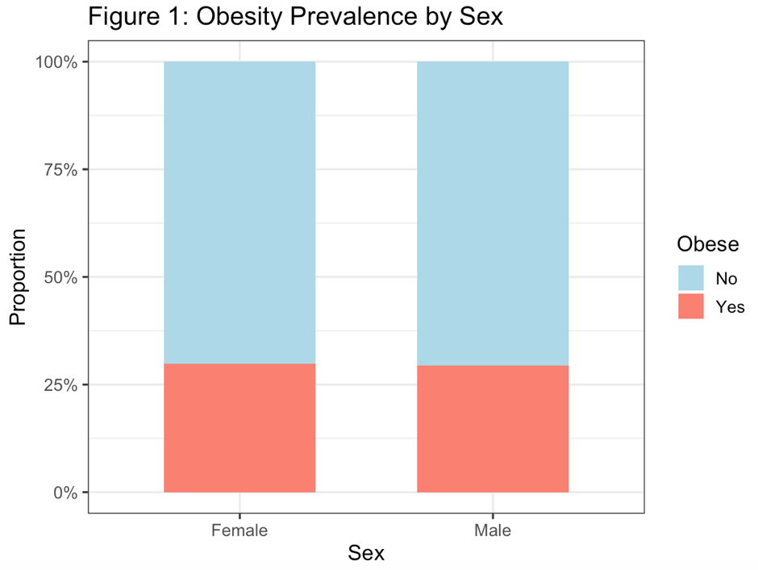
Figure 1. Stacked bar chart showing the proportion of obese and non-obese individuals by sex. Colours indicate obesity status (salmon: obese; light blue: non-obese).
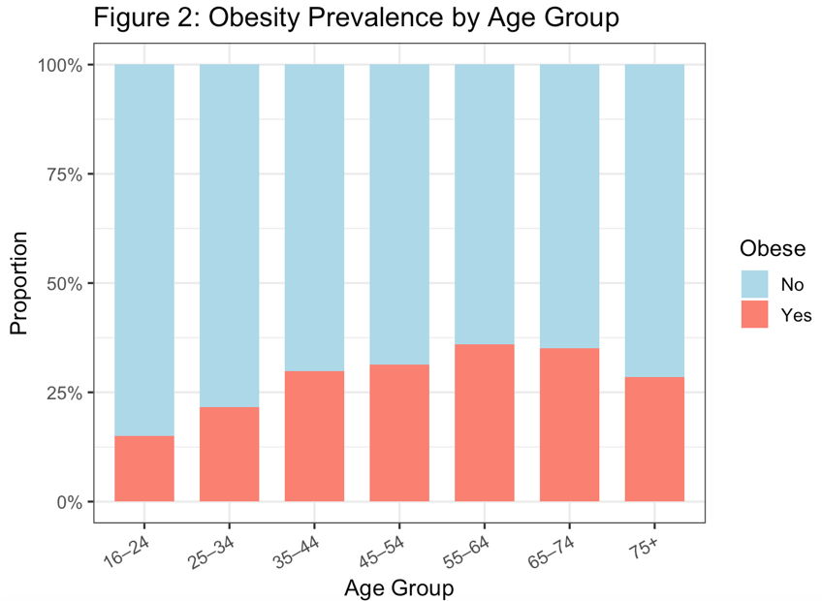
Figure 2. Stacked bar chart of obesity prevalence across seven age groups (16–24 to 75+). Each bar represents the proportion of obese and non-obese respondents within the corresponding age group.
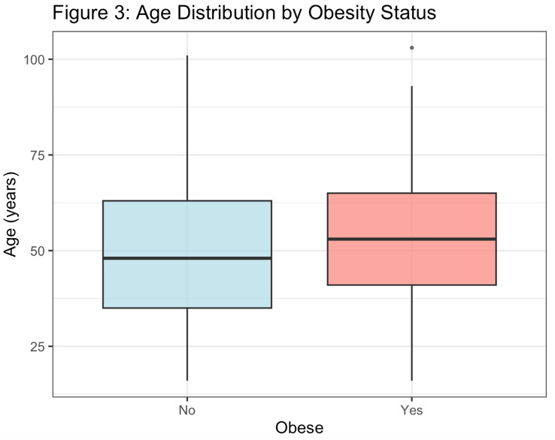
Figure 3. Box plots comparing the age distribution between obese and non-obese individuals. The box represents the interquartile range (IQR), the horizontal line denotes the median, and points indicate outliers.
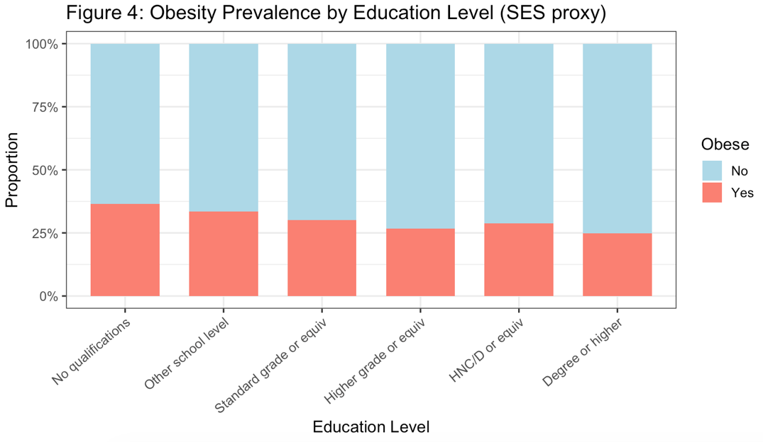
Figure 4. Stacked bar chart of obesity prevalence by educational attainment, ordered from lowest (no qualifications) to highest (degree or above). Education level is used as a proxy for socioeconomic status (SES).
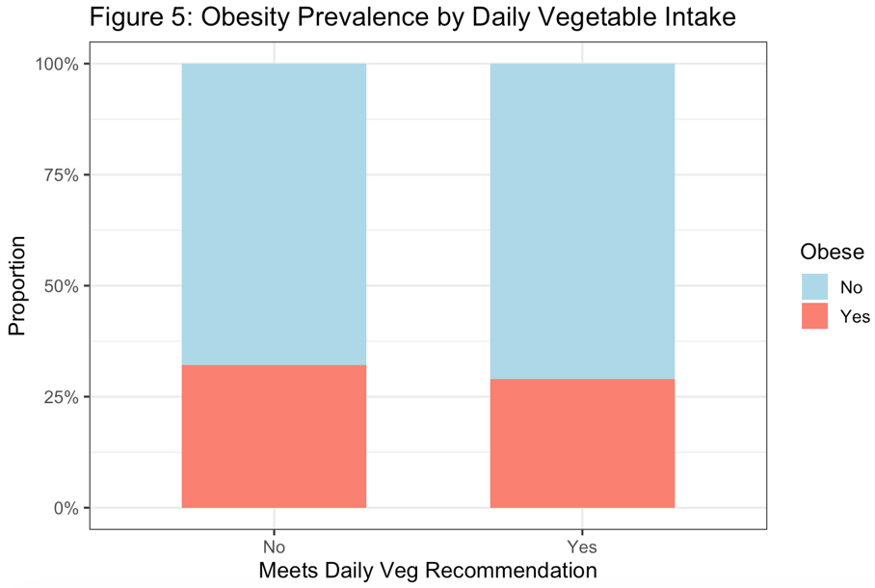
Figure 5. Stacked bar chart comparing obesity prevalence between individuals who meet and do not meet the daily recommended vegetable intake.
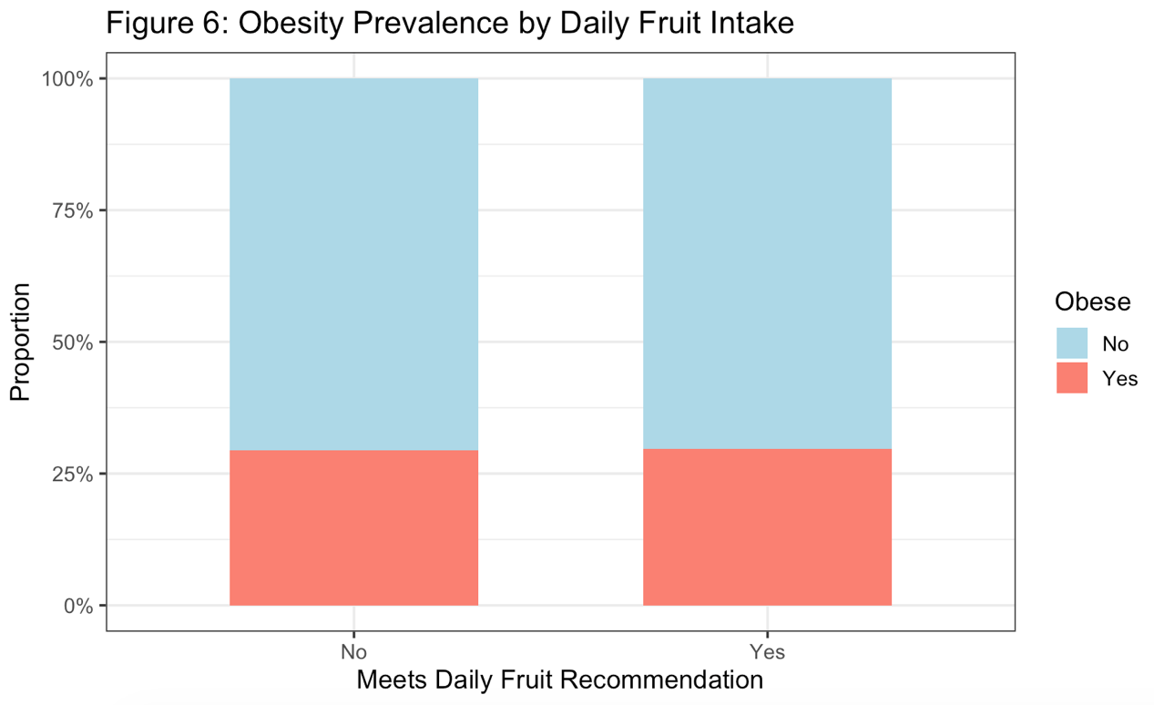
Figure 6. Stacked bar chart comparing obesity prevalence between individuals who meet and do not meet the daily recommended fruit intake.
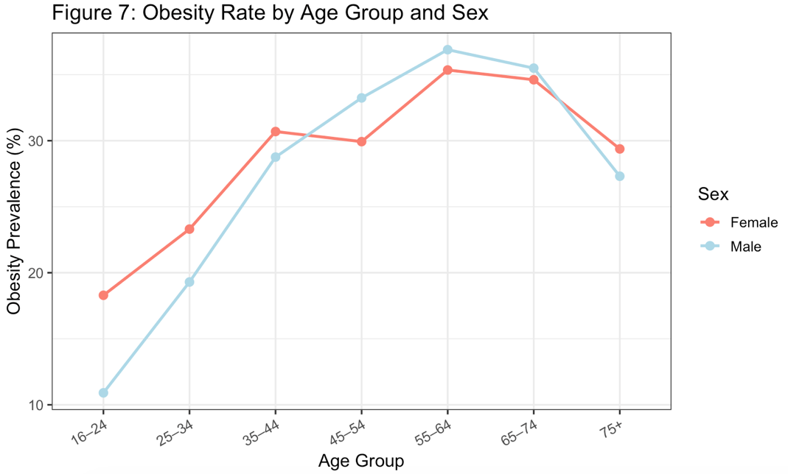
Figure 7. Line plot of obesity prevalence (%) across age groups, stratified by sex. Each point represents the observed obesity rate within a given age group and sex subgroup.
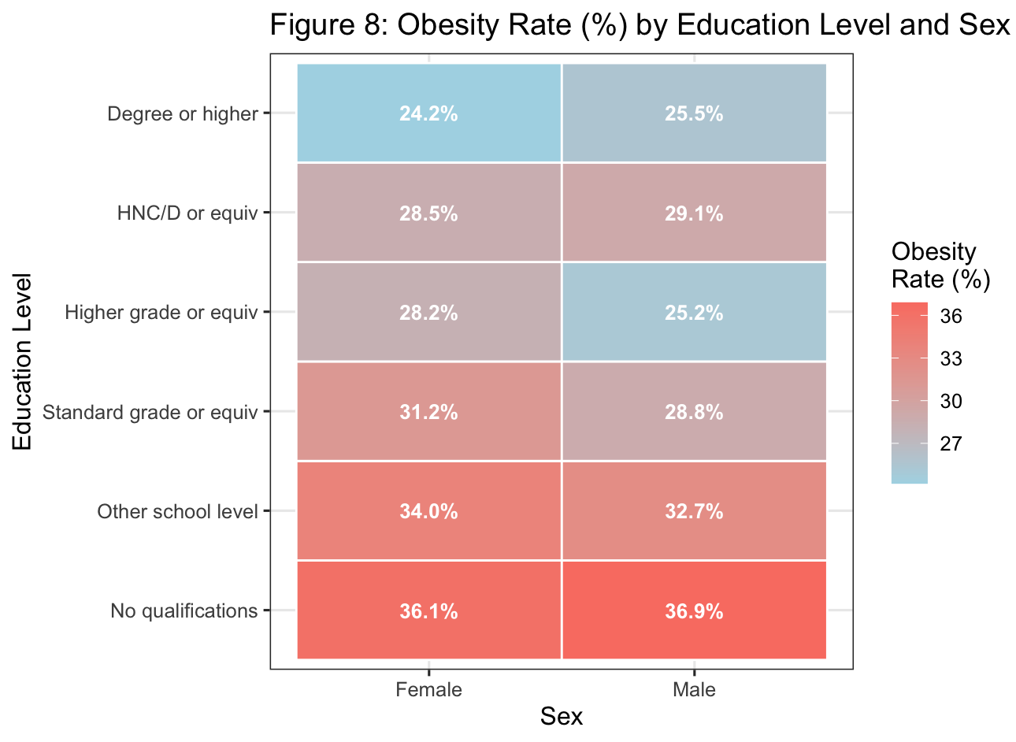
Figure 8. Heatmap of obesity rate (%) stratified by education level and sex. Cell colour intensity reflects the magnitude of obesity prevalence, with exact percentages annotated within each cell.

