Formal data analysis
To investigate whether obesity differed by age, gender, socio-economic status and lifestyle factors, we fitted a binomial logistic regression model with obesity status as the response variable. The response variable Obese was binary, with Yes indicating an obese individual and No otherwise. The explanatory variables included age, sex, education level, vegetable intake and fruit intake. Logistic regression was appropriate because it models a binary outcome using the logit link, ensuring fitted probabilities remain within the unit interval.

There may be an interactive relationship between age and gender parameters in the model. Compare pure additive models and interaction models with age and gender using AIC. The AIC of the interaction model is smaller, so the interaction model should be chosen.
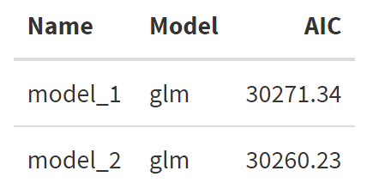
Table 1: Comparison of logistic regression models using AIC
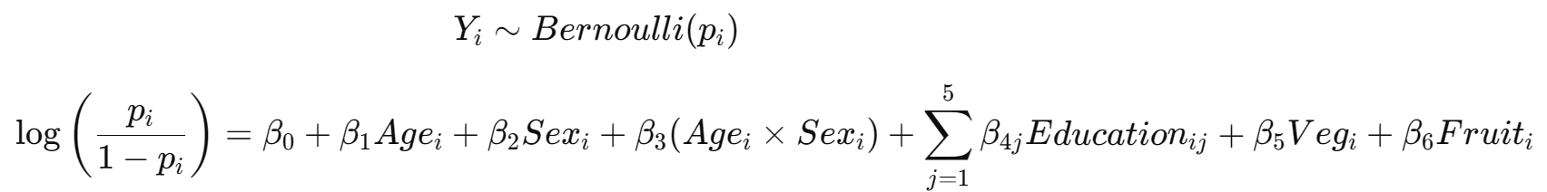
• $Y_{i}$is the obesity status of the $i^{th}$individual (1 = obese, 0 = not obese);
• $p_{i}=P(Y_{i}=1)$is the probability that the $i^{th}$individual is obese;
• $β_{0}$is the intercept of the logistic regression model;
• $β_{1}$represents the change in the log-odds of obesity for a one increase in age for female.
• $β_{2}$represents the difference in the log-odds of obesity between the two sex groups when age is 0;
• $β_{3}$represents the interaction effect between age and sex, that is, how the effect of age on the log-odds of obesity differs by sex;
• $Education_{i}$is a categorical variable describing the education level of the $i^{th}$individual.
The education categories included in the model are: Higher grade or equivalent, HNC/D or equivalent, No qualifications, Other school level, Standard grade or equivalent.
The reference category is Degree or higher.
• $β_{4j}$represents the change in the log-odds of obesity for each education category compared with the reference category (Degree or higher).
• $β_{5}$and $β_{6}$are the regression coefficients for vegetable intake and fruit intake respectively;
• $Age_{i},Sex_{i},Education_{i},Veg_{i},Fruit_{i}$are the explanatory variables for the $i^{th}$individual.
Table 2: Logistic regression results for factors associated with obesity
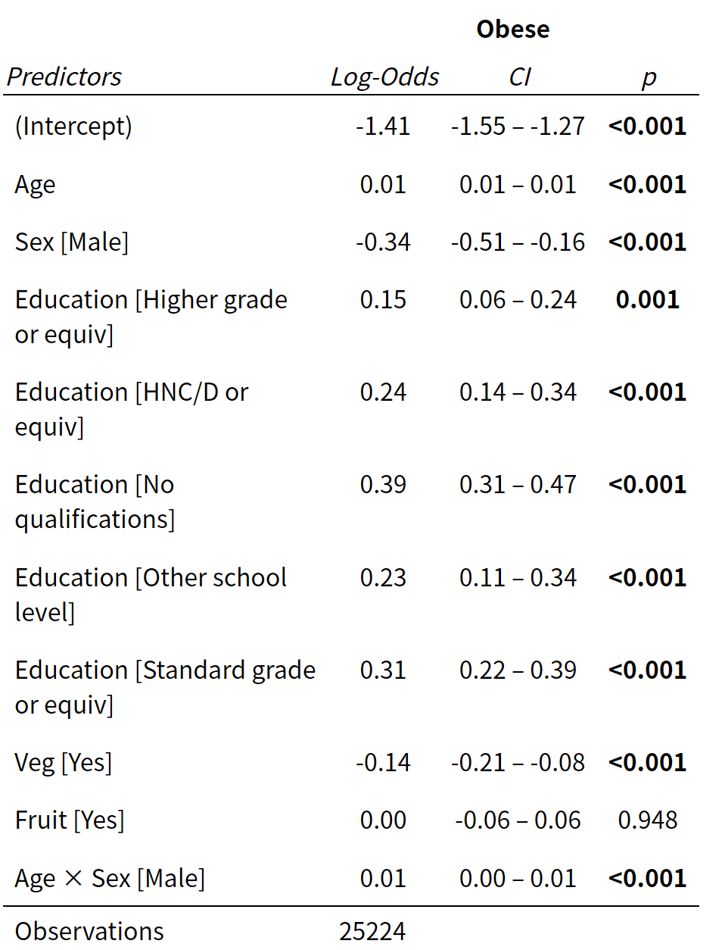
Since the p-value for fruit consumption is greater than 0.05 and the 95% confidence interval includes 0, fruit intake is not significantly associated with obesity. Apart from fruit, all other predictors are statistically significant(The 0.00 in the CI of the interaction item is due to rounding). This provides evidence that age, sex, education level, vegetable consumption and the interaction between age and sex are significantly associated with obesity in this model. Age has β = 0.01, 95% CI: 0.01–0.01, indicating that for females, each additional year of age increases the log-odds of being obese by approximately 0.01. The coefficient for Sex [Male] (β = −0.34, 95% CI: −0.51 to −0.16) represents the difference in log-odds of obesity between males and females when age is zero. The interaction between age and sex has β = 0.01, 95% CI: 0.00–0.01, indicating that the effect of age on obesity differs by sex and increases more strongly for males than for females. Vegetable has β = −0.14, 95% CI: −0.21 to −0.08, indicating that individuals who eat vegetables have lower log-odds of being obese compared with those who do not. All estimated coefficients for the education categories are positive relative to the reference category (Degree or higher), indicating that individuals in these groups have higher log-odds of obesity than those with a degree or higher qualification.
Figure 1: Diagnostic plots for the fitted logistic regression model
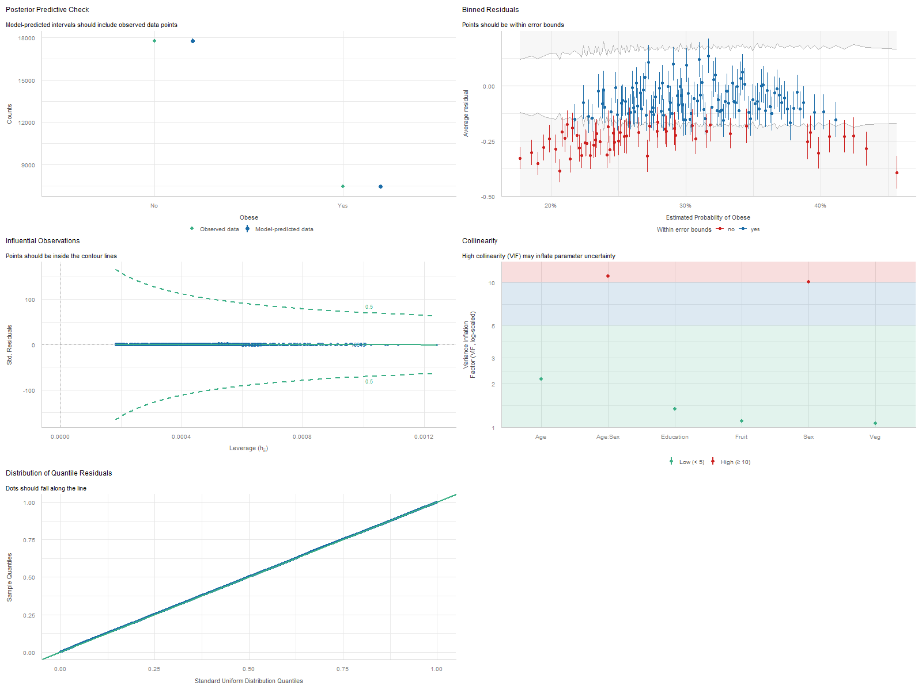
The model-predicted values closely match the observed data. Most residuals fall within the expected error bounds, indicating no strong evidence of systematic lack of fit. No observations fall outside the contour lines, suggesting that there are no highly influential data points affecting the model estimates. Most predictors have relatively low VIF values, indicating that multicollinearity among the explanatory variables is not severe. The quantile residuals lie close to the reference line, suggesting that the residual distribution follows the expected pattern.
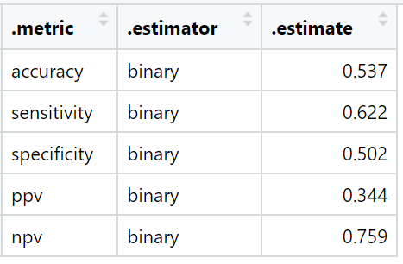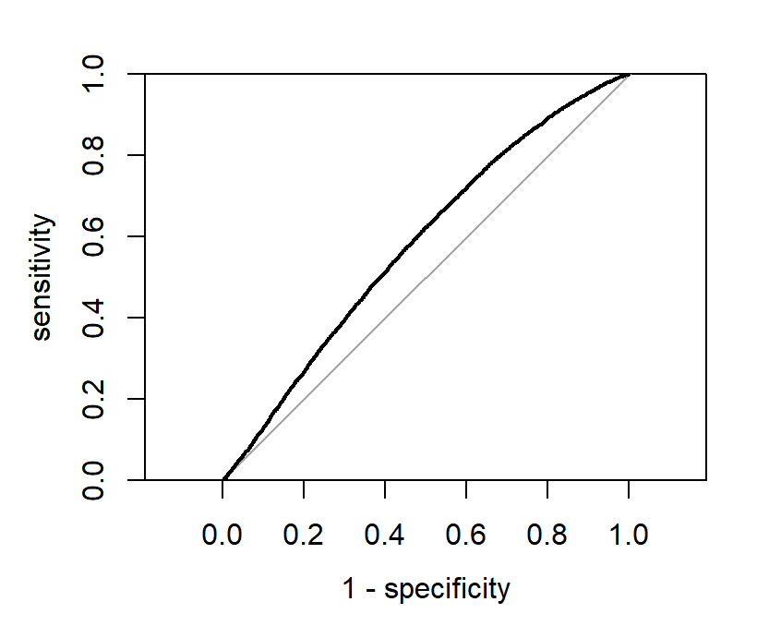
Figure 2: ROC curve for the logistic regression model Table 3: Classification performance metrics for the logistic regression model
The best cut-off probability was approximately 0.28, which provides a balance between sensitivity and specificity. The model achieves an accuracy of 0.537, with sensitivity of 0.622 and specificity of 0.502, indicating moderate ability to identify obese individuals and have limited ability to correctly classify non-obese individuals. The ROC curve lies above the diagonal reference line, suggesting that the model performs better than random classification, although the overall discriminative ability remains relatively modest.

