User Manual of Monopoly

Written by YEUNG Tsz Lok 22076383d

This is Daniel again from Group43. In this Manual, we will cover how users should build the game, the expected rundown, how should player save and load their games, how should gameboard designers do changes, and what are the possible final outputs of game.

By any means, here’s a brief Table of Contents.

1. Game build -------------------------------------pg.2-4
2. Game mechanics----------------------pg.5-
3. Development Kit-------------------------------pg.4
4. IDE------------------------------------------------pg.4
5. Simple setup (Lab computer example)----pg.5-8
6. Building a game

Our design enables very intuitive builds. You may enter the game in no time.

Firstly, run the Application.java as mentioned in Developer Manual*.

1. Starting from Scratch

Firstly, you will be asked whether to build a game. Typing “y” in capital or small will enter the next process, otherwise the program terminates. 

Secondly, you will be asked whether to load a game from save file source, in this case, let us press “enter” to start from scratch.

Thirdly, you need to input number of players. Any non-numbers or numbers out of the range (specifically defined in GAME_CONSTANTS) will lead to re-prompt.

Fourthly, you can decide whether to randomly allocate names of players instead of manually typing them one by one. The random names follow extraction from a file of name_list.txt.

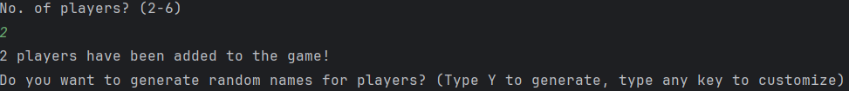

Fifthly, you are assigned to select a gameboard based on a list, users may easily type the number (i.e. index) of gameboard to do so.

Lastly, and fear not, users get to review their drafted settings and decide to run the game with it or not. If the input matches “y”, a Game object will be created with the specs, otherwise allow user to restart from Step 1 root.

1. Start using saved file

However, if you have saved (covered in Part3) a game into file. You may alternatively load the game and proceed with past records, carrying on an unfinished game.

So accepting “Load game from save slots” will display all existing saved game source files. You should type in desired file’s number.

The files contain all details and records necessary to recover a game and start the game object in a specific way to initialize the GameBoard, Players, count of Game Mechanics properly.

And similarly, If the input matches “y”, a Game object will be created with the specs, otherwise allow user to restart from Step 1 root.

1. Game interactions and Game mechanics

You may refer more on Glossary* from SRS* when come to how Squares work in their way and more detailed explanation of Player states.

Here will cover how should users, i.e. players in the game should behave when playing this command prompt based Monopoly.

1. Moving (throw the dice)

The simplest ever operation to do is input “1” to start moving the steps determined by the dice. Every player is expected to finish their turn when completing throwing the dice and finishing his subsequent actions, then pass the computer to next player.

1. Stepped on Property

You may input “y” or any other key to accept or decline the possible ownership of a Property. When stepped on other player’s Property the payment will be automatic.

1. Passed/Stepped on Go

You automatically receive 1500 count of Money.