Digital Library User Guide
Use the library to browse PDF collections, find relevant passages, add documents and ask questions with sources. This guide follows a typical reading and upload session.
Document version 1.3. Updated 19 October 2026. The new English screenshots use synthetic demonstration documents; the Q&A example is a scripted MOCK response.

1 Open the library and choose a language
Open the address supplied by your administrator. The default local installation uses http://127.0.0.1:18501/. At the top of the sidebar, choose English in 界面语言 / Interface language.
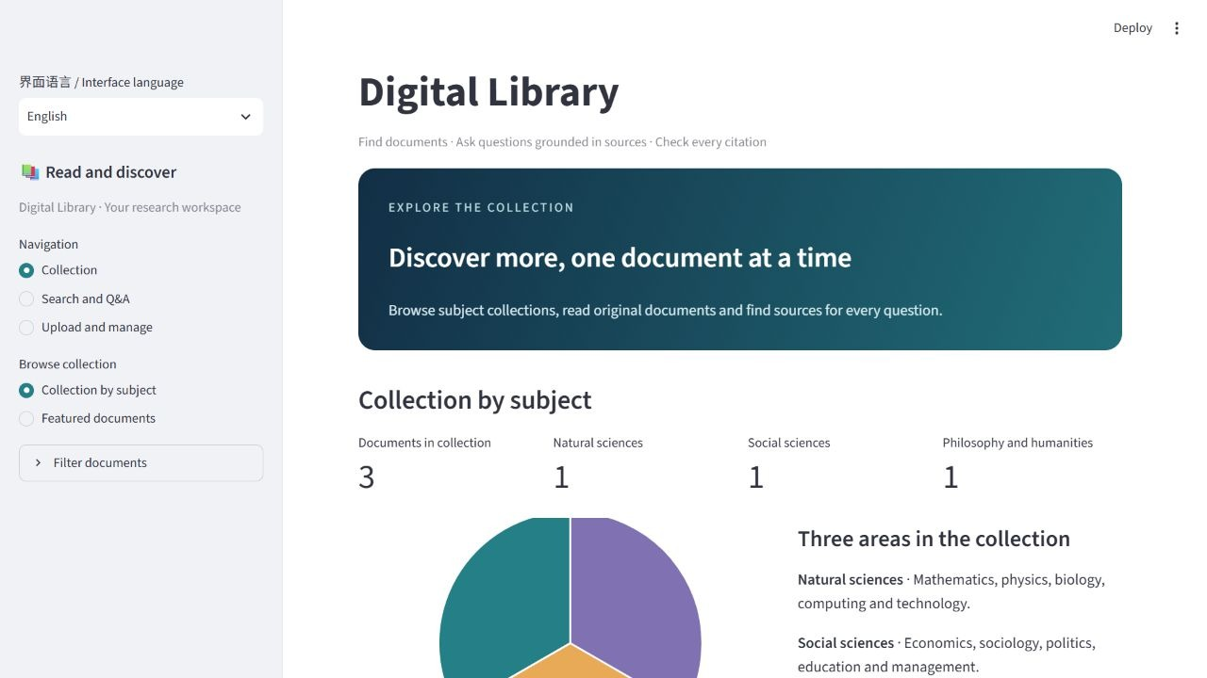
Figure 1 English library homepage
Choose 简体中文 to return to Chinese. Switching keeps your current page, filters, search results, answer and upload draft. Document titles, authors, source text and existing answers keep their original language.
The page address remembers the choice when you refresh. Share an English entry point by adding ?lang=en to the library address; use ?lang=zh for Chinese. A new window without a language parameter starts in Chinese.
To start a local installation, run ./Start-Library.ps1 -Mode real in the project folder. Follow the project installation instructions when setting it up for the first time.

2 Browse the collection
Choose Collection → Collection by subject. The counts and chart show the current collection across Natural sciences, Social sciences, and Philosophy and humanities. Use Browse by subject to focus on one area.
Choose Featured documents to browse PDF covers. Select a cover to open the original document. The order is a selection of library records rather than a readership ranking.
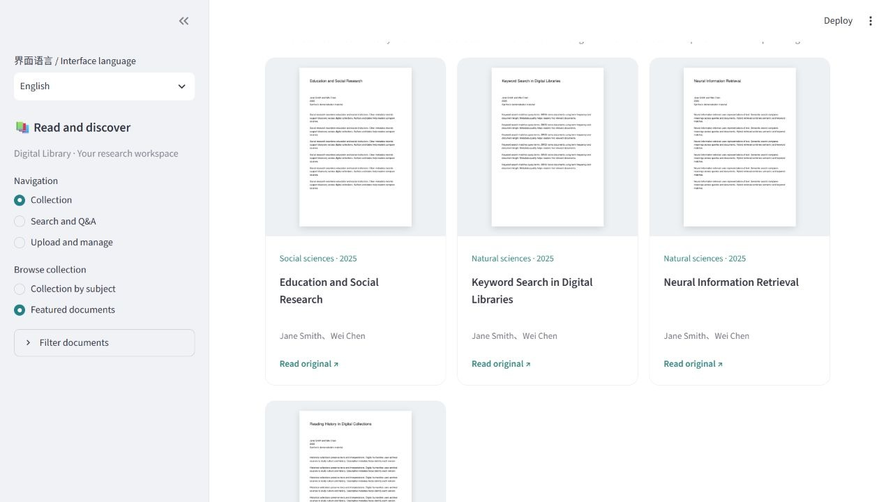
Figure 2 Browse documents by their PDF covers
Expand Filter documents in the sidebar to set a year range or topics. Leave the years blank for any year and separate topics with commas. A document card shows its title, authors, year, topics and source link where available.

3 Search documents and read the results
Open Search and Q&A, enter a title, keyword or question in What would you like to find or understand?, select Search, and click Submit.
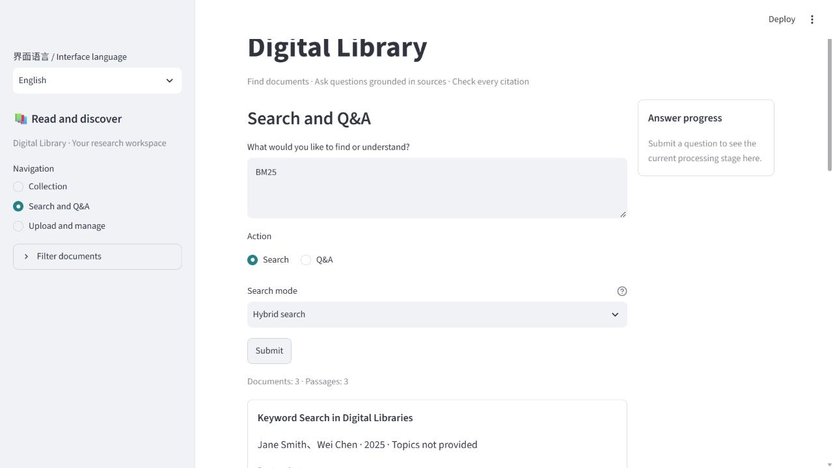
Figure 3 Search results and document previews
Search mode | When to use it
Keyword search | You know a title, abbreviation or technical term, such as BM25
Semantic search | You want to find passages about a meaning or idea
Hybrid search | You want to combine keyword and semantic matches; a useful starting point

The result count lists documents and passages separately. Expand a passage to read it, then select Open page to continue in the PDF. Page numbers start at the first page of the PDF file. If the browser does not jump to that page, turn to the displayed number yourself.
If results are sparse, relax the year and topic filters or try a shorter query. Switching the interface language keeps the submitted results and your query.

4 Upload a PDF and review recognition
Choose Upload and manage → Upload documents, then select a PDF. The default file limit is 25 MB; the page displays the limit for your installation.
Keep Enhanced recognition (recommended) on to use the configured API to read the first two pages. The system suggests a title, authors and a version year. Progress and elapsed time appear while it works.
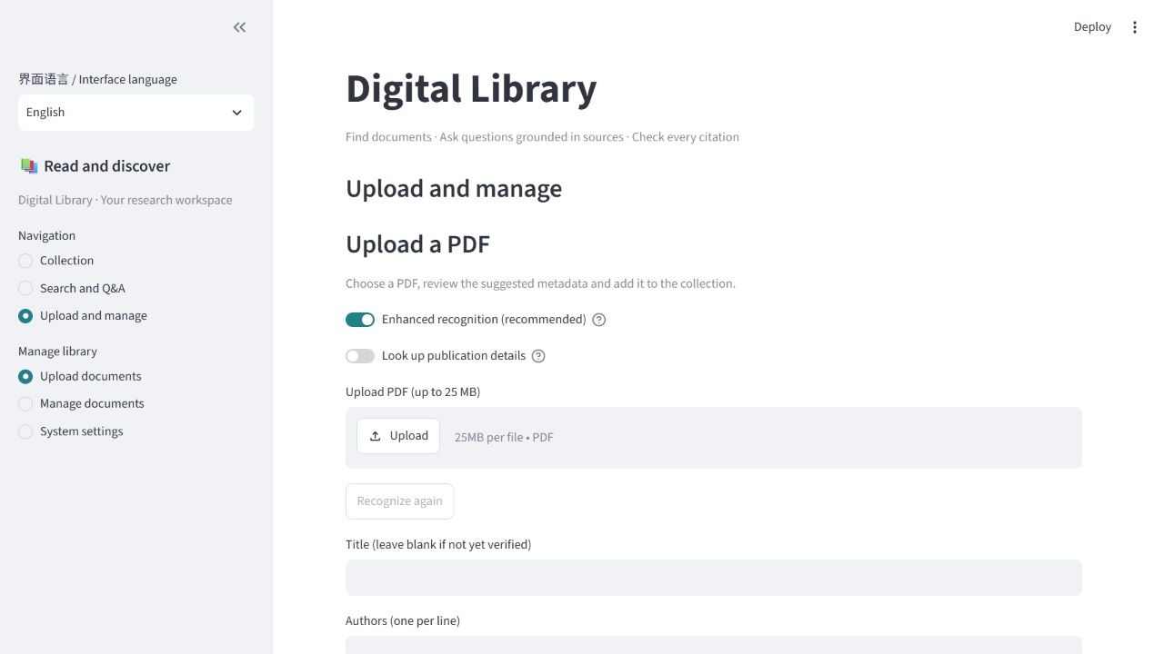
Figure 4 Choose a PDF and recognition options
Expand Suggestions and their sources to compare each suggestion with the PDF. Check the full title and the complete author list in its original order. Fields that cannot be identified reliably can be filled in yourself.
Enable Look up publication details when you want to check a publication source. This searches Crossref with the title and first two author names. After changing recognition options, select Recognize again to update the suggestions. This replaces the suggested fields, so keep any edits you want to reuse first.
If a service is unavailable, follow the page message and enter the information from the PDF. The screenshot uses a demonstration environment with API recognition disabled.

5 Complete the catalogue information and import
Review the form before selecting Import document. The subject is suggested from keywords first; with enhanced recognition enabled, an LLM assists when keywords do not identify it. If it remains blank, choose the closest subject yourself.
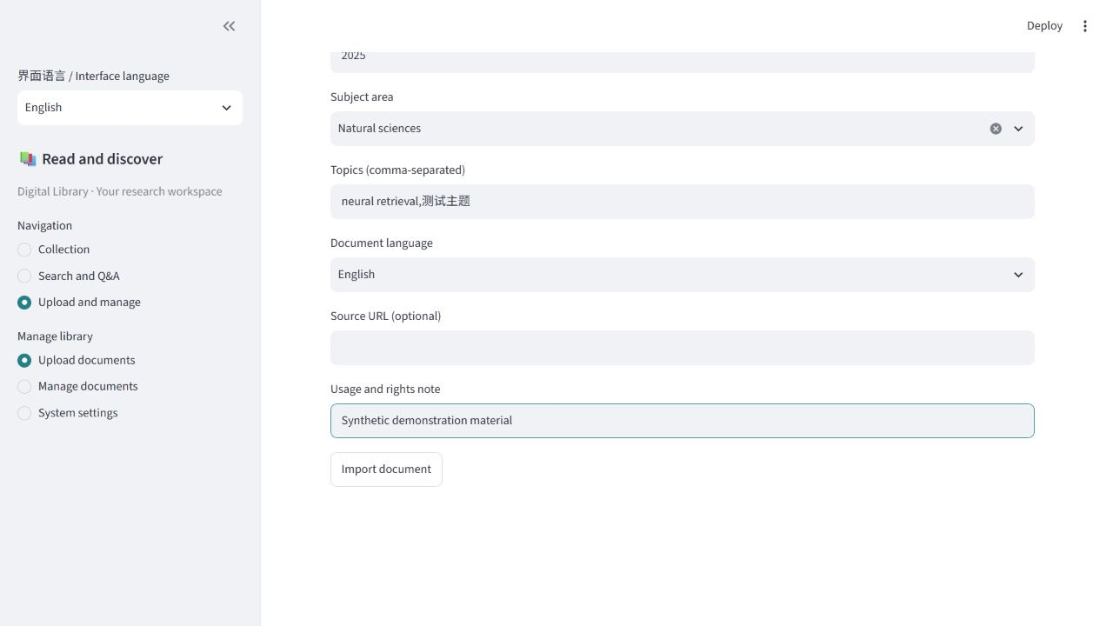
Figure 5 Complete the catalogue form
Field | What to enter
Title | The full title printed in the PDF
Authors | One author per line, in the original order
Version year | The year of this PDF version; leave blank if uncertain
Subject area | The closest of the three subject areas
Topics | Searchable terms, separated by commas
Document language | Chinese, English, Chinese and English, or Unknown
Source link | A document homepage or DOI link, if available
Usage and rights note | A relevant licence or intended use

Preprints and revised versions can be included. Use the date of the version you collected, such as its public release or revision year. A related journal record may describe a different version, so compare it with the PDF before using its date.
After import, the system extracts body text and builds the search index. Language switching keeps the selected file and the form draft, and does not run recognition again.

6 Check the import status
Open Upload and manage → Manage documents and find the new document. When its status is Ready to read, it is available for browsing, search and questions.
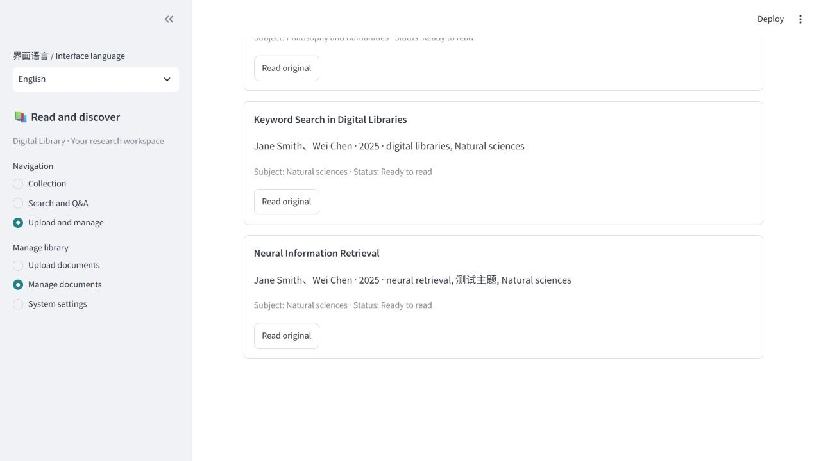
Figure 6 Review imported documents and their status
Status | What to do next
Ready to read | Search its title or open the PDF
Processing or Building search index | Wait for processing to finish, then refresh
Text review required (not searchable) | Check the indicated pages for scans or garbled text
Failed | Read the message, correct the problem and upload again

For a body-text review message, open the indicated PDF pages. Use OCR for scanned pages or obtain a readable text-based copy, then upload the corrected file. Uploading an identical PDF again keeps the existing record. Ask the maintainer if an existing record needs a metadata correction.

7 Ask a question and check its sources
In Search and Q&A, choose Q&A, write a question about a document in the collection and click Submit. Name the document and the point you want to understand. Each question is processed separately, so include that context again for a follow-up.
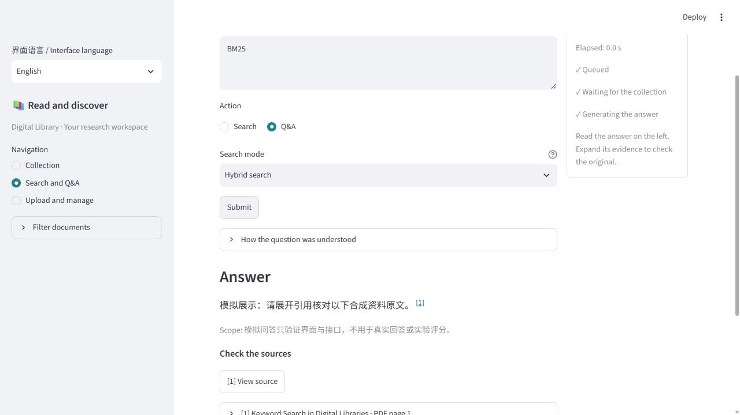
Figure 7 Read an answer and open its evidence
The right column shows actual processing stages and elapsed time. Once the answer appears, expand How the question was understood to see the search interpretation. Read any notes about missing evidence or the scope of the answer. If asked to clarify, select an option and submit it.
Click a citation number to open its source, or use View source to expand the evidence on the page.
An interface switch preserves the answer in its original language. The screenshot shows a Chinese scripted demonstration answer inside the English interface.

8 Read the cited source
In an evidence card, select View highlighted source and PDF page. This opens the extracted source text and a preview of its original PDF page. The source page follows the language of the link you opened.
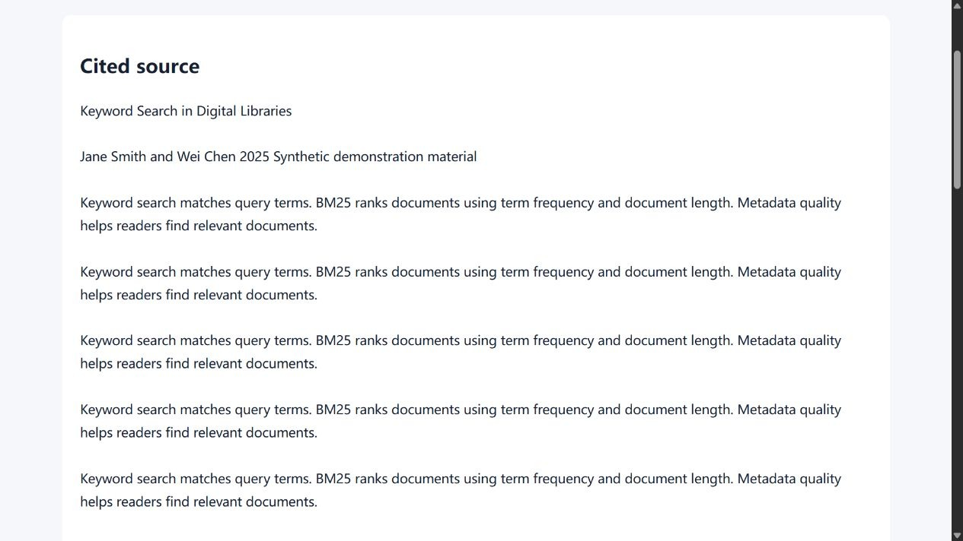
Figure 8 Read the extracted source and open its original PDF
When sentence locations are available, yellow highlights identify the sentences supporting that citation. Read them with the surrounding paragraphs to judge whether the answer reflects the source. Use Open original PDF to keep reading the full document.
The demonstration answer shown here has no sentence locations, so its source page explains that no highlighting is available. Answers with sentence locations open the same page with those sentences marked.

9 Common problems and demonstration tips
What you see | What to try
The page does not open | Check the address and confirm the library is running
Backend connection error | Run ./Status-Library.ps1 -Mode real in the project folder
Recognition does not finish | Retry later or fill in the fields from the PDF
Incomplete title or author list | Correct the fields before import
No useful search results | Relax filters and try the title or keywords
Body text needs review | Check the listed pages and use OCR or a corrected copy
Too little evidence for an answer | Name the document and narrow the question, or add relevant material

System settings displays the service mode, active models and current index. A MOCK service uses synthetic material and scripted answers for demonstrations; a REAL service uses the configured model services.
For a short demonstration, browse a subject collection, search a title, open a matching page, upload a PDF, review its metadata, confirm the import status, then ask a question and check its citation. Switch between Chinese and English while a query or form is filled in to show that your work is preserved. This sequence fits a six to eight minute operation video.

