

FACULTY OF ENGINEERING AND TECHNOLOGY

**REPORT ABOUT STATISTICAL ANNALYSIS OF DATA, PATTERNS, TRENDS AND INSIGHTS**

COURSE UNIT: COMPUTER POGRAMMING

LECTURER: MR. MASERUKA BENEDICTO

GROUP 15

SUBMITTED BY;

GROUP 15 MEMBERS

*DATE OF SUBMISSION: ........./.............../........................*

*SUBMITTED TO: ........................................................................*

# ACKNOWLEDGEMENT:

We are grateful to the almighty God for this guidance and strength throughout this work our sincere thanks go to all who supported us and to every group member for their time and effort. Lastly, we acknowledge the sources and references that contributed to this report.

# ABSTRACT:

This report presents statistical analysis of the development of each group member data efficiently. The first code consolidates each group member’s affirmation attributes into a single variable, while the second code organizes variables by array into separate tables. Additionally, a third code converts this table into structural arrays and outputs the variables into a single workbook. The implementation focuses on enhancing data handling for the MATLAB course, providing a practical solution for data organization and retrieval.

# DEDICATION:

This report is dedicated to our lecturer, Mr. Masruka Benedicto who’s guidance and support have been instrumental in our learning journey. We also dedicate this work to group H members their unwavering encouragement throughout this project.



# DECLARATION:

We, group 15 members hereby declare that this report is our original work, carried out as part of the MATLAB course under the supervision of Mr. Maseruka Benedicto. All sources of information have been duly acknowledged, and this work has not been submitted elsewhere for academic project.

LUGUNGA TIMOTHY.....................................................



ODONG ERICK PERRY...................................................



KATUSIME JOEL..............................................................



NABUKWASI SHAKIRA...................................................



NAZIWA PATRICIA............................................................

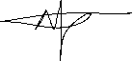

NANDIJJA LAILA.................................................................



SIDENYA KEVIN ..............................................................

|  |  |  |
| --- | --- | --- |
| **STUDENT NAME** | **REG. NO.** | **COURSE** |
| LUGUNGA TIMOTHY | BU/UG/2024/2679 | AMI |
| BAHEMUKA GODWINS | BU/UG/2024/2583 | APE |
| KATUSIIME JOEL | BU/UP/2024/1031 | WAR |
| NABUKWASI SHAKIRA | BU/UP/2023/0862 | WAR |
| NAZIWA PATRICIA | BU/UP/2024/0993 | PTI |
| SIDENYA KEVIN | BU/UP/2O24/3839 | WAR |
| ODONG ERICK PERRY | BU/UP/2024/1059 | WAR |
| NANDIJJA LAILA | BU/UP/2024/3833 | WAR |
| NAMATA LILLIAN KIZZA | BU/UP/2024/0984 | MEB |
| BULUMA DANIEL | BU/UP/2024/4323 | AMI |

# APPROVAL:

This report titled “Statistical Analysis and Visualization of Coffee Sales Data” has been prepared and submitted by Group 15, in partial fulfillment of the requirements for the course. The work presented herein is original and has been carried out under the guidance of the instructor.

We hereby approve this report as a reflection of the student’s effort in applying knowledge from Modules 1 to 4 to analyze, interpret, and visualize real-world data.

Table of Contents

ACKNOWLEDGEMENT: 2

ABSTRACT: 3

DEDICATION: 4

DECLARATION: 5

APPROVAL: 6

LIST OF ACRONYMS: 8

CHAPTER 1: INTRODUCTION: 9

1.1 Background: 9

1.2 Historical Development: 9

CHAPTER 2: STUDY COVERAGE: 10

**2.1 NUMBER ONE:** 10

**2.2 NUMBER TWO** 15

CHAPTER 3: RECOMMENDATIONS AND CONCLUSION 19

3.1 Recommendation: 19

3.2 Conclusion: 20

CHAPTER 4: REFERENCES: 21

# LIST OF ACRONYMS:

**MATLAB**  MATrix LABoratory

**Struct**  Structure

# CHAPTER 1: INTRODUCTION:

# 1.1 Background:

MATLAB, which stands for matrix laboratory, is a high-performance programming language and environment designed primarily for technical computing. Its origins trace back to the late 1970s when Cleve Moler, a professor of computer science, developed it to provide his students with easy access to mathematical software libraries without requiring them to learn Fortran.

# 1.2 Historical Development:

**Initial Development:** The first version of MATLAB was created in Fortran in the late 1970s as a simple interactive matrix calculator. This early iteration included basic matrix operations and was built on top of two significant mathematical libraries: LINPACK and EISPACK, which were developed for numerical linear algebra and eigenvalue problems, respectively.

**Commercial Launch:** MATLAB was officially launched as a commercial product in 1984 by MathWorks, a company founded by Moler along with Jack Little and Steve Bangert. This marked the transition from a simple calculator to a comprehensive programming environment. The software was reimplemented in C, enhancing its capabilities with the addition of user-defined functions, toolboxes, and graphical interfaces.

**Expansion and Toolboxes:** Over the years, MATLAB has expanded significantly. By the late 1980s, it had introduced several specialized toolboxes for various applications, including control systems and signal processing. The introduction of the Simulink environment further allowed users to model and simulate dynamic systems graphically.

**Modern Enhancements:** Recent versions of MATLAB have introduced features like the Live Editor, which allows users to create interactive documents that combine code, output, and formatted text. This evolution reflects MATLAB's ongoing adaptation to meet the needs of its diverse user base across academia and industry.

# CHAPTER 2: STUDY COVERAGE:

# **2.1 NUMBER ONE:**

**GRAPHICAL ANNALYSIS**

Bar and line graphs used to visualize sales patterns, showing trends in coffee types, payment methods and sales over time. These graphs highlight peak periods, popular products and temporal variations in a clear and intuitive way

% loading the dataset file to matlab

filePath = "C:\Users\LUGUNGA TIMOTHY\Desktop\semester 1\coffee sales.xlsx";

group15 = readtable(filePath);

% find year column if it exists and extract Year if Date column exists

if ~ismember('Year', group15.Properties.VariableNames)

if ismember('Date', group15.Properties.VariableNames)

group15.Date = datetime(group15.Date);

group15.Year = year(group15.Date);

else

error('The dataset must have a Year or Date column.');

end

end

% finds all the years in the group15 dataset

years = unique(group15.Year);

% Creating tables and structure arrays for each year

yearlyTables = struct();

yearlyStructs = struct();

for i = 1:length(years)

yr = years(i);

% Table for this year

tbl = group15(group15.Year == yr, :);

yearlyTables.(sprintf('Y%d', yr)) = tbl;

% Converting table to struct array

yearlyStructs.(sprintf('Y%d', yr)) = table2struct(tbl);

end

%saving all yearly tables to one Excell workbook

outputFile = 'Yearly_Data.xlsx';

for i = 1:length(years)

yr = years(i);

tbl = yearlyTables.(sprintf('Y%d', yr));

writetable(tbl, outputFile, 'Sheet', num2str(yr));

end

disp('✅ Yearly data saved to Excel');

% Data visualisation showing all the parameters, patterns ...

%trends and relationships

for i = 1:length(years)

yr = years(i);

tbl = yearlyTables.(sprintf('Y%d', yr));

% Getting the numeric columns in group15 dataset

numericCols = varfun(@isnumeric, tbl, 'OutputFormat', 'uniform');

numVars = tbl.Properties.VariableNames(numericCols);

% --- Line plot of first numeric variable ---

if ~isempty(numVars)

figure;

plot(tbl.(numVars{1}), 'k-s',LineWidth=0.5);

title(['Year ' num2str(yr) ' - Trend of ' numVars{1}]);

xlabel('Record number');

ylabel(numVars{1});

grid on;

saveas(gcf, ['line_' num2str(yr) '.png']);

close;

end

% --- Bar chart of averages ---

if ~isempty(numVars)

figure;

bar(mean(tbl{:, numericCols}, 'omitnan'));

set(gca,'XTickLabel', numVars);

title(['Year ' num2str(yr) ' - Average Values']);

ylabel('Average');

grid on;

saveas(gcf, ['bar_' num2str(yr) '.png']);

close;

end

% --- Scatter plot between first two numeric variables ---

if numel(numVars) >= 2

figure;

scatter(tbl.(numVars{1}), tbl.(numVars{2}), 'filled');

title(['Year ' num2str(yr) ' - Scatter: ' numVars{1} ' vs ' numVars{2}]);

xlabel(numVars{1});

ylabel(numVars{2});

grid on;

saveas(gcf, ['scatter_' num2str(yr) '.png']);

close;

end

% --- Histogram of first numeric variable ---

if ~isempty(numVars)

figure;

histogram(tbl.(numVars{1}));

title(['Year ' num2str(yr) ' - Histogram of ' numVars{1}]);

xlabel(numVars{1});

ylabel('Frequency');

grid on;

saveas(gcf, ['hist_' num2str(yr) '.png']);

close;

end

end

disp('✅ Plots created and saved as images');

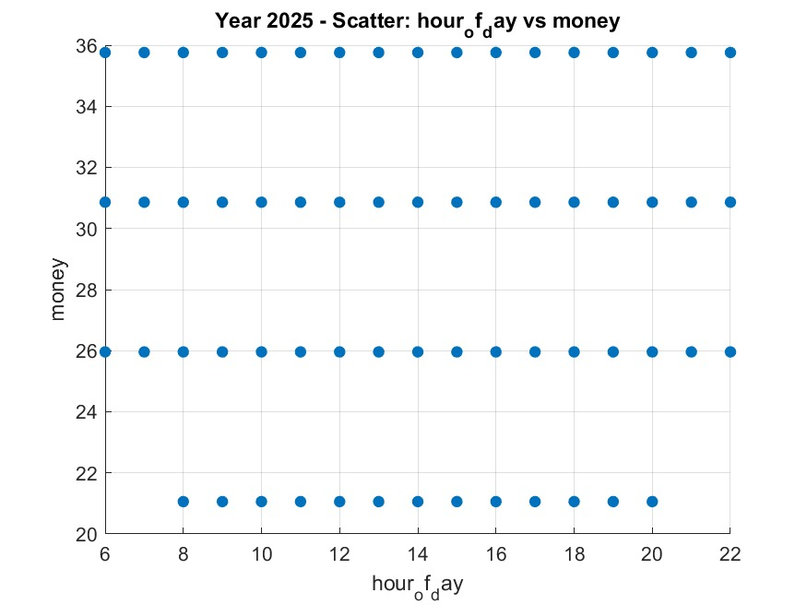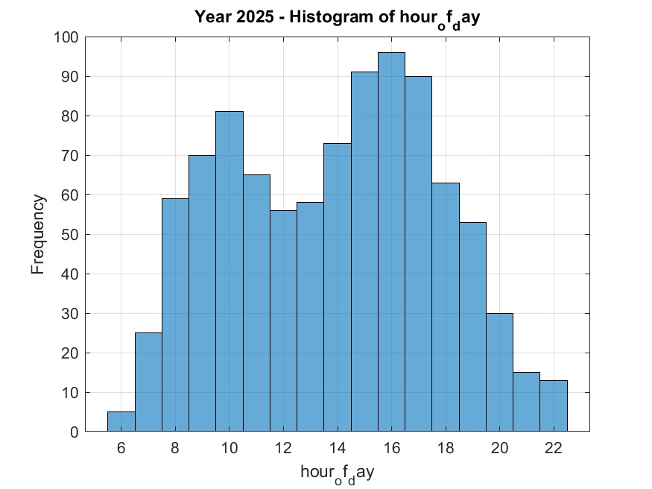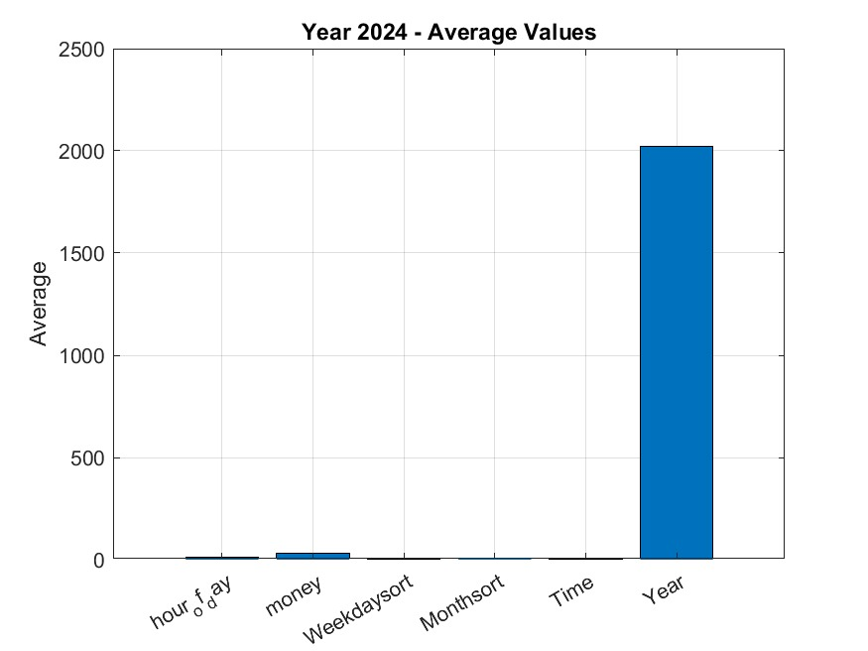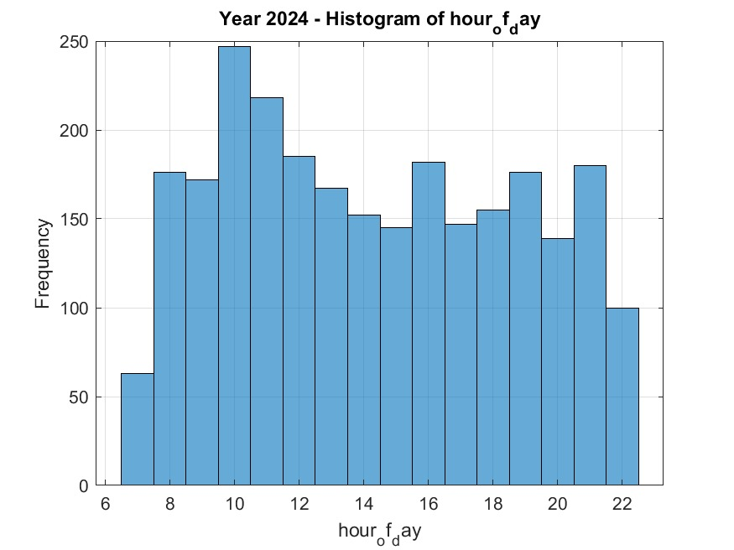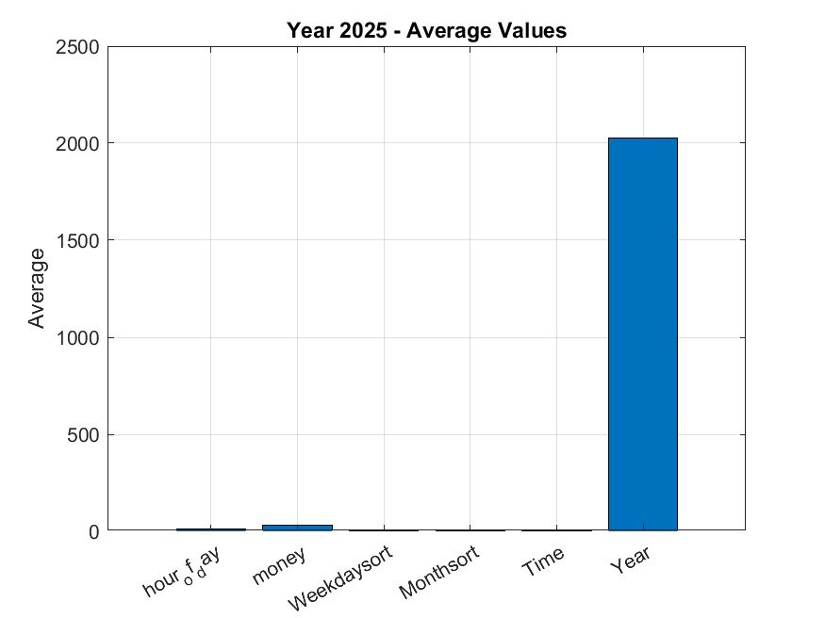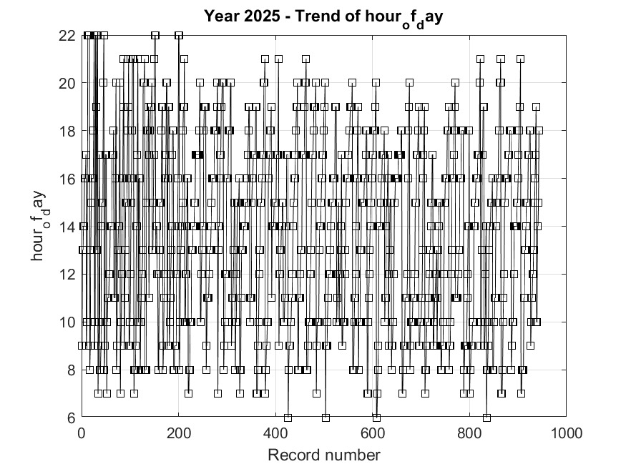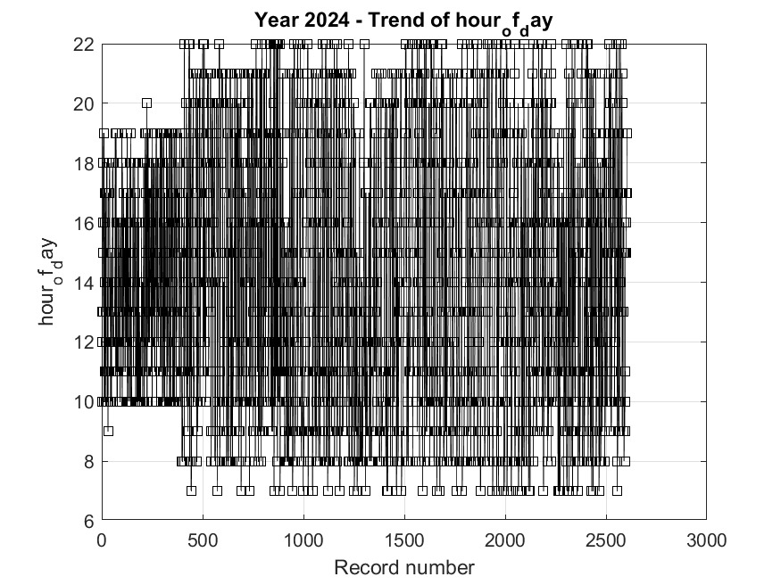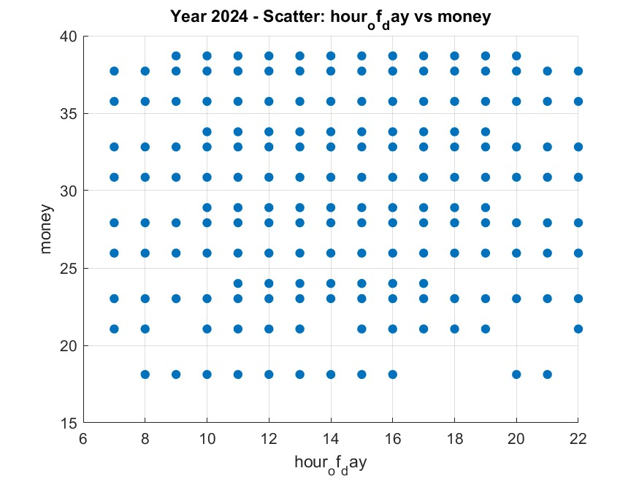

## **2.2 NUMBER TWO**

1. clc;
2. clear;
3. % Creating an empty structure array with the desired attributes
4. groupMembers = struct('name', {}, ...
5. 'age', {}, ...
6. 'homeDistrict', {}, ...
7. 'village', {}, ...
8. 'religion', {}, ...
9. 'course', {}, ...
10. 'tribe', {}, ...
11. 'interests', {}, ...
12. 'facialRepresentation', {});
13. disp('Step 1: Empty structure "groupMembers" created.');
14. % Step 2: Adding Information for Each Group Member
15. groupMembers(1).name = ' Lugunga Timothy';
16. groupMembers(1).age = 21;
17. groupMembers(1).homeDistrict = 'Eastern District';
18. groupMembers(1).village = 'Namutumba';
19. groupMembers(1).religion = 'Christianity';
20. groupMembers(1).course = 'AMI';
21. groupMembers(1).tribe = 'musoga';
22. groupMembers(1).interests = {'Programming , football'};
23. groupMembers(1).facialRepresentation = 'Has no beard';
24. groupMembers(2).name = 'NAMATA LILLIAN KIZZA';
25. groupMembers(2).age = 23;
26. groupMembers(2).homeDistrict = 'central District';
27. groupMembers(2).village = 'Pinecrest';
28. groupMembers(2).religion = 'Christianity';
29. groupMembers(2).course = 'MEB';
30. groupMembers(2).tribe = 'muntoro';
31. groupMembers(2).interests = { 'Robotics'};
32. groupMembers(2).facialRepresentation = 'Wears glasses';
33. groupMembers(3).name = 'KATUSIIME JOEL';
34. groupMembers(3).age = 22;
35. groupMembers(3).homeDistrict = 'Western District';
36. groupMembers(3).village = 'nyamitanga';
37. groupMembers(3).religion = 'none';
38. groupMembers(3).course = 'WAR';
39. groupMembers(3).tribe = 'mukiga';
40. groupMembers(3).interests = {'Cars'};
41. groupMembers(3).facialRepresentation = 'Has a scar on the left cheek'; % Member 4
42. groupMembers(4).name ='NANDIJJA LAILA'; groupMembers(4).age=22
43. groupMembers(4).homeDistrict = 'Western District';
44. groupMembers(4).village = 'katete';
45. groupMembers(4).religion = 'muslim';
46. groupMembers(4).course = 'WAR';
47. groupMembers(4).tribe = 'muganda';
48. groupMembers(4).interests = { 'Hiking'};
49. groupMembers(4).facialRepresentation = 'Has big chicks';
50. groupMembers(5).name = 'SIDENYA KEVIN';
51. groupMembers(5).age = 23;
52. groupMembers(5).homeDistrict = 'Northern District';
53. groupMembers(5).village = 'kwegil';
54. groupMembers(5).religion = 'Buddhism';
55. groupMembers(5).course ='WAR';
56. groupMembers(5).tribe = 'acholi';
57. groupMembers(5).interests = {'Reading'};
58. groupMembers(5).facialRepresentation = 'Wears glasses';
59. groupMembers(6).name = 'NAZIWA PATRICIA';
60. groupMembers(6).age = 20;
61. groupMembers(6).homeDistrict = 'Western District';
62. groupMembers(6).village = 'kotiti';
63. groupMembers(6).religion = 'PENTACOSTAL';
64. groupMembers(6).course = 'PTI';
65. groupMembers(6).tribe = 'musoga';
66. groupMembers(6).interests = {'preaching'};
67. groupMembers(6).facialRepresentation = 'Has a dimple on the left cheek';
68. groupMembers(7).name = 'NABUKWASI SHAKIRA';
69. groupMembers(7).age = 23;
70. groupMembers(7).homeDistrict = 'Eastern District';
71. groupMembers(7).village = 'waki';
72. groupMembers(7).religion = 'muslim';
73. groupMembers(7).course = 'WAR';
74. groupMembers(7).tribe = 'mugisu';
75. groupMembers(7).interests = {'listening to Music'};
76. groupMembers(7).facialRepresentation = 'has long hair and nose';
77. groupMembers(8).name = 'ODONG ERICK PERRY';
78. groupMembers(8).age = 23;
79. groupMembers(8).homeDistrict = 'Northern District';
80. groupMembers(8).village = 'uphill';
81. groupMembers(8).religion = 'Buddhism';
82. groupMembers(8).course = 'WAR';
83. groupMembers(8).tribe = 'Langi';
84. groupMembers(8).interests = {'Reading'};
85. groupMembers(8).facialRepresentation = 'has small nose';
86. groupMembers(9).name = 'BAHEMUKA GODWINS';
87. groupMembers(9).age = 31;
88. groupMembers(9).homeDistrict = 'central District';
89. groupMembers(9).village = 'viva';
90. groupMembers(9).religion = 'Christianity';
91. groupMembers(9).course = 'APE';
92. groupMembers(9).tribe = 'mugisu';
93. groupMembers(9).interests = {'driving'};
94. groupMembers(9).facialRepresentation = 'Has a bold head ';
95. groupMembers(10).name = 'BULUMA DANIEL';
96. groupMembers(10).age = 24;
97. groupMembers(10).homeDistrict = 'Eastern District';
98. groupMembers(10).village = 'bondokolo';
99. groupMembers(10).religion = 'Christianity';
100. groupMembers(10).course = 'AMI';
101. groupMembers(10).tribe = 'samya';
102. groupMembers(10).interests = ' riding';
103. groupMembers(10).facialRepresentation = 'Has a beard';
104. disp(' Information for members has been added to the variable.');
105. % Display the Stored Information
106. disp('Displaying the contents of the "groupMembers" variable:');
107. disp(groupMembers);
108. % Save the Variable to a File
109. fileName = 'groupData.mat';
110. save(fileName, 'groupMembers');
111. disp([' The variable "groupMembers" has been successfully saved to the file "' fileName '".']);
112. disp('You can load it back anytime using the command: load("groupData.mat")');
113. % Creating a Detailed and Expanded Database for Statistical Analysis
114. clc;
115. clear;
116. % -Define possible attributes for random generation ---
117. names = ["Lugunga Timothy", "NAMATA LILLIAN KIZZA","NANDIJJA LAILA", "KATUSIIME JOEL", "BULUMA DANIEL", "ODONG ERICK PERRY", "BAHEMUKA GODWINS", "NAZIWA PATRICIA", "SIDENYA KEVIN", "NABUKWASI SHAKIRA"];
118. districts = ["Central District", "Northern District", "Western District", "Southern District", "Eastern District"];
119. religions = ["Christianity", "Buddhism", "Islam", "None", "Judaism","PENTACOSTAL"];
120. courses = ["AMI","MEB","PTI","WAR","APE"];
121. tribes = ["Musoga", "mutoro", "mugisu","langi","acholi","munyankole", "mukiga"];
122. % Creating the structure
123. groupMembers = struct('name', {}, 'age', {}, 'homeDistrict', {}, 'religion', {}, 'course', {}, 'tribe', {});
124. % Generating 10 members with random data
125. numMembers = 10;
126. for i = 1:numMembers
127. groupMembers(i).name = names(randi(length(names)));
128. groupMembers(i).age = randi([18, 32]);
129. groupMembers(i).homeDistrict = districts(randi(length(districts)));
130. groupMembers(i).religion = religions(randi(length(religions)));
131. groupMembers(i).course = courses(randi(length(courses)));
132. groupMembers(i).tribe = tribes(randi(length(tribes)));
133. end
134. % saving the detailed dataset
135. save('groupData.mat', 'groupMembers');
136. disp(['A detailed database with ', num2str(numMembers), ' members has been created and saved as "groupData.mat".']);
137. disp('Ready for statistical analysis.');
138. % Analyze and Visualize Statistical Characteristics
139. clc;
140. clear;
141. close all;
142. % Data Loading and Preparation
143. disp('Loading and Preparing Data ');
144. if exist('groupData.mat', 'file')
145. load('groupData.mat');
146. disp(['Successfully loaded data for ', num2str(length(groupMembers)), ' members.']);
147. else
148. error('"groupData.mat" not found. Please run "create_detailed_database.m" first.');
149. end
150. ages = [groupMembers.age];
151. districts = categorical([groupMembers.homeDistrict]);
152. religions = categorical([groupMembers.religion]);
153. courses = categorical([groupMembers.course]);
154. tribes = categorical([groupMembers.tribe]);
155. disp('Data has been extracted into individual variables.');
156. % Descriptive Statistics for Numerical Data (Age)
157. disp(' Descriptive Statistics for Age ');
158. % Analysing Categorical Data
159. disp(' Analysis of Categorical Data ');
160. % Analysis 1: Home Districts
161. disp('Home District Distribution ');
162. [district_counts, district_names] = histcounts(districts);
163. district_table = table(district_names', district_counts', 'VariableNames', {'District', 'Count'});
164. disp(district_table);
165. % Analysis 2: Course Enrollment
166. disp(' Course Enrollment Distribution ');
167. [course_counts, course_names] = histcounts(courses);
168. course_table = table(course_names', course_counts', 'VariableNames', {'Course', 'Count'});
169. disp(course_table);
170. % Analysis 3: Tribe Membership
171. disp('Tribe Membership Distribution ');
172. [tribe_counts, tribe_names] = histcounts(tribes);
173. tribe_table = table(tribe_names', tribe_counts', 'VariableNames', {'Tribe', 'Count'});
174. disp(tribe_table);
175. disp(' ');
176. % Visualize Categorical Data (CORRECTED SECTION)
177. disp(' Generating bar and pie charts for categorical data.');
178. % Bar Chart for Course Enrollment
179. figure('Name', 'Categorical Data Analysis');
180. subplot(2, 1, 1);
181. bar(course_names, course_counts);
182. title('Number of Members per Academic Course');
183. xlabel('Course');
184. ylabel('Number of Members');
185. grid on;
186. % Pie Chart for Tribe Distribution
187. subplot(2, 1, 2);
188. pie(tribes);
189. title('Proportional Distribution of Tribes');
190. legend(tribe_names, 'Location', 'eastoutside');
191. % A separate figure for District distribution
192. figure('Name', 'Geographic Analysis');
193. barh(district_names, district_counts);
194. title('Geographic Distribution of Members by Home District');
195. xlabel('Number of Members');
196. ylabel('District');
197. grid on;
198. disp('All analyses and visualizations are complete.');

# CHAPTER 3: RECOMMENDATIONS AND CONCLUSION

# 3.1 Recommendation:

Based on the statistical analysis of the coffee sales data, it is recommended that the business leverages the insights on peak sales periods and popular coffee types to optimize staffing, inventory, and promotional strategies. Targeted promotions could be scheduled during high-traffic hours and on popular days of the week to maximize revenue. Additionally, offering incentives for preferred payment methods or introducing loyalty programs could enhance customer satisfaction and retention. Monitoring seasonal trends can help in planning stock levels and introducing limited-time offerings to meet customer demand efficiently. Overall, data-driven decision-making should guide operational improvements and marketing strategies to boost overall sales performance.

# 3.2 Conclusion:

The analysis of the coffee sales dataset has provided valuable insights into customer purchasing patterns and business performance. By applying statistical methods and visualization techniques, it was possible to examine sales across different time frames, payment methods, and coffee types. The results show clear trends such as peak sales hours, popular coffee choices, preferred payment types, and variations across weekdays and months.

Overall, this study demonstrates the importance of data-driven decision-making in identifying key business drivers and optimizing operations. The findings can support better planning for inventory, staffing, and promotional strategies to maximize sales and customer satisfaction.

# CHAPTER 4: REFERENCES:

Montgomery, D. C., & Runger, G. C. (2018). Applied Statistics and Probability for Engineers (7th ed.). Wiley.

Field, A., Miles, J., & Field, Z. (2012). Discovering Statistics Using R. Sage Publications.

James, G., Witten, D., Hastie, T., & Tibshirani, R. (2013). An Introduction to Statistical Learning with Applications in R. Springer.

MATLAB Documentation. (2025).Statistics and Machine Learning Toolbox.Mathworks.