**Metrocar Funnel analysis report**

**Summary:**

After finishing analyzing the user/ride level funnel and following the various business questions, based on the data gathered:

User level funnel – 3 key drop off points, 'download -> signup ', ' signup -> ride_request ', ' ride_accepted -> ride_pickup ', with the corelating conversion rates: 74.65%, 70.40%, 50.77%.

Ride level funnel – one major drop off point, 'rides_requested -> ride_accepted', which makes up for a 64.43% conversion rate, cancellation rate is 9.94%.

Platform analysis: Precent of users across these 3 platforms: Ios, android, web goes as follows 60.53%, 29.37%, 10.09%.

Age range analysis: The two major age groups are: 'unknown' and '35-44' making up for 22.46% and 21.94% of our customer base.

Price surging analysis: our busiest hours (accounting for all ages) are: 08:00 – 09:00, 16:00 – 19:00, these are the times best suited for a price surge strategy.

I would recommend examining the above-mentioned funnel steps further, most of our user base is using the iOS platform so I would advise advertising there, 'unknown' makes up for our biggest age range group and can go in two ways either <18 or 54< (assuming every user is filling their correct age), in order to maximize revenues I would recommend recruiting more drivers and maybe adding a sort of fine on canceled rides (by driver or passenger).

**Context:**

This project aims to analyze the customer funnel of Metrocar, a ride-sharing app (similar to Uber/Lyft), to identify areas for improvement and optimization.

Metrocar's business model is based on a platform that connects riders with drivers through a mobile application. Metrocar acts as an intermediary between riders and drivers, providing a user-friendly platform to connect them and facilitate the ride-hailing process.

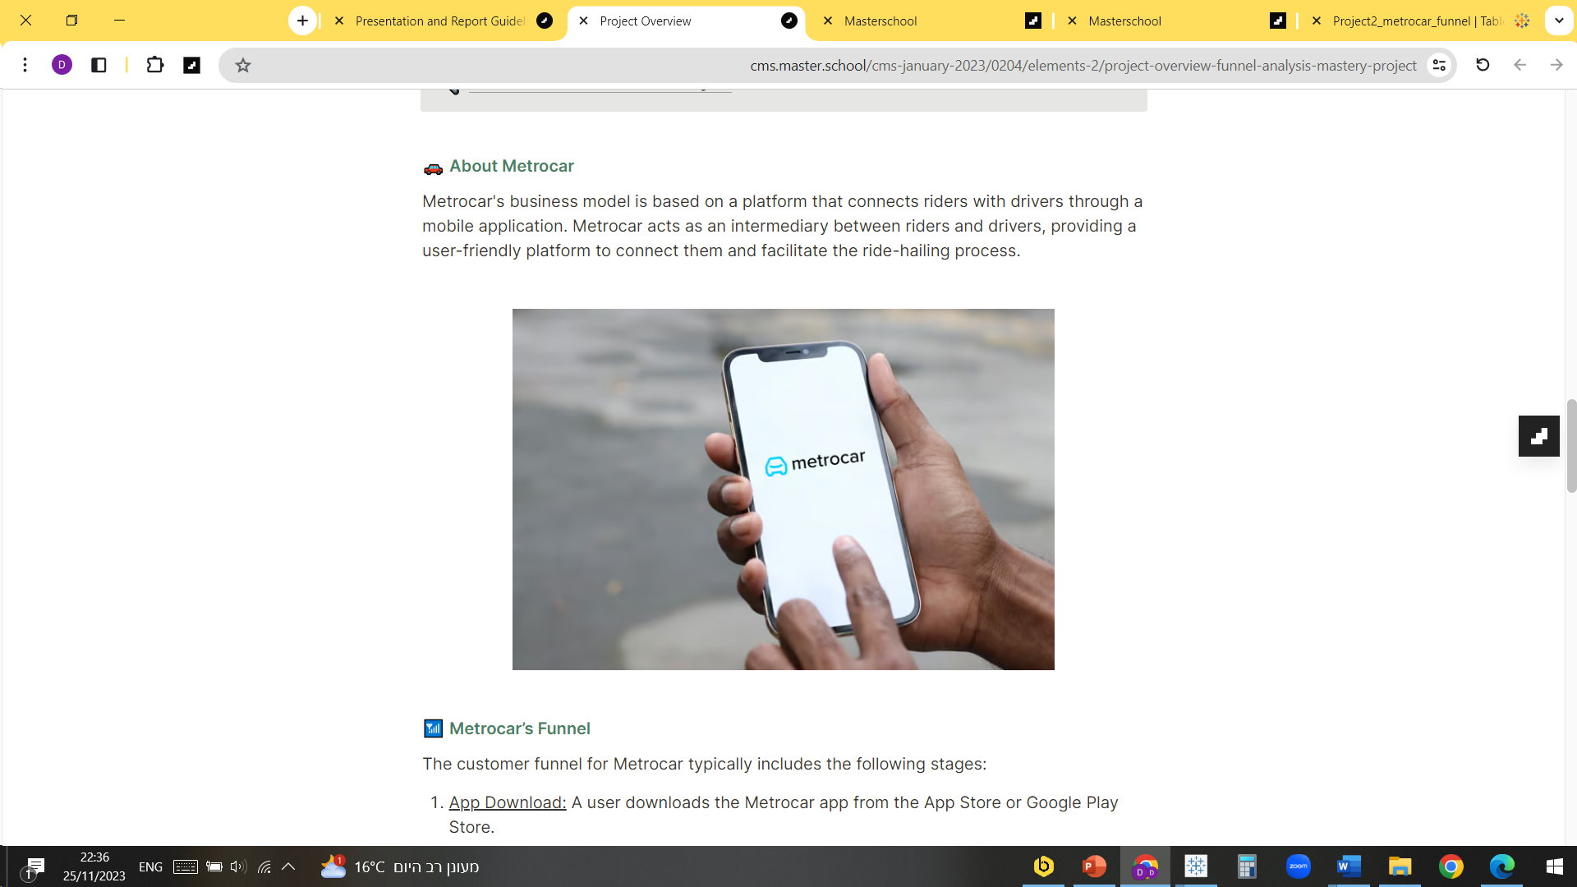

The customer funnel for Metrocar includes the following stages:

1. App Download: A user downloads the Metrocar app from the App Store or Google Play Store.
2. Signup: The user creates an account in the Metrocar app, including their name, email, phone number, and payment information.
3. Request Ride: The user opens the app and requests a ride by entering their pickup location, destination, and ride capacity (2 to 6 riders).
4. Driver Acceptance: A nearby driver receives the ride request and accepts the ride.
5. Ride Pick Up: Driver picks up customer from pick up location.
6. Ride completed: The user gets in the car and rides to their destination.
7. Payment: After the ride, the user is charged automatically through the app, and a receipt is sent to their email.
8. Review: The user is prompted to rate their driver and leave a review of their ride experience.

The dataset is built from 5 tables: app_downloads, signup, ride_requests, transactions, and review.

Each corresponding step in the funnel is being calculated by merging tables to each other starting from app_downloads adding additional tables as we progress through the funnel up until review.

The dataset was being aggregated by download date, platform, age_range and funnel step minimizing its size to get better performance on tableau dashboard, we use two tables one sorted by download dt and one to investigate the possibility of a price surging strategy sorting completed drives by hours of the day they were requested and by extracting the hour from the timestamp for the ride request, both tables are sorted by platform and age range aswell.

**Results:**

* **What steps of the funnel should we research and improve? Are there any specific drop-off points preventing users from completing their first ride?**

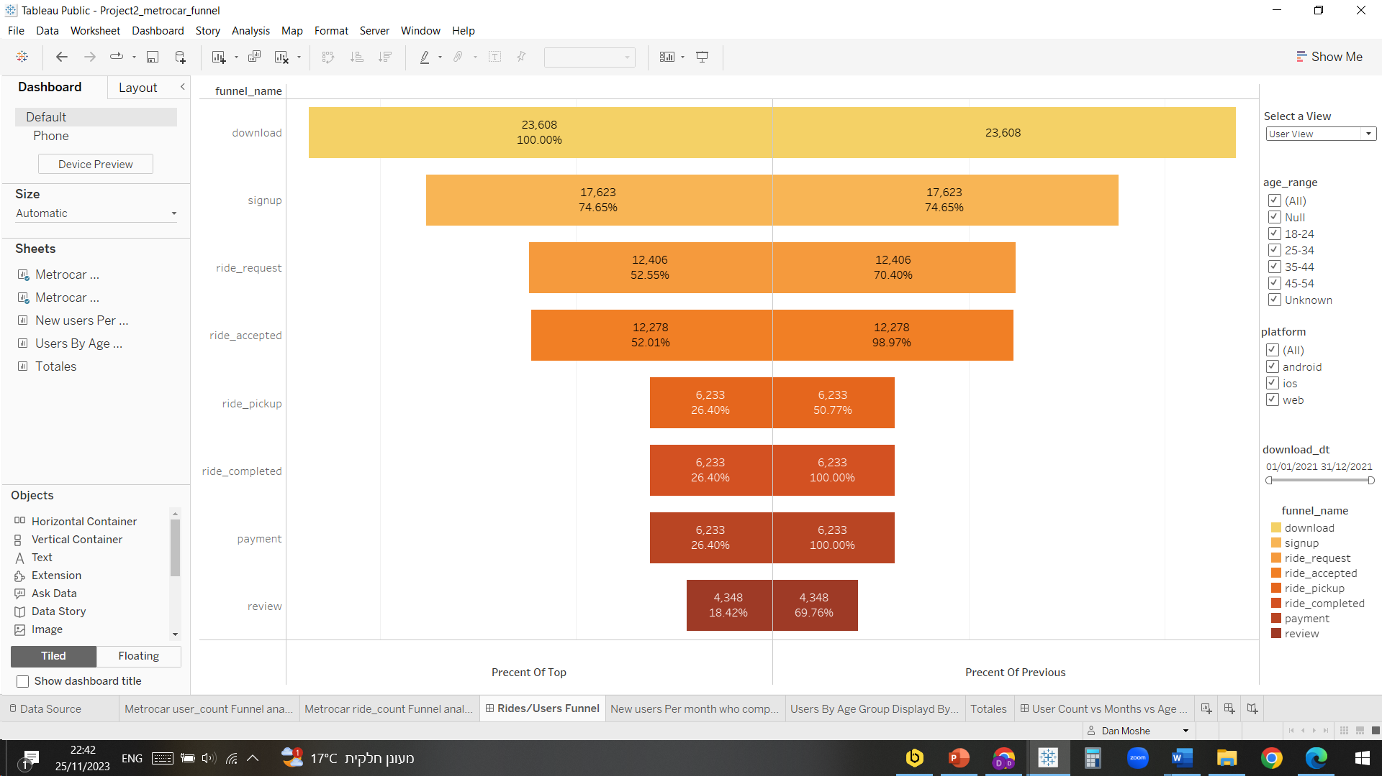**User Level funnel** – after constructing the following funnel from the data gathered we can clearly state where our major drop offs are customers wise.

The funnel is interactive and on the right your can sort it by age groups, platforms, download_dt, in the upper right corner there is a select a view button that is sorting the display between Rides/Users based on parameter.

There are 3 drop off points on the way of users completing their first ride:

download -> signup ,74.65% conversion rate, 5985 customers failing to signup, check user experience on different platforms for new customers.

Signup -> ride_request, 70.4% conversion rate, 5217 customers failing to ask for one ride request.

Ride_accepted -> ride_pickup, 50.77% conversion rate, 6045 customers cancelling/ canceled by drivers before pickup, explore a possibility of charging cancelation fee from drivers and customers under certain conditions.

**Rides level funnel**

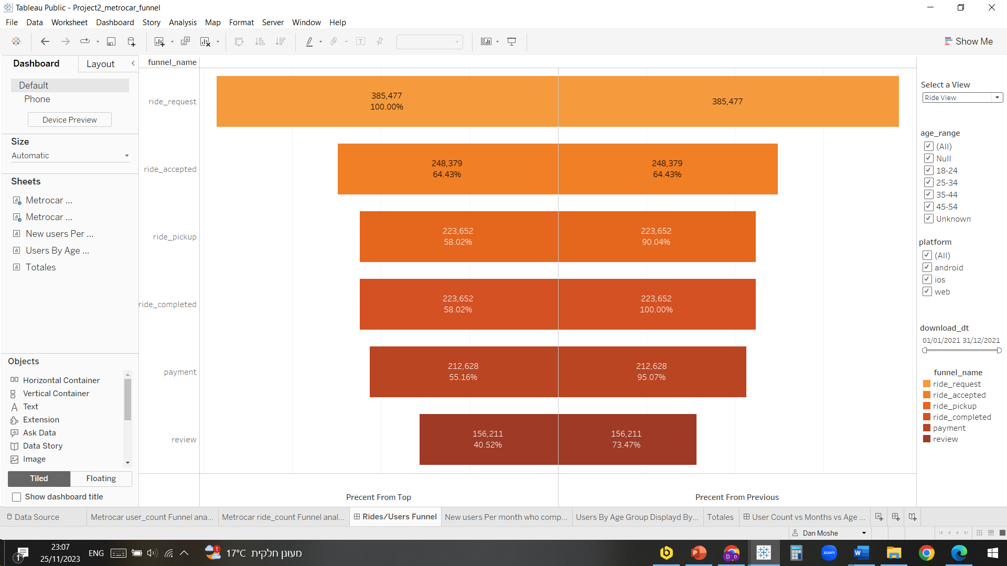

We found one major drop off point and we can finally find out our driver cancelation rate.

Ride_request -> ride_accepted, 64.43% conversion rate, 137089 rides not accepted, either they got canceled by the customer or there weren’t enough drivers around to make the ride, we need to recruit more drivers.

Ride_accepted -> ride_pickup, 90.04% conversion rate, 15021 rides cancelled either by or either by the driver, possibly add a cancelation fee on either driver or customer, our driver cancelation rate is 9.96%. – this is where we lost most of our users before completing their 1st ride, possibly the driver cancelation prevented them from trying again.

* **Metrocar currently supports 3 different platforms: ios, android, and web. To recommend where to focus our marketing budget for the upcoming year, what insights can we make based on the platform?**

**Platform analysis –** after filtering the platform condition in the user/rides filter we found out that the conversion rate between the funnel stages for the different platforms was almost the same across all three but the number of users from each platform had huge differences.

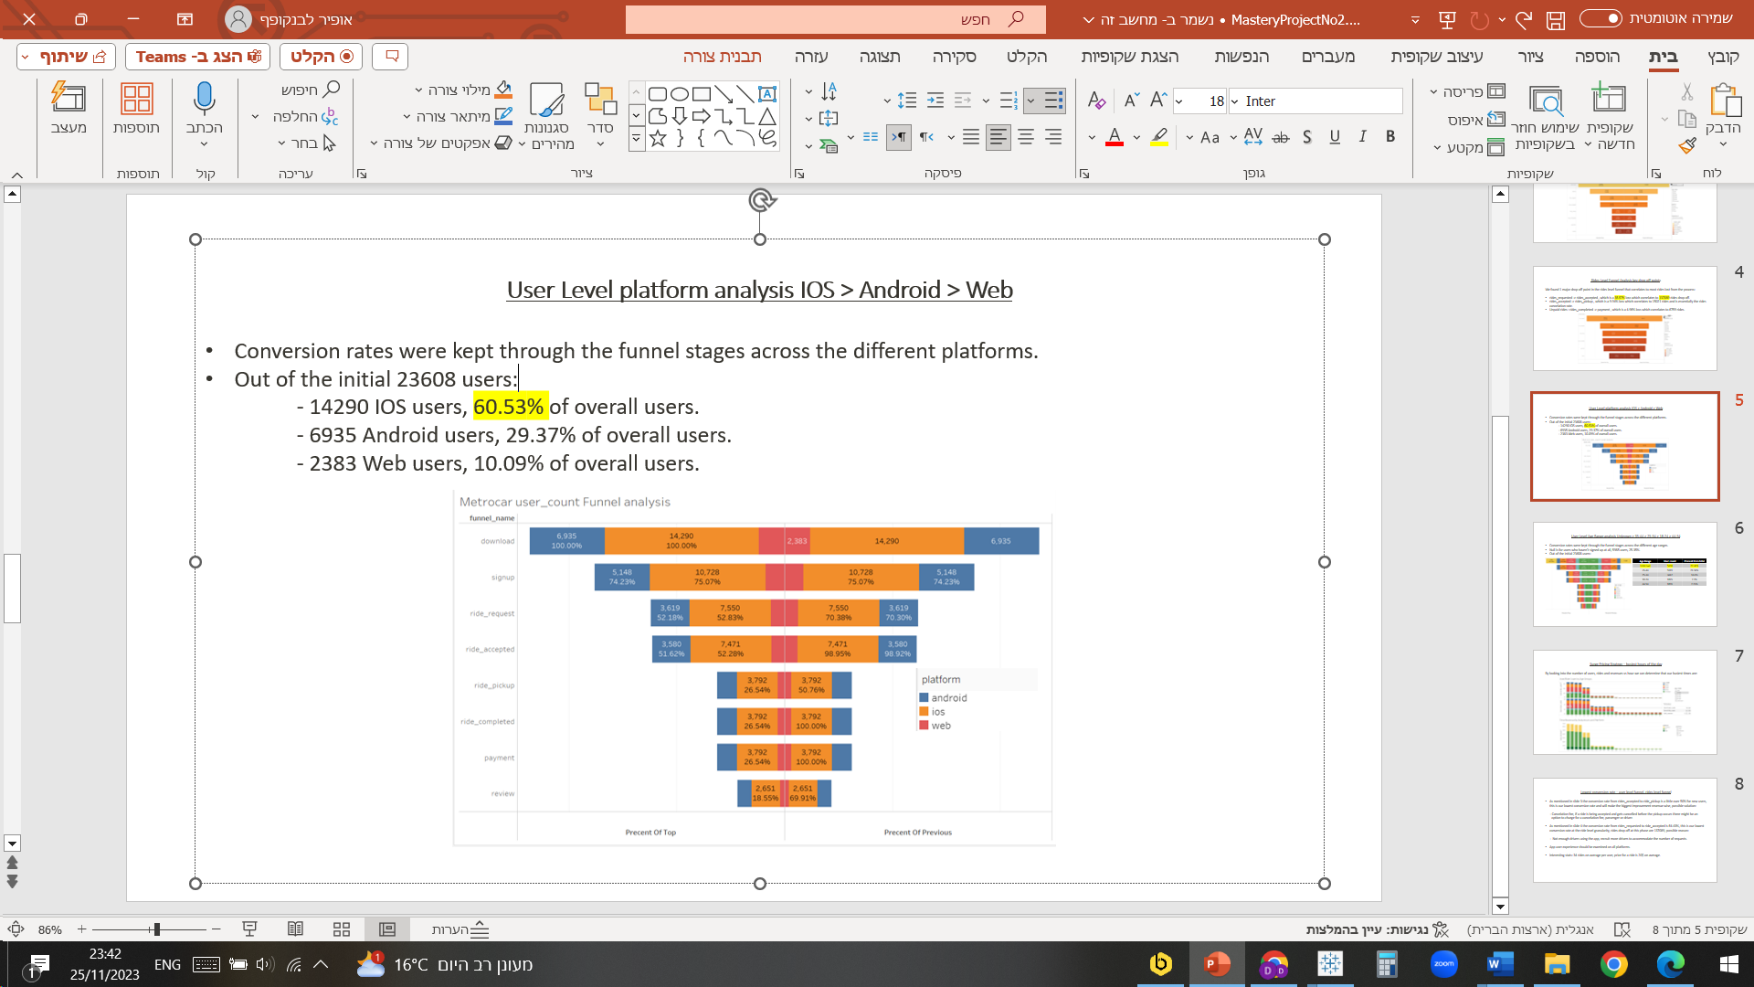

* Out of the initial 23608 users:

- 14290 IOS users, 60.53% of overall

- 6935 Android users, 29.37% of overall users.

- 2383 Web users, 10.09% of overall users.

Most of our customer base is IOS base that’s why I think it will be the wisest to invest our marketing budget specifically on that sector while still looking at new users experience across the 3 platforms.

* **What age groups perform best at each stage of our funnel? Which age group(s) likely contain our target customers?**

**Age range analysis –** after filtering the age range condition in the user/rides filter we found out that the conversion rate between the funnel stages for the different age ranges was almost the same across all ages but the number of users from each age range had huge differences.

As seen in the funnel chart below: Null is for users who haven't signed up at all 25.35%, 5985 users, our customers age range composition goes as follows:

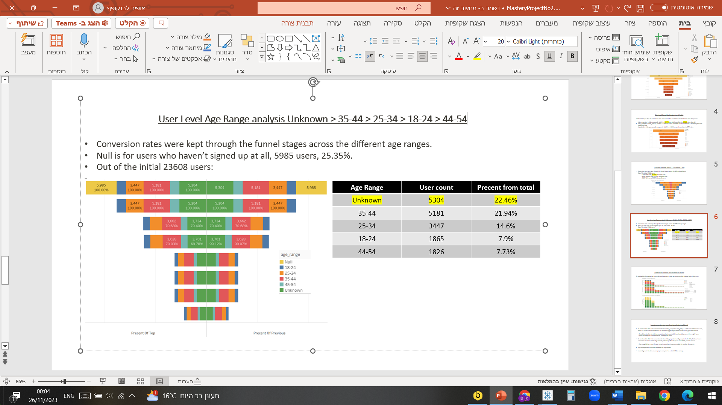

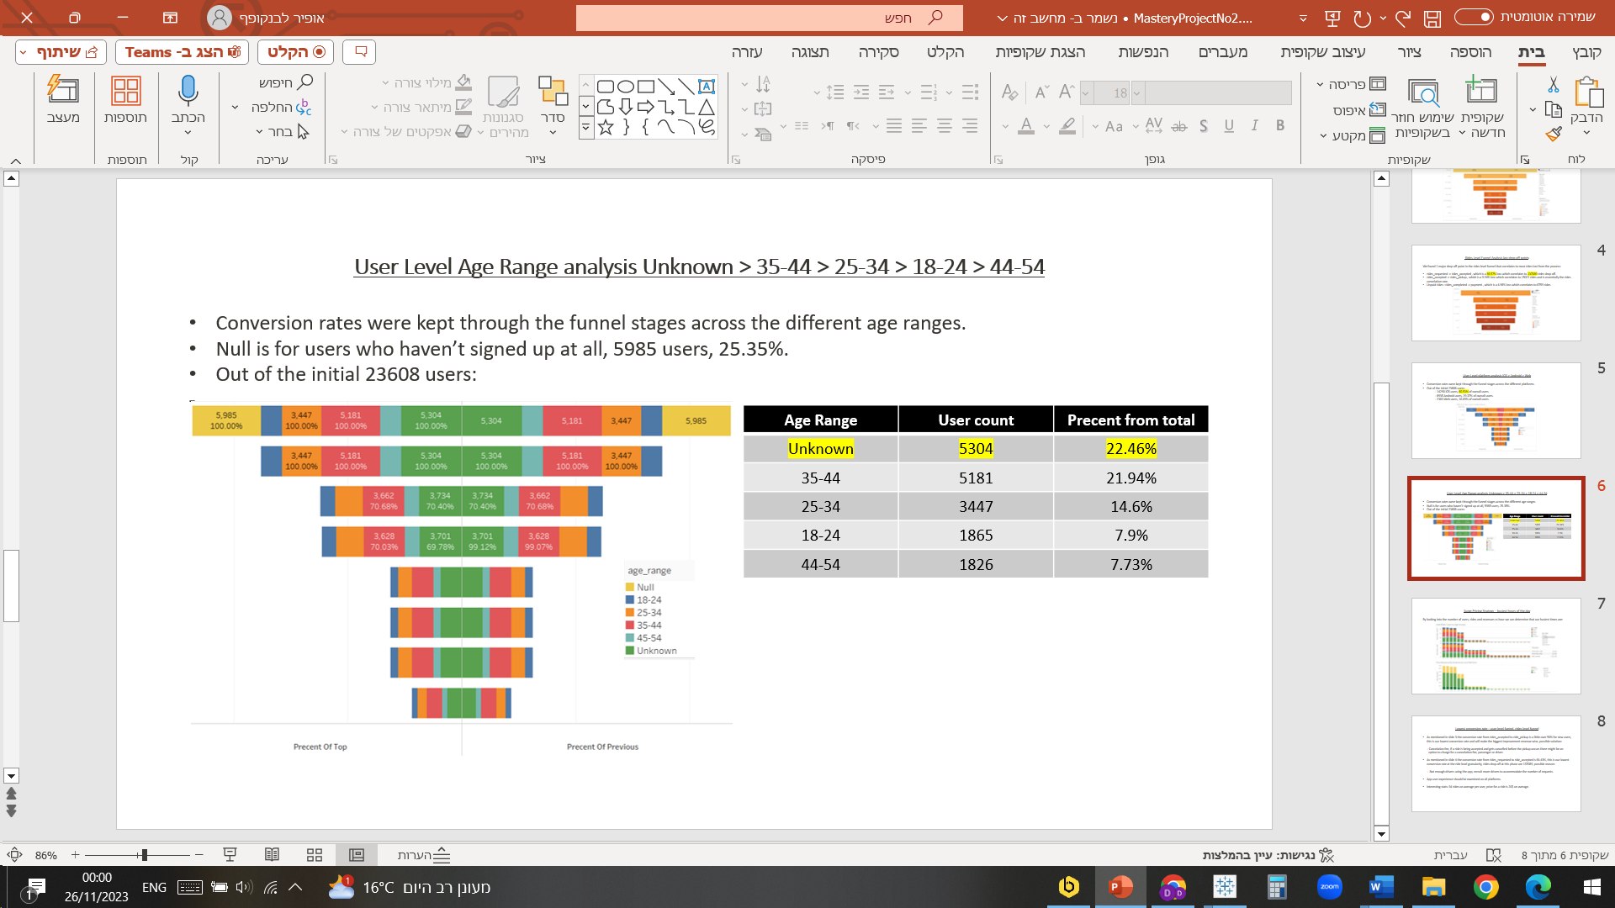

The unknown age range contains most of our customer base percentage, if all the users are filling their ages correctly this means one of two things, either <18 or 54<

, we should add these as age range options to better understand our customer base and market accordingly.

It looks like 35-44 likely contains our target age group.

I used the following dashboard sorting by funnel names to get a better understanding of the numbers for each filtering condition divided by twelve months according to the download_dt, and age_range vs platforms.

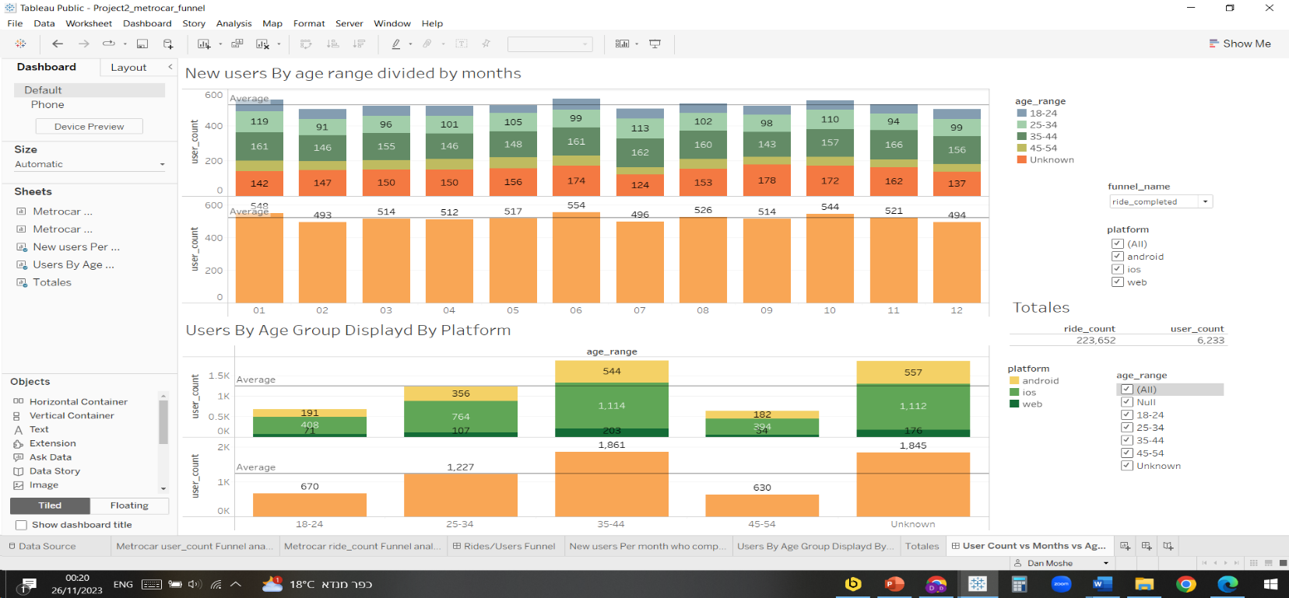

* **Surge pricing is the practice of increasing the price of goods or services when there is the greatest demand for them. If we want to adopt a price-surging strategy, what does the distribution of ride requests look like throughout the day?**

**Surge pricing strategy analysis –** we constructed the 2nd table to estimate based on completed drives only to check and see how the hours distribution looks like throught the day, the table is grouped by platform and age_range, it only contains the completed drives from which we took the revenue and the requested hour from the request time stamp saved in the rides table.

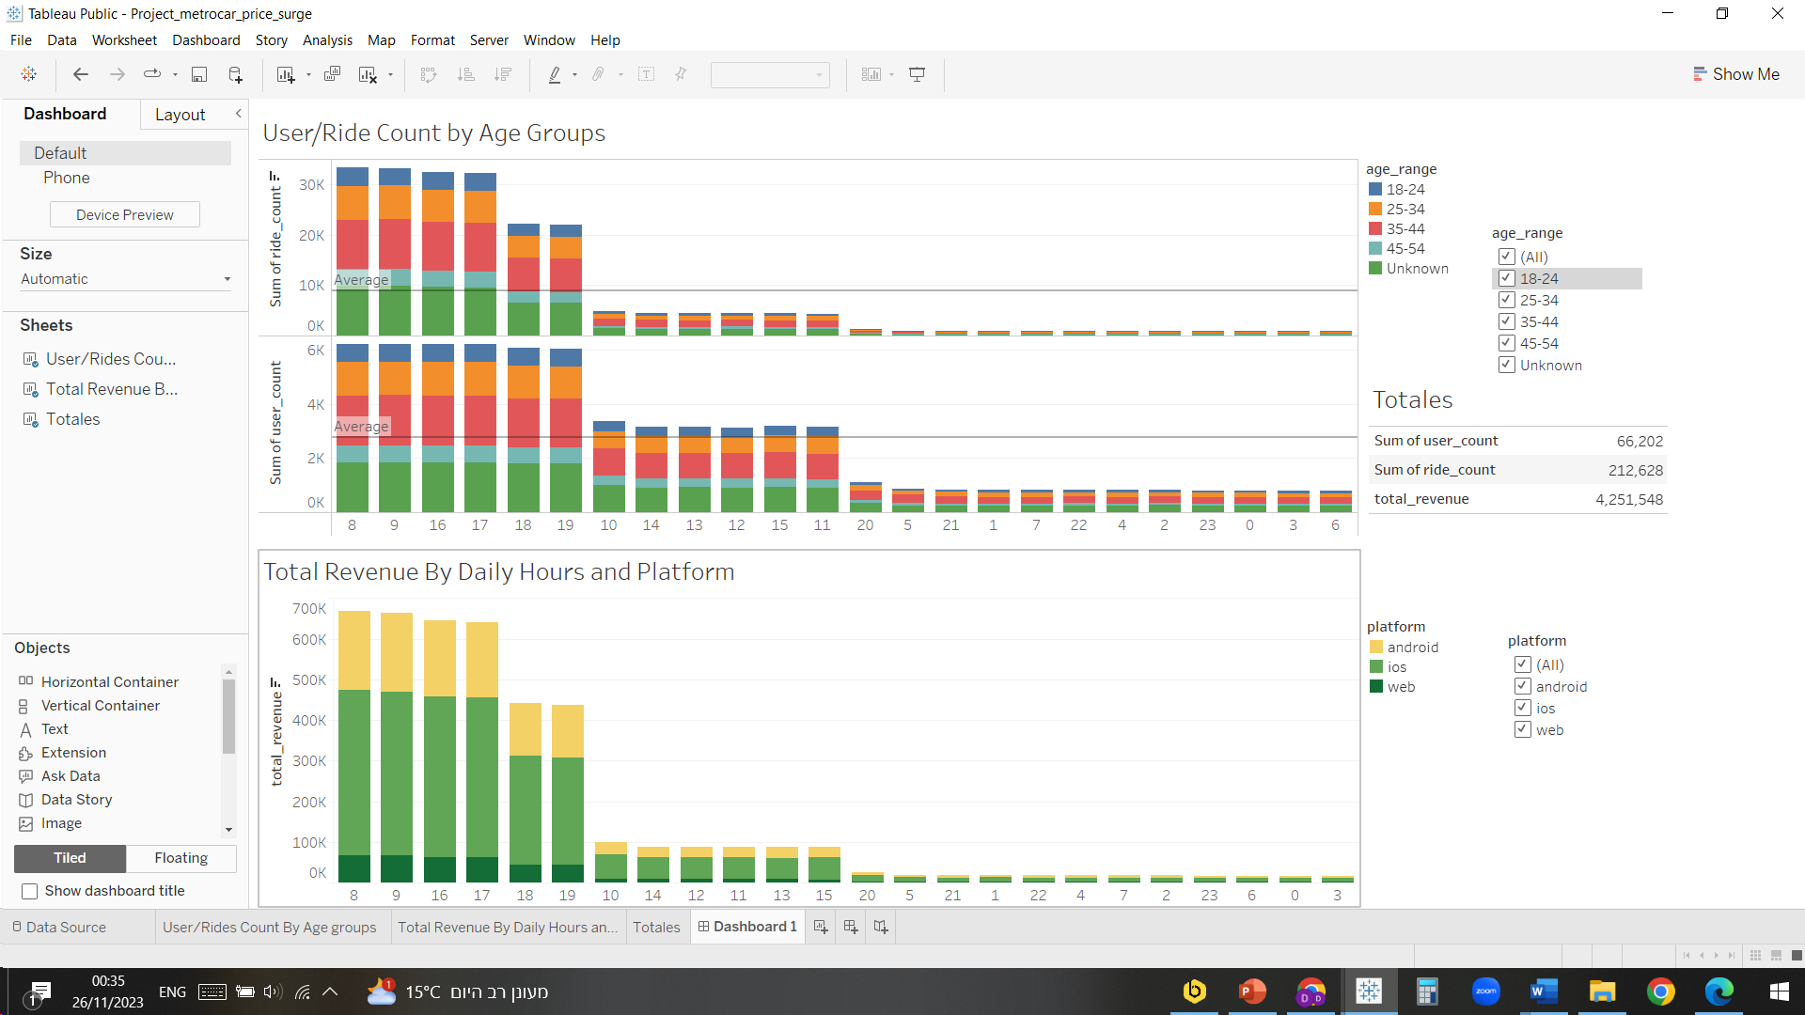

Sorted from top to bottom by revenue, ride count and user count we can see that our most suitable time frames for price surging is 08:00 – 09:00 in the morning and 16:00 – 19:00 in the afternoon.

* **What part of our funnel has the lowest conversion rate? What can we do to improve this part of the funnel?**

As stated on page 3. Funnel stages 4 to 5: Ride_accepted -> ride_pickup, has a 50.77% conversion rate this is our lowest conversion rate, we can improve this part by adding revenue from cancellations either by driver or by customer, there is also a

64.43% conversion in the Rides funnel, stated on page 4, which can also contribute a lot and only demands the recruiting of additional drivers.