

|  |  |  |
| --- | --- | --- |
|  | **SCORE** | |
| **EXAMS** | **RAW** | **WEIGHTED** |
| ESSAY | ${RAW_ESSAY_SCORE} | ${WEIGHTED_ESSAY_SCORE} |
| MCQ | ${RAW_MCQ_SCORE} | ${WEIGHTED_MCQ_SCORE} |
| INTERVIEW | - | ${INTERVIEW_SCORE} |
| APPRAISAL | - | ${APPRAISAL_SCORE} |
| **TOTAL** | **${REMARKS}** | **${TOTAL_SCORE}** |

SECURITIES & EXCHANGE COMMISSION, NIGERIA

**EXAM ID**

${EXAM_ID}

**NAME OF STAFF**

${STAFF_NAME}

**STAFF ID**

${STAFF_ID}

**CURRENT RANK**

${CURRENT_RANK}

**ASPIRED RANK**

${ASPIRED_RANK}

**DEPARTMENT**

${DEPARTMENT}

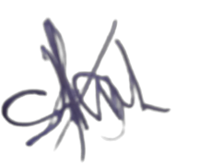

________________________________

**HOD (Human Resources)**

**REMARKS**

**${EXAMINATION_TYPE}**

**PASS MARK**

${PASS_MARK}

**POSITION IN CADRE**

${POSITION_IN_CADRE}