EVALUATING COMPLIANCE AND INFRASTRUCTURE MODERNIZATION AT THE CITY OF LAWTON PUBLICLY OWNED TREATMENT WORKS (POTW): IMPLICATIONS FOR GENERATION FACILITY AND
REGIONAL WATER MANAGEMENT

By
DANNY ENGLE
Bachelor of Science in Geography
Oklahoma State University
Stillwater, OK
2010

Submitted to the Faculty of the
Graduate College of the
Oklahoma State University
in partial fulfillment of
the requirements for
the Degree of
MASTER OF SCIENCE
December 2025

ACKNOWLEDGEMENTS
I would like to thank my wife Temikka and her mother for their support and for enduring the evenings tending to our children as I attended in-person classes. I would like to thank Dr. Tim Lohner with Environmental Services, Greg Carter, Toby Peterson, Kevin Oulette, and Thomas Hancox with Generation Services with American Electric Power for providing mentorship, and introducing me to the topic of reclaimed water usage. I would also like to thank Dr. Thayer, Dr. Fisher, Dr. Scudder, and Dr. Gustavson with OSU PSM faculty for sharing their knowledge to help me further my professional growth.

Name: DANNY ENGLE
Degree Date: DECEMBER 2025
Title: EVALUATING COMPLIANCE AND INFRASTRUCTURE MODERNIZATION AT THE CITY OF LAWTON PUBLICLY OWNED TREATMENT WORKS (POTW): IMPLICATIONS FOR GENERATION FACILITY AND REGIONAL WATER MANAGEMENT
Major Field: ENVIRONMENTAL SCIENCE

Abstract: The quality of treated wastewater is critical to public health protection, industrial reliability, and environmental compliance. This study evaluates the regulatory, technical, and operational challenges of the City of Lawton’s (CoL) activated sludge wastewater treatment plant, with an emphasis on the plant’s role in supplying reclaimed water to an Oklahoma utility operating company’s (OUOC) Thermoelectric Generation Facility (TGF). OUOC utilizes this reclaimed water under an agreement that mandates adherence to the Clean Water Act (CWA). However, Environmental Protection Agency (EPA) monitoring data have revealed episodic exceedances of pollutant discharge limits, raising questions regarding the facility’s ability to sustain regulatory compliance and deliver consistent water quality.

To address these challenges, the CoL has initiated a $370 million, three-phase capital upgrade project aimed at modernizing their waste water treatment plant (WWTP) infrastructure and enhancing process reliability. Phase I focuses on immediate rehabilitation measures; Phase II advances aerobic treatment efficiency and relocates infrastructure from flood-prone zones; and Phase III will complete construction of a new, fully integrated facility designed for long-term resilience and expanded capacity. This analysis examines how these upgrades mitigate existing deficiencies related to seasonal influent variability, equipment aging, and treatment performance instability, thereby improving the reliability of reclaimed water supplied to the OUCO.

The study further contextualizes the importance of reclaimed water within thermoelectric generation systems, particularly in arid regions such as southwestern Oklahoma, where freshwater availability is limited and subject to climatic variability. Thermal power plants require substantial and continuous water inputs for cooling, making the reuse of treated effluent both a practical and sustainable solution. Without robust investment in treatment technology, competent facility management, and rigorous water quality monitoring, reclaimed water use can introduce operational and environmental risks.

Findings indicate that the planned upgrades will significantly enhance treatment performance, regulatory compliance, and water supply reliability. This builds support for the broader significance of strategic wastewater infrastructure investment and integrated water resource management in achieving sustainable industrial and municipal operations.

TABLE OF CONTENTS
Page
1.0 INTRODUCTION 1
1.1 The Relationship between the WWTP and TGF 1
1.2 Historical context about the WWTP 2
2.0 REGULATORY FRAMEWORK 3
2.1 Purpose of the Framework 3
2.2 Why WWTP compliance impacts TGF? 4
2.3 Guidance established but compliance mandated 4
2.4 How does ODEQ fall into the situation? 5
2.5 Summarizing the regulatory framework 6
3.0 CURRENT CHALLENGES 7
3.1 Effluent Quality and Regulatory Compliance 7
3.2 Environmental Impact and Ecosystem Health 8
3.3 Aging Infrastructure and Capacity Limitations 9
3.4 Industrial and Community Relations 9
3.5 Financial Constraints and Funding Challenges 10
4.0 IMPACT ANALYSIS 10
4.1 Impact on TGF 10
4.2 Broader Regional Implications 11
5.0 LITERATURE REVIEW 13
5.1 National Context for Water Reuse in Thermoelectric Generation 13
5.2 Oklaunion Power Plant Case Study 14
5.3 Comanche Power Station Case Study 15
5.4 Pirkey Power Plant Case Study 16
5.5 EPRI Findings on Alternative Water Sources 17
5.6 EPRI Case Study on Algae Prevention and Mitigation 18
5.7 Relevance to the Lawton Case 19
6.0 METHODOLOGY 20
6.1 Research Design 20
6.2 Data Sources and Collection 20
6.3 Measured Parameters and Evaluation Criteria 21
6.4 Measurement Techniques and Data Analysis 21
6.5 Limitations and Reliability Considerations 22
6.6 Ethical and Practical Considerations 22
6.7 Summary 22
7.0 FINDINGS 23
7.1 Flood Mitigation for the POTW 23
7.2 Elevation of Critical Infrastructure 23
7.3 Flood Barriers and Levees 23
7.4 Enhanced Storm water Management 24
7.5 Structural Flood proofing and Relocation of Vulnerable Assets 25
8.0 CONCLUSION 25
REFERENCES 28

LIST OF TABLES
Page
Table 1. Personal Python Pandas Analysis of EPA data workbook 2
Table 2. EPRI Case Study Charting Reduced MWW Usage vs MWW Capacity 19

LIST OF FIGURES
Page
Figure 1. ODEQ Permit section for CoL 5
Figure 2. Title Page of CoL Response to NOV 6
Figure 3. EPRI Observation of Algal counts and TSS 8
Figure 4. Contract Agreement between OUOC and CoL 13
Figure 5. Oklaunion Power Plant 15
Figure 6. Comanche Power plant 16
Figure 7. Pirkey Power Plant 17
Figure 8. FIRM Map of TGS and WWTP 24
Figure 9. NOV response from CoL to ODEQ 2021 26

- INTRODUCTION
Effective management of wastewater is vital for protecting public health, supporting industrial operations, and ensuring compliance with environmental regulations. As part of an environmental mentorship program with a national utility parent company (NUPC), this project examines the challenges and opportunities associated with a municipal wastewater treatment plant (WWTP) and its supply of reclaimed water to a thermoelectric generation facility (TGF). This topic was introduced by the manager of environmental permitting at a NUPC who identified the WWTP as a case study of interest due to its historical performance issues and ongoing modernization efforts. The mentorship afforded the author access to the Oklahoma utility operating company (OUOC) operating area to participate in multiple site visits to generation and treatment facilities and to attend ongoing solution meetings between NUPC and the Electric Power Research Institute (EPRI), providing firsthand insight into the operational and environmental aspects of the system.
1.1 The Relationship between the WWTP and TGF
The WWTP is currently undergoing a $370 million three-phase upgrade to its activated sludge wastewater treatment process. The purpose of this investment is to address compliance challenges, aging infrastructure, and variable effluent quality that have raised concerns among industrial users. The OUOC purchases reclaimed wastewater from the WWTP facility under a contract requiring compliance with federal environmental laws, including the Clean Water Act (CWA). However, Environmental Protection Agency (EPA) data and field observations have documented episodic exceedances of pollutant limits. The exceedance categories are from total suspended solids (TSS), ammonia, and biological oxygen demand (BOD). The exceedances raise questions about the facility’s ability to consistently meet regulatory and contractual standards.
These water quality issues have direct operational implications for the TGF, which uses the reclaimed water to fill the cooling reservoir and must maintain compliance with its own National Pollutant Discharge Elimination System (NPDES) permit for discharges into Nine Mile Creek near Lawton, Oklahoma. OUOC operators have observed the presence of sludge-like material and paper pulp residues in the cooling ponds, indicating inadequate treatment and creating potential safety and environmental risks. Although these issues originate from the municipal supply, OUOC could still face compliance challenges due to the downstream use of the reclaimed effluent.
Table 1. Personal Python Pandas Analysis of EPA data workbook on WWTP https://echo.epa.gov/detailed-facility-report?fid=110022636717
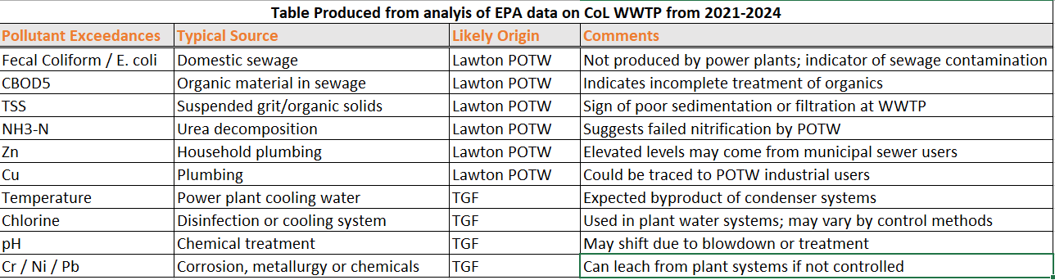

1.2 Historical context about the WWTP
The WWTP has faced difficulties maintaining effluent quality, resulting in a poor reputation and multiple Notices of Violation (NOVs) from the Oklahoma Department of Environmental Quality (ODEQ). The current upgrade project represents a major effort to modernize the facility, improve its treatment reliability, and bring it into full compliance with state and federal regulations. This report evaluates the technical, regulatory, and operational aspects of the WWTP upgrades and their implications for the OUOC’s operations and regional water management. It also explores the broader significance of reclaimed water use in thermoelectric power generation, particularly in arid regions where water scarcity poses ongoing challenges.
Ultimately, this study seeks to assess whether the modernization project will effectively resolve the WWTP’s historical deficiencies and provide a sustainable, compliant, and reliable source of reclaimed water for industrial users. By integrating site observations, regulatory review, and environmental analysis, this paper aims to contribute to a deeper understanding of how municipal and industrial stakeholders can collaborate to achieve shared goals in water resource management, compliance, and environmental protection
- REGULATORY FRAMEWORK
2.1 Purpose of the Framework
The operations of the WWTP and the TGF are governed by a regulatory framework designed to promote environmental protection, ensure compliance with water quality standards, and support sustainable municipal and industrial collaboration. This framework is shaped by federal environmental statutes, state level oversight, and contractual agreements that collectively define the requirements for wastewater treatment, reclaimed water use, and discharge quality.
At the federal level, the CWA serves as the foundation of water quality regulation in the United States. Under the CWA, the Lawton WWTP operates pursuant to a NPDES permit, which establishes specific effluent limitations for pollutants such as total phosphorus, BOD, TSS, and ammonia. Compliance with these parameters is essential to protect receiving waters and maintain the integrity of downstream ecosystems. The water supply contract between the City of Lawton (CoL) and the OUOC explicitly references adherence to Oklahoma Department of Environmental Quality (ODEQ) standards and the requirements of the CoL’s NPDES permit (City of Lawton & PSO, 2021).
2.2 Why WWTP compliance impacts TGF
The TGF is directly affected by the WWTP’s compliance with its regulatory obligations. The facility uses approximately 1.5 million gallons per day (gpd) of reclaimed effluent for cooling reservoir makeup water. There is no additional influent or drainage into the reservoir other than precipitation. The TGF is also regulated under the CWA through its own NPDES permit, which governs the discharge of treated water into Nine Mile Creek. Variability in the quality of the influent from the WWTP poses a compliance risk to the OUOC, as exceedances in ammonia or TSS could impact its ability to meet effluent limits. This interconnectedness of the WWTP and TGF underscores the importance of municipal and industrial coordination in maintaining compliance under the CWA (American Electric Power, 2017; City of Lawton & PSO, 2021).
2.3 Guidance established but compliance mandated
While the Safe Drinking Water Act (SDWA) primarily governs potable water, its underlying principles extend to wastewater treatment and water reuse applications. Although reclaimed water from the WWTP is not intended for human consumption, its quality standards must minimize potential impacts on downstream users and ecosystems. Aligning treatment processes with SDWA expectations helps safeguard public and environmental health, reinforcing the significance of infrastructure investment and operational reliability (American Electric Power, 2017).
2.4 How does ODEQ fall into the situation?
State level oversight by the ODEQ provides an additional layer of regulatory control. The second addendum to the water contract incorporates compliance with Title 252, Chapter 627 of the Oklahoma Administrative Code (OAC), which outlines standards for the operation and maintenance of water reuse systems. This agreement also requires the CoL to notify the OUOC within 72 hours of any permit exceedance or compliance issue, ensuring transparency and enabling proactive risk mitigation.
Figure 1. ODEQ Permit section for CoL
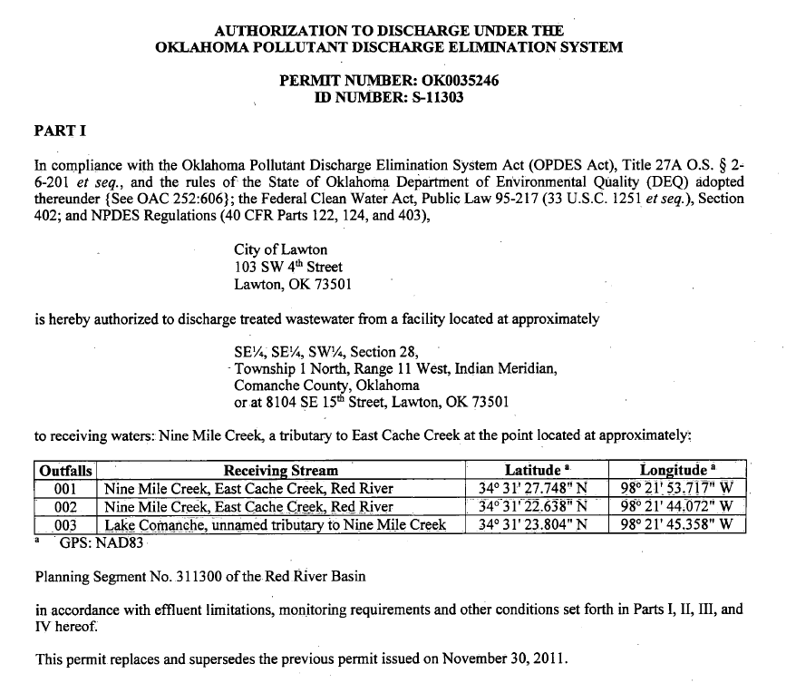

Despite the presence of this robust framework, the WWTP has historically struggled with effluent consistency. Recurrent exceedances of phosphorus, ammonia, BOD, and TSS have prompted multiple NOVs from ODEQ (Lawton NOV, 2024). These compliance failures have reinforced the need for substantial infrastructure upgrades and improved process management. Lawton’s ongoing, three-phase modernization project represents a direct response to these issues, aiming to restore regulatory compliance, enhance process efficiency, and provide reliable reclaimed water for TGF operations.
2.5 Summarizing the regulatory framework
The regulatory framework guiding the WWTP and the TGF highlights the complexity of balancing environmental compliance, municipal responsibilities, and industrial needs. Federal statutes such as the CWA and SDWA, combined with state enforcement by ODEQ and contractual obligations between the Lawton and OUOC, establish the foundation for achieving sustainable water resource management. The success of the WWTP modernization efforts will be instrumental in ensuring long-term compliance, protecting regional ecosystems, and supporting continued industrial reliability.
Figure 2. Title Page of CoL Response to NOV
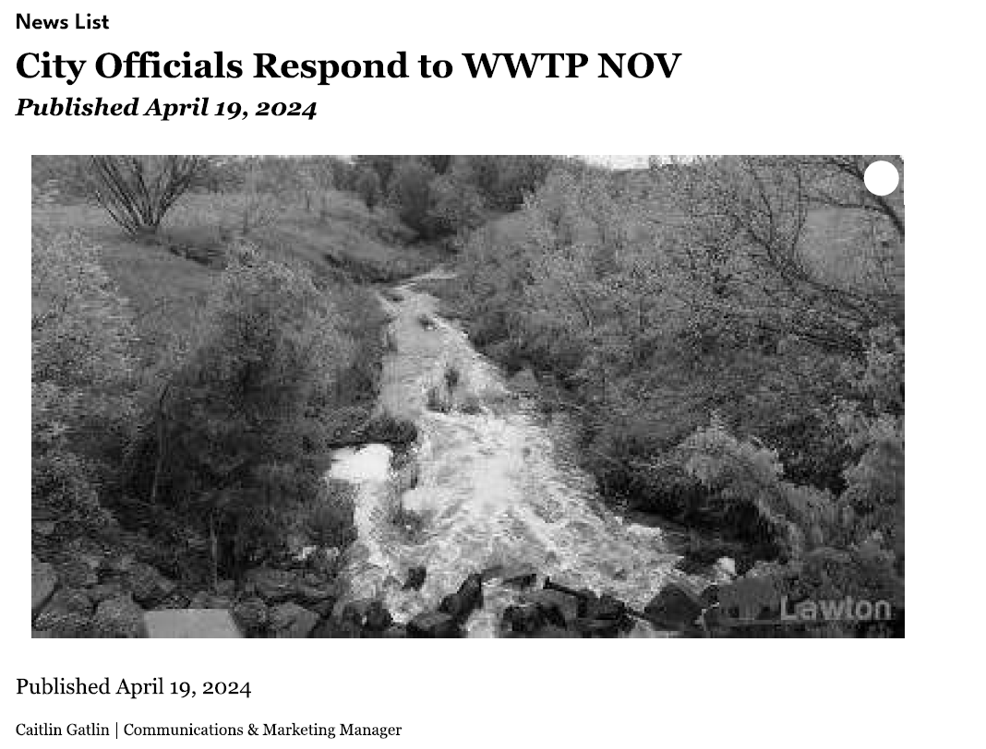

3.0 CURRENT CHALLENGES
3.1 Effluent Quality and Regulatory Compliance
The WWTP continues to face significant operational and compliance challenges that have affected its ability to consistently meet environmental standards established under the CWA and enforced by the ODEQ. These ongoing issues have resulted in multiple NOVs and supports the urgent need for the upgrade project to modernize the facility. The following sections outline the principal challenges currently confronting the WWTP, including effluent quality concerns, environmental impacts, infrastructure limitations, stakeholder relations, and financial constraints.
One of the primary challenges facing the WWTP involve maintaining compliance with its NPDES permit. The facility has struggled to consistently meet effluent limits for key parameters such as ammonia, TSS, BOD, and total phosphorus. Elevated levels of these pollutants have contributed to episodic violations and adverse water quality conditions in downstream ecosystems.
For instance, in July 2024, ODEQ cited the WWTP for excessive ammonia concentrations in its effluent (The Lawton Constitution, 2024). Ammonia discharges are particularly concerning during warmer months, when reduced dissolved oxygen levels in surface waters can exacerbate toxicity and harm aquatic life. Historical data also indicate periodic exceedances of TSS and phosphorus limits, which promote eutrophication, a process that depletes oxygen and disrupts aquatic ecosystems. These exceedances have led to regulatory penalties and diminished stakeholder confidence in the facility’s ability to operate within compliance parameters (Southwest Ledger, 2024).

3.2 Environmental Impact and Ecosystem Health
The environmental consequences of these compliance challenges have been significant. Persistent alga blooms were observed at the TGF in 2021, 2022, 2023. These blooms occurred when the TGF has an algaecide program in place (EPRI, 2024). In August 2024 a fish kill occurred downstream of the WWTP, which happened during the ongoing upgrade process and was attributed to a temporary loss of treatment performance and elevated pollutant concentrations (KOSU, 2024). These events illustrate the ecological vulnerability of local waterways, which serve as critical habitats for fish and other aquatic organisms. Recurrent discharges of inadequately treated effluent can degrade water quality, reduce biodiversity, and undermine viability of aquatic ecosystems downstream in the Red River. These events also contribute to public concern and erosion of trust in municipal environmental management.
Figure 3. EPRI Observation of Algal counts and TSS
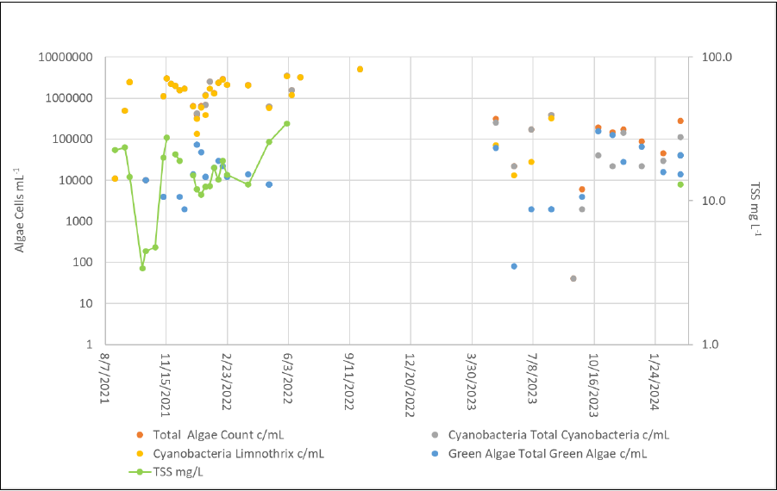

3.3 Aging Infrastructure and Capacity Limitations
Much of the WWTP’s infrastructure predates current regulatory and technological standards, limiting its ability to effectively manage variable influent conditions and peak hydraulic loads. The plant’s aging equipment, combined with outdated process design, constrains its treatment efficiency and responsiveness to changing environmental conditions. Seasonal fluctuations in wastewater characteristics, such as increased organic loading during warm weather or storm-induced inflow and infiltration, often exceed the system’s operational capacity. This results in bypasses or partially treated discharges, which further contribute to permit violations.
Routine maintenance has also become more difficult due to equipment obsolescence and mechanical wear. These issues highlight the urgent need for modernization, which the ongoing multi-phase capital improvement project is intended to address.
3.4 Industrial and Community Relations
The operational challenges at the WWTP extend beyond compliance and infrastructure issues, affecting relationships with industrial partners and the local community. The TGF, which depends on reclaimed water from the WWTP for cooling operations, has reported inconsistencies in influent quality. Variability in parameters such as TSS and ammonia complicates the TGF’s own treatment processes and introduces potential risks for NPDES permit exceedances at its discharge point to Nine Mile Creek (City of Lawton & PSO, 2021; American Electric Power, 2017).
Similarly, Republic Paperboard, another major industrial user, has documented odor and water quality issues linked to the plant’s performance. In response, the company committed $15 million to upgrade its wastewater systems and reimburse the City of Lawton for associated costs (Voith, 2021; KSWO, 2023). Community complaints regarding odor, water quality, and environmental safety have further strained public trust, emphasizing the need for transparent communication and sustained progress toward compliance.
3.5 Financial Constraints and Funding Challenges
Upgrading the WWTP to meet modern environmental and operational standards requires substantial financial investment. The $370 million capital improvement project represents a significant fiscal undertaking for the municipality, which must balance regulatory obligations with long-term budget sustainability. Although the project addresses critical compliance deficiencies, ongoing maintenance and future capacity expansion will demand continued funding and strategic planning. Limited municipal budgets, competing infrastructure priorities, and the need for federal or state grant support compound these financial pressures.
4.0 IMPACT ANALYSIS
4.1 Impact on TGF
Variability in reclaimed water quality from the WWTP has created operational difficulties for the TGF, which relies on a consistent supply of treated effluent for cooling water. Elevated concentrations of ammonia, BOD, and TSS require the OUOC to implement additional on-site treatment and monitoring measures to maintain compliance with its NPDES permit (City of Lawton & PSO, 2021). These additional measures increase operational costs, reduce system efficiency, and complicate maintenance schedules, particularly during peak power demand when reliability is critical.
Inconsistent influent quality also introduces potential regulatory risks. Due to discharge to Nine Mile Creek, The TGF must meet strict effluent limits under the CWA, fluctuations in the quality of reclaimed water can contribute to unintentional permit exceedances. Even when the TGF is not the source of contamination, the OUOC remains responsible for its final discharge quality. This situation underscores the relationship between municipal and industrial water users and the need for improved upstream management to ensure compliance across the entire system (AEP, 2017b).
Despite these risks, the WWTP’s modernization project represents an opportunity to strengthen the OUOC’s operational resilience. Improved wastewater treatment processes are expected to reduce pollutant concentrations and stabilize effluent characteristics, allowing the OUOC to optimize its water reuse operations. Enhanced effluent reliability will also decrease the likelihood of costly interventions and improve confidence in reclaimed water as a sustainable cooling source. The partnership between the OUOC and Lawton illustrates the potential for collaboration to advance shared water management goals.
4.2 Broader Regional Implications
By addressing infrastructure deficiencies and improving effluent quality, the WWTP upgrade will enhance the region’s resilience to environmental stressors such as drought and population growth. Reliable wastewater treatment supports industrial continuity, safeguards natural resources, and contributes to sustainable water management practices across southwestern Oklahoma.
The challenges surrounding the WWTP highlight the importance of collaboration among municipalities, industries, and regulatory agencies. Partnerships between Republic Paperboard, and Lawton demonstrate the value of shared responsibility in addressing water quality issues. For instance, Republic Paperboard’s commitment to a $15 million upgrade of its own wastewater systems and reimbursement of $100,000 to the city highlights the shared responsibility among stakeholders (KSWO, 2023). Such cooperative frameworks can serve as models for other communities managing similar resource and compliance challenges.
Enhanced water quality and regulatory compliance reduce the risk of costly violations, while providing a stable water supply for industrial and municipal use encourages economic development. These improvements align with broader sustainability goals by promoting resource efficiency, protecting aquatic ecosystems, and ensuring compliance with federal and state environmental mandates. Long-term improvements to the WWTP will yield economic and environmental benefits.
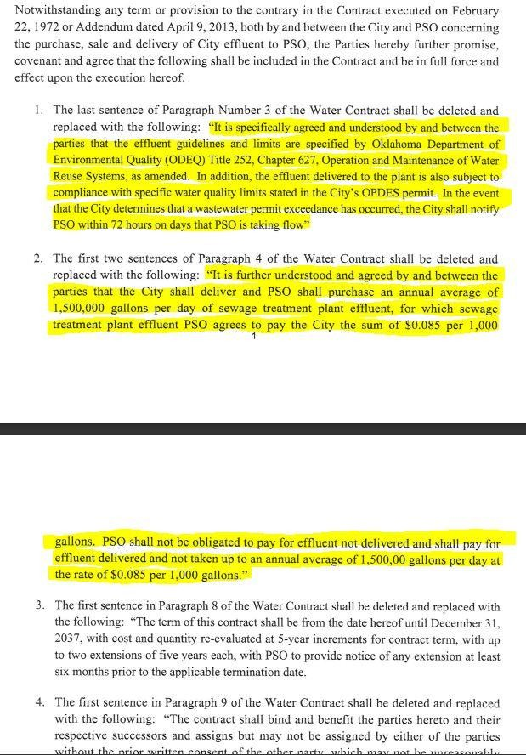
Figure 4. Contract Agreement between OUOC and CoL

5.0 LITERATURE REVIEW
5.1 National Context for Water Reuse in Thermoelectric Generation
Water availability and quality are critical constraints in thermoelectric power generation. This is especially true across the arid and semi-arid regions of the southern United States. Increasing reliance on reclaimed municipal wastewater as an alternative cooling medium and process water source has been driven by climate conditions, environmental regulation, and the need for sustainable industrial operations. This literature review provides several similar case studies and research reports that focus on facilities operated by the NUPC and findings published by the EPRI to identify lessons and implications relevant to the WWTP and the TGF.
Across the United States, power producers have increasingly adopted reclaimed wastewater to supplement or replace freshwater withdrawals for cooling. EPRI (2024) has documented multiple successful examples where utilities integrated treated municipal effluent into power plant operations, reducing strain on local freshwater supplies. EPRI found that the practice not only conserves potable water but also promotes cooperation between municipalities and industry through shared investment in treatment infrastructure. However, the report also noted recurring challenges like variable effluent quality, potential biofouling, and the need for robust monitoring and pretreatment systems. These findings provide a broad context for understanding the operational, environmental, and economic trade-offs associated with reclaimed-water use.
5.2 Oklaunion Power Plant Case Study
The Oklaunion Power Plant near Vernon, Texas, represents one of the NUPC’s most successful reclaimed-water integration projects. As described in Oklaunion Power Plant (AEP, 2017a), the plant transitioned to using brackish groundwater and reclaimed municipal effluent to offset limited freshwater availability. This initiative was driven by both drought-induced supply concerns and long-term regional water planning requirements. The project demonstrated the feasibility of designing multi-source water systems that incorporate reclaimed effluent, brackish sources, and cooling tower blowdown recycling. Additional treatment steps such as lime softening, filtration, and disinfection were also required. The project ultimately reduced freshwater withdrawals and improved operational resilience (AEP, 2017a). Importantly, the Oklaunion experience underscored the value of early municipal collaboration and the necessity of adaptive process design to accommodate seasonal and compositional changes in reclaimed water.
Figure 5. Oklaunion Power Plant

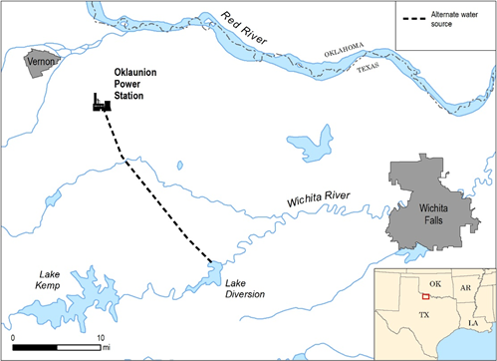

5.3 Comanche Power Station Case Study
Similarly, the TGF (AEP, 2017b) highlights how reclaimed-water use can be tailored to local regulatory and hydrological conditions. The TGF relies on treated municipal effluent supplied by the WWTP under a long-term contract. The partnership between the NUPC and the municipality provided a mutually beneficial solution: the city gained a stable outlet for effluent disposal, while the OUOC secured a non-potable water source for TGF operations. However, the case study also emphasized recurring challenges with water quality variability, including periodic exceedances of BOD, TSS, and ammonia. These fluctuations required operational adjustments to maintain compliance with the plant’s NPDES permit and to protect cooling system integrity (AEP, 2017b). The Comanche case underscores the need for rigorous effluent monitoring and process flexibility which are lessons directly relevant to Lawton’s current WWTP upgrade.
Figure 6. Comanche Power plant
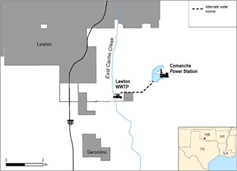

5.4 Pirkey Power Plant Case Study
The Pirkey Power Plant in Hallsville, Texas, provides an additional example of reclaimed-water integration under variable hydrological conditions. According to Case Study: Pirkey Power Plant (AEP, 2017c), the facility developed a reclaimed-water system that balanced industrial needs with municipal treatment capacity, thereby reducing dependence on freshwater sources from the Sabine River Basin. The project demonstrated that successful reuse programs require not only advanced treatment technology but also strong operational coordination between plant and city personnel. Pirkey’s long-term reliability was achieved through proactive maintenance of its reclaimed-water delivery system, consistent monitoring of key parameters (e.g., TSS, nutrients, and microbial activity), and periodic upgrades to ensure compliance with changing water-quality standards. This example reinforces the importance of sustained investment and interagency communication to ensure reclaimed-water reliability (AEP, 2017c).
Figure 7. Pirkey Power Plant
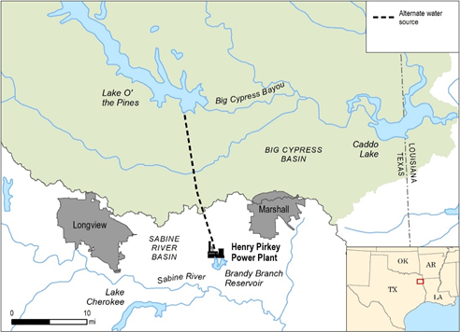

5.5 EPRI Findings on Alternative Water Sources
In its comprehensive 2024 report, EPRI analyzed several power plants that successfully utilized municipal effluent as an alternative water source. The study found that while initial capital costs for treatment and infrastructure could be high, long-term benefits included improved drought resilience, enhanced community relations, and reduced regulatory risk (EPRI, 2024). The report emphasized the significance of pretreatment technologies like microfiltration, reverse osmosis, and disinfection systems to address chemical scaling, corrosion, and biological growth in cooling circuits. Facilities that implemented integrated treatment systems were able to sustain reliable operations and maintain compliance with both environmental discharge permits and occupational safety standards. These findings parallel the ongoing modernization efforts at the WWTP, which aim to stabilize effluent quality and ensure sustainable reclaimed-water supply for the OUOC.
5.6 EPRI Case Study on Algae Prevention and Mitigation
A related issue in reclaimed-water systems is the management of algal blooms and biofouling. The EPRI Case Study: Algae Prevention and Mitigation (2018) detailed multiple strategies for controlling algal proliferation in power plant cooling reservoirs. The study found that untreated or nutrient-rich municipal effluent can accelerate algal growth, reducing cooling efficiency and potentially increasing biocide use. Recommended strategies included source nutrient management, enhanced clarification and filtration, and periodic algal monitoring. The report also highlighted the role of ultraviolet (UV) disinfection and oxidation-based treatments in reducing algal load before water enters the cooling system (EPRI, 2018). These practices are relevant for the TGF, which has experienced periodic algal blooms linked to nutrient variability in the WWTP effluent.

Table 2. EPRI Case study table charting reduced MWW usage vs MWW Capacity
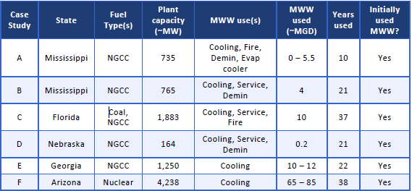

5.7 Relevance to the Lawton Case
Across all reviewed studies, several consistent lessons are present. First, reclaimed-water use in power generation requires comprehensive coordination between municipal and industrial partners. Success depends on technology, management, communication, and regulatory compliance. Second, consistent water quality and monitoring are essential for operational reliability. The challenges faced by NUPC’s Pirkey plants mirror those at the TGF, where seasonal variability and infrastructure limitations affect effluent stability. Third, continuous improvement through infrastructure upgrades, real-time monitoring, and adaptive management is key to sustaining long-term compliance. The experiences documented in these case studies provide a strong empirical foundation for assessing Lawton’s WWTP upgrade initiative and its potential to achieve both environmental and operational objectives.

6.0 METHODOLOGY
6.1 Research Design
This work used a qualitative case study approach to evaluate the regulatory, technical, and operational challenges associated with the WWTP and its impact on the TGF. The research design integrates document review, comparative analysis, and regulatory data interpretation to assess treatment performance, water quality trends, and compliance outcomes. The case study methodology is appropriate for this project because it allows in-depth examination of complex environmental systems within their real-world context (Yin, 2018). By drawing parallels between the Lawton case and documented experiences from other NUPC and EPRI projects, this study identifies best practices and performance benchmarks relevant to wastewater reuse in thermoelectric generation.

6.2 Data Sources and Collection
Primary data sources include EPA and ODEQ compliance records, the CoL’s NOV reports and responses, and the NUPC’s operational data from the TGF. Secondary data were from NUPC and EPRI case studies, and regulatory guidance documents. Observational data from site visits and stakeholder discussions supplemented the documentary evidence. This mixed-source approach ensures validation of observations, enhances reliability by cross-verifying findings across independent datasets and qualitative observations. A detailed description of the NPDES monitoring dataset and analysis steps is provided in Appendix A.

6.3 Measured Parameters and Evaluation Criteria
The study focuses on key performance indicators used to evaluate wastewater treatment and reclaimed-water quality:
- Chemical and physical parameters: total suspended solids (TSS), biological oxygen demand (BOD), ammonia, nitrate, and total phosphorus.
- Operational indicators: effluent flow variability, aeration efficiency, and process reliability during seasonal shifts.
- Regulatory metrics: compliance with NPDES discharge limits, frequency of NOVs, and permit exceedances.
The data is evaluated to determine the extent to which the WWTP upgrades are expected to improve treatment efficiency and effluent quality consistency. Comparative benchmarks from other NUPC facilities (Oklaunion, Pirkey, and Comanche) are used to provide context for performance targets and identify feasible operational improvements.
6.4 Measurement Techniques and Data Analysis
Quantitative data from EPA and ODEQ databases were analyzed using python pandas to identify patterns in pollutant concentration, flow variability, and compliance trends. Qualitative data, including observations and stakeholder feedback, were analyzed to assess perceptions of process reliability and management effectiveness. The comparative analysis aligns EPA’s data with peer facilities documented in NUPC and EPRI case studies, highlighting deviations and potential corrective actions. This was used to ensure robustness by integrating regulatory performance indicators, operational observations, and documented best practices from comparable projects.

6.5 Limitations and Reliability Considerations
This study recognizes several limitations. First, reliance on secondary data introduces potential uncertainties related to data completeness and gaps. This raises a concern, such as the absence of continuous real-time monitoring data and constrains the ability to quantify short-term variability. Second, site observations were limited in duration and may not capture long-term operational variability. Finally, while comparative analysis with NUPC and EPRI case studies enhances external validity, differences in plant design, climate, and regulatory context may limit direct transferability. These limitations are addressed through transparent methodology, contextual analysis, and cautious interpretation of findings.
6.6 Ethical and Practical Considerations
All data used in this study were obtained from publicly available or authorized internal sources, ensuring compliance with ethical research standards. Stakeholder input was incorporated respectfully, and no personal or confidential information was disclosed. Practical considerations include the alignment of research activities with ongoing infrastructure projects at the WWTP and OUOC’s TGF, allowing findings to directly inform management decisions and regulatory compliance strategies.

6.7 Summary
The methodology integrates regulatory analysis, technical evaluation, and cross-case observations to assess the effectiveness of the WWTP upgrade project. By comparing operational and compliance data across multiple NUPC facilities and EPRI-documented projects, the study identifies measurable indicators of performance improvement and risk mitigation. The approach ensures that conclusions are grounded in empirical evidence, relevant to both municipal and industrial stakeholders, and aligned with the broader objectives of sustainable water resource management.

7.0 FINDINGS
7.1 Flood Mitigation for the POTW
The POTW is located at 34.52803, -98.36742, within a federally mapped 100-year floodplain, making it vulnerable to inundation during episodic weather events. Flooding poses serious risks to treatment infrastructure, including electrical systems, chemical storage, and mechanical equipment. Uncontrolled floodwaters can lead to the release of untreated or partially treated wastewater, causing environmental degradation and potential public health hazards. The following mitigation strategies are recommended to reduce these risks and ensure continuity of operations:
7.2 Elevation of Critical Infrastructure
Key components such as pumps, control panels, and chemical feed systems should be elevated above the 100-year flood elevation level. This will reduce vulnerability to flood damage and extend the operational life of critical assets.

7.3 Flood Barriers and Levees
The installation of permanent flood barriers, berms, or levees surrounding the treatment facility can prevent direct inundation during high-water events. Such structures should be designed according to Federal Emergency Management Agency (FEMA) flood protection guidelines and integrated with the City’s broader storm water management plan.

Figure 8. FIRM Map of TGS and WWTP
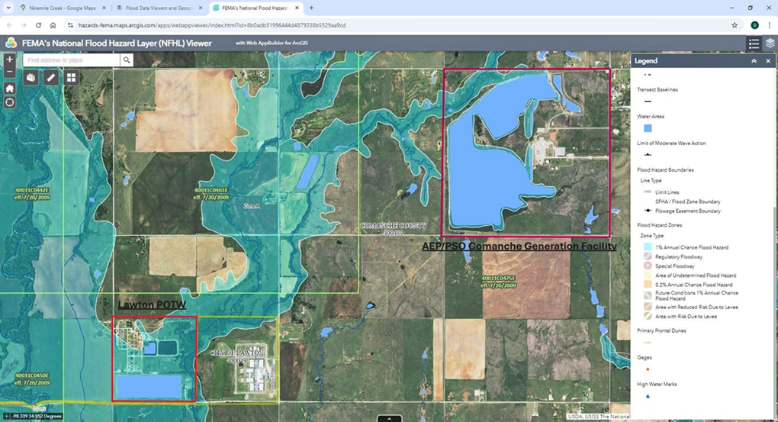

7.4 Enhanced Storm water Management
Improving on-site drainage capacity, constructing retention basins, and upgrading storm water conveyance systems will help manage excess rainfall and surface runoff. These actions will also reduce inflow and infiltration into the wastewater system, improving treatment reliability during storm events.

7.5 Structural Flood proofing and Relocation of Vulnerable Assets
Where elevation is not feasible, structural flood proofing measures, such as sealing foundation walls, installing watertight doors, and adding backflow prevention valves should be implemented. Long-term planning should prioritize relocating key treatment components or constructing new facilities on higher ground, consistent with Phase II and Phase III of the ongoing upgrade project.
These measures collectively align with the city’s modernization efforts, supporting both compliance with the CWA and the protection of municipal assets against climate-related risks. Implementing this system would significantly reduce the risk of noncompliance for both PSO and the POTW while improving the overall reliability of reclaimed water use in industrial operations.
8.0 CONCLUSION
The WWTP serves as a vital component of the region’s environmental and industrial infrastructure. Its ability to consistently treat and supply reclaimed wastewater directly affects the operational reliability of major industrial users such as the TGF, as well as the environmental health of downstream ecosystems. This study has examined the complex relationship between regulatory compliance, infrastructure performance, and sustainable water resource management, highlighting both the challenges and opportunities facing the CoL and its partners.
The analysis identified several key challenges, including inconsistent effluent quality, aging infrastructure, and environmental incidents that have led to regulatory scrutiny and diminished stakeholder confidence. NOVs from the ODEQ and episodes such as the August 2024 fish kill underscore the urgent need for modernization and improved oversight. These issues have direct implications for the TGF, where dependence on reclaimed water links its operational and regulatory compliance to the WWTP’s performance.

Figure 9. NOV response from CoL to ODEQ 2021
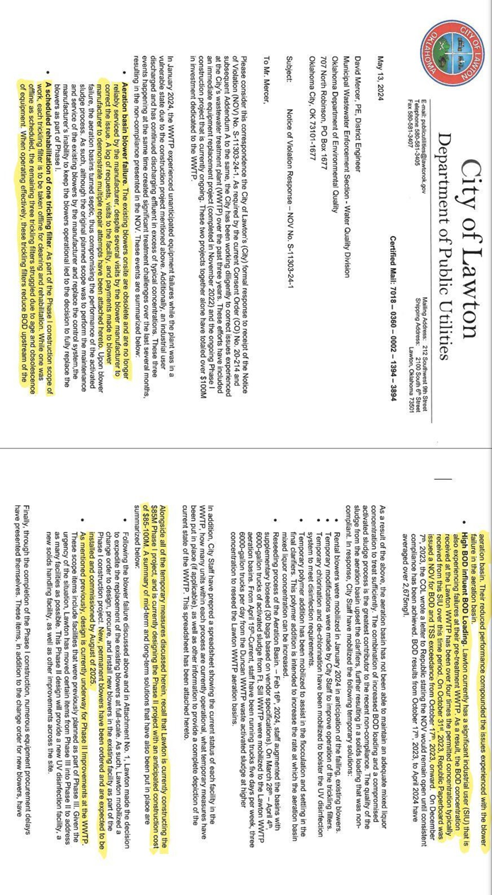
Lawton’s three-phase upgrade project represents a critical investment in long-term reliability and environmental stewardship. The modernization of treatment processes including the relocation of infrastructure from flood-prone zones, improvement of aerobic treatment systems, and construction of a new, fully integrated facility positions the WWTP to achieve sustained compliance with the CWA. As of summer 2025 there have been reductions in sludge present at the TGF after the CoL halted using the WWTP to treat the residual sludge from the drinking water treatment plant. This was a $5.12 million grant through the EPA and $2 million state American Rescue Plan Act (ARPA) grant to help contribute to the project cost (City of Lawton, 2025).
The recommended flood mitigation strategies and implementation of a real-time water quality monitoring system at TGF’s intake site further enhance resilience and transparency. Together, these actions form a proactive management framework that aligns with the principles of adaptive governance, emphasizing data-driven decision-making, interagency collaboration, and continuous improvement. By adopting these measures, the CoL can mitigate future risks, maintain compliance, and safeguard both municipal and industrial interests.
Ultimately, the success of the WWTP modernization project will depend on sustained investment, diligent operation, and cooperative engagement among stakeholders. The case illustrates the broader importance of integrated water resource management in achieving sustainable outcomes for communities and industries alike. As climate variability and population pressures intensify, proactive planning and coordinated infrastructure development will remain essential to balancing economic growth, environmental protection, and regulatory compliance.
REFERENCES CITED

American Electric Power. (2017). Comanche Power Station Case Study.
Electric Power Research Institute. (2024). Case Study: Algae Prevention and Mitigation
City of Lawton & Public Service Company of Oklahoma. (2021). Second Addendum to Water Supply Contract.
Southwest Ledger. (2024). https://www.southwestledger.news/news/lawton-wwtp-cited-again- deq-significant-progress-being-made
The Lawton Constitution. (2024). https://www.swoknews.com/news/lawton-cited-for-high- ammonia-levels-in-wastewater-discharge/article_c4178f57-3ea7-5c4f-b59d-684290eee8c2.html
KOSU. (2024). https://www.kosu.org/energy-environment/2024-08-05/as-lawton-works-to-fix-its- wastewater-treatment-plant-officials-find-fishkill-downstream
Voith. (2021). https://voith.com/corp-en/P-CurtainCoater-PR-210210.pdf
KSWO. (2023). https://www.kswo.com/2023/03/02/republic-paperboard-company-reimburse-city- lawton-local-plant-upgrades/
KSWO. (2024). https://www.kswo.com/2024/04/10/city-lawton-addresses-wastewater-dumping- allegations-east-cache-creek/
City of Lawton. (2025). https://www.lawtonok.gov/CivicAlerts.aspx?AID=62
Yin, Case Study Research. (2018). https://ebooks.umu.ac.ug/librarian/books-file/Case%20Study%20Research%20and%20Applications.pdf
Engle, D. (2025). ENVR5100 capstone project repository [Source code and data]. GitHub. https://github.com/Dan8816/ENVR5100

APPENDIX A
NPDES MONITORING DATA ANALYSIS FOR LAWTON WASTEWATER TREATMENT PLANT

This appendix documents the methods and supporting information used to analyze the National Pollutant Discharge Elimination System (NPDES) monitoring data for the City of Lawton Wastewater Treatment Plant (WWTP), NPDES Permit No. OK0035246. The data was obtained from the U.S. Environmental Protection Agency’s Enforcement and Compliance History Online (ECHO) system as an Excel workbook titled 'Lawton NPDESMonitoringData_OK0035246.xlsx.' The dataset includes monthly monitoring results for multiple outfalls and parameters over the period 2007–2020.
A.1 Data Preparation and Filtering
The monitoring dataset was imported into Python using the pandas library for data analysis. Initial preprocessing steps included:
• Removing header rows and non-data text rows at the top of each worksheet.
• Restricting the analysis to Outfall 003, which represents effluent delivered from the Lawton WWTP to the power generation facility.
• Standardizing column names and converting numeric fields from text to numeric format.
• Filtering to retain only parameters of interest for this project, including carbonaceous biochemical oxygen demand (CBOD₅), total suspended solids (TSS), ammonia nitrogen (NH₃-N), fecal coliform, pH, and selected metals.
A.2 Comparison to Permit Limits
Where permit limits were available in the dataset, individual monitoring results were compared to the corresponding monthly average or daily maximum limit. For each pollutant, records were flagged as:
• "In compliance" measured value less than or equal to the applicable limit; or
• "Exceedance" measured value greater than the applicable limit.
This comparison was used to identify pollutants with repeated or episodic exceedances during the monitoring period. These results informed the discussion in the findings and impact analysis sections of the main text.
A.3 Pollutant Source Attribution Logic
To distinguish pollutants reasonably attributable to the Lawton WWTP from those more likely to originate from power generation operations, pollutants were categorized based on their typical sources. Parameters associated with domestic sewage or biological treatment processes (for example, fecal coliform, CBOD₅, and ammonia nitrogen) were interpreted as originating upstream at the WWTP. In contrast, parameters strongly associated with condensing, cooling, or boiler systems (for example, temperature and some corrosion-related metals) were interpreted as more likely to reflect power plant operations.
Table A-1. Summary of pollutant source attribution logic for parameters observed in the NPDES monitoring data.
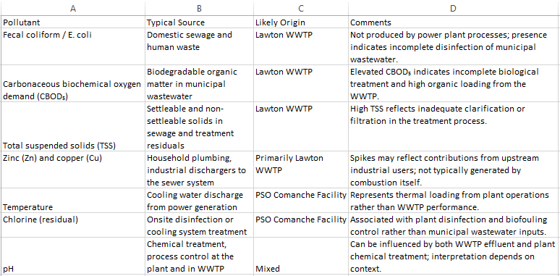
Additional supporting materials, including the full EPA NPDES monitoring dataset, Python analysis scripts, contract documents, and permits not reproduced in this document, are available in the project repository:
Engle, D. (2025). ENVR5100 capstone project repository [Source code and data]. GitHub. https://github.com/Dan8816/ENVR5100

