Assignment 1

Team 126 - Weather Wizard

COS30049

Computing Technology Innovation Project

Team Members:

Rehnuma Rahmat Ullah (104313715)

Dac Tung Duong Nguyen (104357292)

Lehan Lochana Alagedara (104855055)

Table of Contents

I. Project Background and Introduction 3

II. Team Introduction 3

III. Project requirements list and description 4

1. Project Topic Selection 4

2. Data Collection and Dataset Selection 4

3. Machine Learning Model Development 4

4. Project Management Plan 4

5. Work Breakdown Structure (WBS) 4

6. Gantt Chart Creation 4

7. Prototype Design and UI/UX Evaluation 4

8. Integration of Project Management and Design 5

9. Website Development with Data Visualization 5

IV. Scope Management 5

1. Project Scope Definition 5

1.1. Project Objectives 5

1.2. In-Scope Work 5

1.3. Out-of-Scope Work 6

2. Work Breakdown Structure (WBS) 6

3. WBS Dictionary 6

1.1 Project Management 6

1.2 Data Collection and Preprocessing 7

1.3 Machine Learning Model Development 7

1.4 UI/UX Design and Prototype Development 8

1.5 Web Application Development 8

1.6 Testing and Quality Assurance 8

1.7 Documentation and Final Report 9

V. Time Management 10

1 . Task timetable 10

2. Gantt Chart 11

VI. Risk Management 12

1. Risk Identification 12

2. Risk Assessment 12

3. Risk Response Plan 13

4. Risk Monitoring and Control Strategy 14

VII. Monitor Control 14

1. Monitoring Project Progress 14

2. Change Control Process 15

VIII. Closure Plan 16

IX. Project design 16

# Project Background and Introduction

Weather analysis is an essential aspect of understanding and predicting atmospheric conditions, which significantly impacts various industries, including agriculture, aviation, disaster management, and tourism.

The project aims to develop a state of the art machine learning model that can provide accurate predictions for future weather patterns. This project will involve the collection of extensive datasets, thorough data preprocessing, model development, testing, and deployment.

The machine learning model will focus on several key weather parameters such as temperature, precipitation, humidity, and wind speed. By analyzing these factors, the model will be able to predict short-term and long-term weather conditions.

# Team Introduction

Dac Tung Duong Nguyen (Project Manager): He will ensure that all project milestones are met on time, coordinate communication between team members, and handle any risks or challenges that may occur.

Lehan Lochana Alagedara (Data Analyst): His role is crucial in ensuring that the model is accurate, reliable, and capable of making precise weather predictions.

Rehnuma Rahmat Ullah (UI/UX Designer): She will ensure that the application is not only visually appealing but also easy to navigate, with a focus on user-centered design principles.

# Project requirements list and description

## 1. Project Topic Selection

**Requirement:** Choose a specific topic that aligns with the stakeholder’s goals and objectives.

**Description:** The team must select a weather phenomenon or aspect relevant to the project, ensuring sufficient data is available for analysis from given four topics.

## 2. Data Collection and Dataset Selection

**Requirement:** Identify, acquire and pre-process datasets that are suitable for the chosen topic.

**Description:** Team should source datasets from credible platforms such as government meteorological departments, or academic databases. Data pre-processing involves handling missing values, normalizing the data, and possibly enriching it with additional features.

## 3. Machine Learning Model Development

**Requirement:** Develop, train, and validate machine learning models to analyze the weather data.

**Description:** Team must choose the most appropriate machine learning algorithms based on their project's objectives, such as regression models, decision trees, or neural networks (Paialunga, 2022).

## 4. Project Management Plan

**Requirement:** Create a detailed project management plan that outlines the project's scope, time, cost, risk, quality, and communication strategies.

**Description:** The project management plan should include a comprehensive scope statement, a detailed schedule with deadlines, a budget plan, and a risk management strategy.

## 5. Work Breakdown Structure (WBS)

**Requirement:** Develop a Work Breakdown Structure (WBS) to divide the project into smaller, manageable tasks and create a WBS dictionary.

**Description:** The WBS should break down the project into hierarchical levels, starting with high-level deliverables and then into smaller tasks and subtasks.

## 6. Gantt Chart Creation

**Requirement:** Create a Gantt chart to visually represent the project timeline, tasks, and milestones.

**Description:** The Gantt chart should map out the start and end dates of each task, along with their dependencies. Key milestones should be highlighted, and the critical path should be identified to ensure that the project stays on schedule.

## 7. Prototype Design and UI/UX Evaluation

**Requirement:** Design a prototype interface for the web application, focusing on UI/UX principles to ensure usability.

Description: The prototype should be a preliminary version of the web application, designed with the end-user in mind. It should adhere to UI/UX best practices, ensuring that the interface is intuitive, accessible, and responsive.

## 8. Integration of Project Management and Design

**Requirement:** Collaborate effectively as a team to integrate project management strategies with design and technical implementation.

**Description:** The team must ensure that project management plans align with the design and development processes.

## 9. Website Development with Data Visualization

**Requirement:** Develop a dynamic website that allows users to interact with the trained models and visualize data insights.

**Description:** The website should be developed using modern web technologies like HTML, CSS, JavaScript, and frameworks like React or Angular. It should include features for user interaction, such as input forms, machine learning model integration, and dynamic visualizations.

# Scope Management

## **1. Project Scope Definition**

The project scope defines the boundaries and deliverables of the project. For this project, the scope is focused on developing a comprehensive machine learning-based weather analysis system because the topic we chose was Weather Analysis, including a project management plan, machine learning model development, prototype design, website outline creation, and a final report.

#### 1.1. Project Objectives

* Develop a machine learning model to analyse weather data, focusing on prediction, classification, or attribution.
* Create a web application outline that lets users look at the website functionalities and data insights.
* Design a user-friendly interface based on UI/UX principles to ensure usability.
* Produce a detailed project management plan including a Work Breakdown Structure (WBS) and Gantt chart.
* Prepare a comprehensive final report documenting the entire project lifecycle, including testing, quality assurance, and risk management.

#### 1.2. In-Scope Work

* **Data Collection and Preprocessing**: Sourcing and preparing datasets for machine learning.
* **Machine Learning Model Development:** Creating and refining models to analyse the weather data.
* **Web Application Development:** Building a dynamic website with interactive features and data visualization capabilities.
* **UI/UX Design:** Designing the prototype interface with a focus on user experience.
* **Project Management:** Developing a detailed project management plan, including WBS, Gantt chart, and risk management.
* **Testing and Quality Assurance:** Conducting thorough testing of the models, web application, and interface.
* **Documentation:** Preparing the final project documentation and report.

#### 1.3. Out-of-Scope Work

* **Post-Deployment Maintenance:** Ongoing support and updates for the web application after project completion.
* **Advanced AI Integration:** Implementing advanced AI techniques beyond basic machine learning (e.g., deep learning, neural networks beyond basic architecture).

## 2. Work Breakdown Structure (WBS**)**

The Work Breakdown Structure (WBS) decomposes the project into manageable tasks. Each task is clearly defined, allowing for efficient assignment, tracking, and management.

## 3. WBS Dictionary

The WBS Dictionary provides detailed descriptions of each WBS element, ensuring clarity and understanding of the work required for each task.

### 1.1 Project Management

#### 1.1.1 Scope Management

**1.1.1.1 Define project scope:** Develop a clear and concise project scope statement that outlines the project's goals, deliverables, and boundaries.

**1.1.1.2 Develop WBS and WBS dictionary**: Create the WBS to break down the project into manageable tasks and develop the WBS dictionary to describe each task in detail.

#### 1.1.2 Schedule Management

**1.1.2.1 Create Gantt chart:** Develop a Gantt chart that visually represents the project timeline, tasks, and milestones.

**1.1.2.2 Set milestones and deadlines:** Identify key project milestones and set realistic deadlines for each task and subtask.

#### 1.1.3 Risk Management

**1.1.3.1 Identify potential risks:** Conduct a risk assessment to identify potential risks that could impact the project’s success.

**1.1.3.2 Develop risk mitigation strategies:** Develop strategies to mitigate identified risks, including alternative paths for critical tasks.

#### 1.1.4 Communication Management

**1.1.4.1 Develop communication plan:** Create a communication plan outlining how information will be shared among team members and stakeholders.

**1.1.4.2 Schedule regular team meetings:** Establish a regular meeting schedule to discuss project progress, issues, and upcoming tasks.

### 1.2 Data Collection and Preprocessing

1.2.1 Data Collection

**1.2.1.1 Identify relevant datasets:** Research and identify datasets relevant to the chosen weather analysis topic.

**1.2.1.2 Acquire datasets:** Obtain the identified datasets, ensuring they are in a usable format.

#### 1.2.2 Data Preprocessing

**1.2.2.1 Clean data:** Handle missing values, outliers, and other data quality issues.

**1.2.2.2 Normalize and format data:** Ensure the data is in a consistent format and normalize it if necessary.

**1.2.2.3 Feature engineering:** Create additional features from the existing data that may improve model performance.

### 1.3 Machine Learning Model Development

#### 1.3.1 Model Selection

**1.3.1.1 Research potential models:** Explore various machine learning models suitable for the project’s objectives.

**1.3.1.2 Select appropriate model(s):** Choose the most suitable model(s) based on the research and project needs.

#### 1.3.2 Model Training

**1.3.2.1 Split data into training, validation, and test sets:** Divide the dataset to ensure proper training, validation, and testing of the model.

**1.3.2.2 Train model on the training set:** Develop the model by training it on the prepared dataset.

#### 1.3.3 Model Evaluation and Tuning

**1.3.3.1 Evaluate model performance:** Assess the model’s performance using relevant metrics.

**1.3.3.2 Tune model hyperparameters:** Adjust the model’s hyperparameters to optimize performance.

**1.3.3.3 Select final model:** Finalize the model that offers the best performance based on evaluation.

### 1.4 UI/UX Design and Prototype Development

#### 1.4.1 UI/UX Research and Planning

**1.4.1.1 Conduct user research and define requirements:** Understand user needs and define UI/UX requirements.

**1.4.1.2 Develop UI/UX design plan:** Create a plan for the UI/UX design, outlining key design principles and elements.

#### 1.4.2 Prototype Design

**1.4.2.1 Design wireframes and mockups:** Create initial wireframes and visual mockups of the user interface.

**1.4.2.2 Create interactive prototype:** Develop an interactive prototype to simulate the user experience.

#### 1.4.3 User Testing

**1.4.3.1 Conduct usability testing:** Test the prototype with users to identify usability issues.

1**.4.3.2 Collect and analyze user feedback:** Gather feedback from users and analyze it to refine the design.

### 1.5 Web Application Development

#### 1.5.1 Frontend Development

**1.5.1.1 Develop user interface:** Build the user interface based on the finalized design.

**1.5.1.2 Integrate data visualization tools:** Implement tools for visualizing data within the web application.

#### 1.5.2 Backend Development

**1.5.2.1 Develop server-side logic:** Build the backend logic to support user interactions and data processing.

**1.5.2.2 Integrate machine learning model:** Incorporate the machine learning model into the backend to process user inputs.

1.5.3 Integration and Deployment

**1.5.3.1 Integrate frontend and backend:** Ensure seamless communication between the frontend and backend components.

**1.5.3.2 Deploy application to a web server:** Deploy the final web application to a live server for user access.

### 1.6 Testing and Quality Assurance

#### 1.6.1 Unit and Integration Testing

**1.6.1.1 Test individual components:** Conduct unit testing on individual components of the application.

**1.6.1.2 Test interactions between components:** Perform integration testing to ensure components work together as expected.

#### 1.6.2 User Acceptance Testing

**1.6.2.1 Conduct user testing sessions:** Test the application with end-users to gather feedback on functionality and usability.

**1.6.2.2 Implement user feedback:** Make necessary adjustments based on user feedback to improve the application.

#### 1.6.3 Quality Assurance and Risk Management

**1.6.3.1 Develop QA plan:** Create a quality assurance plan that outlines testing procedures and quality standards.

**1.6.3.2 Identify risks and implement mitigation strategies:** Identify potential risks during the QA phase and develop mitigation strategies, including alternative paths for critical components.

#### 1.7 Documentation and Final Report

#### 1.7.1 Project Documentation

**1.7.1.1 Document project management plan:** Create detailed documentation of the project management plan, including scope, schedule, and risk management.

**1.7.1.2 Document technical development:** Prepare technical documentation covering data collection, preprocessing, model development, and application development.

#### 1.7.2 Final Report Preparation

**1.7.2.1 Compile project findings and results:** Gather all project findings, results, and analyses into a final report.

**1.7.2.2 Review and finalize the report:** Review the final report for completeness, accuracy, and clarity before submission.

# Time Management

1. Task timetable

|  |  |  |
| --- | --- | --- |
| **Summary** | **Start date** | **Due date** |
| Scope Management | 7/29/2024 | 8/11/2024 |
| Schedule Management | 8/5/2024 | 8/18/2024 |
| Risk Management | 8/19/2024 | 8/25/2024 |
| Assignment 1 Submission | 7/29/2024 | 8/25/2024 |
| Data Collection | 8/26/2024 | 8/31/2024 |
| Data Processing | 8/28/2024 | 9/2/2024 |
| Model Selection | 9/3/2024 | 9/6/2024 |
| Model Training | 9/5/2024 | 9/10/2024 |
| Model Evaluation and Tuning | 9/5/2024 | 9/12/2024 |
| UI/UX Research and Planning | 9/9/2024 | 9/15/2024 |
| Prototype Design | 9/16/2024 | 9/22/2024 |
| User Testing | 9/23/2024 | 9/29/2024 |
| Assignment 2 Submission | 8/26/2024 | 9/29/2024 |
| Frontend Web Development | 9/30/2024 | 10/6/2024 |
| Backend Web Development | 10/7/2024 | 10/13/2024 |
| Integration and Development | 10/14/2024 | 10/20/2024 |
| Testing and Quality Assurance | 10/21/2024 | 10/27/2024 |
| Project Documentation and Final Report | 10/28/2024 | 11/3/2024 |
| Assignment 3 Submission | 9/30/2024 | 11/3/2024 |

The color scheme corresponds to the colors used in weekly view of Gantt chart (see below).

## 2. Gantt Chart

*Figure: Monthly view of Gantt chart*

*Figure: Weekly view of Gantt chart*

This Gantt chart represents the timeline for our project tasks, broken down into three groups according to three assignment requirements, with each phase indicated by different colors:

* **Red Blocks (Weeks 1 to 4):** These represent the tasks for **Assignment 1**. The tasks in this phase are foundational and include Scope Management, Schedule Management, and Risk Management. These tasks are crucial for setting up the project structure, timelines, and identifying potential risks early on.
* **Green Blocks (Weeks 5 to 8):** These represent the tasks for **Assignment 2**. During this period, some of the key project activities are carried out, such as Data Collection, Data Processing, Model Selection, Model Training, Model Evaluation and Tuning, UI/UX Research and Planning, Prototype Design, and User Testing. This phase is focused on both developing the machine learning model and designing the user interface, along with testing to ensure that the designs meet user needs.
* **Blue Blocks (Weeks 8 to 13):** These represent the tasks for **Assignment 3**. Tasks in this phase include Frontend Web Development, Backend Web Development, Integration and Development, Testing and Quality Assurance, and Project Documentation and Final Report. The focus here is on bringing all the components together, testing the complete system, and finalizing all documentation.

# Risk Management

This section will identify, evaluate, and create risk management plans for potential risks associated with the development of the machine learning-based weather analysis system. We will also consider every stage of the project lifecycle, starting with the planning stages and ending with the deployment and reporting phases.

## 1. Risk Identification

**Activity:**

We conducted a brainstorming session to identify potential risks in various areas such as data availability, machine learning model performance, web application functionality, UI/UX design, and stakeholder engagement. The identified risks are categorized by their likelihood (High, Medium, Low) and impact (High, Medium, Low).

|  |  |  |
| --- | --- | --- |
| **Risk** | **Likelihood** | **Impact** |
| 1. Insufficient or poor-quality weather data | Medium | High |
| 1. Machine learning model underperformance | High | High |
| 1. Delays in web application development | Medium | Medium |
| 1. Poor user adoption due to inadequate UI/UX design | Low | Medium |
| 1. Miscommunication between team members leading to project delays | Medium | Medium |

## 2. Risk Assessment

**Activity:**

We evaluated each identified risk for its possible effect on the project's outcome, determined how likely it was to occur, and ranked the risks according to severity.

1. Insufficient or poor-quality weather data

* Impact: High - This would cause the machine learning models' accuracy to be compromised, producing unreliable results.
* Likelihood: Medium - There is a chance of incomplete or unclean data, but overall, the sources of the information are trustworthy.
* Priority: High

1. Machine learning model underperformance

* Impact: High - The system will become ineffective if the model performs poorly and is unable to satisfy the project objectives.
* Likelihood: High - Model building is inherently uncertain, especially when it comes to choosing and fine-tuning algorithms.
* Priority: High

1. Delays in web application development

* Impact: Medium - This could cause a delay in the project's overall schedule, which would impact jobs like testing and deployment that come next.
* Likelihood: Medium - Delays are possible due to the frontend and backend integration's complexity.
* Priority: Medium

1. Poor user adoption due to inadequate UI/UX design

* Impact: Medium: A poorly designed application may result in low user engagement and unmet project objectives.
* Likelihood: Low – This risk can be reduced with appropriate UI/UX planning and testing.
* Priority: Low

1. Miscommunication between team members leading to project delays.

* Impact: Medium - Inadequate communication may cause misconceptions that compromise work progress and project deadlines.
* Likelihood: Medium - There are scheduled meetings and regular contact, but miscommunication is still a possibility.
* Priority: Medium

## Risk Response Plan

**Activity:**

For the top three risks identified, we have developed a Risk Response Plan, detailing the specific actions to be taken and assigning responsibilities.

1. Insufficient or poor-quality weather data

* Response:
  + Action: Before developing a model, identify several data sources and cross-check the accuracy of the data.
  + Responsibility: Data Collection Team
  + Backup Plan: Apply data augmentation strategies or obtain additional datasets in the event of data problems.

1. Machine learning model underperformance

* Response:
  + Action: Conduct extensive testing and fine-tuning of the model and investigate substitute models in the event that preliminary findings prove inadequate.
  + Responsibility: Machine Learning Team
  + Backup Plan: Provide additional time in the timeline for model improvement and, if needed, take hybrid models into consideration.

1. Delays in web application development

* Response:
  + Action: build and test application features iteratively, use agile development techniques.
  + Responsibility: Web Development Team
  + Backup Plan: Modify the project schedule to account for probable setbacks and, if practical, consider concurrent development activities.

## Risk Monitoring and Control Strategy

**Activity:**

We have put in place a Risk Monitoring and control strategy to efficiently manage and mitigate the biggest risks.

* Ongoing Monitoring:
  + Procedures: To evaluate the status of hazards that have been identified, schedule frequent risk review sessions. Track risk levels and actions with project management tools.
* Trigger Points:
  + Specific events or thresholds that will require additional action or escalation.
    - Data quality issues found during initial preprocessing
    - During evaluation, the model's accuracy drops below a predetermined level.
    - Development of web applications takes more than a week.
* Communication Plan:
  + Stakeholders will get risk updates via in-depth progress reports and weekly project meetings. To guarantee a prompt response, immediate dangers that need immediate attention will be shared via email or direct messaging.

# Monitor Control

Monitoring and controlling the project ensures that it stays on track, meets its objectives, and delivers the desired outcomes. This process involves continuously tracking the project's progress, managing any changes that arise, and ensuring alignment with the project's goals, timeline, and budget.

## 1. Monitoring Project Progress

Effective monitoring is essential to keep the project moving toward its objectives. It involves regularly tracking key performance indicators (KPIs), managing resources, and ensuring that the project stays within its defined scope and schedule.

**Key Activities:**

* **Tracking Key Performance Indicators (KPIs):**   
  Monitoring KPIs such as Schedule Variance (SV), Cost Variance (CV), and Performance Indices (SPI and CPI) helps assess whether the project is on schedule and within budget. These indicators provide a quantitative basis for making decisions and adjustments as needed.
* **Progress Reporting:**   
  Regular status reports should be generated to document the project’s progress. These reports can include visual tools like Gantt charts, which map out the timeline of tasks and milestones, and dashboards that provide real-time data on the project’s status. These reports help keep all stakeholders informed and aligned.
* **Quality Assurance:**   
  Continuous monitoring of the quality of deliverables ensures that the project meets the required standards. This involves using tools like control charts to monitor process stability, and checklists to ensure all necessary steps are completed.
* **Risk Management:**   
  As the project progresses, risks must be continuously assessed and managed. This involves updating the risk register, identifying new risks, and implementing mitigation strategies to avoid potential disruptions.

## 2. Change Control Process

Change control is a critical component of the project management, particularly in dynamic projects like this, where requirements may evolve over time. A structured change control process ensures that all changes are evaluated, approved, and implemented systematically, minimizing disruption.

**Key Steps in the Change Control Process:**

1. **Identification of Change Requests:**   
   Any proposed changes to the project should be formally documented as a change request. These requests can come from stakeholders, team members, or be necessitated by external factors.
2. **Change Control Board (CCB) Review:**   
   The Change Control Board (CCB), consisting of key stakeholders and project leaders, reviews each change request. The CCB evaluates the impact analysis and decides whether to approve, reject, or defer the change.
3. **Implementation of Approved Changes:**   
   Once a change is approved by the CCB, it is implemented according to the updated project plan. This may involve adjusting schedules, reallocating resources, or modifying the scope of work. The project management team should ensure that all changes are communicated to the relevant stakeholders and that the project documentation is updated accordingly.
4. **Impact Analysis:**   
   Once a change request is identified, it must undergo a thorough impact analysis to assess how it will affect the project’s scope, timeline, cost, and quality. This analysis is critical for understanding the potential consequences of the change.
5. **Updating the Change Log:**   
   A Change Log is maintained to document every change request, including its status, decision, and impact. This log serves as a historical record, providing transparency and accountability throughout the project.
6. **Communication and Stakeholder Engagement:**   
   Effective communication is essential during the change control process. Stakeholders should

# Closure Plan

The closure plan for the Weather Analysis project is designed to ensure that all project activities are finalized, deliverables meet the required standards, and stakeholders are satisfied with the outcomes. This plan outlines the essential steps to conclude the project effectively.

1. **Project Deliverables:**
   * **Completion of Outputs:**
     + Ensure that all project outputs, including the machine learning model, web application, and documentation, are completed according to the project plan. Each deliverable should be thoroughly reviewed to confirm that it meets the quality standards set out at the beginning of the project.
     + The web application should be fully functional, offering accurate weather predictions and an intuitive user experience. The machine learning model must be validated for accuracy and reliability.
2. **Acceptance Criteria:**
   * **Verification Process:**
     + The project deliverables will be verified against the predefined acceptance criteria agreed upon with the client and stakeholders. This includes ensuring that the machine learning model meets the specified accuracy requirements and that the web application functions as intended across all supported devices.
     + Usability testing results must show a minimum satisfaction score of 85% from user feedback, ensuring that the application meets the necessary usability standards.
3. **Obtain Formal Acceptance:**
   * **Securing Approval:**
     + Once the deliverables meet the acceptance criteria, formal approval will be sought from the client or stakeholders. This formal sign-off will confirm that the project has fulfilled its objectives and that the deliverables are acceptable.
     + A final review meeting will be conducted with stakeholders to present the deliverables, address any last-minute concerns, and secure their approval.
4. **Document Final Deliverables:**
   * **Compilation and Archiving:**
     + All project documentation will be compiled, including the project management plan, final report, meeting minutes, and technical documentation. These documents will provide a comprehensive record of the project’s execution and outcomes.
     + The final report will summarize the project's performance, including the results of the machine learning model, user feedback, and any lessons learned. This documentation will be archived for future reference and as a resource for similar projects.
5. **Release Project Resources:**
   * **Reassignment and Resource Management:**
     + Upon obtaining formal acceptance, all project resources, including the project team, budget allocations, and equipment, will be released. Team members will be reassigned to new projects, and any remaining budget will be returned to the organization or reallocated as needed.
     + A formal notification will be sent to all involved parties, indicating the release of resources and the official closure of the project.
6. **Conduct Post-Project Review:**
   * **Evaluation and Lessons Learned:**
     + A post-project review will be conducted to evaluate the overall performance of the project. This review will assess how well the project met its objectives, adhered to the timeline, and managed risks.
     + The review will include feedback from team members, users, and stakeholders, focusing on what went well and areas that could be improved in future projects.
     + Lessons learned will be documented and shared with the organization to inform best practices and improve project management processes.

By following this closure plan, the Weather Analysis project will be concluded in a structured and efficient manner, ensuring that all objectives are met, and that the project’s success is thoroughly documented and recognized.

# Project design

1. Visibility of System Status  
   Design Alignment:  
   Our design clearly displays the current weather status for Melbourne at the top of the screen , along with the temperature (16°C). This keeps users informed about the current conditions in an easily visible and prominent location.  
   The expected rain information is also clearly visible, providing users with timely updates on what to expect.
2. Match Between System and the Real World  
   Design Alignment:  
   The use of familiar weather-related terms and visuals (e.g., temperature, humidity, visibility, UV index) ensures that the system speaks the user’s language. The use of icons like the sun, clouds, and rain reflects real-world weather conditions, making the interface intuitive and easy to understand.
3. User Control and Freedom  
   Design Alignment:  
   The navigation menu at the top ("Home", "Weather Analysis", "Monthly") provides users with clear options to navigate between different sections of the site. This supports the principle of user control by allowing users to easily access the information they need without getting lost.
4. Consistency and Standards  
   Design Alignment:  
   The design uses consistent colours, fonts, and layouts across different sections, ensuring a uniform look and feel. The left sidebar consistently displays the weather for different cities (Melbourne, Sydney, Perth, Darwin), making it easy for users to compare conditions across locations.
5. Error Prevention  
   Design Alignment:  
   Although not explicitly shown in the design, the simplicity and clarity of the interface reduce the likelihood of user errors. By providing clear, easily understandable information, the design helps prevent users from misunderstanding or misinterpreting the data.
6. Flexibility and Efficiency of Use  
   Design Alignment:  
   The design caters to both novice and experienced users by providing essential information upfront while also allowing for more detailed analysis through the "Weather Analysis" section. The search function at the top right adds to the flexibility by enabling users to quickly find specific locations.
7. Aesthetic and Minimalist Design  
   Design Alignment:  
   The interface maintains a clean and uncluttered design, with sufficient whitespace and a balanced layout. The focus is on essential weather information, with no unnecessary elements that could distract the user. This minimalist approach enhances the overall usability of the application.

***Home Page:***

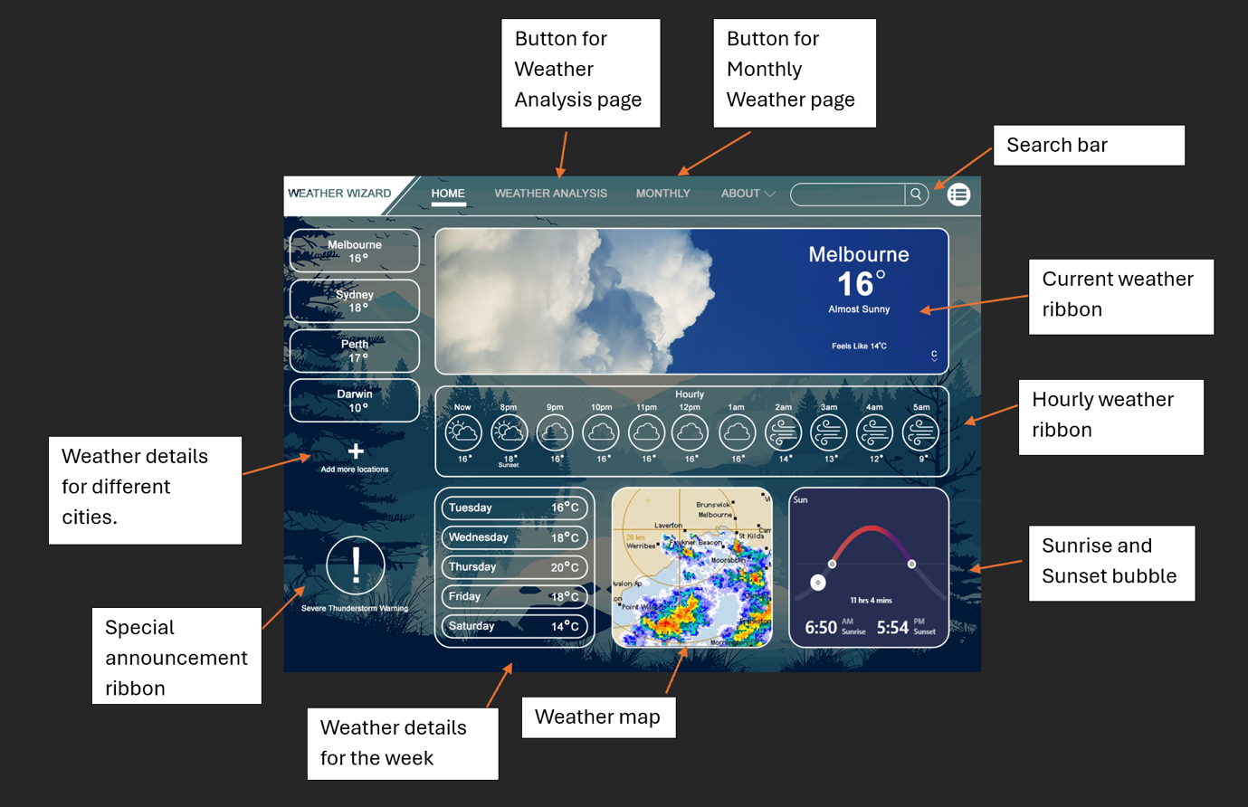

This is the home page for our website. A few sections will have interactive functions like:

Current weather ribbon – This section shows the current weather, current temperature, and the temperature it feels like. The temperature can also be displayed in Fahrenheit when the link on bottom right of the ribbon is clicked. The background image of the ribbon will change according to the weather condition in the moment.

Search bar – This can be used to search the weather for the different locations.

Hourly weather ribbon – In this ribbon it displays the weather for the hours of the day. The different weather conditions are displayed using small icons. The temperature changes throughout the day are also displayed in this ribbon.

In the pane on the left of the webpage the current temperatures of the saved main cities are shown. More cites can also be added using the button at the bottom of the pane. Then in the bottom of the page there are few sections that that show the average weather conditions and the highest temperature of the day, there is a weather map, and also a section that displays the sunrise and sunset time and the number of hours of daylight left in the day.

***Weather Analysis Page:***

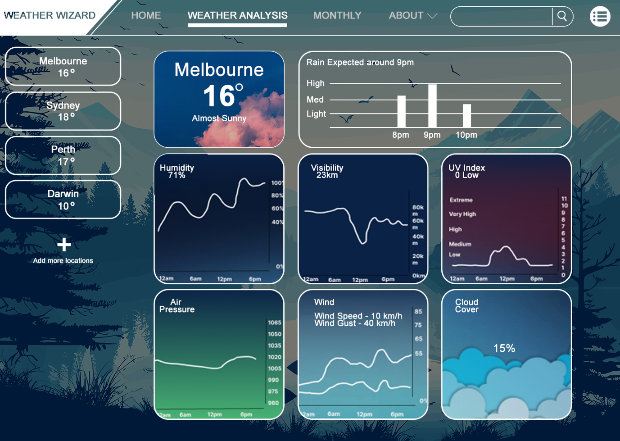

Weather Wizard Analysis interface effectively combines aesthetic appeal with functional usability. The layout is visually engaging, with a dark-themed background that contrasts well with the vibrant weather data, making the information pop out for the user. The use of clear and distinct graphical elements, such as the temperature display, humidity graph, and UV index, ensures that users can quickly grasp the weather conditions briefly. The inclusion of additional data points like air pressure, wind speed, and cloud cover enhances the application's depth, catering to both casual users and those looking for more detailed meteorological insights. The interface is also well-organized, with intuitive navigation and easily accessible options for viewing weather details for multiple locations, supporting a competent user experience.

***Monthly Forecast Page:***

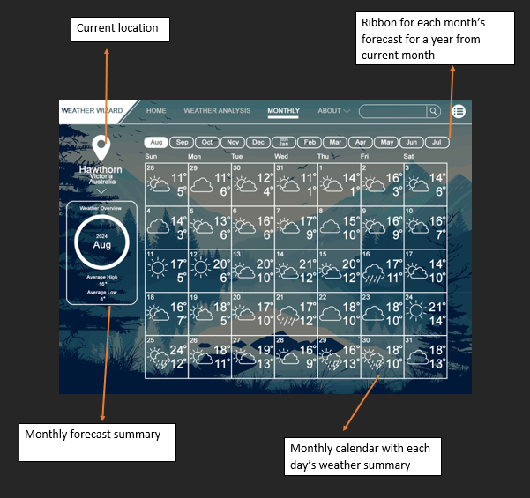

In this page the details of the weather that can be seen throughout a month for a selected location can be seen. There is a ribbon that can be used to view the monthly calendar with each day’s weather summary. Clicking on each day will show the analysis of forecast of the day by taking the user to the weather analysis page. Also, in the left side of the webpage there is a bubble that displays the average highest and average lowest temperatures.

# REFERENCES:

1. Paialunga, P. (2022). Weather forecasting with Machine Learning, using Python. [online]. Available at**:** [**https://towardsdatascience.com/weather-forecasting-with-machine-learning-using-python-55e90c346647**](https://towardsdatascience.com/weather-forecasting-with-machine-learning-using-python-55e90c346647)
2. Clint Fontanella (2024) 10 Essential Usability Heuristics You Need to Know: <https://blog.hubspot.com/website/usability-heuristics>