**Tableau Homework Screenshots**

**Dan Boulden**

My goal is to find out if there is a correlation between the number of rentals and the distance between the beginning station and where the most bikes from that station are returned.

To do this I created a formula to get the distance between the start and end stations for each rental.

Note: that something went wrong twice and I lost everything I had created in Tableau so I started using ACL Analytics to do the heavy lifting with the data and only used Tableau for generating the Distance field and for all visualizations.

This first visualization is supposed to show the top 20 locations with the color being starting station rental number and the color indicating the end station rental number. However, I was unable to get the end station number to not be the same as the start station number. I even tried creating a calculated field that added the end station Lat and Lon and converted it to a positive number, but it would not show up correctly.

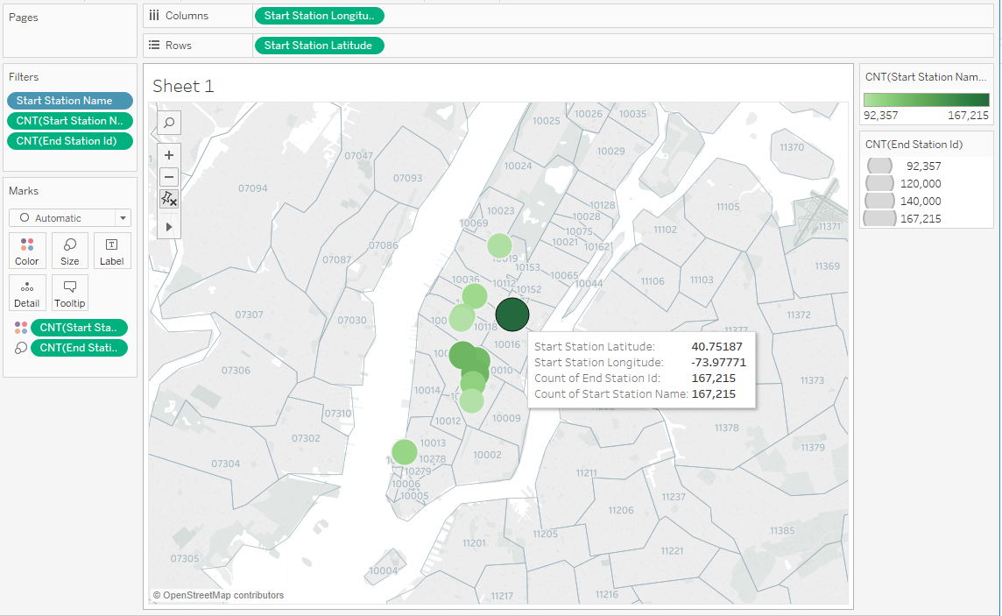

Here is the calculated field…

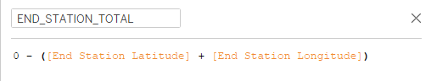

I exported the data to ACL and with ACL I created a summarized version of the data that gives us the total distance of all trips from each start station to each end station (if even one trip was made). I also used ACL to create a top 20 list for both starting and ending locations. Next I joined the top 20 station data with the computed distance data to have one table that could be imported into Tableau and present the visualizations we are making.

To create the distance between the start and stop sites I created a calculated field.

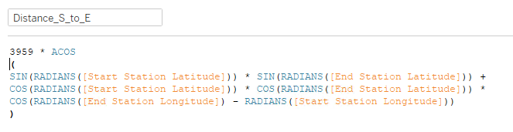

This is the script from ACL to complete this task before Tableau.

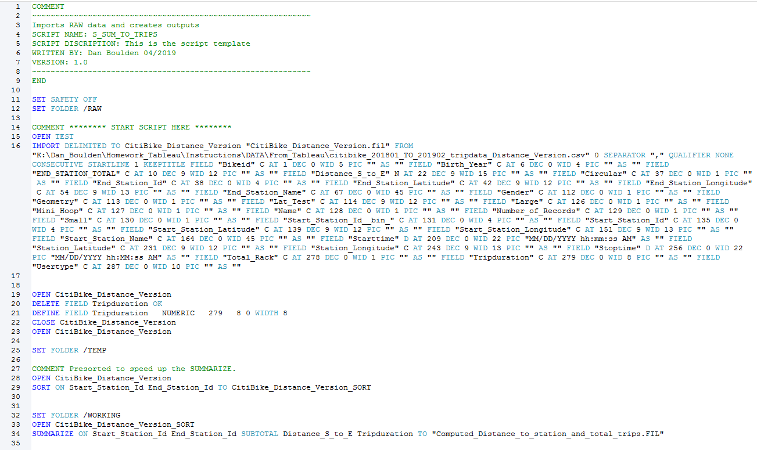

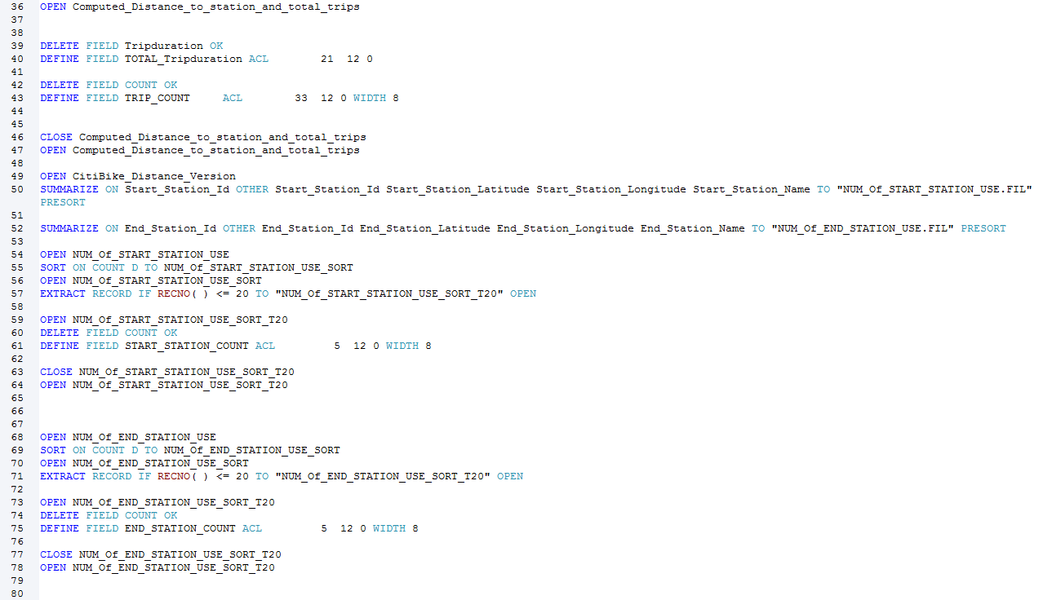

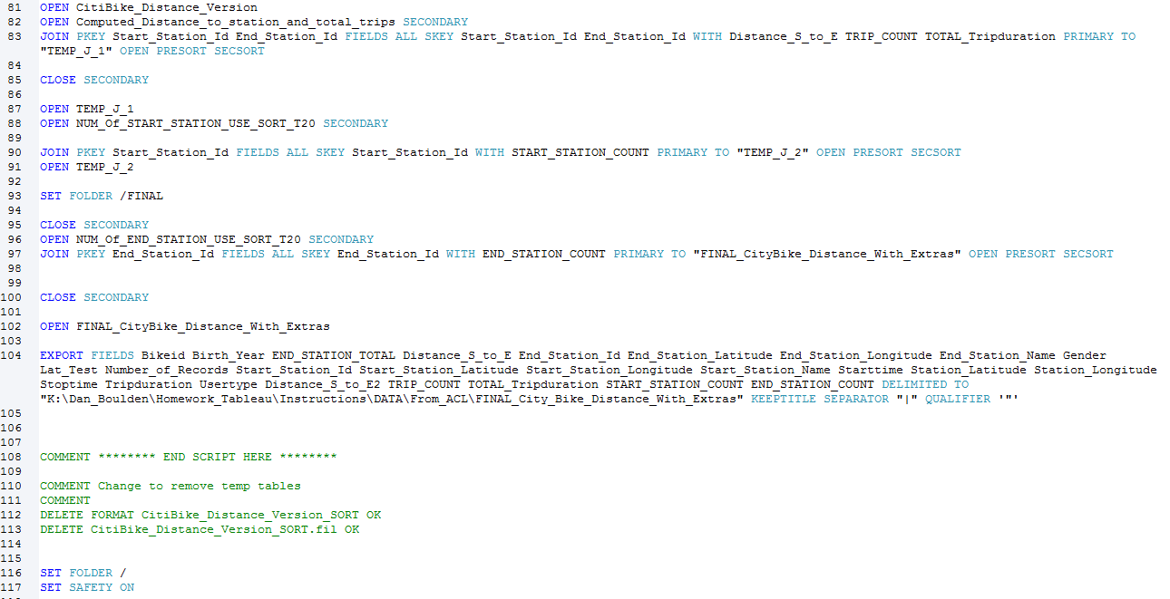

Now with the data from ACL we can easily show the top 20 from both start and end locations. Below are the screenshots.

