**Testing Log for University Network Website**

|  |  |
| --- | --- |
| **Test Name:** | False Data / SQL Injection / NMAP / Server Security Check |
| **Tester Name:** | Luke McCann |
| **Date Tested:** | February 2017 |

|  |  |  |  |  |  |  |
| --- | --- | --- | --- | --- | --- | --- |
| **Test Case ID:** | **Test Objective ID:** | **Test Conditions/ Description:** | **Test Data Used:** | **Expected Results:** | **Actual Results:** | **Solutions/ Future Response:** |
| 1 | 1 | Username Register | fakeEmail@fake.fake | Expected to allow as there is no method used for detecting fake emails other than searching for ‘@’ | Email Accepted, however unable to verify the account | In the future we could implement a string-search for ensuring that the email ends in a valid address, however this is a more complex issue than needed for this site. |
| 2 | 2 | Password Strength | Password123 | Password not strong enough | Strong Password | To sort this we could use a dictionary search algorithm to check if users are using dictionary words in their passwords, also we could explicitly ensure users cannot use the word ‘password’ |
| 3 | 3 | Bad language username | shitbag123 | Error forbidden word | Error forbidden word | This works as expected |
| 4 | 4, 1 | Bad Language Username Workaround | S4itb4g123 | Error forbidden word | Allows the username to be accepted | This could be controlled by other users reporting as it is harder to detect, however another way would be to detect numeric substitution, this would take a while to implement and is quite complex however. |
| 5 | 5 | SQL injection: Registration Input | 1“ or “1”=”1  SELECT * FROM Users; | Error + removal of operators | Error + removal of operators | This fails as expected |
| 6 | 6 | SQL Injection: Search Input | SELECT * FROM Users WHERE UserId = 105 or 1=1; | Error no search results + removal of operators | Error no search results | This SQL injection fails as expected |
| 7 | 7 | Fake Verification | Various fake verifications of the same length as the verification filler | Error: no verification exists | Error: no verification exists | Returns the error as expected |
| 8 | 8, 9, 10 | Server Security Check | NA | Track and Cookies | Various issues with privacy and other areas seen in the screenshot | More issues than expected |
| 9 | 11 | NMAP: attempt to map server | Nmap -sS -f 104.18.35.232 | Unable to connect eth0, eth1, eth2 | Unable to connect eth0, eth1, eth2 | Blocked connection as expected |

## Test Case #1

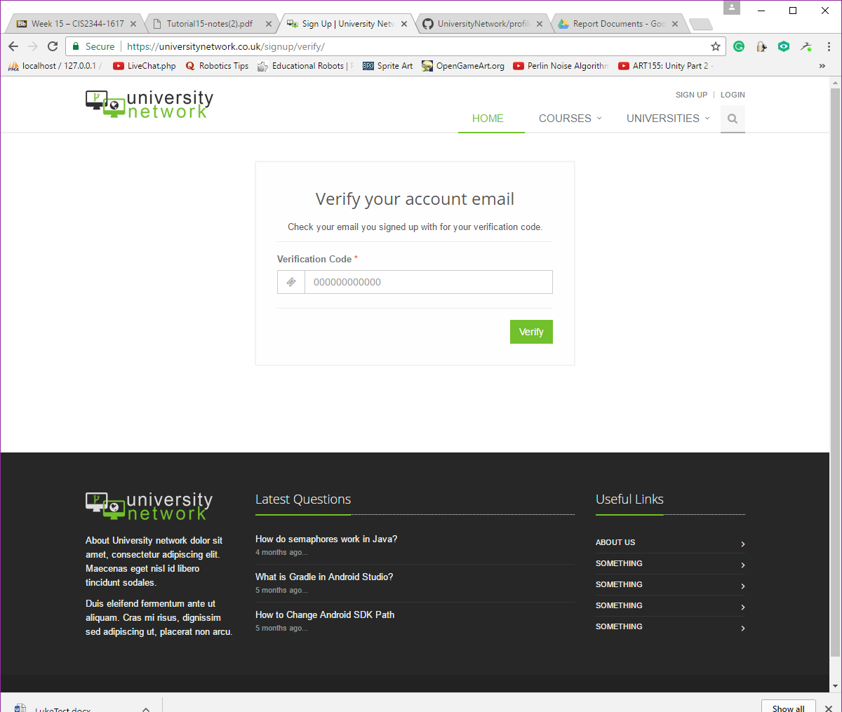

## Test Case #2

## Test Case #3

## Test Case #4

## Test Case #5

## Test Case #6

## Test Case #7

## Test Case #8

## Test Case #9

## Test Case #10

## Test Case #11