Instructions for SUPER-LI supplier’s program.

Dear user,

To use SUPER-LI supplier’s program, you need java installed on your computer.

After you installed java, you can run the program by downloading the project and typing the following command on your cmd window (when inside the project home directory):

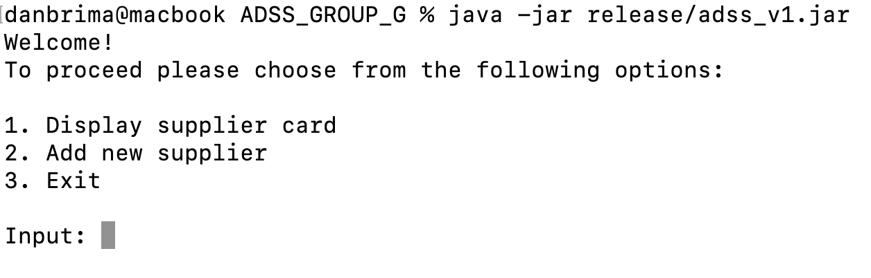

The program is initialized with 2 suppliers – biko and shufersal. Each supplier has a contract for three products: bisli, bamba and waffle. Each contract has different product prices and a different wholesale threshold.

To procced, you need to enter ‘1’ or ‘2’.

After pressing ‘1’, you will procced to the next menu:

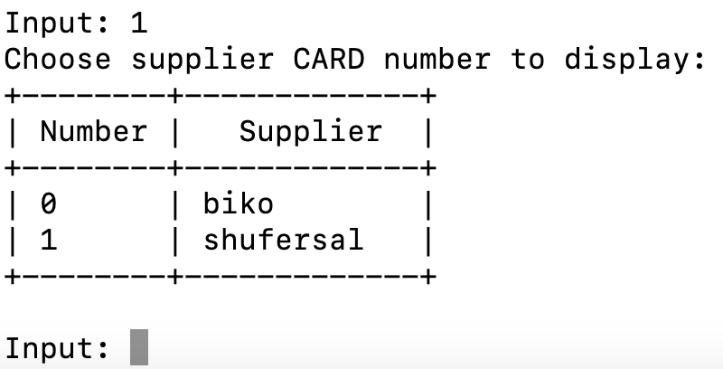

After each input, the program outputs a menu with the option to select a new option. Let’s take the previous example:



In the red section, an explanation about the screen is displayed. In our example, asking you to pick a supplier card number from the list.

In the Blue section, the actual data is displayed. In our example, the suppliers list.

In the green section, you are required to enter your input. The program will process your input and proceed to the next stage.

Choosing supplier open the screen of supplier cards and list of contracts with the supplier.

After choosing the supplier, the user can choose to view existing contract with the supplier or adding contract.

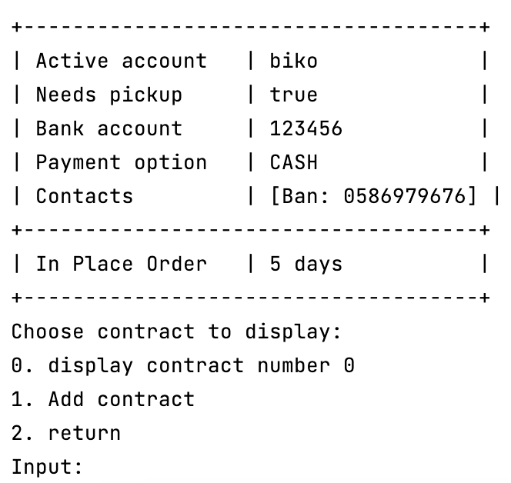

In the Blue section, the supplier card data is displayed.

In the red section, an explanation about the input options. In our example having only 1 contract, asking you to pick the contract to display adding a contract or exit.

In the green section, you are required to enter your input. The program will process your input and proceed to the next stage.

After choosing contract to display, the system shows all the contract detail’s including products, prices, amounts and if the whole contract has discount on wholesale.

