Model3D

Model3D is a resource which represents the geometry of a 3D model. It only contains a vector of meshes.

**Mesh**

These meshes contain a geometry data type which contains a count of vertices and indices and where they are located within the single vertex buffer they are held in.

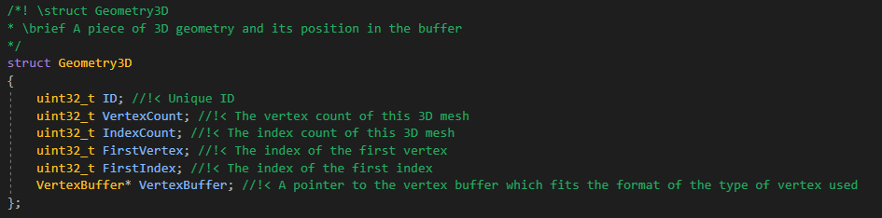

**Model**

Models only require a name upon construction. To populate a model instance with valid geometry, you must pass the mesh list with the **getMeshes** function which returns by reference to a function which will add to it. An example of this is the **assimp loader**.

Geometry cannot be removed from the vertex buffer at present, may be an addition in the future.