INSERT TITLE HERE
A DISSERTATION SUBMITTED TO MANCHESTER METROPOLITAN UNIVERSITY
FOR THE DEGREE OF MASTER OF SCIENCE
IN THE FACULTY OF SCIENCE AND ENGINEERING

2026
By
Daniel Cleaver
Department of Computing and Mathematics

Abstract
AI is a still growing industry and while the current trend of AI is heading towards the usage of Large Language Models, I believe there is a genuine use case for machine learning models within video games. The focus of this project is to uncover the current reasons behind why the industry doesn’t use machine learning AI for uses such as Non-Player Characters or local multiplayer games. This is approached by covering the design choices and code architecture of implementing a machine learning model into the Unity game engine. To evaluate whether the AI is functional, data has been gathered using a mix of qualitative and quantitative research. This research was collected through a short survey given to participants.

Declaration
No part of this project has been submitted in support of an application for any other degree or qualification at this or any other institute of learning. Apart from those parts of the project containing citations to the work of others, this project is my own unaided work. This work has been carried out in accordance with the Manchester Metropolitan University research ethics procedures, and has received ethical approval number 88111.
Signed: Daniel Cleaver
Date: 08/05/2026

Acknowledgements
I would like to thank my supervisor Matthew Crossley, and tutor Jimmy Mullin for their advice, support and guidance towards the development of **insert name here**. I would also like to thank my family and friends for their support and encouragement throughout the development of this game and the write up of this dissertation.

Table of Contents
Abstract ii
Declaration iii
Acknowledgements iv
Table of Contents v
Table of Figures vi
Chapter 1 – Introduction 1
1.1 Background 1
1.2 Aims 1
1.2.1 Main Aim 1
1.2.2 Additional Aims 2
1.3 Objectives 2
1.3.1 Scope 2
1.3.2 Research Objectives 2
1.3.3 Design Objectives 3
1.3.4 Implementation Objectives 3
1.3.5 Results, Evaluation and Playtesting Objectives 3
Chapter 2 – Literature Survey 4
2.1 Literature Survey Introduction 4
2.2 Comparative Research 4
2.2.1 World Generation 4
2.2.1.1 Perlin Noise 4
2.2.1.2 Binary Space Partitioning 5
2.2.1.3 Cellular Automata 5
2.2.2 Pathfinding 6
2.2.2.1 Dijkstra 6
2.2.2.2 A* 7
2.2.2.3 Jump Point Search 7
2.2.3 AI Integrations 7
2.2.3.1 Neural Network 7
2.2.3.2 Reinforcement Learning 7
2.2.3.3 Imitation Learning 8
Chapter 3 – Design 9
3.1 World Generation 9
3.1.1 The tile and its storage 9
References 9

Table of Figures
Figure 1 (Wikipedia, n.d.), (Scher, 2017) 5
Figure 2 (Kartik, 2026) 6
Figure 3 (Murel & Kavlakoglu, 2024) 8
Figure 4 9

Chapter 1 – Introduction

1.1 Background
In this report, I will follow the design, creation, implementation and thought process behind **insert title here**. The game will be designed so the player will be gradually pushed into playing better moves to stay ahead of the AI enemy through tasks such as putting the AI on the backfoot, pressuring the AI into making mistakes and attacking the AI into submission. The player will be able to play the AI in 5-9 games in which the AI will learn previous player moves and begin to cover them off. For example, if the player attacks early to win game 1, the AI will prioritize the defence of their units and structures.
This project has been designed with the intention to create a game that will fit in the 4X and Turn-Based genre. It will include many features such as a randomly generated world for the player to explore, expand, exploit and exterminate any resources/players they come across, support for up to 6 players/computers. This game will have a visually appealing art style that is designed to stay unified between structure pieces, world pieces and units.

The game will start the player off in a randomly generated world on a roughly equidistant tile from any other players, giving them the freedom to settle their first city immediately or to move them around to somewhere that may be more suited to their playstyle. The player will then be able to farm the lands resources to stimulate city growth, population growth and overall production. I have designed the game in this way to hopefully create a replay-able and fun game for players to enjoy and come back to.

1.2 Aims

1.2.1 Main Aim
The main aim for this project is to investigate and explore the usage of machine learning models for real time gaming uses, primarily for opponent AI, allowing users to have a unique experience each time they play the game without the need for a significant number of diverging paths. This will be implemented in a way that doesn’t overwhelm the player through difficulty and create a situation where the player manages to enjoy the game and win against the AI.

1.2.2 Additional Aims
The additional aims of this project are going to be smaller but necessary aims that need to be established to make the game:
- Easy to pick up.
- Easy to understand.
- Provide a clear game loop within a short period of time.
- Provide replayability.
These aims are objectives that through playtesting and surveys, will be used to draw results from. Some of these will be objective targets and will be easy to tell if they have been hit, such as providing a clear game loop and providing replayability. Other objectives will be significantly harder to measure and will likely be inferred from the playtesting and survey data.

1.3 Objectives

1.3.1 Scope
The objectives in terms of scope for this project are going to be generally quite broad and consist of specific milestones. The core objectives in regards to the scope are:
- Creating a game with informed design decisions based on research and practical usages.
- A working controller for the player that not only feels dynamic but allows the player to control their units and cities in the way they want.
- A working AI controller that can interface with a machine learning model to “generate” the best possible move for each of its units and cities.
- A way to significantly amplify the weighting of the data fed into the machine learning model to ensure it learns more from the player than its original training, allowing responsive actions in subsequent games.

1.3.2 Research Objectives
For the research objectives for the game, research will be conducted into other types of media with similar features. This research will include a comparison of similar games and their features and the overall impact of those features on this project. This will be done to find a balance for the difficulty of the game and to evaluate the necessary features for the game. Some topics of features and mechanics that will be researched include: World Generation, Pathfinding and AI integrations for games. A significant amount of research will be done into various machine learning models, their strengths and weaknesses and how these can be integrated into my game.
Other areas of research that will be explored are core design principles for replayability and an interaction balance to not overwhelm the player with too many actions to make at any given time, as well as research into UI and UX design.

1.3.3 Design Objectives
My design objectives will be focused around creating a 4X turn-based strategy game that uses a machine learning model to play against. The primary focus is to ensure that the game’s systems work together to produce balanced gameplay while also being unique each time. Given the competitive structure of the game, consisting of 7 matches played in a 1v1 style against the AI, the design will also account for short-term progression.
To achieve this, the following list has been created:
- Design and implement a procedural world generation system that creates strategically meaningful maps for each session, giving each player a roughly equal starting position
- Establish the gameplay loop of a typical 4X game (explore, expand, exploit and exterminate)
- Establish a basic economy and resource system that supports each city
- Establish a consistent art style that provides clarity to the player
- Design the architecture to accommodate a machine learning opponent that can adapt over multiple sessions.

1.3.4 Implementation Objectives
The implementation chapter will be used to explain the development of the game, making the objectives for this project being:
- Create the world generation.
- Make the tile sprites.
- Create the pathfinding graph.
- Create the unit types and cities.
- Make the models for the unit types and cities.
- Create the machine learning model and integration into the game.
- Create the turn system, game evaluation system and the match-up system.

1.3.5 Results, Evaluation and Playtesting Objectives
These objectives will be used to collect data and evaluate if the objectives mentioned above were satisfied. Therefore, the objectives are:
- Make a survey that asks questions about satisfying the above objectives.
- Evaluate the final product
- Evaluate the initial aims and if they have been hit.

Chapter 2 – Literature Survey

2.1 Literature Survey Introduction
In this literature survey, I will be conducting an investigation into other similar products in the industry, picking apart and evaluating the reasoning behind certain choices made during the development process of the product. There will be documentation demonstrating the research and an assessment of those findings. Additionally, there will be evidence indicating where this will be relevant and significant to the game's future development.

2.2 Comparative Research
The upcoming section will contain research which will be used to compare and discuss aspects, mechanics, design choices and other related features that will inspire and inform later decisions during the process of creating **insert name**.

2.2.1 World Generation
In 4X strategy games such as Sid Meier’s Civilization VI (2016) and Stellaris (2016), world generation plays a crucial role in shaping how players explore, expand, and interact with the game environment. The structure and distribution of terrain, resources, and starting positions can dramatically influence both gameplay strategies and overall fairness.
Games that will be researched for this section include Minecraft (2009), The Binding of Isaac (2011), Terraria (2011), Sid Meier’s Civilization VI (2016) and Stellaris (2016).

2.2.1.1 Perlin Noise
Perlin Noise is used in the majority of world generations due to its versatility. It works through the use of layering pseudo-random textures, also known as octaves, on top of each other and taking an average of each pixel’s value in the texture. The scale and lacunarity relate to how far you “view” the texture from and how much you “zoom” in on each successive octave.
In Minecraft (2009), Sid Meier’s Civilization VI (2016) and Stellaris (2016), it is used primarily to define the games biomes, heightmaps and resource distribution. It is also used to create continents and other landmasses.
 |  | 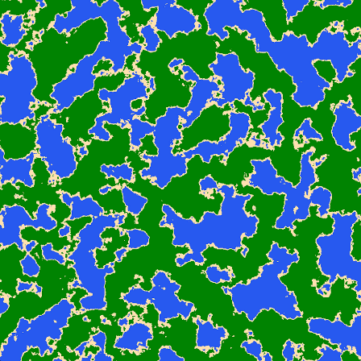
Figure 1 (Wikipedia, n.d.), (Scher, 2017)
Figure 1 shows how Perlin Noise can be transformed from random noise into a complex and diverse word generation tool, utilizing randomness and height variables to define continents and landmasses.

2.2.1.2 Binary Space Partitioning
Binary Space Partitioning is used in many games, often due to its low complexity and predictability. It works by initially splitting a predefined area down the middle, this can be vertical or horizontal. The algorithm then picks one side and makes another division and keeps going until the desired number of divisions. Where the algorithm makes the next division can be based on several things such as a randomly generated number to define the side.
In The Binding of Isaac (2011), this is used to generate the floor layout through recursive subdivision and assigning a room to each subdivision that can be connected together to allow the player to traverse a dungeon.

2.2.1.3 Cellular Automata
Cellular Automata is used mostly within 2D games, often due to its customizability and simplicity in defining rules. It works by defining a grid and then randomly placing the cells inside the grid. Then a ruleset can be defined, which in more simple designs, normally only consider the neighbouring tiles in the grid, such as moving towards another neighbour.
The most famous use of cellular automata is likely to be Conway’s Game of Life (1970) where it is used to “evolve in discrete timesteps (called generations or ticks) according to the following two rules: If a cell is alive, it survives to the next generation if it has 2 or 3 live neighbors; otherwise it dies. If a cell is dead, it comes to life in the next generation if it has exactly 3 live neighbors; otherwise it stays dead.” (Johnston & Greene, 2021)
In Terraria (2011), cellular automata are used in this exact way, the game randomly defines a grid and randomly places alive cells and dead cells in the grid, typically weighted to the bottom of the grid. The game then simulates a given number of ticks, and the output of that is the world map. At this stage, biomes can be identified in one of two ways, randomly allocating sections of the world to each desired biome or using the final “weighting” of the alive cells to create the biomes.

2.2.2 Pathfinding
Pathfinding is one of the most important features of any turn-based game. Pathfinding can completely change the approach a player must take to a strategy game as it defines how many turns a player will take to reach the destination.
In this section, I will be evaluating different games for their interpretation of pathfinding. The games I will be directly referencing are as follows: Civilisation VI (2016), Stellaris (2016). The types of pathfinding I will be evaluating are: A*, Dijkstra, and Jump Point Search.

2.2.2.1 Dijkstra
Dijkstra’s algorithm is a pathfinding algorithm that uses a breadth first search, meaning it goes wider before it goes longer, that can contain a path cost. It is always guaranteed to find the shortest path but is not very optimized. The starting point is marked, then the movement cost is calculated to each neighbour node, this is repeated on every connected node to the new nodes until the end point is found. The algorithm then calculates the shortest path back to the starting point.
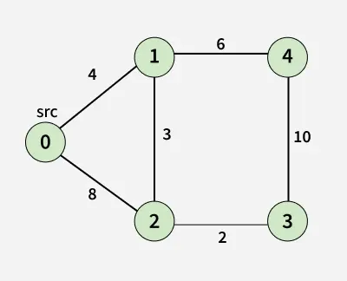
Figure 2 (Kartik, 2026)
Figure 2 shows how a graph is constructed and shows the movement cost of each path. For example, from our source node, node 0, we calculate the distance to all of its neighbour nodes, in this case being nodes 1 and 2 and take a “step towards” the smallest node. From node 1, the algorithm then updates the total distance travelled so the distance to node 2 is now 7, the distance to node 4 becomes 10. The algorithm then makes a “step towards” node 2 as it is closer than node 4, and repeats the same process. The distance to node 3 becomes 9 and after node 3 is processed, it makes a step towards node 4, noticing that the cost is greater than the path it reached earlier and doesn’t update the distance as a shorter one already exists.

2.2.2.2 A*
A* is an algorithm that shares the same approach as Dijkstra, although it is more efficient. In order to be more efficient, the algorithm “combines Dijkstra’s algorithm with a case-specific heuristic value” (Lääveri, 2017). This is always guaranteed to find the shortest path and the heuristic value allows the algorithm to disregard paths that lead away from the destination, allowing for major optimizations in regard to the computation speed of the algorithm.

2.2.2.3 Jump Point Search
Jump Point Search, or JPS, is a highly efficient pathfinding algorithm designed for uniform-cost grid maps. Due to A*’s “high memory overhead, low operation efficiency, and many path corners” (Yang, et al., 2022), JPS serves as a substantial optimization through the use of “pruning” unnecessary nodes and “jumping over” empty spaces. Disregarding the path cost calculations along with the aforementioned optimizations allows JPS to be significantly faster than A*, even up to an order of magnitude faster.

2.2.3 AI Integrations
AI is one of the core components of this game and as such needs to be meticulously researched before implementing to ensure I get it right. AI will be used within this game to primarily drive the player’s opponent.
In this section of research, I will be researching 3 different types of AI for their strengths and weaknesses and their application within my game. The types of AI I will be researching are: Neural Networks, Reinforcement Learning, and Imitation Learning.

2.2.3.1 Neural Network
Neural Networks are AI models that are inspired by the human brain, utilizing artificial neurons and weights to identify patterns and make predictions. Neural networks need training data to be able to recognize patterns and alter behaviours. This training data allows the network to “know” things about its input, for example, positions of objects.
After the initial training phase, if we present the network with a pattern it hasn’t seen before in its training data, it should classify the unseen pattern correctly, only if it has learnt the underlying structure of the problem (Gurney, 2018).

2.2.3.2 Reinforcement Learning
Reinforcement Learning, or RL, works by training an “agent” to make decisions through trial-and-error, interacting with an environment to maximize rewards. A reward can be as simple as giving a higher number for the “correct” result or more complex such as rewarding the AI for every possible action taken.
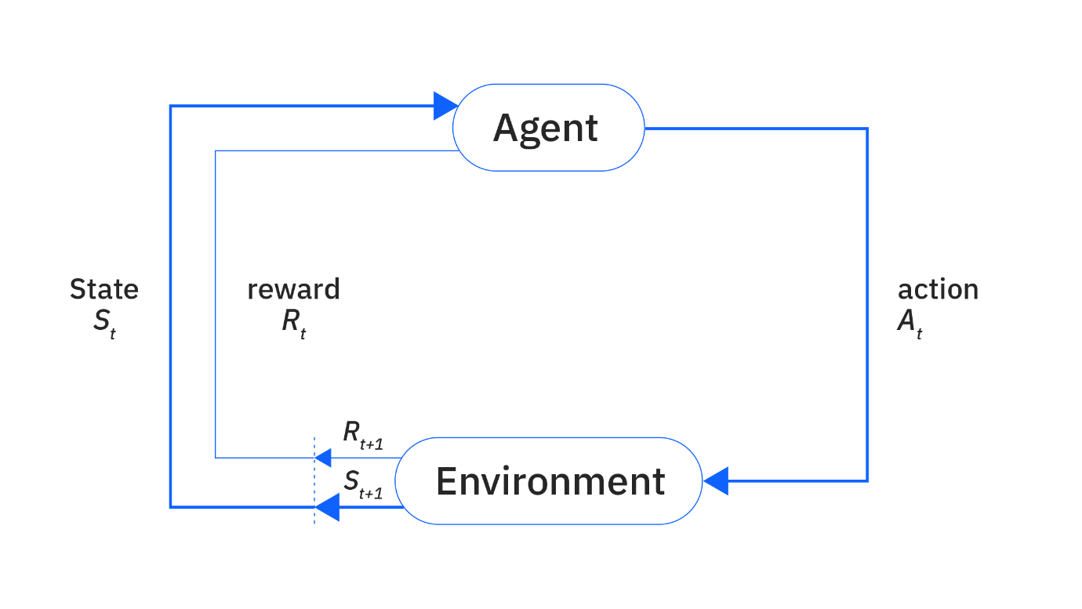
Figure 3 (Murel & Kavlakoglu, 2024)
Figure 3 shows a very simple reinforcement learning model in which the agent reads the state of the environment and performs an action, the environment then rewards the agent. The agent’s purpose is to maximize the reward. There are 2 types of learning for reinforcement models: “Supervised” and “Unsupervised”. Supervised learning uses “manually labelled data to produce predictions” (Murel & Kavlakoglu, 2024) while unsupervised learning “aims to uncover and learn hidden patters from unlabelled data” (Murel & Kavlakoglu, 2024).

2.2.3.3 Imitation Learning
Imitation learning, or IL, is a technique where an agent learns to perform tasks by mimicking expert demonstrations, which are often human, rather than relying on rewards. The simplest approach to IL is Behavioural Cloning, this uses “supervised learning to predict the expert’s action for any given state” (Orsini, et al., 2021). Behavioural Cloning is often unreliable as prediction errors compound extremely quickly.
Adversarial Imitation Learning aims to “remedy this using inspiration from Generative Adversarial Networks and Inverse RL” (Orsini, et al., 2021). Generative Adversarial Networks are a machine learning framework where two neural networks, a generator and a discriminator, compete against each other in a zero-sum game to create realistic albeit synthetic data. Inverse RL is a technique that gives a reward based on behaviour rather than having a condition be met. “The policy is trained to generate trajectories that are indistinguishable from the expert’s ones” (Orsini, et al., 2021).

Chapter 3 – Design
The design chapter will outline the main features of **insert game name** and the reasoning behind choosing these techniques. This chapter will be dedicated to the overall technical decisions made before implementing these ideas. The subchapters in this section are labelled after each of the research subchapters from the literature survey.

3.1 World Generation
After the research of world generation types, I conclude that the most effective method for this game would be to make the game use Perlin noise to generate its world and landmasses. I came to this conclusion as Binary Space Partitioning requires many iterations to make convincing landmasses, and Cellular Automata would require simulation of the Cellular Automata which is relatively computationally heavy.

3.1.1 The tile and its storage
I have decided to store each interactable space as a tile. I will create a custom class for the tile that contains references to its neighbouring tiles, the tiles biome (likely stored as an enum), the resources on that tile and its overall gold and production values.
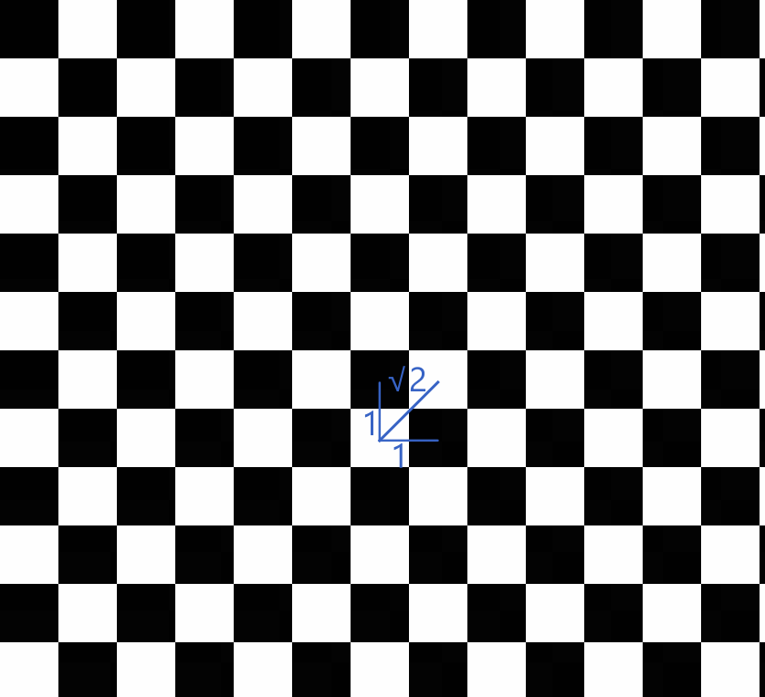
Figure 4
Figure 4 shows how on a square grid, although the vertical and horizontal axis are identical, the diagonal creates an unfair advantage on movement, being a cost of √2 while getting the movement of 2 tiles. In order to combat this, I have decided to use a hexagonal grid which has uniform lengths to all neighbouring tiles.

References
Gurney, K., 2018. An introduction to neural networks. s.l.:CRC press.
Johnston, N. & Greene, D., 2021. Conway's Game of Life: Mathematics and Construction. s.l.:Lulu.com.
Kartik, 2026. Dijksta's Algorithm. [Online]
Available at: https://www.geeksforgeeks.org/dsa/dijkstras-shortest-path-algorithm-greedy-algo-7/
[Accessed 04 18 2026].
Lääveri, T., 2017. Integrating AI for Turn-Based 4X Strategy Game, Helsinki: s.n.
Murel, J. & Kavlakoglu, E., 2024. What is reinforcement learning?. [Online]
Available at: https://www.ibm.com/think/topics/reinforcement-learning
[Accessed 16 April 2026].
Orsini, M. et al., 2021. What Matters for Adversarial Imitation Learning?, s.l.: Google Research, Brain Team.
Scher, Y., 2017. Playing with Perlin Nosie: Generating Realistic Archipelagos. [Online]
Available at: https://medium.com/@yvanscher/playing-with-perlin-noise-generating-realistic-archipelagos-b59f004d8401
[Accessed 18 04 2026].
Wikipedia, n.d. Perlin noise. [Online]
Available at: https://en.wikipedia.org/wiki/Perlin_noise
[Accessed 18 04 2026].
Yang, Z., Li, J., Yang, L. & Chen, H., 2022. A Smooth Jump Point Search Algorithm for Mobile Robots Path Planning Based on a Two-Dimensional Grid Model, Kunming: s.n.

