#4 Omi-directional Movement (5 Points)

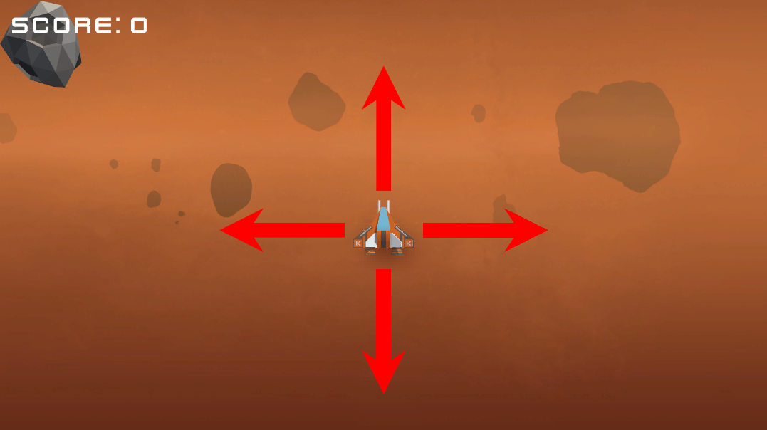

Feature Description:

The player ship can move up and down as well as the originally implemented left and right.

Conditions of satisfaction:  
1. When the Up or Down arrow keys are pressed, the player ship moves up or down on the Y Axis, respectively.

2. If the player attempts to leave the screen bounds on the bottom or top (Y Axis) they will not be able to continue further, just like if they attempted to move out of bounds on the left or right (X Axis).

3. If the player maneuvers into the path of their own laser, they do not get destroyed.

Tech design:

* Function layout

Update in player will call functions for up and down movement when either the up arrow or down arrow are pressed.

* Using transform.Translate

Inside those functions we will update the position of the player on the Y Axis using transform.Translate on the gameObject, applying speed and delta time variables to insure consistency and expectancy of movement.

* Bounds checking

To ensure the player ship cannot leave the screen an “if” statement inside the functions will check if the Y position of the gameObject’s transform has exceeded or subceded the bounds, and subsequently not allow further movement in that direction.