**ELECTRONICS FOR EMBEDDED SYSTEMS PROJECT by DANIELE CASTRO s253244**

The present document shows the other two complementing mini-projects I have made to let you know my knowledge in:

- Programmable Logic Devices (PLD) and VHDL final state machine

- Communication protocols (SPI)

- Power management (PWM)

**Programmable Logic Device:**

I have developed a High Level State Machine (HLSM) that implements a preamble generator for ethernet II protocol. I have used a Moore machine model for representing it.

This machine will generate “10101010” every time start signal is asserted. Reset is asynchronous.

Here is the RTL design with the Final State Machine:

combinational logic

state register

cnt register

start

clk

data_out

curstat

nxtstat

cnt

cntnxt

idle/

patterna/

patternb/

cnt >= 4

start = 1

cnt < 4

data_out = 0

data_out = 0

data_out = 1

cnt++

PREAMBLE GENERATOR

start

clk

rst

data_out

States explanation: the initial machine state is idle and the output data_out is low. Then, when start signal goes high, current state (curstat) moves to patterna where the output data_out is high. At this point we move unconditionally to patternb where the output data_out is again low. Now we check if cnt register is less then 4. If it is, we increment cnt and go back to patterna and repeat the cycle above described. Otherwise we go back to idle.

This automaton is represented in VHDL as a two processes machine. The first process represents respectively the “state register” that moves the machine through the various states and the “cnt register” that increments the counter. The second and last process represents the “combinational logic” that defines the machine behavior based on the above listed input signals.

**library** ieee**;**

**use** ieee**.**std_logic_1164**.all;**

**entity** preamble **is**

**port(**

rst**,** clk**,** start **:** **in** std_logic**;**

data_out**,** rst_o**,** clk_o**,** start_o **:** **out** std_logic

**);**

**end** preamble**;**

**architecture** beh **of** preamble **is**

**type** states **is** **(**idle**,** patterna**,** patternb**);**

**signal** curstat**,** nxtstat **:** states**;**

**signal** cnt**,** nxtcnt **:** integer**;**

**begin**

rst_o **<=** rst**;**

clk_o **<=** clk**;**

start_o **<=** start**;**

**process(**rst**,** clk**)**

**begin**

**if(**clk'**event** and clk **=** '1'**)** **then**

**if(**rst **=** '1'**)** **then**

curstat **<=** idle**;**

cnt **<=** 0**;**

**else**

curstat **<=** nxtstat**;**

cnt **<=** nxtcnt**;**

**end** **if;**

**end** **if;**

**end** **process;**

**process(**curstat**,** cnt**,** start**)**

**begin**

nxtcnt **<=** cnt**;**

**case** curstat **is**

**when** idle **=>**

**if(**start **=** '1'**)** **then**

nxtstat **<=** patterna**;**

**else**

nxtstat **<=** idle**;**

**end** **if;**

data_out **<=** '0'**;**

nxtcnt **<=** 0**;**

**when** patterna **=>**

nxtstat **<=** patternb**;**

data_out **<=** '1'**;**

**when** patternb **=>**

**if(**cnt **>=** 3**)** **then**

nxtstat **<=** idle**;**

**else**

nxtstat **<=** patterna**;**

nxtcnt **<=** cnt **+** 1**;**

**end** **if;**

data_out **<=** '0'**;**

**end** **case;**

**end** **process;**

**end** beh**;**

For testing the machine I have designed a dsPIC33FJ128GP802 program that generates the same testbench’s input signals pattern.

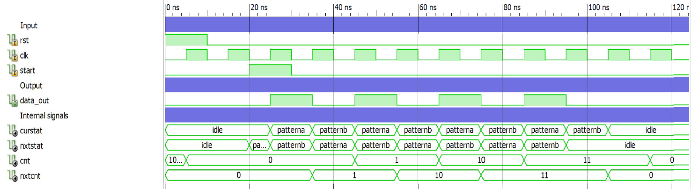

The dsPIC program uses the serial port for displaying the simulation state. The user has only to press “return” every time he wants to toggle clk and the other input signals in the DE2 board where the VHDL code above explained is fisically implemented.

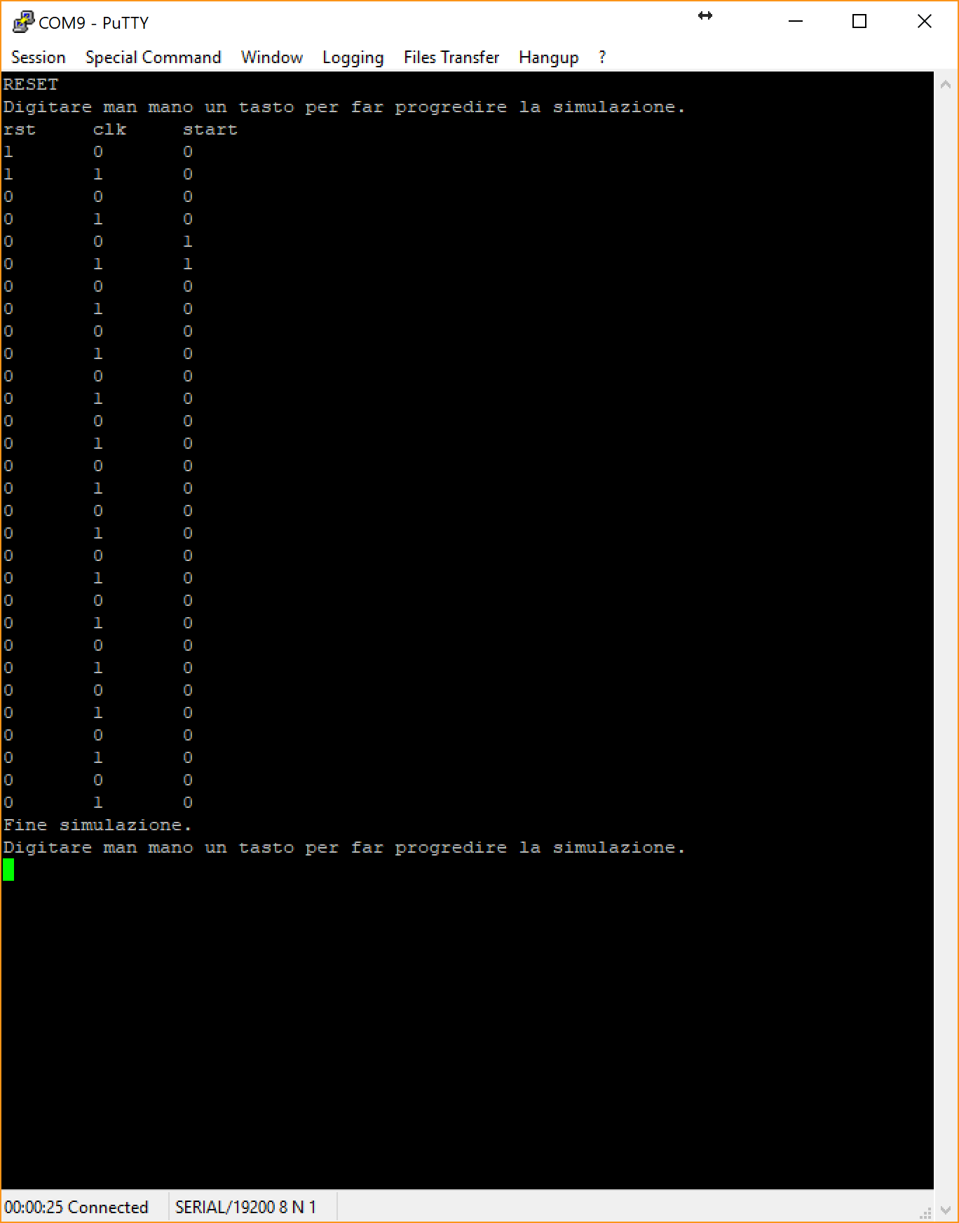

Results and input signals will be shown through four DE2 board’s LEDs.

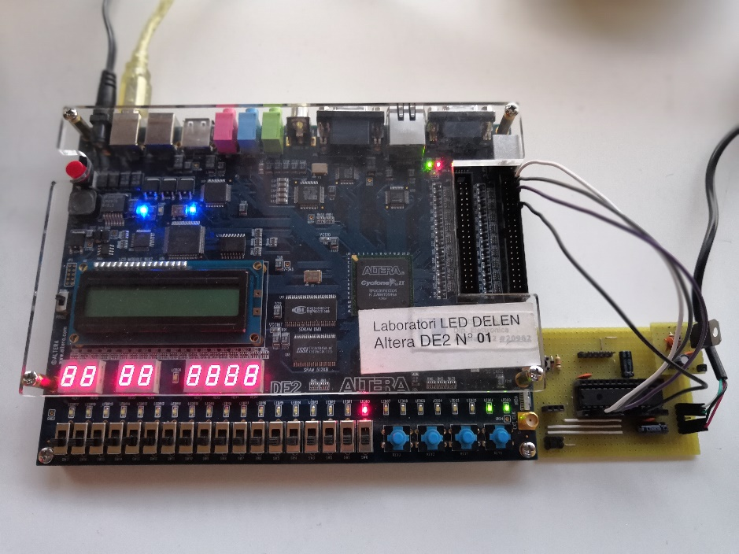

Pin mapping on the DE2 board is:

clk, Input, PIN_M23

clk_o, Output, PIN_AF22

data_out, Output, PIN_AE23

rst, Input, PIN_K26

rst_o, Output, PIN_W19

start, Input, PIN_M20

start_o, Output, PIN_AE22

On dsPIC33FJ128GP802:

rst, Output, RA0

clk, Output, RA1

start, Output, RB0

Concerning the hardware implementation automatically made by the tool Quartus II on the Cyclon II FPGA, we can observe this internal structure:

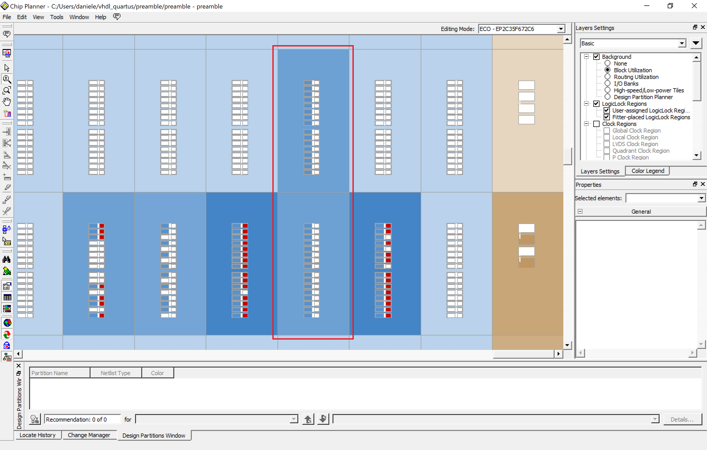

In particular we can observe the highlighted part in which we can notice a big use of logic cells in arithmetic mode instead of the normal one:

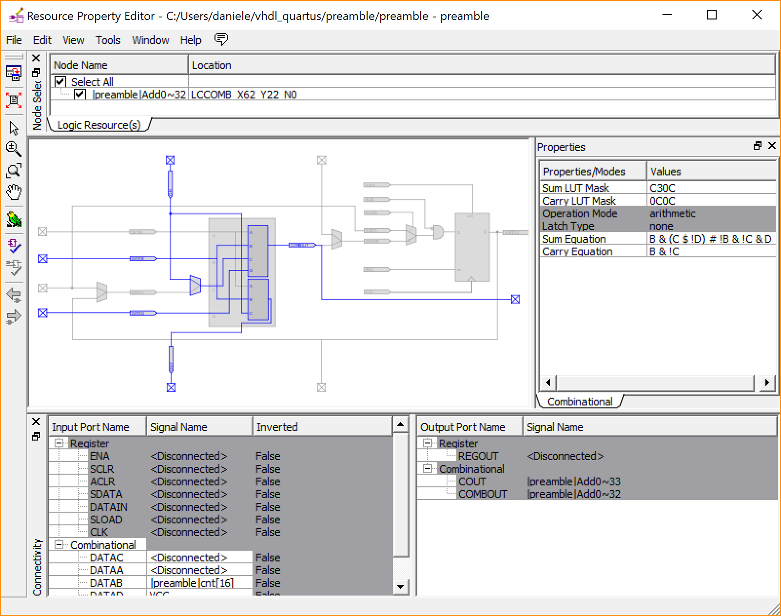

This increases the working speed and this was possible thanks to the FSM implementation. The automatic tool can translate FSM designs more easily than the other ones.

The component’s maximum working speed resulted in 131.84 MHz. Assigning pins in a more efficient way will surely increase this clock speed even more because of the PAD distance from the internal logic core.

**Communication protocol:**

For the last two parts I have made a single PIC18F26K22 program that implements both SPI protocol reading and writing strings to three 23LCV1024 in one SPI bus and a PWM signal with selectable duty cycle used for driving a simple DC motor using the L293D full H bridge. This device will also use serial port for interfacing with the user.

This time, to set quickly all the necessary registers, I have used the MPLAB Code Configurator tool (MCC) by Microchip. In this way I could concentrate exclusively to the SPI and PWM protocol.

As I said above I’ll use three 1Mb NVRAM. Those RAMs can automatically switch using or if no is applied. They can also work both with 5 or 3.3 volts. They have three different working modes:

- “Byte Operation” for reading or writing a single byte

- “Page Operation” for reading or writing page blocks

- “Sequential Operation” for reading or writing the entire memory array starting from a specified address.

We are interested only in the “Sequential Operation” mode.

The device has also the possibility to use SDI (Serial Dual Interface) protocol to transfer data instead of SPI.

The 23LCV1024 has some binary commands for selecting what said above.

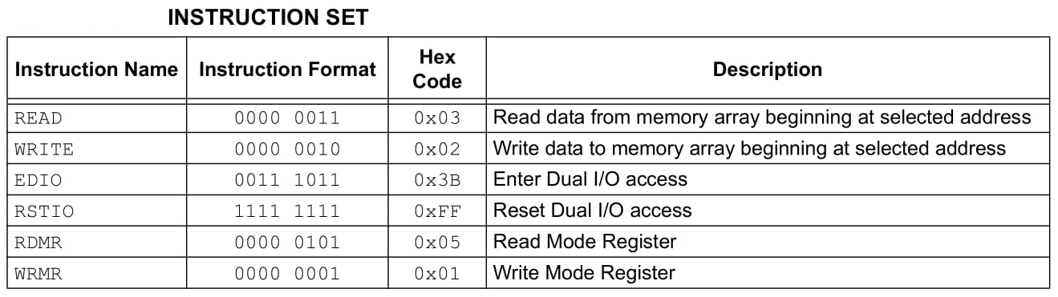

We are interested only in READ, WRITE and RSTIO for resetting into SPI mode.

The datasheet shows timing both for writing and reading in “Sequential Operation” mode:

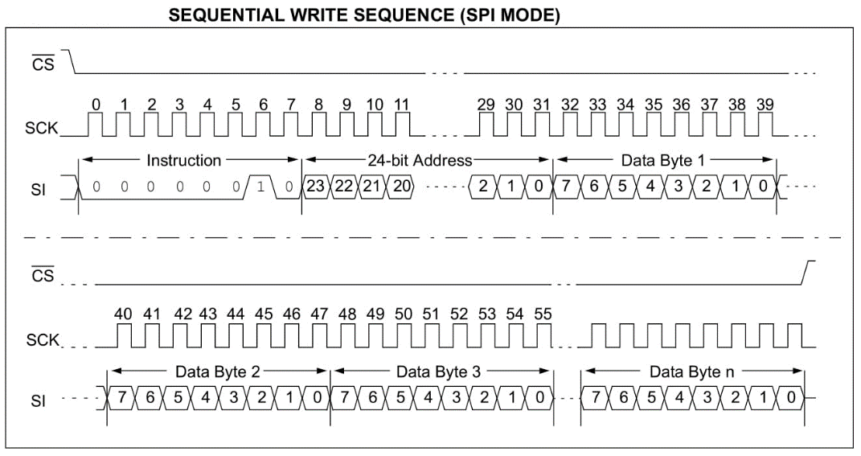

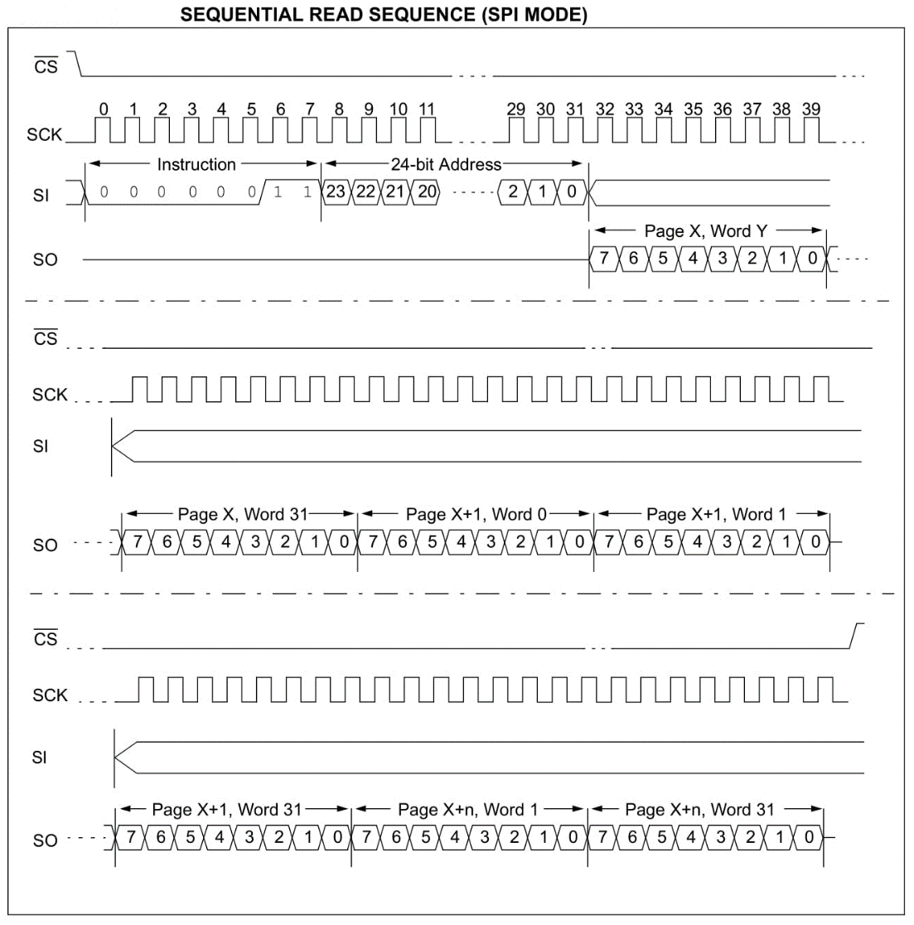

It also shows the SPI timing that will result in SPI mode 0:

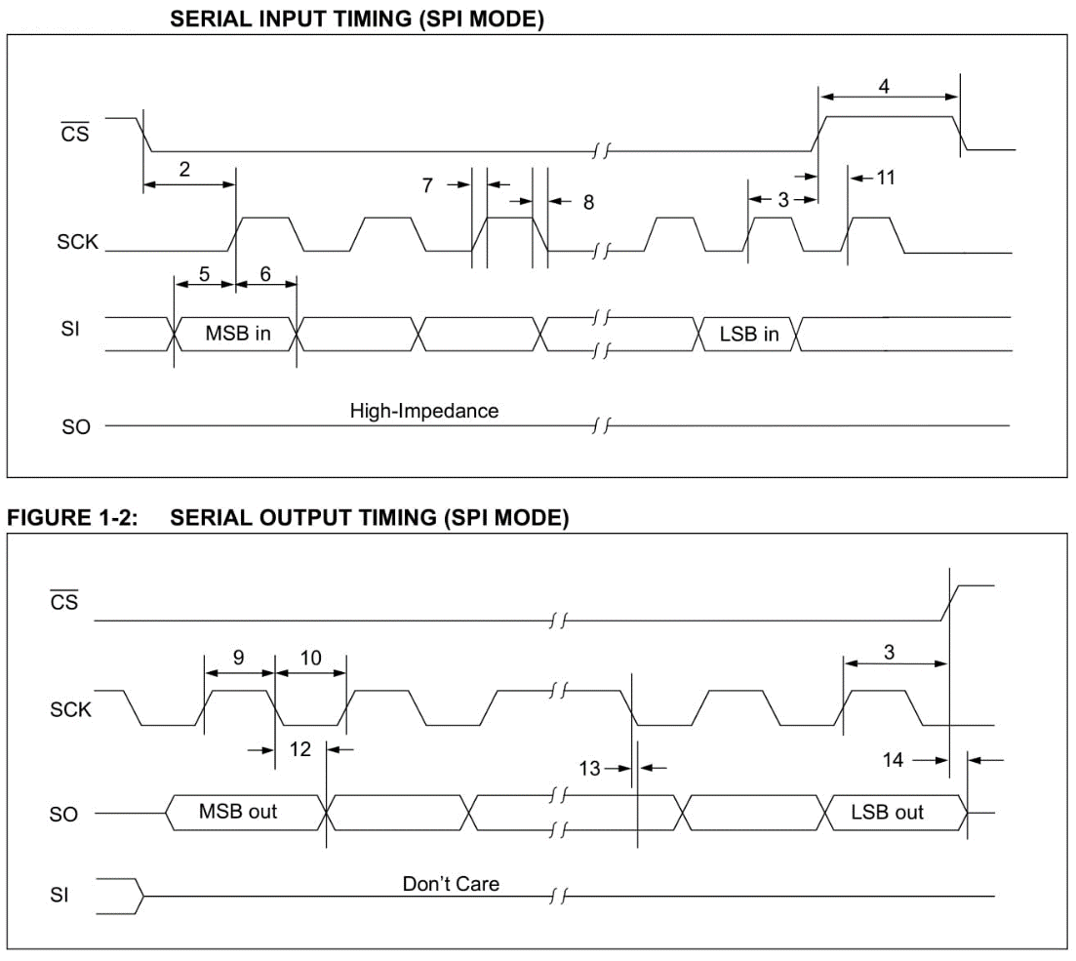

Once peripherals have been correctly configured by MCC I have written the routines for reading and writing from these RAMs. MCC has generated these two functions automatically:

uint8_t SPI1_Exchange8bit**(**uint8_t data**)** **{**

// Clear the Write Collision flag, to allow writing

SSP1CON1bits**.**WCOL **=** 0**;**

SSP1BUF **=** data**;**

**while** **(**SSP1STATbits**.**BF **==** SPI_RX_IN_PROGRESS**)** **{**

**}**

**return** **(**SSP1BUF**);**

**}**

* It retrieves and sends one byte (exchanges a byte)

uint8_t SPI1_Exchange8bitBuffer**(**uint8_t **\***dataIn**,** uint8_t bufLen**,** uint8_t **\***dataOut**)** **{**

uint8_t bytesWritten **=** 0**;**

**if** **(**bufLen **!=** 0**)** **{**

**if** **(**dataIn **!=** **NULL)** **{**

**while** **(**bytesWritten **<** bufLen**)** **{**

**if** **(**dataOut **==** **NULL)** **{**

SPI1_Exchange8bit**(**dataIn**[**bytesWritten**]);**

**}** **else** **{**

dataOut**[**bytesWritten**]** **=** SPI1_Exchange8bit**(**dataIn**[**bytesWritten**]);**

**}**

bytesWritten**++;**

**}**

**}** **else** **{**

**if** **(**dataOut **!=** **NULL)** **{**

**while** **(**bytesWritten **<** bufLen**)** **{**

dataOut**[**bytesWritten**]** **=** SPI1_Exchange8bit**(**DUMMY_DATA**);**

bytesWritten**++;**

**}**

**}**

**}**

**}**

**return** bytesWritten**;**

**}**

* It simply bufferizes the above uint8_t SPI1_Exchange8bit**(**uint8_t data**)** function.

So, the following three functions I have written will:

void RAM_set_SPI_mode**(**volatile unsigned char**\*** latch**,** uint8_t pin_number**)** **{**

**\***latch **&=** **~(**1 **<<** pin_number**);** //metto CS in low per avviare i trasferimenti

SPI1_Exchange8bit**(**0b11111111**);** //comando RSTIO

**\***latch **|=** **(**1 **<<** pin_number**);** //metto CS in high per bloccare i trasferimenti

**}**

* send the RSTIO (0b11111111) command for resetting the SPI mode instead of the SDI one putting CS in low during transfers that single byte transfer.

void RAM_sequential_SPI_write**(**volatile unsigned char**\*** latch**,** uint8_t pin_number**,** uint24_t address**,** uint8_t **\***data_out**,** uint8_t data_out_size**)** **{**

uint8_t address_array**[**3**];**

address_array**[**2**]** **=** address**;**

address_array**[**1**]** **=** address **>>** 8**;**

address_array**[**0**]** **=** address **>>** 16**;**

**\***latch **&=** **~(**1 **<<** pin_number**);** //metto CS in low per avviare i trasferimenti

SPI1_Exchange8bit**(**0b00000010**);** //comando WRITE

SPI1_Exchange8bitBuffer**(**address_array**,** 3**,** **NULL);**

SPI1_Exchange8bitBuffer**(**data_out**,** data_out_size**,** **NULL);**

**\***latch **|=** **(**1 **<<** pin_number**);** //metto CS in high per bloccare i trasferimenti

**}**

* split the 24-bit address into three 8-bit long address_array**[**…**]** variables, so they can be sent through SPI using SPI1_Exchange8bitBuffer**(**address_array**,** 3**,** **NULL);** after WRITE command has sent through SPI1_Exchange8bit**(**0b00000010**);** clearly CS is low during all the transfers. Data to be sent must be in data_out with specified length in data_out_size.

void RAM_sequential_SPI_read**(**volatile unsigned char**\*** latch**,** uint8_t pin_number**,** uint24_t address**,** uint8_t **\***data_in**,** uint8_t data_in_size**)** **{**

uint8_t address_array**[**3**];**

address_array**[**2**]** **=** address**;**

address_array**[**1**]** **=** address **>>** 8**;**

address_array**[**0**]** **=** address **>>** 16**;**

**\***latch **&=** **~(**1 **<<** pin_number**);** //metto CS in low per avviare i trasferimenti

SPI1_Exchange8bit**(**0b00000011**);** //comando READ

SPI1_Exchange8bitBuffer**(**address_array**,** 3**,** **NULL);**

SPI1_Exchange8bitBuffer**(NULL,** data_in_size**,** data_in**);**

**\***latch **|=** **(**1 **<<** pin_number**);** //metto CS in high per bloccare i trasferimenti

**}**

* split the 24-bit address into three 8-bit long address_array**[**…**]** variables, so they can be sent through SPI using SPI1_Exchange8bitBuffer**(**address_array**,** 3**,** **NULL);** after WRITE command has sent through SPI1_Exchange8bit**(**0b00000010**);** clearly CS is low during all the transfers. Retrieved data will be in data_in with the specified length in data_in_size.

Serial interface will result in this figure in a serial terminal output:

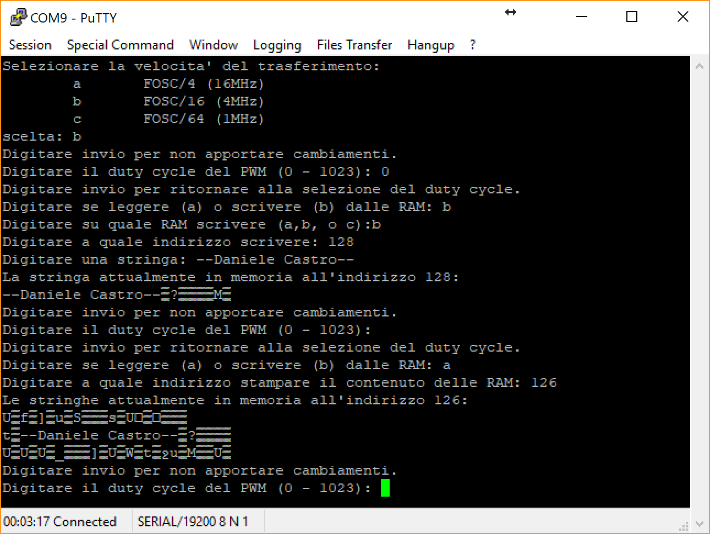

The datasheet says that these memories cannot go faster than 20MHz. This is true in a SPI bus with multiple SPI slaves. But in a single slave bus I was able to achieve 64MHz.

Strange characters are random values coming from the yet unprogrammed memory.

Below the 23LCV1024 footprint and my 3Mb SPI NVRAM bank for perfored boards:

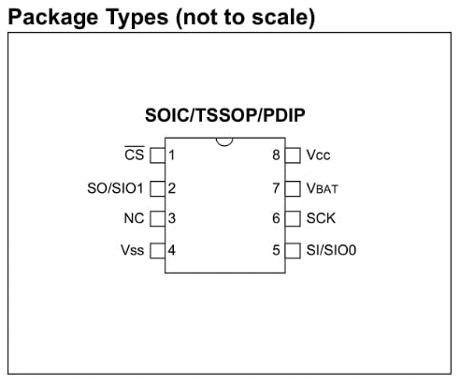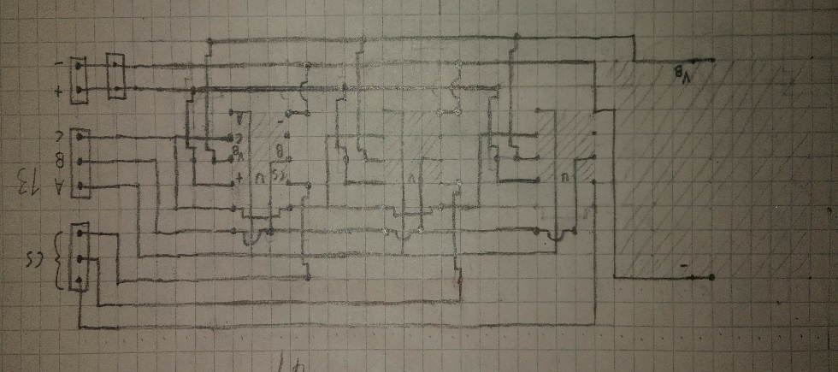

**Power management:**

As I said before the PWM (Pulse With Modulation) signal will be generate from the same PIC18F26K22 circuit board discussed above and I will also configure CCP4 (CAPTURE/COMPARE/PWM MODULE 4) again using MCC.

Below the simplified block diagram of the CCP4 module in PWM working mode from the datasheet and a simple explanation of the registers involved in the control of the PWM period and duty cycle:

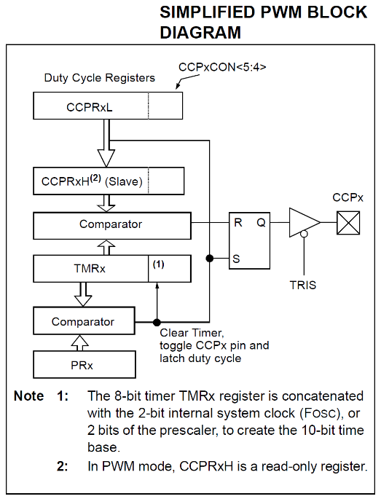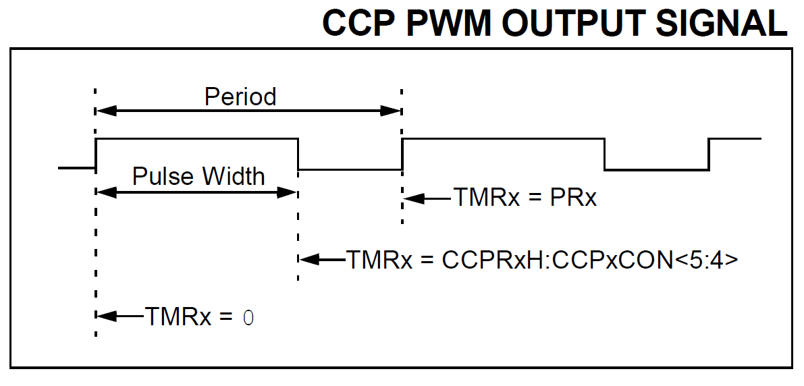

As shown in the figures the CCP4 module will use timer 2 (TMR2) module for controlling the PWM period/frequency. TMR2 register is the timer value and PR2 register will contain the value, in the range of a 16-bit value, at which the timer must go back to 0. CCPR4H and CCPR4CON are MSB and LSB registers in which will be stored the value at with the signal will go from high to low. In other words the duty cycle. This value must fit in 10-bit.

PR2 was set to 0xFFFF so the timer period will be 4.096 ms because, starting from 64MHz of system clock, I have set both timer prescaler and postscaler at 1:16 divisor value.

MCC has generated this function automatically and this let me easily control the duty cycle:

void PWM4_LoadDutyValue**(**uint16_t dutyValue**)** **{**

// Writing to 8 MSBs of pwm duty cycle in CCPRL register

CCPR4L **=** **((**dutyValue **&** 0x03FC**)** **>>** 2**);**

// Writing to 2 LSBs of pwm duty cycle in CCPCON register

CCP4CON **=** **(**CCP4CON **&** 0xCF**)** **|** **((**dutyValue **&** 0x0003**)** **<<** 4**);**

**}**

In the above figure it is possible to see the serial interface asking to input the desired duty cycle.

For controlling the DC motor I have used the L293D full H bridge like in this schematic:

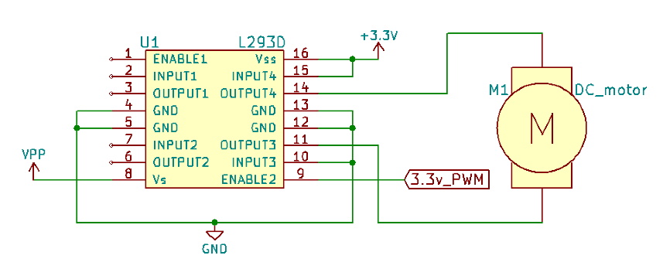

Here is shown the complete circuitry I have made:

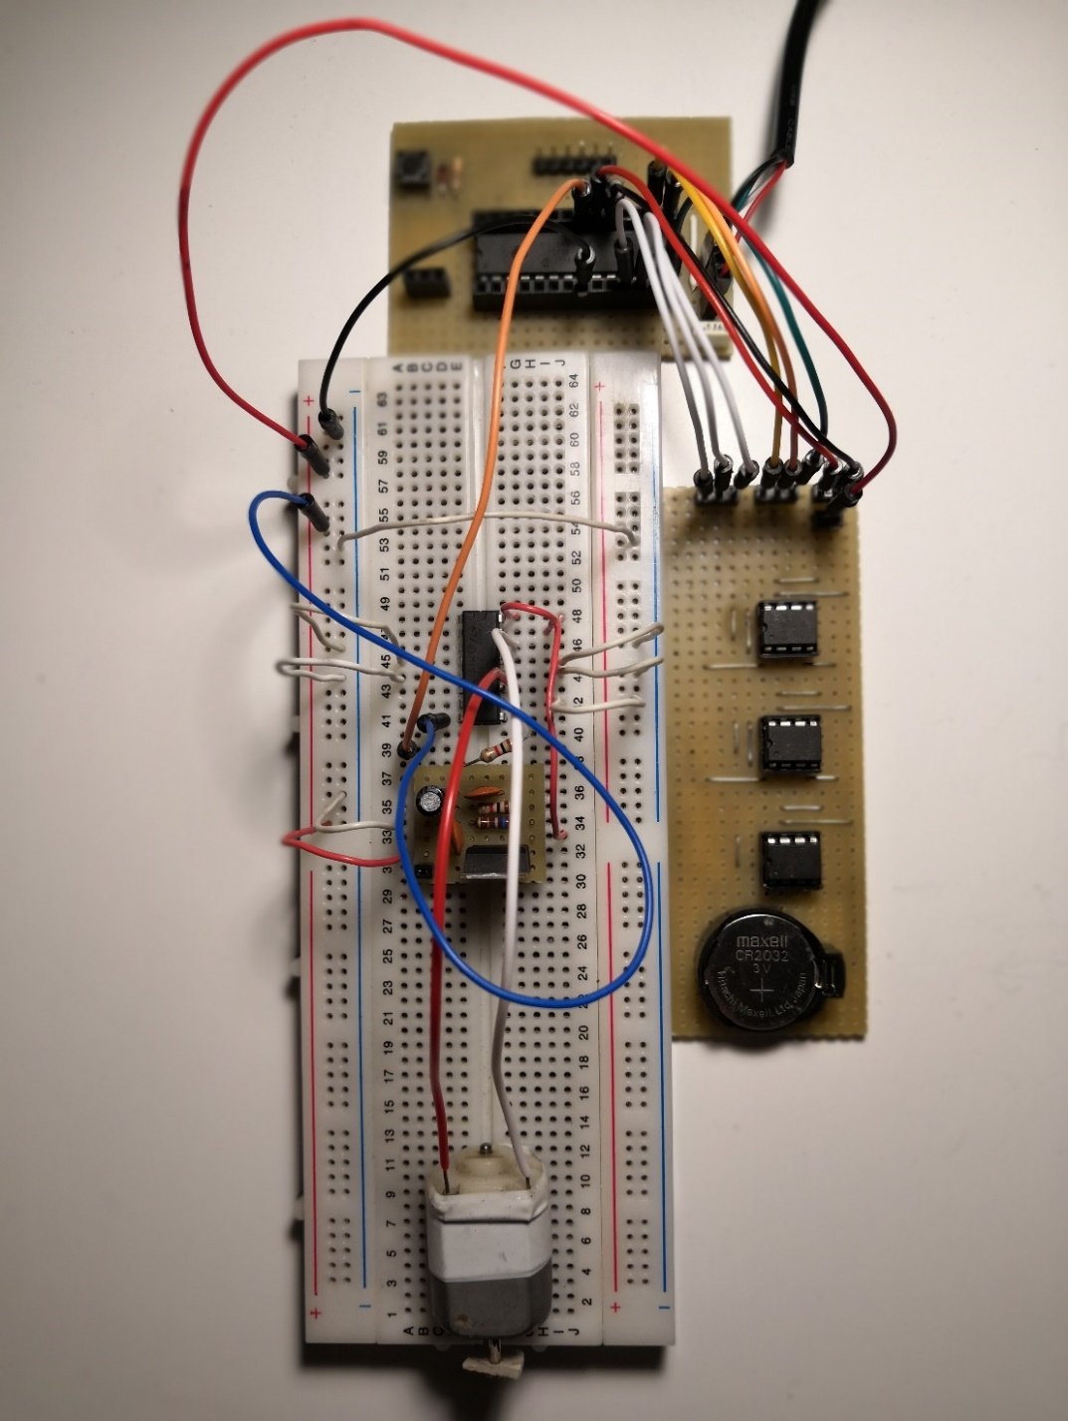

In the left the PIC18F26K22 board. On the right the breadboard with the L293D, the motor and my 3,3 volt power supply module also used in my dsPIC and PIC32 boards. At the top of the picture the 3 Mb SPI NVRAM module.

Here are the two modules of the above picture:

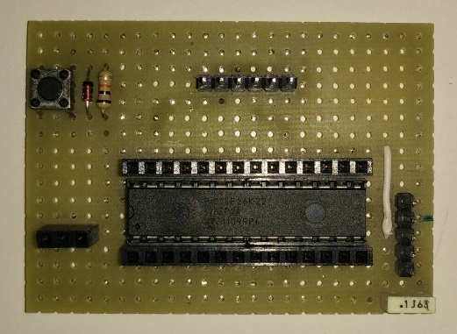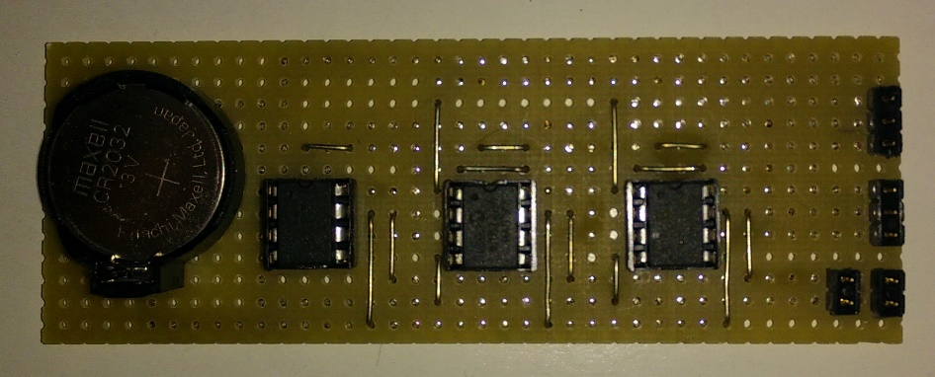

The PIC18F26K22 board project for perfored board:

