BIO5702: Student homework for the #CandyPhenotyping module

Dan Chitwood

April 17, 2016

The following is unaltered homework exploring the multivariate nutrition, shape, and color information from 75 different candy types and 980 individual candy pieces. It was written by the students of Bio5702, a graduate course at Washington University in St. Louis, "Current Approaches in Plant Research".

So I have the tab delimited file of all the color and shape data called Color_Data_all

That file has the color information for each region of interest split into 3 rows; e.g. image 1's ROI 1 will have a Red row, Green row, and Blue row.

What I need to do is create a new dataframe that instead of having each ROI with those 3 rows, we want only one row for each ROI, and 3 columns each with the pertinent Red, Green, and Blue intensity.

* E.g. instead of:

ID color value

id01 red 00

id01 green 00

id01 blue 00

* We want this:

id red green blue

01 00 00 00

R Reshape example:

library(reshape2)

1. First, melt the data, newdata <- melt(data, id=c("RATING", "TIME_TO_MATURITY", "INDUSTRY_CODE", "BOND_TYPE"));
2. Second, cast the data based on your needs, for instance, to get the total amount of each industry, cast(newdata, INDUSTRY_CODE ~ variable, sum) returns you a data.frame

Read in my data properly

allcolordata <- read.table("./Color_Data_all_with_color.txt", header=TRUE)

Okay, so to apply that to our information, first I want to create a new data.frame with only the candy id and ROI id, the color column, and the color's intensity

subset_colors<- allcolordata[c(1:6, 11:15)]

Now I want to "unstack" my "long format" data into "wide format" meaning the 3 rows per ROI need to be collapsed into a single row, but with 3 columns for the mean values of each color.

Example of long format:

Subject Gender Test Resul

1 1 M Read 10

2 2 F Write 4

3 1 M Write 8

4 2 F Listen 6

5 2 F Read 7

6 1 M Listen 7

Example of command to turn into wide format:

wide_format <- unstack(observations_long, Result ~ Test)

wide_format

Listen Read Write

1 6 10 4

2 7 7 8

wide_color <- unstack(mastercolor, Mean ~ Color)

Now look at my new table

wide_color

***That didn't work at all.***

Let's try another approach to do the same thing, convert long format into wide format, using reshape()

First download the "stats" command library

library(stats)

now create a "wide format" dataframe from my smaller dataframe that

color_to_wide <- reshape(subset_colors, timevar = "Color", idvar = c("Label", "ID"), direction = "wide")

Open that text file in Excel, open as space delimited, and fix the fact that the very top row is shifted left by one cell. Make sure that the columnname ID is over the actual candy IDs, not the number values added by R that span from 1 to 3518

Okay, the file we just made has color words added to a bunch of the column names that don't need to be there, so we'll manually delete those.

Also, manually delete all the duplicate columns, e.g. Solidity.Red, Solidity.Green, etc. (eveything except Mean.Red, Mean.Green, Mean.Blue)

Open that file that contains both the color and shape data

shape_color_wide <- read.table("./widedata.txt", header=T)

Open the nutrition information that has the ID's all capitalized

nutrition_facts <- read.table("./candy_nutrition_415.txt", header=T)

Now merge those two data.frames

merged_color_shape_nutrition <- merge(x=shape_color_wide, y=nutrition_facts, by.x = "ID", by.y = "ID", all.x=TRUE)

Now load all the libraries needed for the principle component analysis and graph making

library(ggplot2)  
library(ggrepel)  
library(ggdendro)  
library(ape)

Now normalize all the nutrition information to the grams per serving size

merged_color_shape_nutrition$total_fat_per_serv <- merged_color_shape_nutrition$total_fat_g/merged_color_shape_nutrition$serving_size_g  
merged_color_shape_nutrition$saturated_fat_per_serv <- merged_color_shape_nutrition$saturated_fat_g/merged_color_shape_nutrition$serving_size_g  
merged_color_shape_nutrition$cholesterol_per_serv <- merged_color_shape_nutrition$cholesterol_mg/merged_color_shape_nutrition$serving_size_g  
merged_color_shape_nutrition$sodium_per_serv <- merged_color_shape_nutrition$sodium_mg/merged_color_shape_nutrition$serving_size_g  
merged_color_shape_nutrition$total_carb_per_serv <- merged_color_shape_nutrition$total_carb_g/merged_color_shape_nutrition$serving_size_g  
merged_color_shape_nutrition$dietary_fiber_per_serv <- merged_color_shape_nutrition$dietary_fiber_g/merged_color_shape_nutrition$serving_size_g  
merged_color_shape_nutrition$sugars_per_serv <- merged_color_shape_nutrition$sugars_g/merged_color_shape_nutrition$serving_size_g  
merged_color_shape_nutrition$protein_per_serv <- merged_color_shape_nutrition$protein_g/merged_color_shape_nutrition$serving_size_g

First we'll do a principle component analysis and make plots based on ALL the information in our dataframe.

Now we're going to center and scale our data, only the quantitative columns, excluding slice because that value is always 1, and excluding the non-normalized nutrition information.

pca <- prcomp(merged_color_shape_nutrition[c(4:5, 7:12, 28:35)], center = TRUE, scale. = TRUE)

Look at the PC analysis summary

summary(pca)

## Importance of components:  
## PC1 PC2 PC3 PC4 PC5 PC6  
## Standard deviation 2.2973 1.7865 1.4712 1.00950 0.92506 0.88108  
## Proportion of Variance 0.3299 0.1995 0.1353 0.06369 0.05348 0.04852  
## Cumulative Proportion 0.3299 0.5293 0.6646 0.72830 0.78178 0.83030  
## PC7 PC8 PC9 PC10 PC11 PC12  
## Standard deviation 0.76773 0.6986 0.65256 0.52835 0.50151 0.47779  
## Proportion of Variance 0.03684 0.0305 0.02661 0.01745 0.01572 0.01427  
## Cumulative Proportion 0.86714 0.8976 0.92425 0.94170 0.95742 0.97169  
## PC13 PC14 PC15 PC16  
## Standard deviation 0.42589 0.40975 0.27009 0.17548  
## Proportion of Variance 0.01134 0.01049 0.00456 0.00192  
## Cumulative Proportion 0.98302 0.99352 0.99808 1.00000

Look at it. The PC# column that has the largest value in the Proportion of Variance row is the PC that we want to use.

pca$rotation

## PC1 PC2 PC3 PC4  
## cm2 0.171721082 -0.32025207 0.008855066 -0.11012480  
## Circ -0.003357819 0.48173318 0.031578251 -0.21656721  
## AR -0.065668295 -0.42592154 -0.205927101 0.06121716  
## Round 0.085770081 0.47505573 0.161692940 0.04831627  
## Solidity 0.059194321 0.39363103 -0.093175316 -0.29854478  
## Mean.Green 0.081879539 -0.12930591 0.552199711 -0.20261162  
## Mean.Blue 0.102984580 -0.16183742 0.411539488 -0.15134460  
## Mean.Red 0.025560486 -0.15412701 0.475201921 -0.25043020  
## total_fat_per_serv 0.417989129 0.03003611 0.031514837 0.10150232  
## saturated_fat_per_serv 0.384833931 0.08088974 0.039039886 0.14405956  
## cholesterol_per_serv 0.287382221 -0.01865257 0.111525848 0.46172353  
## sodium_per_serv 0.194053643 -0.09045451 -0.188693780 -0.63314001  
## total_carb_per_serv -0.406909843 0.05029688 0.137018274 0.01451941  
## dietary_fiber_per_serv 0.372031064 0.07700141 0.029554105 0.12670948  
## sugars_per_serv -0.232495620 0.10852171 0.387769026 0.23389261  
## protein_per_serv 0.369147672 -0.02148365 -0.031829567 -0.05482351  
## PC5 PC6 PC7 PC8  
## cm2 0.141623758 -0.6890913275 0.10290641 0.36134120  
## Circ -0.070679366 -0.0232424224 -0.19463254 -0.21931496  
## AR -0.009779902 0.0005725076 -0.20311728 -0.52622468  
## Round -0.024970069 0.0890290958 0.29668002 0.06804219  
## Solidity 0.164602750 -0.4207613169 -0.50690434 -0.08737201  
## Mean.Green 0.067687693 0.2024223023 -0.17347123 -0.08175505  
## Mean.Blue -0.584732725 0.0811260993 -0.31543621 0.31345270  
## Mean.Red 0.510184125 -0.0021999509 0.11212128 -0.32689503  
## total_fat_per_serv -0.064590092 -0.0444010606 0.14776663 -0.11376305  
## saturated_fat_per_serv -0.087069254 0.0341117177 0.25798579 -0.24070658  
## cholesterol_per_serv -0.210902703 -0.2168673568 -0.33349941 -0.29666175  
## sodium_per_serv -0.404189645 -0.0946553082 0.34577730 -0.25852944  
## total_carb_per_serv -0.073054910 -0.1271603323 0.08365219 -0.04304734  
## dietary_fiber_per_serv 0.104698316 -0.0754952314 0.06098377 0.03669027  
## sugars_per_serv -0.133767501 -0.4073374085 0.28823403 -0.10620361  
## protein_per_serv 0.294206461 0.2125231298 -0.10082811 0.28311624  
## PC9 PC10 PC11 PC12  
## cm2 -0.0183480177 0.15807228 -0.344048722 0.01196855  
## Circ 0.2737963765 -0.08131065 -0.530439279 0.40421361  
## AR 0.4847493902 0.15312452 -0.118176866 -0.14566243  
## Round -0.0461545785 0.15148064 -0.078618425 -0.23208307  
## Solidity -0.0005836826 0.07459780 0.278074326 -0.37281455  
## Mean.Green -0.1050089175 0.71379496 0.041202452 0.12930726  
## Mean.Blue 0.2271184043 -0.32380734 -0.004900792 -0.24055245  
## Mean.Red -0.1151934647 -0.52040091 0.001577512 -0.09203812  
## total_fat_per_serv 0.0620541938 0.04609866 -0.079461241 -0.14476442  
## saturated_fat_per_serv 0.0682081839 0.06875432 -0.200296766 -0.44730380  
## cholesterol_per_serv -0.4929003732 -0.12240849 -0.010601947 0.29058553  
## sodium_per_serv -0.1686637461 -0.01422877 0.173724749 0.23357517  
## total_carb_per_serv 0.0218769339 0.04144857 0.097909607 0.04472440  
## dietary_fiber_per_serv 0.4177584103 -0.01540826 0.619474584 0.28319266  
## sugars_per_serv 0.3304394196 0.00115083 0.051054718 0.15240586  
## protein_per_serv 0.2182084890 -0.08530292 -0.168526947 0.27180843  
## PC13 PC14 PC15 PC16  
## cm2 -0.15545944 -0.202864533 0.074664630 -0.070360012  
## Circ 0.07532884 -0.308203290 0.016806813 -0.035073375  
## AR -0.38615804 0.081600848 0.001184060 0.021666870  
## Round -0.74022915 0.055779384 -0.032148061 -0.009162178  
## Solidity 0.07099997 0.217206488 -0.001520532 0.030279202  
## Mean.Green 0.08584855 -0.027091158 -0.021378434 -0.027533447  
## Mean.Blue -0.08872384 -0.040655582 0.028081227 -0.007047344  
## Mean.Red -0.08766092 -0.083073313 -0.009774137 0.009688475  
## total_fat_per_serv 0.17594260 -0.088967519 -0.152309769 0.822709397  
## saturated_fat_per_serv 0.36408148 0.007802981 0.363224984 -0.419182348  
## cholesterol_per_serv -0.18467259 0.101416166 0.105523262 -0.051808571  
## sodium_per_serv -0.07122248 0.196540903 0.029978852 -0.031208578  
## total_carb_per_serv -0.02463391 -0.009891422 0.811076532 0.331992913  
## dietary_fiber_per_serv -0.09279399 -0.373809802 0.113200395 -0.130932423  
## sugars_per_serv 0.17715820 0.442665707 -0.290293124 -0.065490202  
## protein_per_serv -0.04293091 0.636353539 0.263951270 0.059776414

This is neat to look at but we don't really need it, because the PC1 and PC2 are going to be our x and y axes, at least for our first graphs.

Now we want to get the PC scores, look at them, and bind those PC scores with the original data

scores <- as.data.frame(pca$x)  
pca_scores <- cbind(merged_color_shape_nutrition, scores)

Now plot our candy information using PC1 and PC2

p <- ggplot(pca_scores, aes(PC1, PC2, colour=class))  
p + geom_point(size=5, alpha=0.6) + scale_colour_brewer(type="qual", palette = 2)

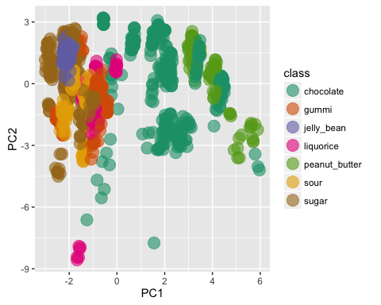

Now we'll make the point the mean colors of the actual candies

p <- ggplot(pca_scores, aes(PC1, PC2, colour=rgb(Mean.Red, Mean.Green, Mean.Blue, maxColorValue = 255)))  
p + geom_point(size=5, alpha=0.6) + scale_color_identity()

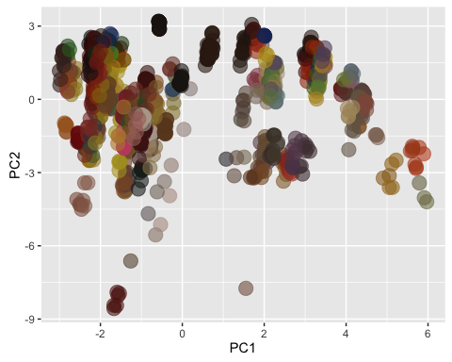

Second, we'll do a principle component analysis based only on the shape information.

shape_pca <- prcomp(merged_color_shape_nutrition[c(4:5,7:9)], center = TRUE, scale. = TRUE)  
  
summary(shape_pca)

## Importance of components:  
## PC1 PC2 PC3 PC4 PC5  
## Standard deviation 1.7258 0.9317 0.8064 0.52541 0.47659  
## Proportion of Variance 0.5957 0.1736 0.1301 0.05521 0.04543  
## Cumulative Proportion 0.5957 0.7693 0.8994 0.95457 1.00000

shape_pca$rotation

## PC1 PC2 PC3 PC4 PC5  
## cm2 0.3182575 -0.850962662 0.2421031 0.3278451 -0.09207804  
## Circ -0.5072872 -0.004143061 -0.3381955 0.5795874 -0.54068924  
## AR 0.4676279 0.141779777 -0.5902492 0.4722855 0.43563163  
## Round -0.5027325 0.011938292 0.4052726 0.4020241 0.64903641  
## Solidity -0.4122574 -0.505570326 -0.5606869 -0.4146312 0.29690671

shape_scores <- as.data.frame(shape_pca$x)  
shape_pca_scores <- cbind(merged_color_shape_nutrition, shape_scores)  
  
p <- ggplot(shape_pca_scores, aes(PC1, PC2, colour=class))  
p + geom_point(size=3, alpha=0.6) + scale_colour_brewer(type="qual", palette = 2)

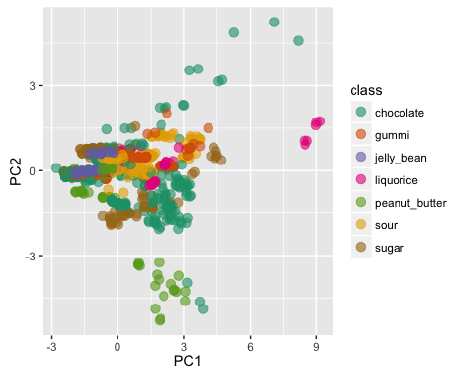

Now we'll do a principle component analysis based only on the color information

color_pca <- prcomp(merged_color_shape_nutrition[c(10:12)], center = TRUE, scale. = TRUE)  
  
summary(color_pca)

## Importance of components:  
## PC1 PC2 PC3  
## Standard deviation 1.4062 0.8548 0.54041  
## Proportion of Variance 0.6591 0.2435 0.09735  
## Cumulative Proportion 0.6591 0.9026 1.00000

color_pca$rotation

## PC1 PC2 PC3  
## Mean.Green -0.6476034 -0.05127971 0.7602501  
## Mean.Blue -0.5195724 0.75952945 -0.3913560  
## Mean.Red -0.5573637 -0.64844846 -0.5185174

shape_scores <- as.data.frame(color_pca$x)  
color_pca_scores <- cbind(merged_color_shape_nutrition, shape_scores)  
  
p <- ggplot(color_pca_scores, aes(PC1, PC2, colour=class))  
p + geom_point(size=3, alpha=0.6) + scale_colour_brewer(type="qual", palette = 2)

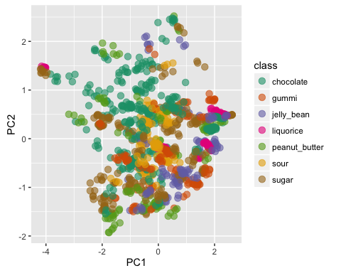

This would look really cool using the actual candy colors.

p <- ggplot(color_pca_scores, aes(PC1, PC2, colour=rgb(Mean.Red, Mean.Green, Mean.Blue, maxColorValue = 255)))  
p + geom_point(size=5, alpha=0.6) + scale_color_identity()

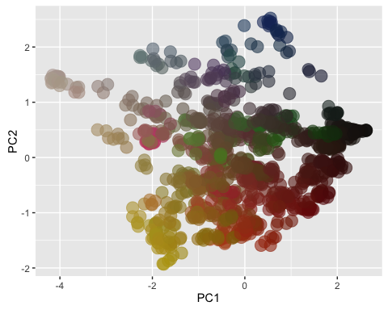

Now do a principle component analysis on the nutrition information

nutrition_pca <- prcomp(merged_color_shape_nutrition[c(28:35)], center = TRUE, scale. = TRUE)  
  
summary(nutrition_pca)

## Importance of components:  
## PC1 PC2 PC3 PC4 PC5 PC6  
## Standard deviation 2.2385 1.0962 0.82961 0.71756 0.51022 0.45949  
## Proportion of Variance 0.6264 0.1502 0.08603 0.06436 0.03254 0.02639  
## Cumulative Proportion 0.6264 0.7766 0.86261 0.92698 0.95952 0.98591  
## PC7 PC8  
## Standard deviation 0.28062 0.18436  
## Proportion of Variance 0.00984 0.00425  
## Cumulative Proportion 0.99575 1.00000

nutrition_pca$rotation

## PC1 PC2 PC3 PC4  
## total_fat_per_serv -0.4258544 0.15230008 0.16678991 0.08750172  
## saturated_fat_per_serv -0.3944010 0.19234821 0.21817337 0.14084474  
## cholesterol_per_serv -0.2903991 0.44901914 0.12870489 -0.76038133  
## sodium_per_serv -0.2021186 -0.58361848 0.72868972 -0.01256169  
## total_carb_per_serv 0.4250225 0.12582020 0.16144698 0.06762863  
## dietary_fiber_per_serv -0.3791893 0.20707763 -0.02021696 0.39933066  
## sugars_per_serv 0.2623695 0.57791402 0.44406256 0.38496156  
## protein_per_serv -0.3803234 -0.06986875 -0.39161518 0.28624225  
## PC5 PC6 PC7 PC8  
## total_fat_per_serv -0.23343218 0.025030924 -0.21178334 -0.81240874  
## saturated_fat_per_serv -0.67253884 0.002228528 0.35266521 0.40413732  
## cholesterol_per_serv 0.29027798 -0.105963657 0.14346969 0.05685352  
## sodium_per_serv 0.25308010 -0.124502755 0.07374769 0.04900847  
## total_carb_per_serv 0.04282573 0.066248098 0.79109931 -0.37526708  
## dietary_fiber_per_serv 0.49659213 0.614583472 0.12001742 0.12140788  
## sugars_per_serv 0.16029882 -0.367005906 -0.27810544 0.11857060  
## protein_per_serv 0.26600110 -0.675162398 0.29524203 -0.03750560

shape_scores <- as.data.frame(nutrition_pca$x)  
nutrition_pca_scores <- cbind(merged_color_shape_nutrition, shape_scores)  
  
p <- ggplot(nutrition_pca_scores, aes(PC1, PC2, colour=class))  
p + geom_point(size=3, alpha=0.6) + scale_colour_brewer(type="qual", palette = 2)

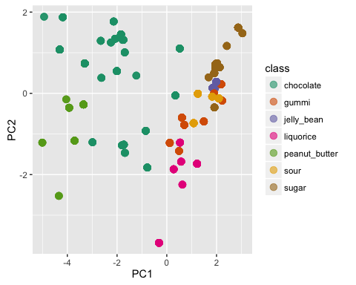

# HIERARCHICAL CLUSTERING TIME

scaled_everything <- scale(merged_color_shape_nutrition[c(4:5, 7:12, 28:35)])  
scaled_candies <- scale(t(scaled_everything))  
colnames(scaled_candies) <- as.matrix(merged_color_shape_nutrition[2])  
  
corell_nutrition <- cor(scaled_everything, method="spearman")  
corell_candies <- cor(scaled_candies, method="spearman")  
  
dist_nutrition <- as.dist(1-abs(corell_nutrition))  
dist_candies <- as.dist(1-abs(corell_candies))  
  
hc_nutrition <- hclust(dist_nutrition, method="ward.D2")  
hc_candies <- hclust(dist_candies, method="ward.D2")  
  
plot(hc_nutrition, cex=0.8)

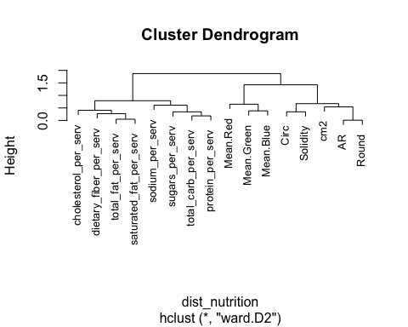

plot(hc_candies, cex=0.8)

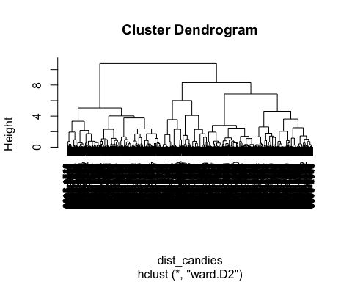

plot(as.phylo(hc_nutrition), type="cladogram", label.offset=0.01)

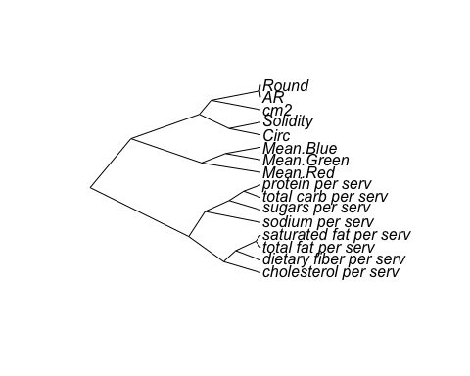

plot(as.phylo(hc_candies), type="cladogram", label.offset=0.01, cex=0.5)

