# RESEARCH STATEMENT

Plants are possibly the best system to study the integration of environmental and developmental signals. They sense changing environment and translate it to molecular signals resulting in altered cell division, expansion, and differentiation of the meristem, which ultimately leads to a different plant architecture that can be quantified using modern phenotyping techniques. Investment in new tissues is initially energetically expensive but increases plant productivity by adding new source tissues, such as leaves or roots. Alterations of plant architecture are even more important under environmental stress conditions, including drought, salt stress, and low nutrient availability. **My hypothesis is that abiotic stress tolerance is a result of stress-induced changes in plant architecture, providing an evolutionary advantage in wild relatives of crop plants.** By describing the allocation of the biomass to individual organ type using dynamic functions and fractal-based methods, I intend to summarize the dynamics of plant growth at a much more functional level. By applying this combined approach to wild tomato relatives, I intend to examine changes specific to tolerant and susceptible accessions and identify traits contributing to yield maintenance under abiotic stress. Candidate genes will be identified using omics approaches and forward genetics. **My integrative approach (Fig. 1) combines modern phenotyping, descriptive growth models, forward genetics and OMICs approaches yielding new and broadly applicable fundamental knowledge and identification of new genetic components of abiotic stress tolerance.** The acquired knowledge can be applied to develop breeding programs with increased stress tolerance for the countries with limiting freshwater resources, as well as reduce the environmental footprint of the horticulture industry. At the later stage, identified functional architecture differences between different taxonomic groups will be used for understanding the broader relationship between form and function.

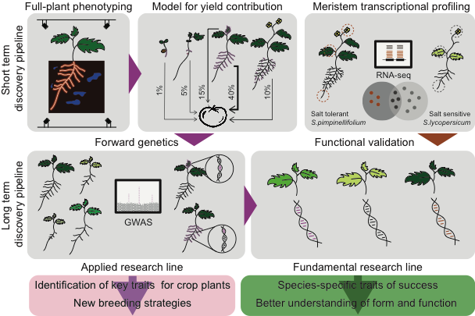**Figure 1. The graphical abstract of proposed research.** Plant architecture results from the differential allocation of the biomass to growing tissues and is hypothesized to contribute to salt stress tolerance. The distribution of the biomass between root, shoot and flower tissues will be examined usingRGB cameras. The collected data will be used to develop a dynamic model, combining simple functions and fractal systems to describe plant architecture under control and salt stress conditions. The individual aspects of this plant architecture model will be evaluated using quantile regression for their contribution to yield and plant performance. Simultaneously, the root, leaf and flower meristem of salt-tolerant *S.pimpinellifolium* accessions and reference *S.lycopersicum* (cv. Moneymaker) will be used for transcriptome profiling. Transcripts specific to tolerant genotypes will be identified. The plant architecture with the highest contribution to salinity tolerance will be the focus of screen of 215 *S.pimpinellifolium* accessions followed by Genome Wide Association Study (GWAS). Candidate genes identified using RNAseq and GWAS will undergo functional validation. In future screening commercially and ecologically interesting species will form the basis of fundamental and applied research lines, revealing species-specific plant architecture traits contributing to plant performance in adverse environmental conditions.

## Research accomplishments

I am interested in how interactions with environment shape plant architecture. During my Ph.D. I focused on changes in root architecture in response to salinity in Arabidopsis. I developed a Root-Fit model, allowing a functional insight into salt stress-induced reprogramming of root architecture. By studying natural variation in salt-induced responses across 350 Arabidopsis accessions and GWAS, I learned that high sodium accumulation in the root, due to high HKT1 expression, is detrimental for lateral root development. During my PostDoc,​ I studied transcriptome profiles in lines with high HKT1 expression and gained a better understanding of the processes hindering lateral root development under salt stress. Next to it, I studied salt-induced changes in root-to-shoot ratio in Arabidopsis, and discovered that maintenance of root and shoot coordination might be indicative of salt stress tolerance. The GWAS revealed 15 genetic loci regulating root-to-shoot maintenance. Currently, I am at the stage of validation of candidate genes identified through RNAseq and GWAS, and I am thrilled to see clear effects of the identified genes not only on plant architecture but also overall salt stress tolerance. I also developed a pipeline for phenotypic data curation and analysis, MVApp, which is now broadly used by my scientific peers.

## Wild Tomato As Model For Studying Salt Stress Tolerance

Tomato is one of the most important horticultural crop in the USA and worldwide. However, due to its breeding history, it has limited genetic diversity. Tomato’s cultivating conditions often result in increased soil/substrate salinity[1], reducing the productivity of commercial elite varieties. Species closely related to cultivated tomato, like *S.pimpinellifolium*, show high water use efficiency[2], as well as salt tolerance (Fig.2). Additionally, wild tomato plants exhibit high diversity in plant and leaf architecture[3], which might affect plant performance under salt stress. The recent advances in genome sequencing of *S.pimpinellifolium*[4] open the doors for forward genetic and omics studies, where we can dissect the genetic components of their salt stress tolerance. Developing breeding programs for tomato varieties with increased abiotic stress tolerance will not only allow growing tomatoes in low-tech countries, where the fresh water availability is limiting plant productivity but will also decrease the environmental impact of tomato horticulture in the well-developed infrastructure countries, such as the USA.

## Plant Architecture As A Key Model To Salinity Tolerance

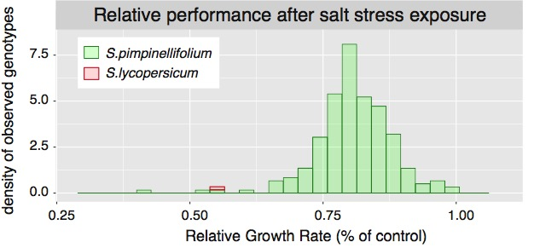Plant architecture responds to the changing environment by optimizing the balance between investment in the new organs and the costs of their maintenance. The compactness of the plant decreases water loss[5], leaf-shape complexity affects photosynthetic efficiency[6], while the maintenance of lateral root emergence ensures salinity tolerance at the seedling stage[7]. Although the above-mentioned traits have important role in plant performance, they are often studied separately, using different experimental setups. Recent advances in phenotyping[8],[9] yield new possibilities for studying plant growth, architecture and performance. Statistical tools, such as quantile regression[10], will allow quantification of individual traits to overall plant performance in adverse environmental conditions. Branching of above or belowground organs can be easily described using fractal-based Lindenmayer-system[11], yet its application has not been pursued beyond theoretical biology. I intend to implement simultaneous measurement of root and shoot architecture and describe changes therein by combining dynamic and fractal-based models. By studying the development of all the organs simultaneously under control and salt stress conditions, I can quantify the biomass re-distribution across the tolerant and susceptible genotypes between leaves, roots, and flowers. Studying both shoot and root phenotypes in one system will provide the full picture of the plant stress response and reveal the complementary processes.

**Figure 2. Natural variation in salt stress tolerance in *S.pimpinellifolium*.** The relative performance of 215 *S.pimpinellifolium* accessions and one *S.lycopersicum* line (cv. Moneymaker) is based on the shoot growth rate under salt stress relative to control conditions. The salt stress was imposed 3 weeks after germination and the growth rate is based on two weeks of observations. The presented data was obtained at Prof. Mark Tester’s group (KAUST), which agreed to share it as preliminary resource.

## Research vision

Changing environment has a continuous effect on plant development and reproductive success rate. My hypothesis is that wild tomato *S.pimpinellifolium* show enhanced survival and productivity under salt stress conditions due to their specific and highly adaptive plant architecture. Many scientists, including myself, study stress responses at the level of individual tissues, or focus on one life stage. Although the tissue-specific responses are undoubtedly important, the integration of environmental signal takes place at a whole-plant level. Therefore, I aim to examine plant architecture changes in response to salt stress in a phenotyping setup where the development of plant root and shoot can be observed simultaneously.

The short-term aim of my research focuses on developing a simple phenotyping system for screening the development of root and shoot. The imaging station will be set up using transparent rhizotrons, allowing for quantification of root architecture, while the shoot growth will be monitored from above. The imaging station will consist of RaspberryPi computers operating multiple digital cameras. The imaging will start four days after germination and will continue for two months. The system will be tested on *S.lycopersicum* cv. Moneymaker seedlings, and later on expanded to five salt-stress tolerant and susceptible *S.pimpinellifolium* lines (Fig. 2). Once the majority of plants reach a size and complexity beyond the phenotyping system capacity, plants will be transferred to larger pots for fruiting and ripening, allowing quantification of yield. Based on collected data, we will develop a mathematical model combining descriptive modeling[12] and Lindenmayer-system and quantify the contribution of individual plant architecture aspects to overall and relative plant performance under salt stress. The model will be made accessible for other scientists to use and collaborate through open-source platforms such as GitHub. The traits identified to have the major contribution to yield maintenance using the model, and sufficiently high heritability will be the focus of my long-term research line, where I intend to perform forward genetic screen of 215 genotyped *S.pimpinellifolium* accessions made available through collaboration with Prof. Mark Tester’s lab (KAUST). We will conduct a Genome Wide Association Study (GWAS) using simple and multi-trait GWAS models[13] to capture genetic components of traits of major interest, as well as *GxE* interactions. The molecular context of identified candidate genes will be evaluated using reverse genetic approaches in cultivated tomato background (*S.lycopersicum* cv. Moneymaker) and Arabidopsis, using stable and transient transformation system and speed-breading setup[14] to enhance the generation of homozygous lines.

Additionally, I intend to examine the transcriptional activity at root, shoot and flower meristems of the salt tolerant genotypes of *S.pimpinellifolium* and reference line *S.lycopersicum* cv. Moneymaker. By performing comparative transcriptomic analysis, I aim to identify genotype- and meristem type-specific responses to salinity. Transcripts showing significant responses to salinity will be compared between salt-tolerant *S.pimpinellifolium* lines and the reference line (Moneymaker) to identify signatures specific to the tolerant accessions. To validate the identified signals for their role in salt stress tolerance, we will use the tomato stable and transient hairy root transformation method[15] in Moneymaker background and Arabidopsis and study changes in salinity tolerance of plants transformed with overexpression constructs and knock-out lines, both generated using CRISPR/Cas9[16]. The molecular context will be further assessed by hormone profiling and ion accumulation measurements of the transgenic plants.

The importance of the plant architecture derived salt tolerance will finally be evaluated by studying the performance of the transgenic lines under field conditions. I intend to perform this field-based evaluation in collaboration with commercial partners, as well as international collaborations in developing countries, suffering from limited freshwater availability. The fundamental knowledge generated by the proposed research will feed into breeding programs as well as new forward genetic screens in other species and identification of new genetic components underlying plant performance under stress conditions. Evaluating other species with commercial and ecological importance will shed more light on traits contributing to plant performance in various environments and their ecological and evolutionary importance. The proposed research will have a significant contribution to the research interest areas in the BTI: Cell Biology, Stress Responses, and Genomics and Systems.

1. Carmassi et al., J. of Plant Nut. 2005
2. Cantero-Navarro et al., 2016 Plant Sci.
3. Darwin et al., 2003 Systematics and Biodiv.
4. Razali et al., 2017 bioRxiv
5. Borba et al., 2017 Genet Mol Res.
6. Nicotra et al., 2008 Oecologia
7. Julkowska et al., 2017 The Plant Cell
8. Gehan et al., 2017 PeerJ
9. Tovar et al., 2018 Plant Sciences
10. Julkowska et al., 2018 MVApp Figshare
11. Lindenmayer, 1968 J. Theoret. Biology
12. Julkowska et al., 2014 Plant Physiology
13. Korte et al., 2012 Nature Gen.
14. Watson et al., 2018 Nature Plants
15. Ron et al., 2014 Plant Phys.
16. Shan & Voytas, 2018 Nature Plants