How Does an HTML Form Work?
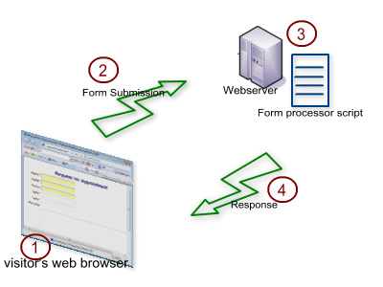

This first diagram shows how a user may initially receive a HTML form. First of all the user must send a request for the page that contains the form. The webserver will then respond with the page along with the form, which the web browser will load. Generally once the form has been submitted it will trigger javascript code that will validate the data to prevent errors. The data within the form is then submitted to what is known as an “action” URL, which is most often a script that then deals with the data. Once the web server has processed the request it will then send a response to the browser which most often gives feedback, usually as a confirmation box or a re-direct to another page.
Both of the primary HTTP methods are used within form submission, first of all GET Is used to receive the page along with the form, whereas POST is used to send the data within the form to the web server to be processed by the script; unless the script is client side, in which case it is processed before being sent.

